Supporting Information
Melamine sponge skeleton loaded organic conductors for mechanical sensors with high sensitivity and high resolution
Yufeng Wu^{1,2}, Jianbo Wu^{1,*}, Yan Lin¹, Junchen Liu², Xiaolong Pan^{3,*}, Xian He², Ke Bi^{2,*}, Ming Lei²
¹ Zhejiang Provincial Key Laboratory for Cutting Tools, Taizhou University, Taizhou 318000, Zhejiang, China
² State Key Laboratory of Information Photonics and Optical Communications, Beijing University of Posts and Telecommunications, Beijing 100876, China
³ The School of Information and Electronics, Beijing Institute of Technology, Beijing 100081, China
Email: wujb@tzc.edu.cn; panxiaolong2018@126.com; bike@bupt.edu.cn

Fig. S1 Chemical structure and formula of TTF, TCNQ and MS.

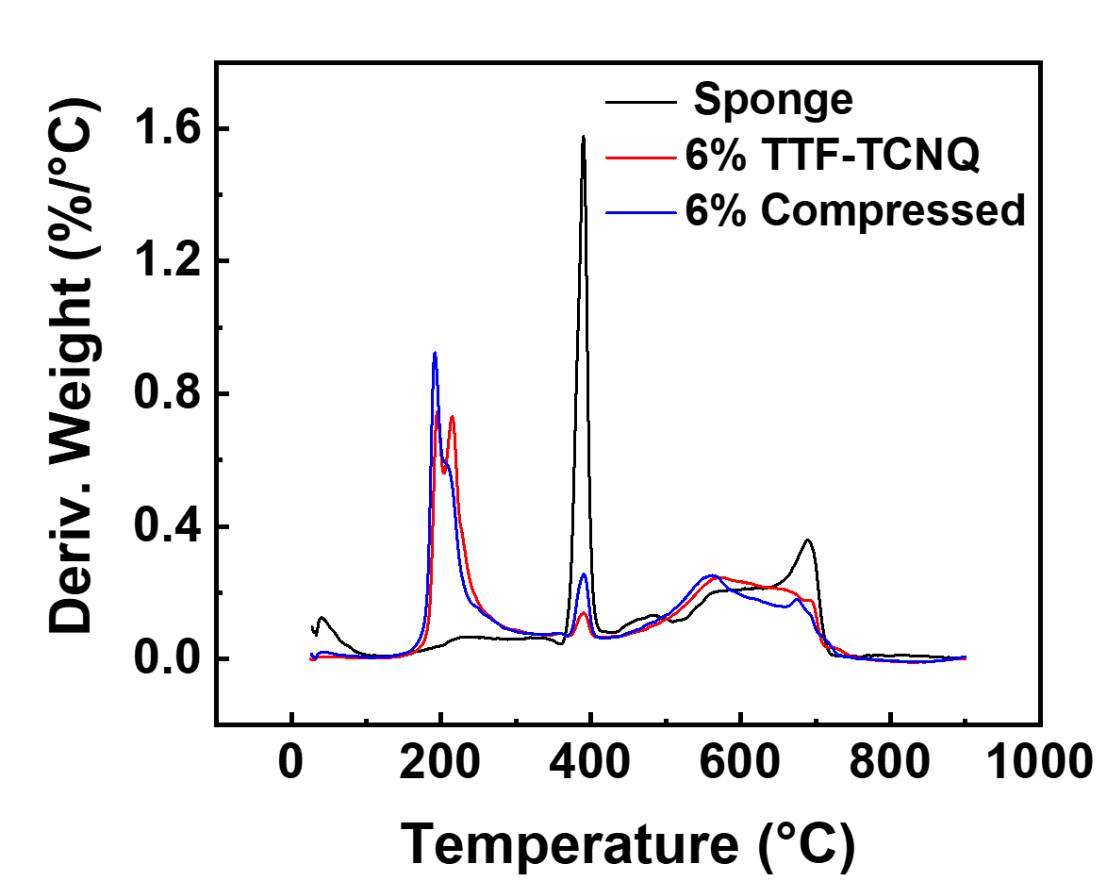
Fig. S2 DTG Curve.
Fig. S3 XPS of TTMS. (a) Survey, (b) C 1s, (c) O 1s.

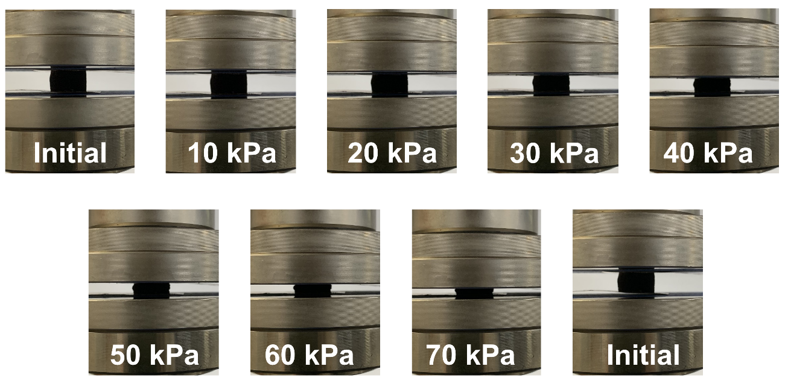
Fig. S4 Optical images of TTMS compression process.
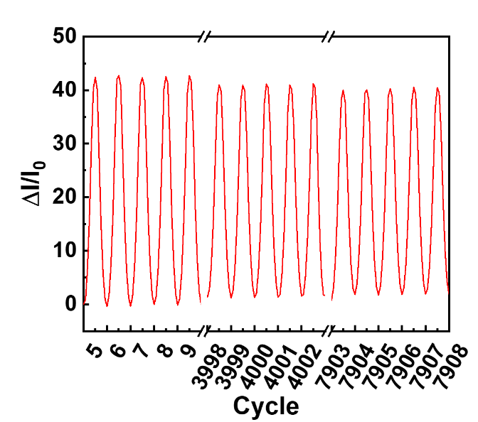
Fig. S5 Detailed presentation of several cycles in the repeated compression process (156th to 150th, 4606 to 4610th and 9880th to 9884th).

Fig. S6 Conductivity-strain curve.
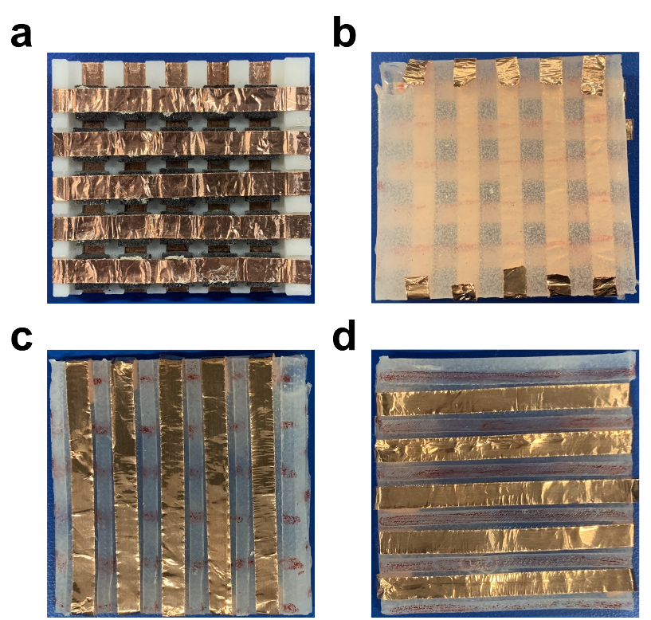
Fig. S7 The substrates of the sensor. (a) PLA, (b) Ecoflex, (c, d) The upper and lower layers of the Ecoflex substrate.

