Supplementary Information
Balanced coexistence of reversible and irreversible covalent bonds in a conductive triple polymeric network enables stretchable hydrogel with high toughness and adhesiveness
Kyuha Park^{1,2†}, Kyumin Kang^{1,2†}, Jungwoo Kim³, Subin Jin³, Mikyung Shin^{2,3,4}*, and Donghee Son^{1,2,5}*
¹Department of Electrical and Computer Engineering, Sungkyunkwan University, Suwon 16419, Republic of Korea
²Center for Neuroscience Imaging Research, Institute for Basic Science (IBS), Suwon 16419, Republic of Korea
³Department of Intelligent Precision Healthcare Convergence, Sungkyunkwan University, Suwon 16419, Republic of Korea
⁴Department of Biomedical Engineering, Sungkyunkwan University, Suwon 16419, Republic of Korea
⁵Department of Superintelligence Engineering, Sungkyunkwan University, Suwon 16419, Republic of Korea
†These authors contributed equally to this work.

This Supplementary Information includes:
Fig. S1 to S7
Table S1
Captions for Supplementary Video 1 to 4
Supplementary Figures
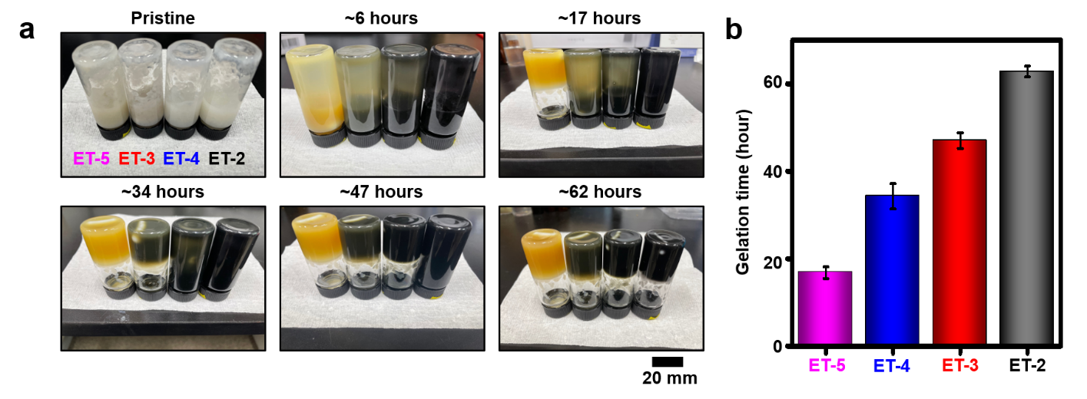
Fig. S1 a) Photographs for gelation of each formulation, ET-2, ET-3, ET-4, and ET-5, as a function of time. Scale bar = 20 mm. b) Time to complete gelation of the formulations.
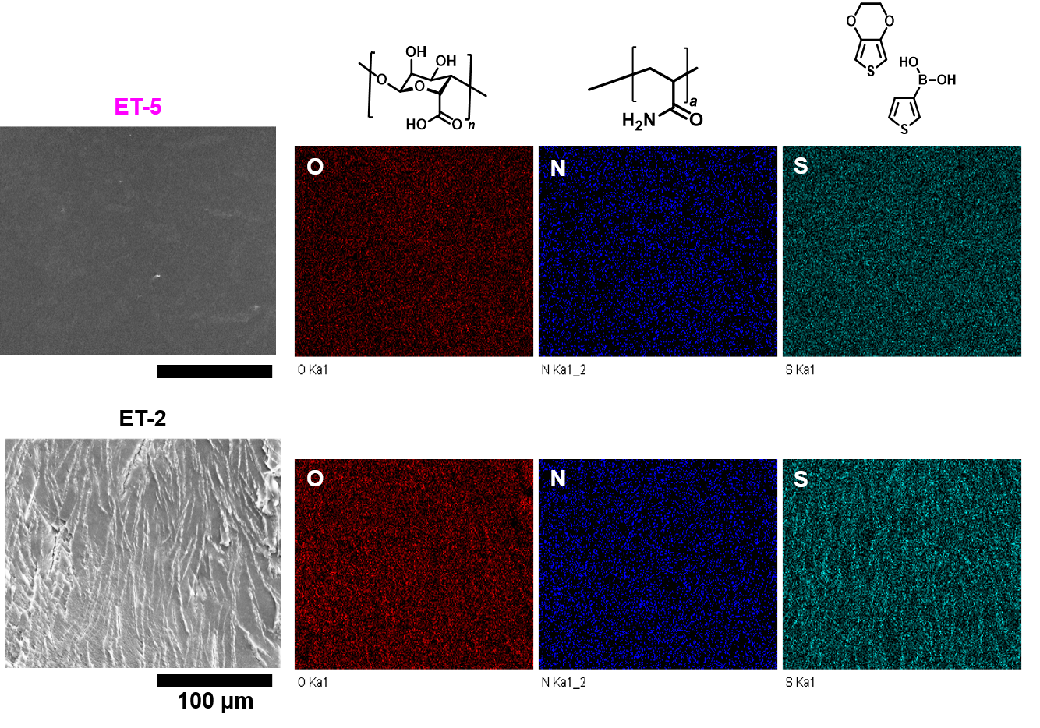
Fig. S2. Cross-sectional SEM images of ET-2 (top) and ET-5 (bottom) and their elemental analysis of oxygen (O; red), nitrogen (N; blue), and sulfur (S; cyan).
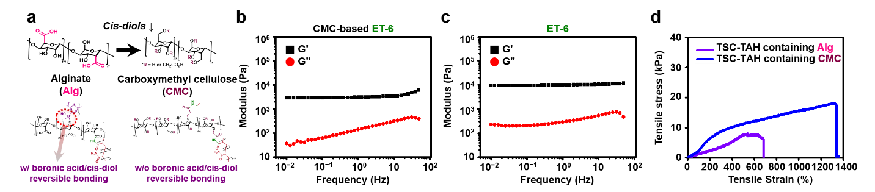
Fig. S3 a) Comparison of chemical structures of Alg with cis-diol groups to that of CMC without cis-diol groups. b) and c) Rheological properties of CMC-containing ET-6 hydrogels b) or Alg-containing ones c). G’ for black symbol and G” for red one. d) Tensile stress-strain curves of CMC- (blue) or Alg- (purple) based ET-4.
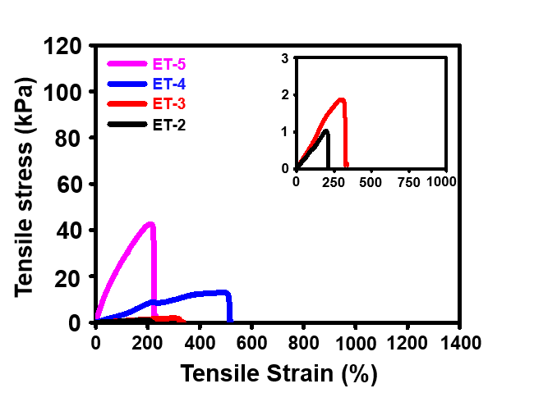
Fig. S4 Strain–stress curves of 50% notched ET-2 (black), ET-3 (red), ET-4 (blue), and ET-5 (pink). The inset graph for clarifying the curves of ET-2 and ET-3.

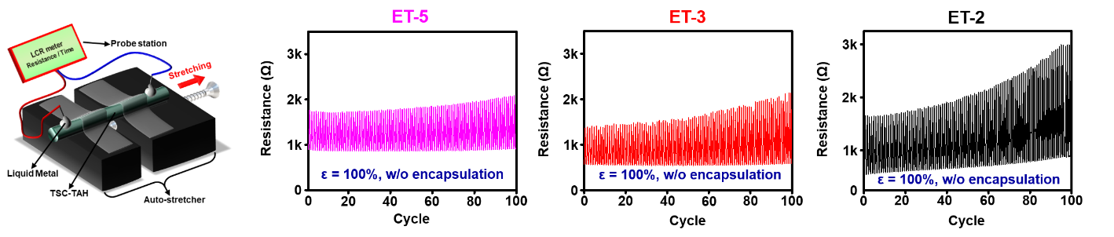
Fig. S5 Changes in electrical resistance of ET-2, ET-3, and ET-5 during one-hundred cyclic stretching test (at a speed of 0.3 mm/s, strain of 100%). The 1st scheme includes experimental setting and variables for the stretching test.

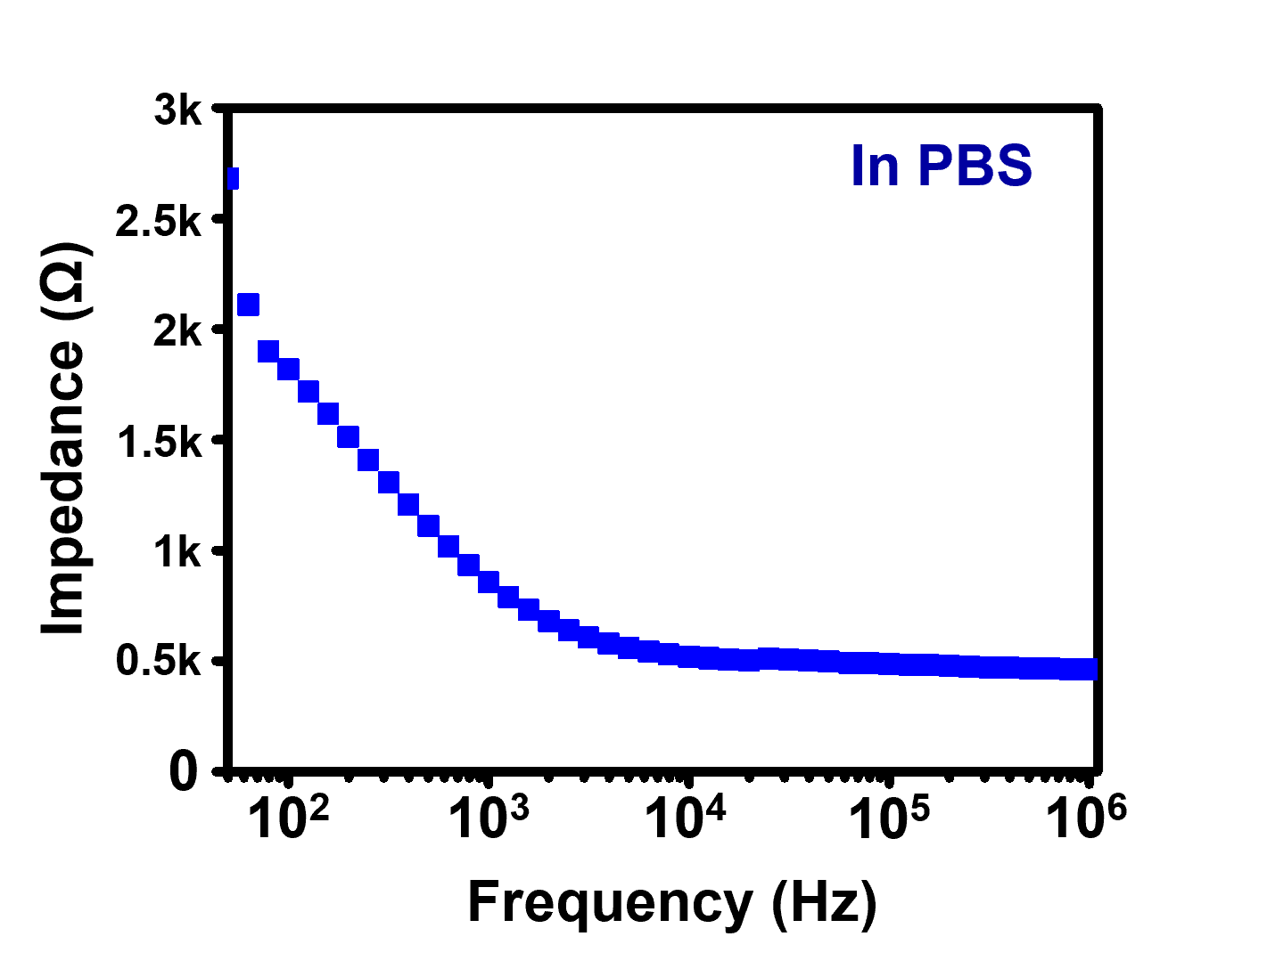
Fig. S6. Electrochemical impedance of TSC-TAH at the frequency ranging from 50 to 100,000 Hz when immersed in phosphate buffered saline (PBS).

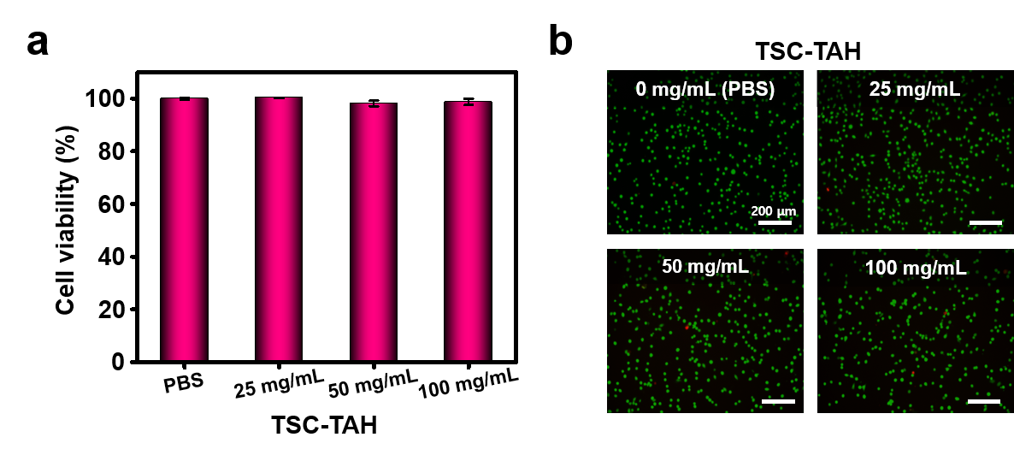
Fig. S7. a) In vitro cytotoxicity (%) of TSC-TAH as a function of concentration, 25, 50, and 100 mg/mL. b) Fluorescent images of the live cells (green dots) and dead cells (red dots) after 24-hour treatment of the releasates from the TSC-TAH.

Supplementary Table
Table S1. Quantity of precursors to fabricate TSC-TAH.
Precursor | ^{a)}Alg | ^{b)}CMC | ^{c)}EDOT: ^{d)}TBA | ^{e)}AAm | ^{f)}MBAA | ^{g)}TEMED | ^{h)}APS
Weight (mg) | 300 | 364 | 134:0 (‘ET-1’)  120.6:10 (‘ET-2’)  84.4:37 (‘ET-3’)  49.6:63 (‘ET-4’)  13.4:90 (‘ET-5’)  0:100 (‘ET-6’)  0:0 ('Alg/PAAm' or 'CMC/PAAm') | 2400 | 10 | 7.76 | 800
Mol (mmol) | 1.388 | 1.388 | 0 to 0.7034 | 33.765 | 0.130 | 0.172 | 3.506
Molar ratio to Alg | 1 | 1 | 0 to 0.5067 | 24.325 | 0.093 | 0.124 | 2.526
^{a)}Alg = sodium alginate, ^{b)}CMC = sodium carboxymethylcellulose, ^{c)}EDOT = 3,4-ethylenedioxythiophene, ^{d)}TBA = 3-thienylboronic acid, ^{e)}AAm = acrylamide, ^{f)}MBAA = N,N'-methylenebisacrylamide, ^{g)}TEMED = N,N,N',N'-tetramethyl ethylenediamine, and ^{g)}APS = ammonium persulfate

Captions for the Supplementary Videos
The Videos (from 1 to 4) are available online.
Video 1. Robust adhesiveness of TSC-TAH onto skin tissues.
Video 2. Stretching the TSC-TAH about 200% strain.
Video 3. Demonstration of the TSC-TAH-based IS-HMI for paper and rock motions.
Video 4. Demonstration of the TSC-TAH-based IS-HMI for handshaking motions.

