Authors Biography

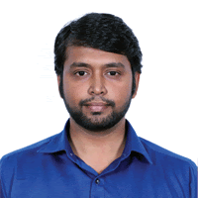
Mr. R. Karthikeyan pursuing his Ph.D in Bharathiar University. Currently, he is working as Assistant Professor in the Department of Computer Technology at Sri Krishna Adithya College of Arts and Science, Coimbatore, Tamilnadu, India.
.

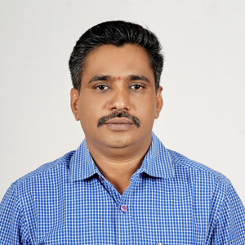
Dr. R. Vadivel Completed his B.E. in Periyar University. M.E. in Annamalai University. He obtained his PhD degree from Manonmaniam Sundaranar University. At present, he is working as an Assistant Professor in the Department of Information Technology, Bharathiar University, Coimbatore. He has published more than 45 research papers in National, International Journals and Conferences.His research interest lies in the area of Computer Networks & Security, Mobile Computing, Mobile Ad-Hoc Networks, Wireless Sensor Networks, Data mining and Digital Signal Processing. He is a life member of CSI, ISTE, ACS, ISCA, AMIE, IACSIT and IAENG.

