Submitted to : Structural Chemistry
Supporting Information

The structure, stability, thermochemistry and bonding in SO₃-(H₂O)n (n=1–7) clusters: a computational analysis

A. Suvitha,^{a,b} N. S. Venkataramanan,^{c*} R. Sahara^{d}

ªDepartment of Chemistry,
Thassim Beevi Abdul Kader College for Women, Kilakarai – 623 517. India
Email: suvithaa@gmail.com

^{b}SHARP Substratum, Adavathur East, Trichy – 620 102. India

ªDepartment of Chemistry,
K.Ramakrishanan College of Engineering, Samayapuram – 620 112. India
Email: nsvenkataramanan@gmail.com
http://orcid.org/0000-0001-6228-0894

^{d}Research Center for Structural Materials, NIMS, 1‑2‑1 Sengen,
Tsukuba, Ibaraki 305‑0047. Japan

Figure Legend:
Fig. S1 Optimized low-lying isomer for SO₃-(H₂O)₂
Fig. S2 Optimized low-lying first eight isomers for SO3-(H₂O)₃
Fig. S3 Optimized low-lying first eight isomers for SO3-(H₂O)₄
Fig. S4 Optimized low-lying first eight isomers for SO3-(H₂O)₅
Fig. S5 Optimized low-lying first eight isomers for SO3-(H₂O)₇
Fig. S6. Plot of variation of E^{sol} vs the number of water molecules
Fig. S7. Plot of RDG S versus sign(λ₂)ρ for SO₃-(H₂O)_{3.} The figure inserts are the corresponding NCI-RDG isosurfaces with S = 0.5.
Fig. S8. Plot of RDG S versus sign(λ₂) ρ for SO₃-(H₂O)₄. The figure inserts are the corresponding NCI-RDG isosurfaces with S = 0.5.
Fig. S9. Plot of RDG S versus sign(λ₂)ρ for SO₃-(H₂O)₅. The figure inserts are the corresponding NCI-RDG isosurfaces with S = 0.5.
Fig. S10. Plot of RDG S versus sign(λ₂) ρ for SO₃-(H₂O)₆. The figure inserts are the corresponding NCI-RDG isosurfaces with S = 0.5.
Fig. S11. Plot of RDG S versus sign(λ₂)ρ for SO₃-(H₂O)₇. The figure inserts are the corresponding NCI-RDG isosurfaces with S = 0.5.

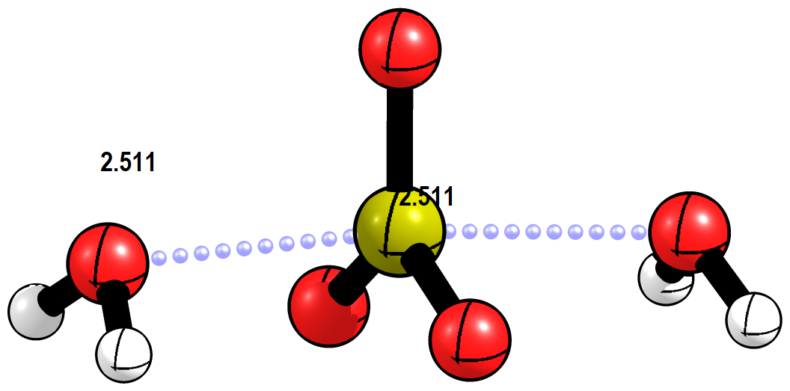

Figure S1.

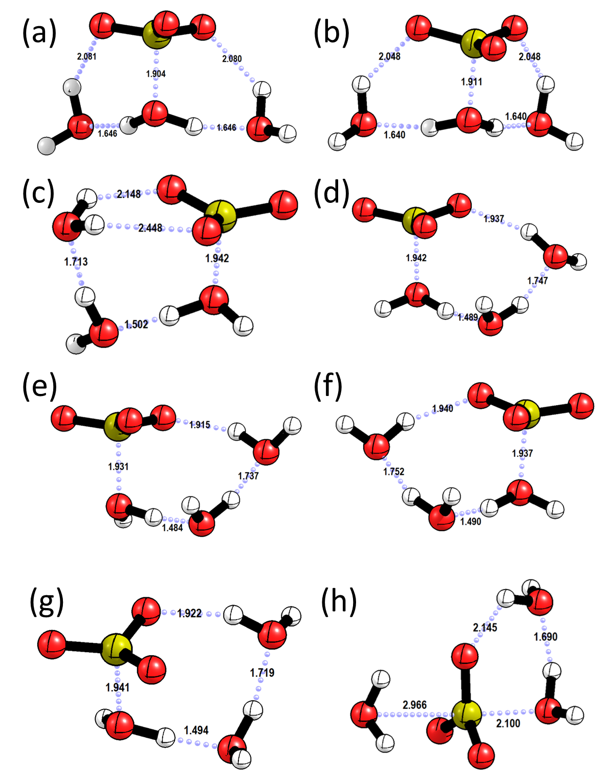

Figure S2
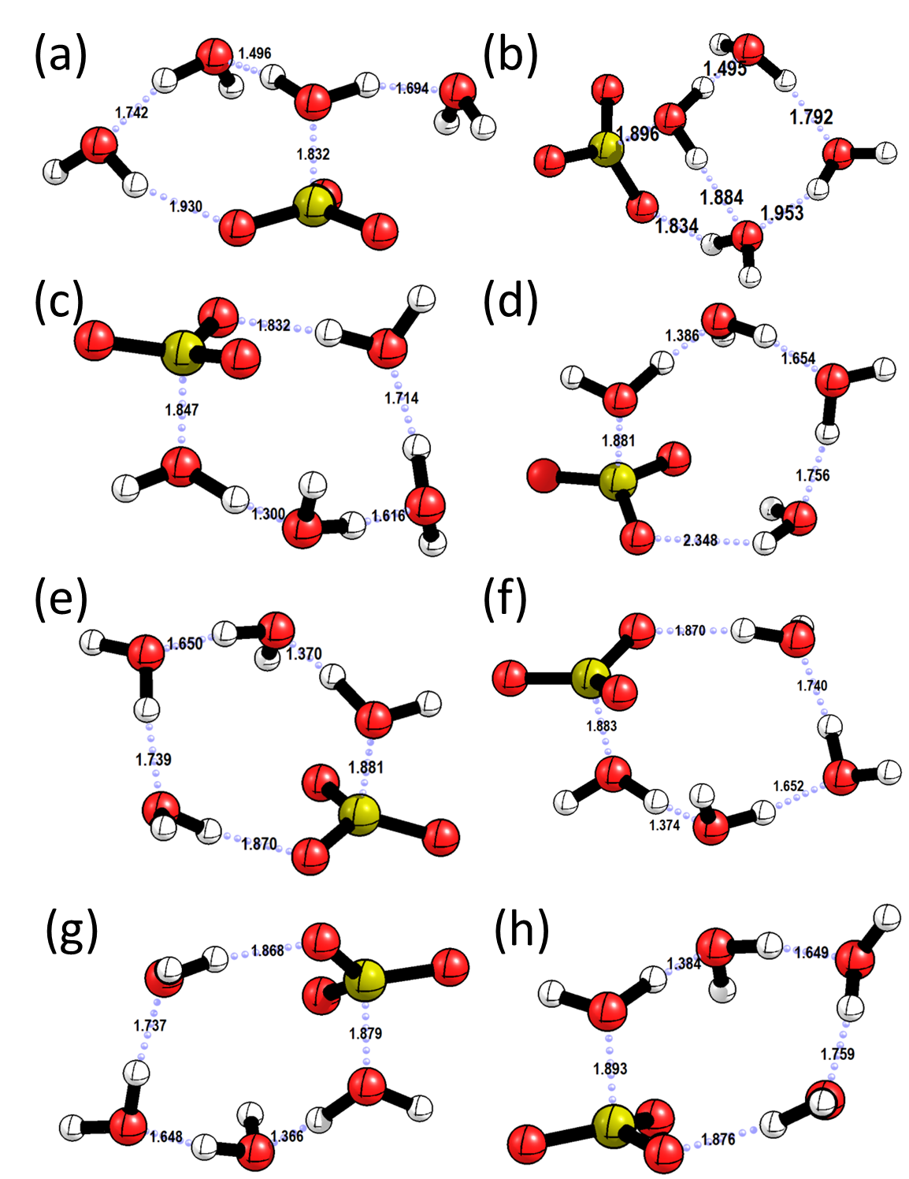

Figure S3

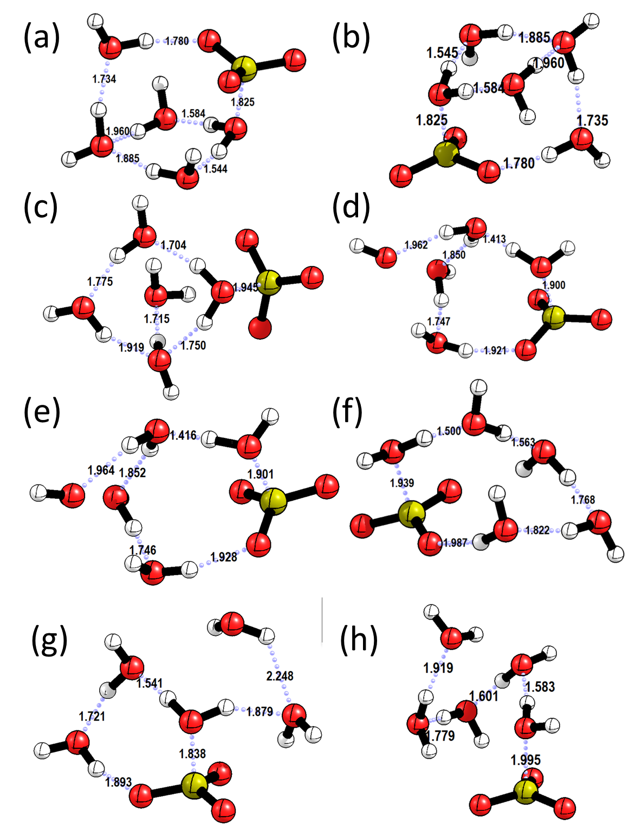

Figure S4

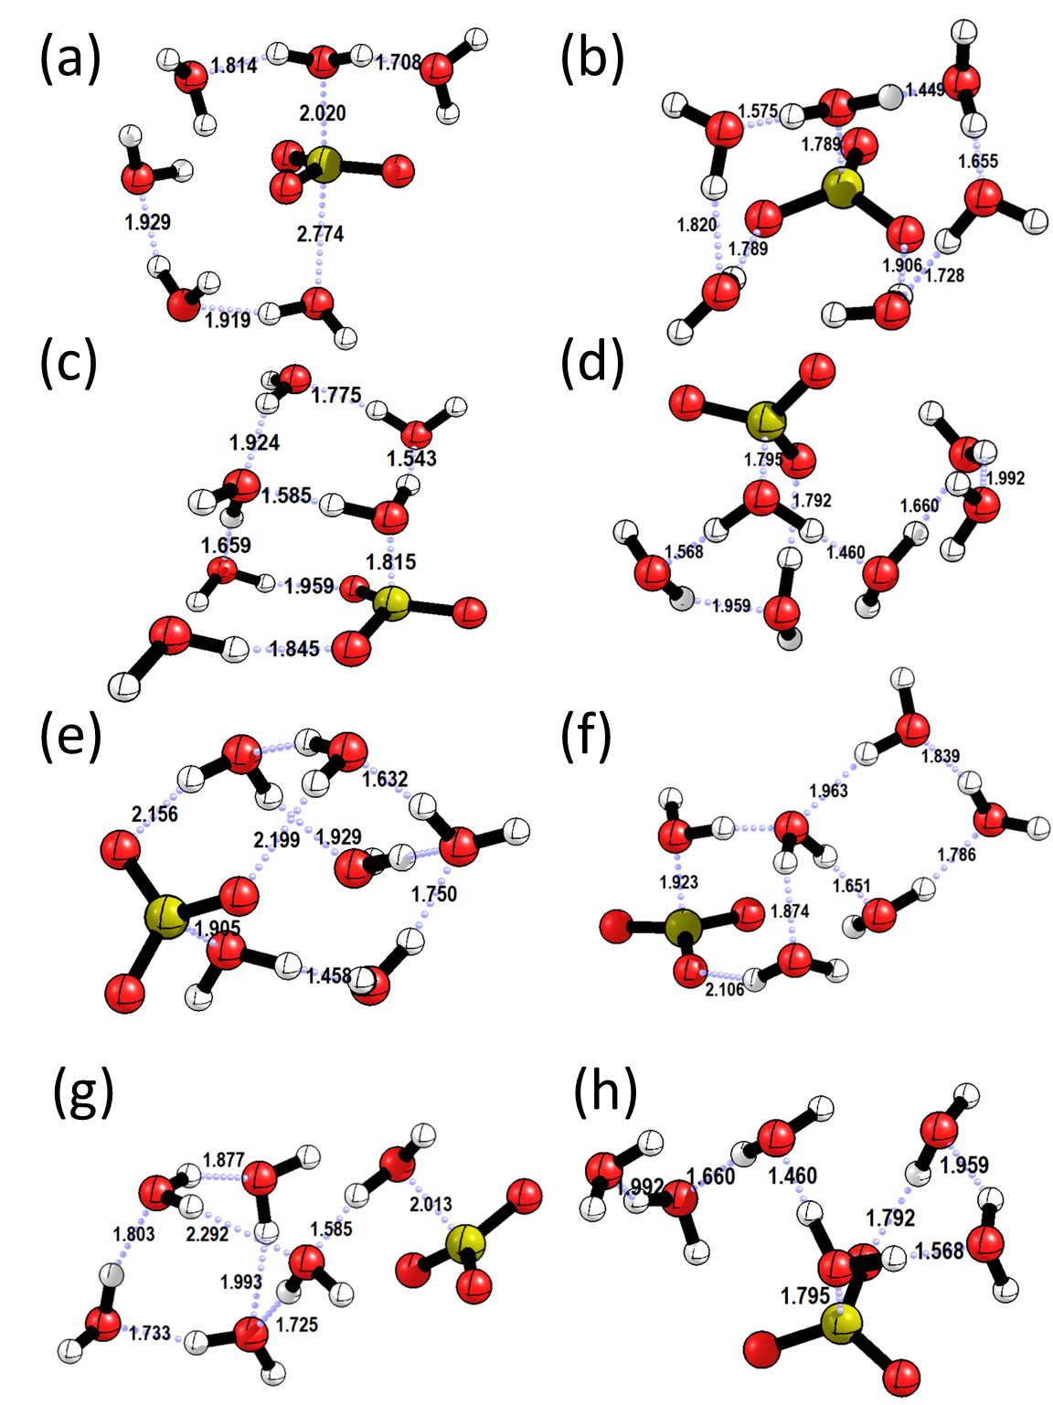

Figure S5

Figure S6.

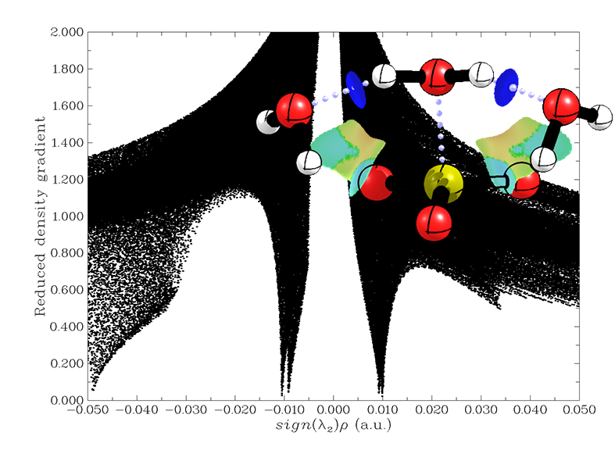
Figure S7

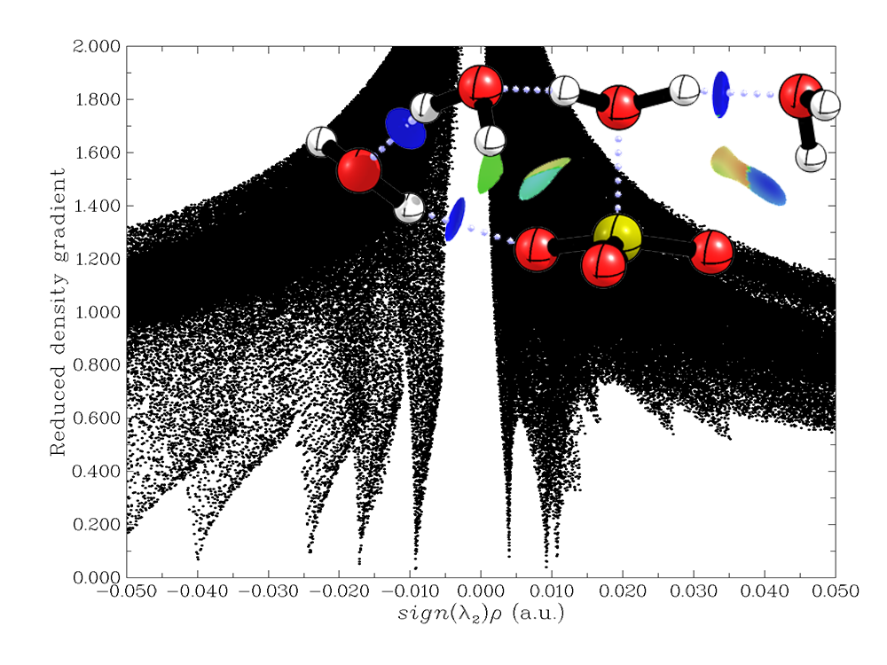
Figure S8

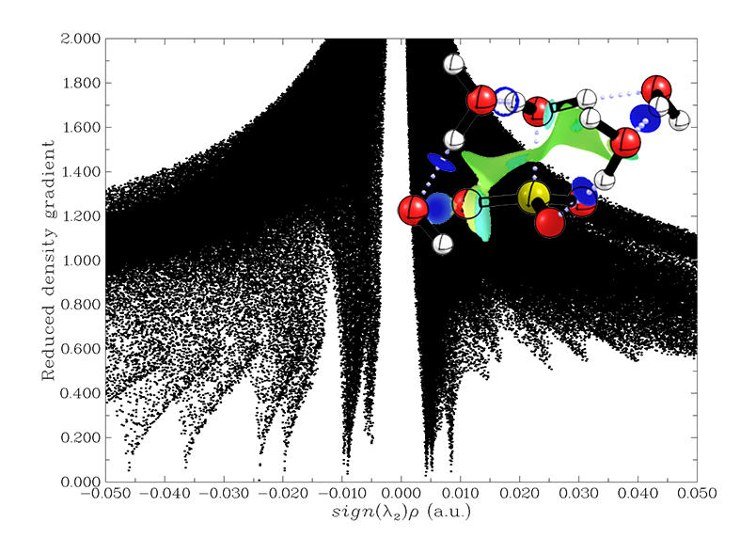
Figure S9

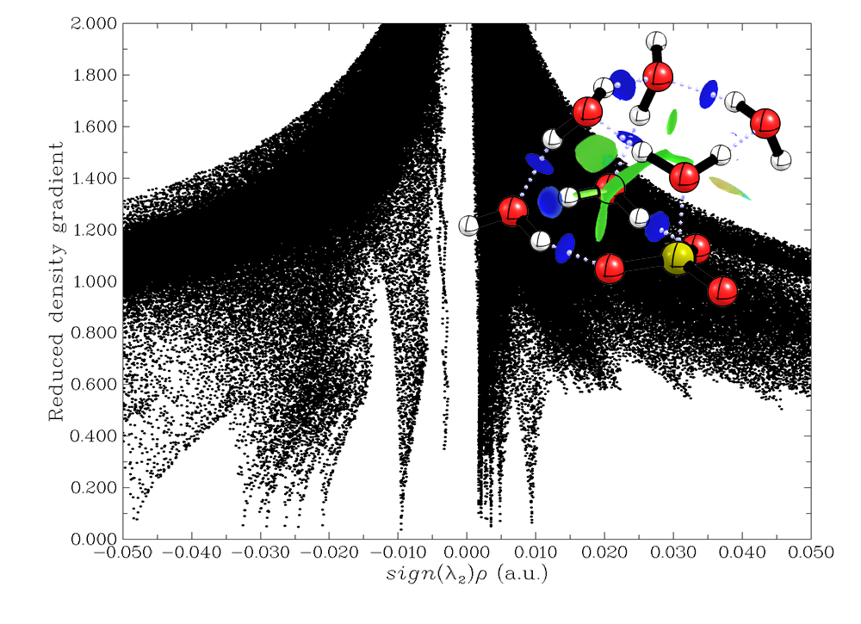
Figure S10

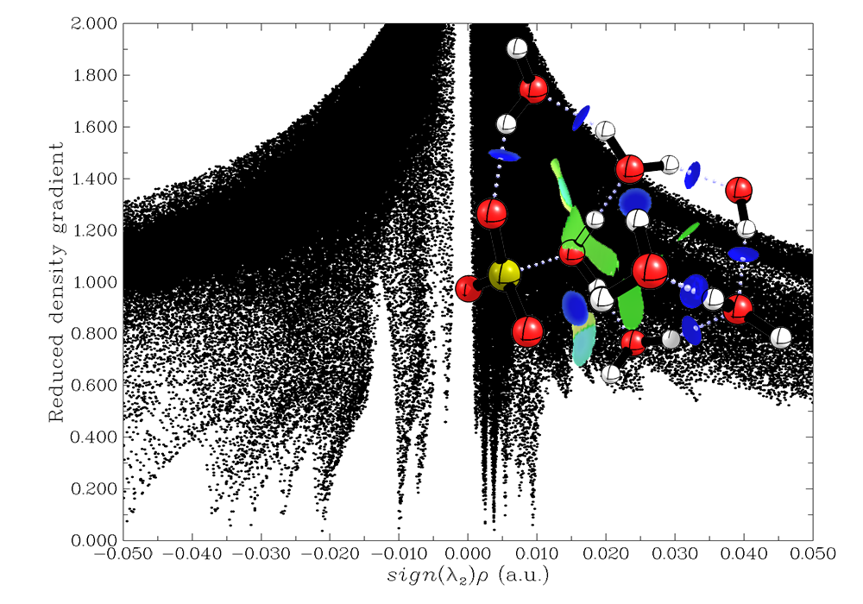
Figure S11

Table S1. The QTAIM parameters correspond to intermolecular bonding between the SO₃ and water in SO₃ –(H2O)₂ cluster.
Atoms | ρ(r) | ∇²ρ(r) | λ₁ | λ₂ | λ₃ | V(r) | G(r) | H(r) | ε
S1 - O8 | 0.08671 | 0.06327 | -0.11286 | -0.1098 | 0.28597 | -0.08008 | 0.04795 | 0.03213 | 0.02752
O5 - H10 | 0.04915 | 0.1268 | -0.09064 | -0.0883 | 0.30577 | -0.05106 | 0.04138 | 0.00968 | 0.02615
O2 - H6 | 0.01610 | 0.07265 | -0.01939 | -0.0167 | 0.10873 | -0.01145 | 0.0148 | -0.0034 | 0.16171

Table S2. The QTAIM parameters corresponding to intermolecular bonding between the SO₃ and water in SO₃ –(H2O)₃ cluster.
Atoms | ρ(r) | ∇²ρ(r) | λ₁ | λ₂ | λ₃ | V(r) | G(r) | H(r) | ε
S1 - O8 | 0.12582 | -0.0583 | -0.1820 | -0.1766 | 0.30032 | -0.1423 | 0.06384 | 0.07842 | 0.03074
O5 - H10 | 0.04895 | 0.12093 | -0.0896 | -0.0855 | 0.29605 | -0.0502 | 0.0402 | 0.00997 | 0.04797
H9 - O11 | 0.04895 | 0.12093 | -0.0896 | -0.0855 | 0.29606 | -0.0502 | 0.0402 | 0.00997 | 0.04796
O4 - O11 | 0.01056 | 0.04696 | -0.0099 | -0.0046 | 0.06141 | -0.0065 | 0.00914 | -0.0026 | 1.15854
O4 - O5 | 0.01056 | 0.04696 | -0.0099 | -0.0046 | 0.06141 | -0.0065 | 0.00914 | -0.0026 | 1.15975

Table S3: The QTAIM parameters corresponding to intermolecular bonding between the SO₃ and water in SO₃ –(H2O)₄ cluster.
Atoms | ρ(r) | ∇²ρ(r) | λ₁ | λ₂ | λ₃ | V(r) | G(r) | H(r) | ε
S1 - O5 | 0.14696 | -0.1577 | -0.2179 | -0.2115 | 0.27164 | -0.1917 | 0.07614 | 0.11557 | 0.03046
H7 - O14 | 0.08055 | 0.1189 | -0.1795 | -0.1746 | 0.47308 | -0.0921 | 0.06091 | 0.03118 | 0.02794
O8 - H15 | 0.04011 | 0.12009 | -0.0685 | -0.066 | 0.25453 | -0.0392 | 0.03462 | 0.00459 | 0.03766
O2 - H13 | 0.01716 | 0.07514 | -0.021 | -0.0173 | 0.11339 | -0.0122 | 0.0155 | -0.0033 | 0.21566
H6 - O11 | 0.05149 | 0.12596 | -0.0968 | -0.0932 | 0.31595 | -0.0539 | 0.04272 | 0.01123 | 0.03885

Table S4: The QTAIM parameters corresponding to intermolecular bonding between the SO₃ and water in SO₃ –(H2O)₅ cluster.
Atoms | ρ(r) | ∇²ρ(r) | λ₁ | λ₂ | λ₃ | V(r) | G(r) | H(r) | ε
S1 - O8 | 0.15545 | -0.1992 | -0.2298 | -0.2249 | 0.25556 | -0.2187 | 0.08443 | 0.13422 | 0.02193
O3 - H15 | 0.01977 | 0.07951 | -0.0261 | -0.0240 | 0.1296 | -0.0143 | 0.0171 | -0.0028 | 0.08716
O2 - O14 | 0.00909 | 0.04165 | -0.0068 | -0.0037 | 0.05218 | -0.0059 | 0.00815 | -0.0023 | 0.83829
H12 - O14 | 0.04621 | 0.11836 | -0.0827 | -0.0807 | 0.28175 | -0.0466 | 0.03811 | 0.00852 | 0.02455
O11 - H18 | 0.00976 | 0.0393 | -0.0101 | -0.0084 | 0.05778 | -0.0056 | 0.00774 | -0.0021 | 0.20849
H9 - O11 | 0.06005 | 0.12729 | -0.1199 | -0.1157 | 0.36288 | -0.0651 | 0.04845 | 0.01662 | 0.03643
O2 - H19 | 0.02399 | 0.09491 | -0.0335 | -0.0326 | 0.16098 | -0.0195 | 0.02159 | -0.0021 | 0.02633
H7 - O17 | 0.03653 | 0.11269 | -0.0604 | -0.0561 | 0.22914 | -0.0341 | 0.03115 | 0.00298 | 0.07596
O5 - H10 | 0.083 | 0.11761 | -0.1888 | -0.1825 | 0.48892 | -0.0956 | 0.06252 | 0.03312 | 0.03470

Table S5: The QTAIM parameters corresponding to intermolecular bonding between the SO₃ and water in SO₃ –(H2O)₆ cluster.
Atoms | ρ(r) | ∇²ρ(r) | λ₁ | λ₂ | λ₃ | V(r) | G(r) | H(r) | ε
S1 - O11 | 0.16197 | -0.2315 | -0.2431 | -0.2344 | 0.24600 | -0.2393 | 0.09070 | 0.14858 | 0.03705
O3 - H9 | 0.02447 | 0.09471 | -0.0354 | -0.0336 | 0.16374 | -0.0198 | 0.02176 | -0.0019 | 0.05289
O3 - O17 | 0.00956 | 0.04336 | -0.0079 | -0.0029 | 0.05415 | -0.0062 | 0.00853 | -0.0023 | 1.78630
O8 - H16 | 0.04839 | 0.12366 | -0.0879 | -0.0852 | 0.29674 | -0.0498 | 0.04037 | 0.00945 | 0.0318
H10 - O20 | 0.02102 | 0.08277 | -0.0286 | -0.0268 | 0.13817 | -0.0159 | 0.01829 | -0.0024 | 0.06423
H6 - O20 | 0.02919 | 0.10274 | -0.0440 | -0.0434 | 0.19020 | -0.0254 | 0.02554 | -0.0001 | 0.01412
O14 - H18 | 0.02998 | 0.10199 | -0.0464 | -0.0445 | 0.19296 | -0.0260 | 0.02573 | 0.00023 | 0.0422
O5 - H12 | 0.08218 | 0.11745 | -0.1868 | -0.1799 | 0.48414 | -0.0941 | 0.06173 | 0.03237 | 0.0383
RCP | 0.00944 | 0.04478 | -0.0076 | 0.00421 | 0.04820 | -0.0064 | 0.00881 | -0.0024
RCP | 0.0048 | 0.02169 | -0.0034 | 0.00485 | 0.02028 | -0.0028 | 0.00410 | -0.0013
RCP | 0.00268 | 0.01168 | -0.0014 | 0.00570 | 0.00738 | -0.0015 | 0.00220 | -0.0007
RCP | 0.00292 | 0.01316 | -0.0019 | 0.00690 | 0.00820 | -0.0017 | 0.00248 | -0.0008
RCP | 0.00207 | 0.00787 | -0.0005 | 0.00311 | 0.00528 | -0.0010 | 0.00149 | -0.0005
RCP | 0.00211 | 0.00864 | -0.0011 | 0.00318 | 0.00655 | -0.0011 | 0.00164 | -0.0005
RCP | 0.00346 | 0.01344 | -0.0022 | 0.00139 | 0.01420 | -0.0018 | 0.00257 | -0.0008
CCP | 0.00201 | 0.007848 | 0.000748 | 0.003248 | 0.003852 | -0.0010 | 0.00148 | -0.00048
CCP | 0.001705 | 0.007192 | 0.00094 | 0.002213 | 0.004039 | -0.0008 | 0.001334 | -0.00047

Table S6 : The QTAIM parameters corresponding to intermolecular bonding between the SO₃ and water in SO₃ –(H2O)₇ cluster.
Atoms | ρ(r) | ∇²ρ(r) | λ₁ | λ₂ | λ₃ | V(r) | G(r) | H(r) | ε
S1 - O8 | 0.15512 | -0.1983 | -0.2312 | -0.2232 | 0.25617 | -0.217 | 0.08374 | 0.13331 | 0.03611
H10 - O17 | 0.07812 | 0.12486 | -0.1749 | -0.1671 | 0.46688 | -0.089 | 0.0601 | 0.02889 | 0.04629
H9 - O23 | 0.06871 | 0.12352 | -0.1444 | -0.1392 | 0.40707 | -0.0763 | 0.05358 | 0.0227 | 0.0376
O3 - H16 | 0.02199 | 0.09261 | -0.0311 | -0.0291 | 0.15279 | -0.0175 | 0.02035 | -0.0028 | 0.06614
O14 - H19 | 0.03707 | 0.11881 | -0.0611 | -0.0595 | 0.23934 | -0.0356 | 0.03267 | 0.00296 | 0.02727
O2 - H7 | 0.02084 | 0.08234 | -0.0279 | -0.0266 | 0.13689 | -0.0155 | 0.01802 | -0.0026 | 0.04971
O2 - O23 | 0.01000 | 0.04492 | -0.0092 | -0.0046 | 0.05873 | -0.0063 | 0.00879 | -0.0024 | 0.9831
O5 - H13 | 0.04939 | 0.1235 | -0.0905 | -0.0879 | 0.30187 | -0.051 | 0.04096 | 0.01009 | 0.02998
O11 - H21 | 0.02700 | 0.09509 | -0.0404 | -0.039 | 0.17455 | -0.0223 | 0.02305 | -0.0007 | 0.03587
O2 - O23 | 0.01000 | 0.04492 | -0.0092 | -0.0046 | 0.05873 | -0.0063 | 0.00879 | -0.0024 | 0.9831
H6 - O17 | 0.02114 | 0.08262 | -0.0287 | -0.0265 | 0.1378 | -0.0159 | 0.01827 | -0.0024 | 0.08595
H18 - O20 | 0.03459 | 0.11538 | -0.0562 | -0.0538 | 0.22535 | -0.0324 | 0.03062 | 0.00177 | 0.04352
RCP | 0.00382 | 0.01698 | -0.0008 | 0.00463 | 0.01319 | -0.0023 | 0.00325 | -0.001
RCP | 0.00373 | 0.01563 | -0.0002 | 0.00339 | 0.01249 | -0.0021 | 0.00301 | -0.0009
RCP | 0.00941 | 0.04621 | -0.0078 | 0.00748 | 0.04652 | -0.0065 | 0.00903 | -0.0025
RCP | 0.00254 | 0.0095 | -0.0011 | 0.00200 | 0.00859 | -0.0013 | 0.00183 | -0.0005
RCP | 0.00225 | 0.01012 | -0.0012 | 0.00352 | 0.00785 | -0.0013 | 0.0019 | -0.0006
RCP | 0.00542 | 0.02678 | -0.0038 | 0.00894 | 0.02161 | -0.0035 | 0.00508 | -0.0016
CCP | 0.00373 | 0.01587 | 0.00022 | 0.00403 | 0.01163 | -0.0022 | 0.00307 | -0.0009

