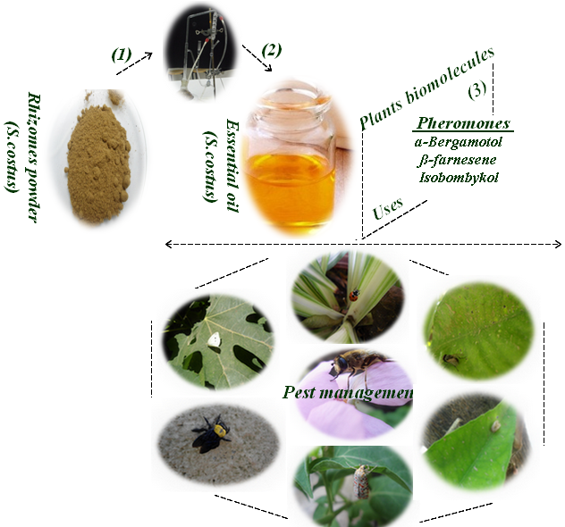

Text for the Graphical Abstract
Plants with insecticidal properties and containing many pheromones are used for monitoring insect’s abundance and attack. Their essentials oils offer an attractive alternative to replace chemical pesticides and are promising candidate for pest management.

