Supplemental
Table S1
Records at different time points of physiological status of mice in different groups(n=30).

GROUP  TIME  (hour) | WT + NS | ICA69-/- + NS | WT + DL | ICA69-/- + DL
1h | Normal mental state and activity.  Normal diet. | Normal mental state and activity.  Normal diet. | Normal mental state and activity.  Normal diet. | Normal mental state and activity.  Normal diet.
2h | Normal mental state and activity.  Normal diet. | Normal mental state and activity.  Normal diet. | Normal mental state and activity.  Normal diet. | Near-normal mental state and activity.  Near-normal diet.
3h | Normal mental state and activity.  Normal diet. | Normal mental state and activity.  Normal diet. | Fairly normal mental state and activity.  Fairly normal diet. | Slightly weak in mental state and activity.  Eating slightly reduced.
4h | Normal mental state and activity.  Normal diet. | Normal mental state and activity.  Normal diet. | Slightly weak in mental state and activity.  Eating slightly reduced. | Weak in mental state and activity.  Eating reduced.
5h | Normal mental state and activity.  Normal diet. | Normal mental state and activity.  Normal diet. | Weak in mental state and activity.  Eating reduced. | Obviously weak in mental state and activity. Slow in reacting. Barely eating.
6h | Normal mental state and activity.  Normal diet. | Normal mental state and activity.  Normal diet. | Obviously weak in mental state and activity.  Barely eat. | Four mice in this group were dead by this time. The remaining mice were obviously weak in mental state and activity. Slow in reacting, barely eating.
7h | Normal mental state and activity.  Normal diet. | Normal mental state and activity.  Normal diet. | One mouse in this group was dead. The remaining mice were obviously weak in mental state and activity. Slow in reacting, eating. | Around 75% mice in this group were dead. The remaining mice were obviously weak in mental state and activity. Slow in reacting, barely eating.
8h | Normal mental state and activity.  Normal diet. | Normal mental state and activity.  Normal diet. | Around 75% mice in this group were dead. The remaining mice were slightly weak in mental state and activity. Fairly normal diet, eating a little. | All mice in this group were dead.
12 | Normal mental state and activity.  Normal diet. | Normal mental state and activity.  Normal diet. | The remaining mice weak in mental state and activity. Fairly normal diet, eating a little. | ---

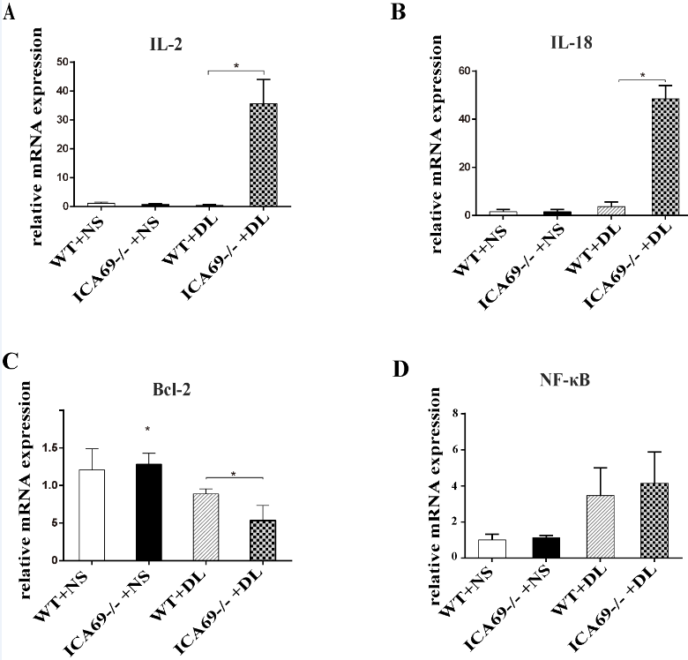
Figure S1
Hepatic IL-2, IL-18, Bcl-2, and NF-κB mRNA expression determined by qRT-PCR (n = 3). Data show mean ± SEM (n = 5/group). *P < 0 05, **P < 0 01.
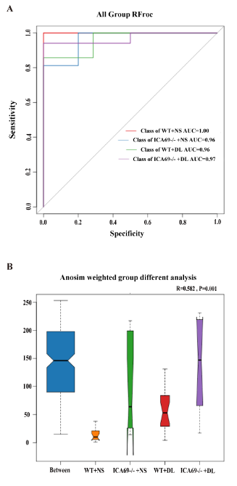
Figure S2
(A) The ROC curve (receiver operating characteristic), which is a comprehensive indicator reflecting the continuous variables of sensitivity and specificity. The ROC curve sets a continuous variable to a number of different critical values ​​to calculate a series of sensitivities and specificities. The larger the area under the curve, the higher the diagnosis accuracy is. The value of area under the ROC curve is between 1.0 and 0.5. AUC has higher accuracy above 0.9. (B) Anosim is an analysis used to test whether the difference between groups is significantly greater than the difference within the group, thus determining whether the group is meaningful. The R-value ranges between -1 and 1. An R-value > 0 indicates significant difference between groups; an R-value < 0 indicates that the difference within the group is greater than the difference between the groups. The reliability of the statistical analysis is represented by the P value, with P < 0.05 indicating that the statistics are significant.
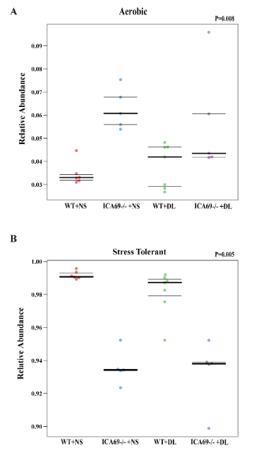
Figure S3
(A) (B) show the relative abundance differences of aerobic and oxidative stress tolerance phenotypes of bacterial communities between different groups respectively. The three lines from the top to the bottom represent the upper quartile, the average and the lower quartile, respectively. P < 0.05 indicates that the statistics are significant.

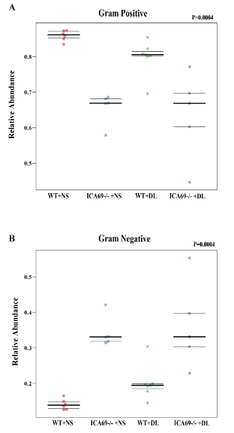
Figure S4.
(A) (B) show the relative abundances of gram-positive and gram-negative tolerance phenotypes of bacterial communities between different groups, respectively. The three lines from the top to the bottom represent the upper quartile, the average and the lower quartile, respectively. P < 0.05 indicates that the statistics are significant.

