Supplementary Material

Analysis of protein-protein interaction and weighted co-expression networks revealed key modules and genes in multiple tissues of Agave sisalana

Lucas M. Carvalho^{a,b} ; Nicholas Vinícius Silvaª; Luís Guilherme F. de Abreuª; Marina Püpke Maroneª; Alexandra Russolo Cardelliª; Fabio Trigo Rayaª; Guido Araújo^{b,c}, Marcelo Falsarella Carazzolle^{a,b}; Gonçalo Amarante Guimarães Pereira^{a*}.

a. Laboratory of Genomics and bioEnergy (LGE), Department of Genetics, Evolution, Microbiology, and Immunology, Institute of Biology, State University of Campinas, Campinas, SP, 13083-862, Brazil.
b. Center for Computing in Engineering and Sciences, State University of Campinas, Campinas, São Paulo, 13083-861, Brazil.
c. Institute of Computing, UNICAMP, Campinas, São Paulo, 13083-852, Brazil.

*Corresponding author: goncalo@unicamp.br

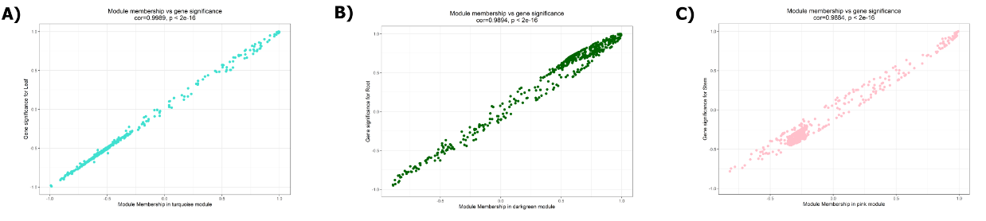
Figure 1S. Scatter plots highlighting the association between (A) GS in Leaf tissue and MM based on genes from the turquoise module; (B) GS in Root tissue and MM based on genes from the darkgreen module; (C) GS in Stem tissue and MM based on genes from the pink module.

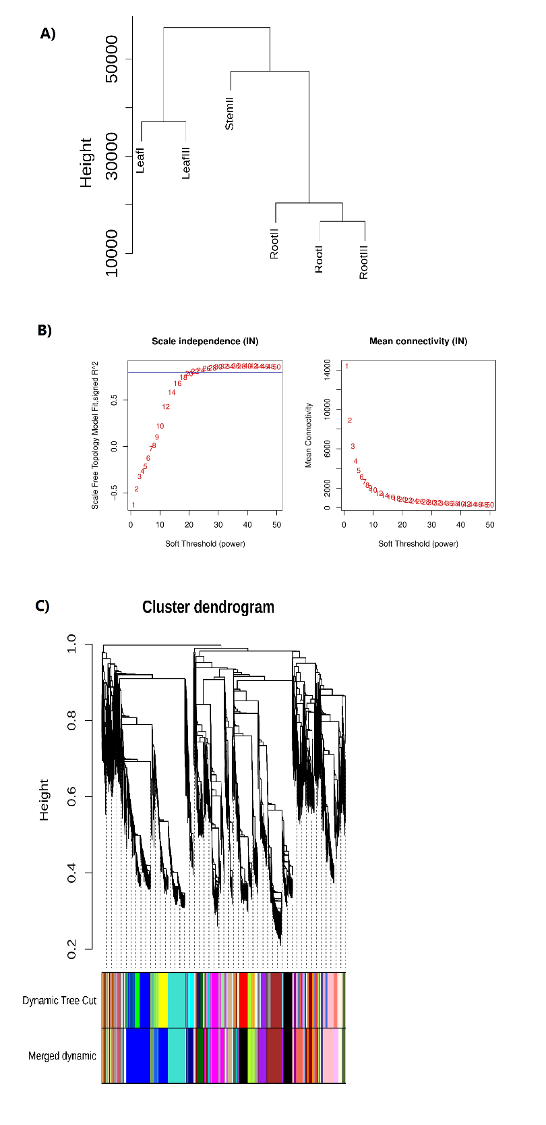
Figure 2S. Co-expression network analysis based on WGCNA. (A) Clustering of tissue samples to identify similar gene expression profiles. (B) Analysis of network topology for various soft-thresholding powers. (C) Identification of tissue-specific modules. Each branch represents an expression module of a highly interconnected groups of genes; each color indicates a corresponding co-expression module.

