Supplementary Materials for
Exosomes Derived from Human Adipose Mesenchymal Stem Cells Ameliorate Hepatic Fibrosis by Regulating Choline Metabolism and PI3K/Akt/mTOR Pathway
Zilong Zhang^{1,2,3,4}†, Jin Shang^{1,2,3}†, Qinyan Yang^{1,2}*†, Zonglin Dai^{1,2,3}, Yuxin Liang^{1,2,3}, Chunyou Lai^{1,2}, Tianhang Feng^{1,2,3}, Deyuan Zhong^{1,2,3}, Haibo Zou^{1,2,3}, Guibao Ji⁴, Lelin Sun³, Yuhao Su^{1,2,3}, Su Yan^{1,2,3}, Jie Chen⁵, Yutong Yao^{1,2,3}, Ying Shi^{1,2,3}*, Xiaolun Huang^{1,2,3}*
- Department of Hepatobiliary-Pancreatic Surgery, Cell Transplantation Center, Sichuan Provincial People's Hospital, University of Electronic Science and Technology of China, Chengdu 610072, China.
- Clinical Immunology Translational Medicine Key Laboratory of Sichuan Province and Organ Transplant Research Institute, Chinese Academy of Sciences Sichuan Translational Medicine Research Hospital, Chengdu, China.
- School of Medicine, University of Electronic Science and Technology of China, Chengdu 610054, Sichuan, China.
- Department of Hepatobiliary-Pancreatic and Hernia Surgery, Wuhan Fourth Hospital, Puai Hospital, Tongji Medical College, Huazhong University of Science and Technology, Wuhan 430033, China.
- Department of Core laboratory, Sichuan Provincial People's Hospital, University of Electronic Science and Technology of China, Chengdu, China.

†These authors have contributed equally to this work.
*Corresponding author:
Xiaolun Huang: Department of Hepatobiliary-Pancreatic Surgery, Cell Transplantation Center, Sichuan Provincial People's Hospital, University of Electronic Science and Technology of China. No. 32, West Second Section, First Ring Road, Qingyang District, Chengdu 610072, Sichuan, China.
Email: huangxiaolun@med.uestc.edu.cn
Tel: +86-87393753
Fax: 86- 28 85423052
Ying Shi: School of Medicine, University of Electronic Science and Technology of China, Chengdu 610054, Sichuan, China.
Email: shiying_uestc@uestc.edu.cn.

Supplemental Files
Supplemental Figure 1-11
Supplemental Table 1-5.

Figure. S1

Figure S1 Characterization of hADMSCs. (A) The potential of hADMSCs on differentiation of osteoblasts, adipocytes, and chondrocytes in the specified medium was identified by the Alizarin Red staining, Oil Red O staining, and Alcian Blue staining, respectively; Scale bar: 500 μm. (B) Flow cytometry detection of the typical surface markers CD44 CD73, CD90, and CD105 in hADMSCs; Blue curves: the isotype controls; red curves: the test samples.

Figure. S2

Figure S2 TGF-β1 activates hepatic stellate cells leading to ECM deposition and EMT progression. (A) Representative phase-contrast images of quiescent HSCs or treated with 10 ng/ml TGF-β1 for 12h, 24h, 48h and 72h. Original magnifcation, 100× (upper), 200×(lower). (B) The protein level of ECM-related marker (α-SMA) and EMT--related marker (Vimentin, β-catenin and E-catenin) were determined by western blot. (C) The relative expression levels of α-SMA, Vimentin, β-catenin and E-catenin. Data are presented as means with SEM (n=3 independent experiments). ns, not significant, *p < 0.05, **p < 0.01, ***p < 0.001 and ****p < 0.0001.

Figure. S3

Figure S3 Inhibition of activated HSCs proliferation and activation by hADMSCs. (A) Representative immunofluorescence images of LX-2 cells or co-cultured with hADMSCs at the indicated concentration in the presence of TGF-β1 (10 ng/ml) for 24 h. Scale bars, 100 mm. (B) Edu assay showed that hADMSCs could inhibit proliferation of aHSCs. (C) α-SMA protein levels in LX-2 or treated with pbs, hADMSCs in the presence of TGF-β1 (10 ng/ml) for 24 h were measured by immunofluorescence staining. Data are presented as means with SEM (n=3 independent experiments). *p < 0.05 and **p < 0.01.
Figure S4
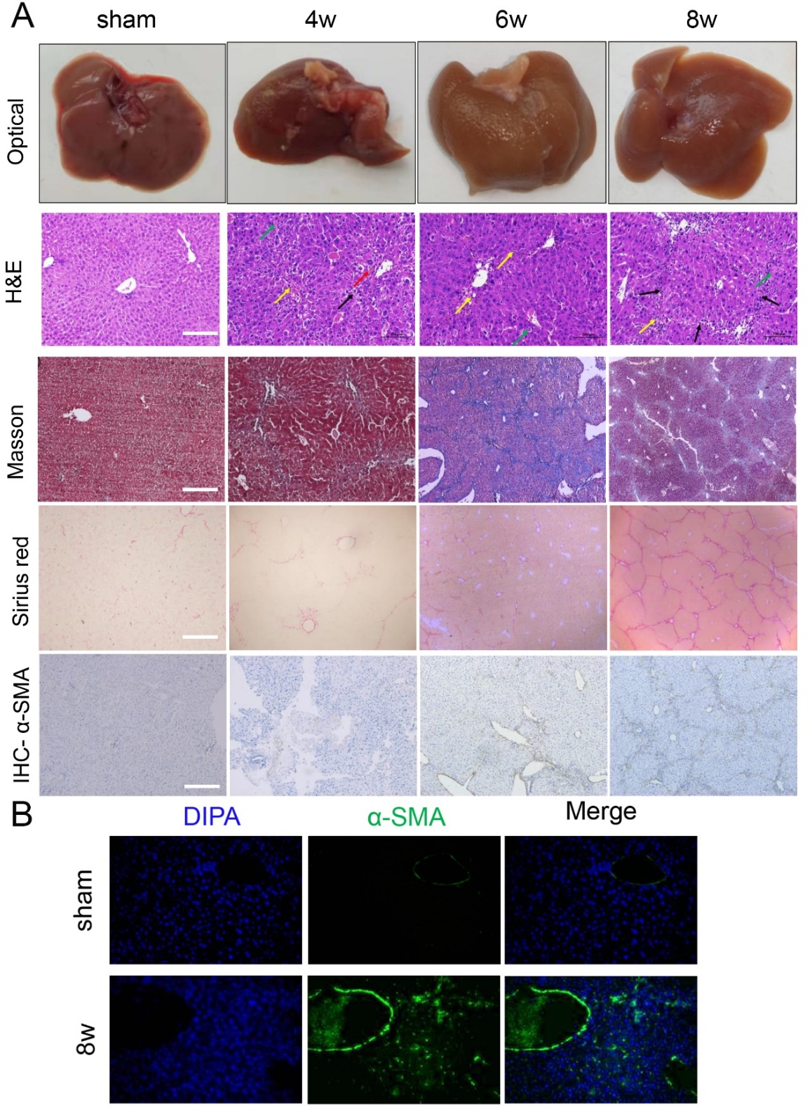
Figure S4 Liver cirrhosis was successfully induced in C57BL/6J mice with CCl4 i.p. injections twice a week for 8 weeks. (A) Representative photographs, histopathology and immunohistochemistry of normal and CCl4-induced livers from mice for 4 weeks, 6 weeks and 8 weeks. (B) Representative Images of immunohistochemistry staining of α-SMA in normal and CCl4-induced livers from mice for 8 weeks.
Figure. S5

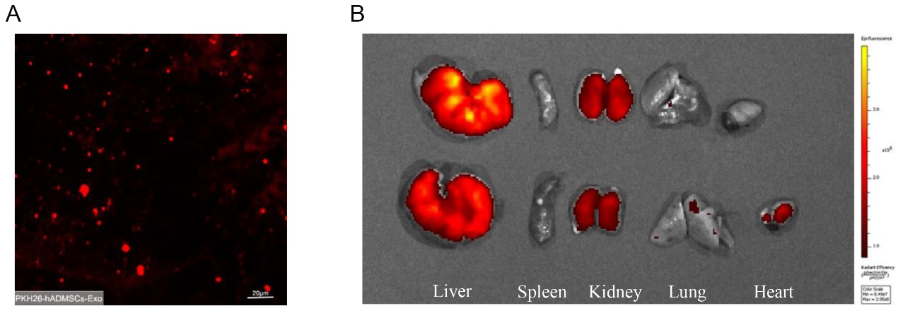
Figure S5 Ex vivo organ distribution of PKH26-hADMSCs-Exo in CCl4-induced liver fibrosis mouse model. (A) CLSM images of hADMSCs-Exo labeled with PKH26. (B) Ex vivo organ imaging of PKH26-hADMSCs-Exo after 3 days at vital organs, including liver, spleen, kidney, lung and heart.

Figure. S6

Figure S6 liver stiffness of mouse with different treatments was measured by Shear wave elastrography (SWE) at predetermined time. (A) liver stiffness of mouse with different treatments prior to the start of treatment (baseline). (B) SWE verified the successful of modeling. (C) liver stiffness of mouse with different treatments during treatment (weeks 2). LFG, liver fibrosis group, REG, regression group. ns, not significant, *p < 0.05, **p < 0.01.
Figure. S7

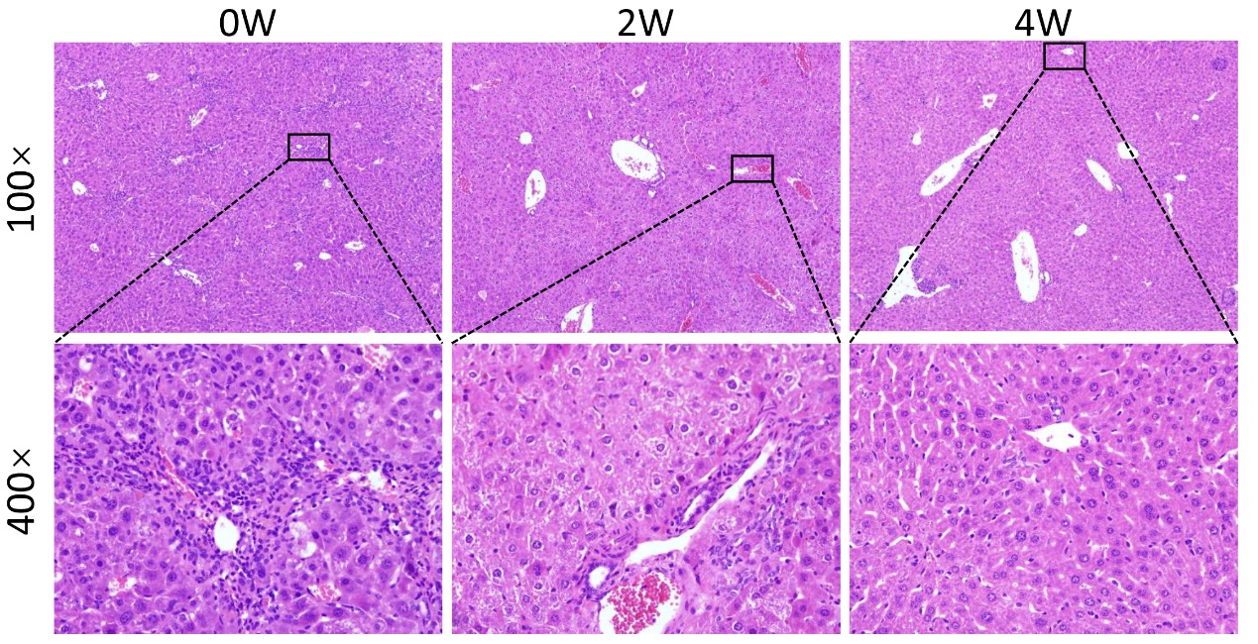
Figure S7 Representative histopathology analysis of liver sections after 0, 2 and 4 weeks of hADMSCs-Exo treatment. There are numerous of hepatocytes swelling, cytoplasm loose light dye, intravenous surrounding connective tissue hyperplasia, occasional portal area with a small amount of inflammatory cell infiltration, hepatocyte dotted necrosis, nucleus dissolved in the liver at 2 weeks of hADMSCs-Exo treatment. The results showed that the hepatic fibrosis was not completely resolved after 2 weeks of hADMSCs-Exo treatment.
Figure. S8

Figure S8 GO and KEGG pathway analyses between LFG vs hADMSCs-Exo or REG. (A-B) GO pathway analyses between LFG vs hADMSCs-Exo showed that hADMSCs-Exo might involve in ECM, ECM structural construction, collagen fibril organization. (C) KEGG pathway analyses between LFG vs hADMSCs-Exo showed that hADMSCs-Exo involved in ECM-receptor interaction and PI3K/AKT signaling pathway. (D) KEGG pathway analyses between LFG vs REG. LFG, liver fibrosis group, REG, regression group, ECM, extracellular matrix.
Figure. S9

Figure S9 Western blot assay for AKT, mTOR and phosphorylated and total PI3K p85 and PI3K p110 in vivo (A) and in vitro (B). LFG, liver fibrosis group, REG, regression group. Data are presented as means with SEM (n=3 independent experiments). ns, not significant, *p < 0.05, **p < 0.01, ***p < 0.001 and ****p < 0.0001.
Figure. S10

Figure S10 The gene coding for the key metabolite expression analysis in transcriptome. Slc44a1-4, Solute Carrier Family 44 Member. Chka, Choline Kinase Alpha. Chkb, Choline Kinase beta. Sp1, Sp1 Transcription Factor. Pcyt1a, Phosphate Cytidylyltransferase 1A. Pcyt1a, Phosphate Cytidylyltransferase 1B. Chpt1, Choline Phosphotransferase 1. Gpcpd1, Glycerophosphocholine Phosphodiesterase 1. PEMT, Phosphatidylethanolamine N-Methyltransferase. Data are presented as means with SEM (n=3). ns, not significant.

Figure. S11
Figure S11 Western blot assay for pro-fibrogenic and PI3K/AKT/mTOR signaling protein expression in aHSCs following supplementation with hADMSCs-Exo and 10 mM choline or 10 mM phosphorylcholine simultaneously in vitro. (A) Western blot assay for α-SMA， collagen Ⅰ, vimentin protein expression. (B) Western blot assay for AKT, mTOR and phosphorylated and total PI3K p85 and PI3K p110 protein expression, vs. the TGF-β1+PBS group. PC, phosphorylcholine. Data are presented as means with SEM (n=3 independent experiments). ns, not significant, *p < 0.05, **p < 0.01, ***p < 0.001 and ****p < 0.0001.

Supporting Tables

Table S1 Primer sequences used in reverse transcription quantitative PCR (RT-qPCR)
Gene | Forward primer (5′–3′) | Reverse primer (5′–3′)
Cdkn1a | CCTGGTGATGTCCGACCTG | CCATGAGCGCATCGCAATC
Col6a1 | CTGCTGCTACAAGCCTGCT | CCCCATAAGGTTTCAGCCTCA
Col6a2 | GCTCCTGATTGGGGGACTCT | CCAACACGAAATACACGTTGAC
Lama4 | ATGAGCTGCAAGGAAAACTATCC | CTGTTTCGTTGGCTTCACTGA
Itga8 | CGAAGCCGAACTCTTTGTTATCA | GGCCTCAGTCCCTTGTTGT
Lamb1 | AGACTTTGGGGGTTCATGTCA | ATCGTCCCGTCTCCTTGTCA
MMP2 | GTATTTGATGGCATCGCTCA | CATTCCCTGCAAAGAACACA
Tnc | GGTGCGCTACACTTCTGTC | CCTGATACTCCACACCTGGTC
Thbs2 | CACGGGAGACAAACTCAGCC | CTGGCAGGGACTTGATAAAATGT
Col1a1 | GCCCAGAGATAGAGTGACCTG | CGCACTTCTCGAAAGTTGCTG
Col1a2 | GCTCCTGATTGGGGGACTCT | CCAACACGAAATACACGTTGAC
IL-10 | CCCATTCCTCGTCACGATCTC | TCAGACTGGTTTGGGATAGGTTT
IL-6 | AAGAGCCGGAAATCCACGAAA | GTCTCAAAAGGGTCAGGGTACT
TNF-α | CTTTCGGTTGCTCTTTGGTTG | CGACAGCACAAGTCACAGC
IL-2 | TGAGCAGGATGGAGAATTACAGG | GTCCAAGTTCATCTTCTAGGCAC
IL-1β | AGTTGACGGACCCCAAAAG | AGCTGGATGCTCTCATCAGG
AKT | ATGAACGACGTAGCCATTGTG | TTGTAGCCAATAAAGGTGCCAT
mTOR | ACCGGCACACATTTGAAGAAG | CTCGTTGAGGATCAGCAAGG
Slc44a1 | TTTGCCCAAGCTACCAG | GAGCACAGCGATGGAAGAA
Slc44a2 | CCTGGTGCTTGGCTATGG | CAAGGTCCAGGGAGA
Slc44a3 | GGTCATTTTGGGATTGCTGT | ACTGAGGTCGTTGGTGTAGTCA
Slc44a4 | ACTCTGTCCCCGTTTCCTTC | AAGTTGATGTTGGGGAGTGG
Chka | GGGTGGTCTCAGTAACATGCT | GAACCCTGGACTCACCATCTT
Chkb | AGGATGCTAAGTGCCCAGAG | TCACGGGACAAACGCTCAG
Pcyt1a | GATGCACAGAGTTCAGCTAAAGT | TGGCTGCCGTAAACCAACTG
Pcyt1b | GAAACAGGTATCCCAAAATCCCT | GCATGTGTGCTCTATTTCCTCCA
CHPT1 | ACTGAGATCCAGGTAGCTTTAGT | GTAGACCCATTCTTGCCAACA

Table S2 Antibodies utilized in Western blot, immunohistochemistry or Immunofluorescence staining
Antibodies | SOURCE | IDENTIFIER
GAPDH (WB:1/10000) | Proteintech | Cat No: 10494-1-AP
β-actin (WB:1/10000) | Proteintech | Cat No: 66009-1-Ig
Anti-rabbit IgG, HRP-linked Antibody (WB:1/5000) | ZENBIO | Cat No: 511203
Anti-mouse IgG, HRP-linked Antibody (WB:1/5000) | ZENBIO | Cat No: 511103
TSG101(WB:1/2000) | Abcam | Ca#ab125011
CD63(WB:1/2000) | Abcam | Ca#ab134045
CD81(WB:1/500) | Abcam | Ca#ab79559
α-SMA(WB:1/5000, IHC:1/3000, IF:1/300) | Proteintech | Cat No. 14395-1-AP
Collagen Ⅰ (WB:1/2000, IHC:1/1000) | Proteintech | Cat No. 14695-1-AP
Fibronectin (IF:1/200) | Proteintech | Cat No. 15613-1-AP
TGF-β1 (WB:1/2500) | Proteintech | Cat No. 21898-1-AP
E-catenin (WB:1/2000) | Proteintech | Cat No. 12831-1-AP
β-catenin (WB:1/1000) | Proteintech | Cat No. 51067-2-AP
Vimentin (WB:1/1000) | Cell Signaling | Ca#46173SF
Ki67 (IHC:1/200) | Abcam | Ca#ab15580
HNF-4α (IHC:1/400) | BIOSS | Ca#bs-3828R
Caspase 3 (IHC:1/1000) | Cell Signaling | Ca#9662S
AKT (WB:1/1000, IF:1/300) | Cell Signaling | Ca#4060S
PI3K p85 (WB:1/1000) | Cell Signaling | Ca#4257S
PI3Kp110 (WB:1/1000) | Cell Signaling | Ca#4249S
P-PI3K p85 (WB:1/1000) | Cell Signaling | Ca#17366S
P--PI3KCA (WB:1/1000) | BIOSS | Ca#bs-5570R
mTOR (WB:1/1000) | Cell Signaling | Ca#2983S
Goat anti-rabbit IgG (H+L) secondary antibody, Alexa Fluor 488 (IF:1/350) | Invitrogen | Cat#A-11008
Goat anti-rabbit IgG (H+L) secondary antibody, Alexa Fluor 594 (IF:1/350) | Invitrogen | Cat#A-11012
Goat anti-mouse IgG (H+L) secondary antibody, Alexa Fluor 594 (IF:1/350) | Invitrogen | Cat#A-11005

Table S3 The top 25 significant KEGG pathway between hADMSCs-Exo group (n=3) and regression group (REG, n=3)
PathwayID | Pathway | DEG_number | Pvalue | FDR | Up_gene | Down_gene
mmu04512 | ECM-receptor interaction | 9 | 8.2626E-07 | 0.000156164 | - | Itga8,Tnc,Lama4,Col6a1,Col6a2,Lamb1,Thbs2,Col1a1,Col1a2
mmu04974 | Protein digestion and absorption | 7 | 0.00017506 | 0.011870001 | - | Col5a2,Col6a1,Col6a2,ln,Col3a1,Col1a1,Col1a2
mmu04510 | Focal adhesion | 10 | 0.00018841 | 0.011870001 | - | Itga8,Myl9,Lama4,Tnc,Col1a1,Col1a2,Col6a1,Lamb1,Col6a2,Thbs2
mmu05146 | Amoebiasis | 6 | 0.0015111 | 0.05711959 | Itgam | Lama4,Col3a1,Lamb1,Col1a2,Col1a1
mmu04933 | AGE-RAGE signaling pathway in diabetic complications | 6 | 0.0015111 | 0.05711959 | Ager | F3,Col3a1,Mmp2,Col1a2,Col1a1
mmu05410 | Hypertrophic cardiomyopathy (HCM) | 5 | 0.00344713 | 0.102162179 | Prkag3,Tnnc1 | Itga8,Des,Tnnt2
mmu05165 | Human papillomavirus infection | 11 | 0.00452849 | 0.102162179 | Cdkn1a,Notch1 | Col6a1,Lamb1,Itga8,Lama4,Tnc,Col6a2,Thbs2,Col1a1,Col1a2
mmu04610 | Complement and coagulation cascades | 5 | 0.00515561 | 0.102162179 | Itgam,Serpina1e | Plat,F3,C7
mmu05222 | Small cell lung cancer | 5 | 0.00592823 | 0.102162179 | Gadd45g,Cdkn1a,Traf1 | Lamb1,Lama4
mmu04710 | Circadian rhythm | 3 | 0.00609178 | 0.102162179 | Cry1,Prkag3 | Nr1d1
mmu05202 | Transcriptional misregulation in cancer | 7 | 0.00630086 | 0.102162179 | Gadd45g,Itgam,Cdkn1a,Cd40,Traf1 | Plat,Igfbp3
mmu00830 | Retinol metabolism | 5 | 0.00648649 | 0.102162179 | Cyp2c38,Cyp4a12b,Cyp4a12a | Ugt1a5,Cyp2c55
mmu04270 | Vascular smooth muscle contraction | 6 | 0.00751686 | 0.109283509 | Cyp4a12a,Cyp4a12b,Npr2 | Actg2,Myl9,Acta2
mmu04115 | p53 signaling pathway | 4 | 0.01199632 | 0.156746139 | Pmaip1,Gadd45g,Cdkn1a | Igfbp3
mmu05033 | Nicotine addiction | 3 | 0.01353466 | 0.156746139 | Gabrb3 | Gabrp,Gabra3
mmu04151 | PI3K-Akt signaling pathway | 10 | 0.01398125 | 0.156746139 | Cdkn1a | Col6a1,Lamb1,Itga8,Tnc,Lama4,Col6a2,Thbs2,Col1a1,Col1a2
mmu04530 | Tight junction | 6 | 0.01409886 | 0.156746139 | Prkag3,Nedd4l | Myh11,Myl9,Tuba1a,Cldn5
mmu05414 | Dilated cardiomyopathy (DCM) | 4 | 0.02022871 | 0.209278703 | Tnnc1 | Des,Tnnt2,Itga8
mmu03320 | PPAR signaling pathway | 4 | 0.0210386 | 0.209278703 | Cyp4a12a,Plin4,Cyp4a12b | Scd1
mmu04926 | Relaxin signaling pathway | 5 | 0.02232451 | 0.210966601 | - | Col1a2,Col1a1,Col3a1,Acta2,Mmp2
mmu00590 | Arachidonic acid metabolism | 4 | 0.02447578 | 0.22028204 | Cyp4a12a,Cyp4a12b,Cyp2c38 | Cyp2c55
mmu00140 | Steroid hormone biosynthesis | 4 | 0.02631428 | 0.22403733 | Cyp2c38 | Akr1c18,Ugt1a5,Cyp2c55
mmu05032 | Morphine addiction | 4 | 0.0272638 | 0.22403733 | Pde1b,Gabrb3 | Gabra3,Gabrp
mmu05144 | Malaria | 3 | 0.02994316 | 0.235802407 | Tlr9,Cd40 | Thbs2
mmu05206 | MicroRNAs in cancer | 5 | 0.03126975 | 0.236399326 | Cdkn1a,Notch1,Cdc25c | Reck,Tnc
Table S4. Significant metabolites between hADMSCs-Exo treatment group (n=6) and regression group (n=6) in the liver tissue samples.
No. | Name | RTª (min) | m/z | VIP | P-value^{b} | Fold change (Exo/REG) | Trend^{c}
1 | Oleamide | 771.536 | 282.279 | 1.409 | 0.005 | 82.945 | ↑
2 | Sphingosine | 771.811 | 300.290 | 1.204 | 0.005 | 70.448 | ↑
3 | FMN | 396.669 | 437.086 | 1.073 | 0.005 | 65.352 | ↑
4 | Sphinganine | 760.812 | 302.305 | 1.484 | 0.005 | 10.453 | ↑
5 | Tridemorph | 789.669 | 298.310 | 1.244 | 0.031 | 9.8949 | ↑
6 | N-a-Acetylcitrulline | 102.761 | 216.098 | 1.315 | 0.031 | 9.7391 | ↑
7 | Troxilin B3 | 668.421 | 335.224 | 1.374 | 0.031 | 8.7584 | ↑
8 | Equol | 787.785 | 242.284 | 1.263 | 0.008 | 6.3518 | ↑
9 | L-Alanyl-gamma-D-glutamyl-L-lysine | 97.477 | 347.191 | 1.656 | 0.008 | 6.1537 | ↑
10 | 5-Methyl-2-furancarboxaldehyde | 285.204 | 111.044 | 1.368 | 0.031 | 6.0525 | ↑
11 | 4,5-Dihydroorotic acid | 193.684 | 158.960 | 1.237 | 0.020 | 0.10861 | ↓
12 | GMP | 90.832 | 362.050 | 1.554 | 0.008 | 0.07309 | ↓
13 | Raffinose | 90.453 | 487.163 | 1.647 | 0.005 | 0.034457 | ↓
14 | Acetylcysteine | 63.670 | 162.998 | 1.425 | 0.003 | 0.00048013 | ↓
15 | S-(Formylmethyl)glutathione | 467.289 | 350.100 | 1.248 | 0.028 | 0.00014934 | ↓
16 | Pantothenic acid | 369.973 | 220.118 | 1.407 | 0.028 | 3.12E-05 | ↓
17 | Choline | 111.279 | 104.107 | 1.299 | 0.010 | 2.89E-05 | ↓
18 | D-Fructose | 489.214 | 161.046 | 1.587 | 0.010 | 6.64E-06 | ↓
19 | 2-Hydroxy-2-ethylsuccinic acid | 469.011 | 161.046 | 1.342 | 0.010 | 2.45E-06 | ↓
20 | Betaine | 721.221 | 116.069 | 1.287 | 0.003 | 1.04E-06 | ↓
ª Retention time of the metabolites during LC-MS.
^{b} P values were calculated by Student’s t-test (threshold<0.05)
^{c} Trend, the up and down arrows represent a relative increase and decrease, respectively, in the level of the metabolite in the hADMSCs-Exo treatment group when compared with the regression group.

Table S5. Significant metabolites between hADMSCs-Exo treatment group (n=6) and liver fibrosis group (n=6) in the liver tissue samples.
No. | Name | RTª (min) | m/z | VIP | P-value^{b} | Fold change (Exo/LFG) | Trend^{c}
1 | FMN | 396.669 | 437.086 | 1.113 | 0.005 | 59.205 | ↑
2 | Oleamide | 771.536 | 282.279 | 1.349 | 0.005 | 21.429 | ↑
3 | Troxilin B3 | 668.421 | 335.224 | 1.486 | 0.013 | 17.766 | ↑
4 | 3alpha,7alpha-Dihydroxy-12-oxo-5beta-cholanate | 752.978 | 389.269 | 1.575 | 0.005 | 15.603 | ↑
5 | Sphingosine | 771.811 | 300.290 | 1.125 | 0.020 | 13.357 | ↑
6 | 5-Methyl-2-furancarboxaldehyde | 285.204 | 111.045 | 1.421 | 0.008 | 12.795 | ↑
7 | N-a-Acetylcitrulline | 102.761 | 216.098 | 1.387 | 0.020 | 11.918 | ↑
8 | L-Alanyl-gamma-D-glutamyl-L-lysine | 97.477 | 347.191 | 1.658 | 0.005 | 8.5351 | ↑
9 | Tridemorph | 789.669 | 298.310 | 1.188 | 0.031 | 7.7516 | ↑
10 | Baicalein | 673.469 | 270.050 | 1.924 | 0.005 | 7.3761 | ↑
11 | Allocholic acid | 677.197 | 408.285 | 1.333 | 0.045 | 7.1738 | ↑
12 | Sphinganine | 760.812 | 302.305 | 1.410 | 0.005 | 7.0491 | ↑
13 | Betaine | 721.221 | 116.069 | 1.715 | 0.003 | 2.36E-06 | ↓
14 | 2-Hydroxy-2-ethylsuccinic acid | 469.011 | 161.046 | 1.069 | 0.003 | 6.30E-06 | ↓
15 | D-Galactose | 272.4625 | 161.045 | 1.672 | 0.003 | 6.31E-06 | ↓
16 | Choline | 111.279 | 104.107 | 1.787 | 0.003 | 9.63E-06 | ↓
17 | D-Fructose | 489.214 | 220.118 | 1.543 | 0.003 | 1.47E-05 | ↓
18 | Pantothenic acid | 369.973 | 220.118 | 1.593 | 0.003 | 4.58E-05 | ↓
19 | S-(Formylmethyl)glutathione | 467.289 | 350.100 | 1.216 | 0.003 | 0.000345 | ↓
20 | Acetylcysteine | 63.670 | 162.999 | 1.729 | 0.003 | 0.000621 | ↓
21 | Oleic acid | 794.9885 | 282.279 | 1.333 | 0.004 | 0.005948 | ↓
22 | S-[(E)-N-Hydroxy(indol-3-yl)acetimidoyl]-L-glutathione | 104.65 | 350.100 | 1.329 | 0.010 | 0.010966 | ↓
23 | Stearolic acid | 783.715 | 281.248 | 1.806 | 0.005 | 0.051517 | ↓
24 | Retinol | 781.083 | 269.227 | 1.652 | 0.005 | 0.06952 | ↓
ª Retention time of the metabolites during LC-MS. ^{b} P values were calculated by Student’s t-test (threshold<0.05). ^{c} Trend, the up and down arrows represent a relative increase and decrease, respectively, in the level of the metabolite in the hADMSCs-Exo treatment group when compared with the liver fibrosis group.

