Supplementary information

Liquid Ga-In-Sn alloys printing of novel GaInSnO ultra-thin semiconductor films and controllable performance field effect transistors

Bangdeng Du¹, Qian Li^{1,}*, Xianwei Meng¹, Jing Liu^{1,2,}*
1 Beijing Key Lab of Cryo-Biomedical Engineering and Key Lab of Cryogenics, Technical Institute of Physics and Chemistry, Chinese Academy of Sciences, Beijing 100190, P. R. China.
2 Department of Biomedical Engineering, School of Medicine, Tsinghua University, Beijing 100084, P. R. China.

* Corresponding Author
E-mail addresses: Li, Q. (liqian@mail.ipc.ac.cn), Liu, J. (jliu@mail.ipc.ac.cn)

Supplementary Note 1: Characterization of InSnO multilayers obtained from the surface of liquid In₇₅Sn₂₅ (wt%) alloys
In order to better clarify the effect of Ga on the formation of GaInSnO film on liquid galinstan alloys’ surface, the formed metal oxide on the surface of liquid In₇₅Sn₂₅ (wt%) alloys was also characterized in this work. Using the printing process illustrated in Fig. 1, an oxide multilayer on SiO₂/Si substrate was harvested by repeating roll-printing liquid In₇₅Sn₂₅ alloys 10 times, the optical image of the obtained oxide multilayers was shown in supplementary Fig. 1a. AFM analysis (supplementary Fig. 1b) shows that the thickness of printed oxide multilayers is about 18.5 nm. Supplementary Fig. 1c shows the XPS analyses of the obtained oxide multilayers. The In3d_{5/2} and In3d_{3/2} peaks located at ~444.4 eV and 452.1 eV imply the existence of In³⁺ in the oxide multilayers. The Sn3d_{5/2} peak of ~486.5 eV and Sn3d_{3/2} peak of ~495.00 eV are corresponding to the Sn⁴⁺ of SnO₂. The obtained split O1s peaks of InSnO multilayers are different from the observed split O1s peaks of GaInSnO multilayers (Fig. 2f), due to the absence of Ga₂O₃ in InSnO multilayers. The observed split O1s peaks can be fitted as O1s of SnO₂ at ~530.40 eV and O1s of In₂O₃ at ~532.10 eV. The aforementioned XPS analysis results reveal the printed oxide multilayers are InSnO (a mixture of In₂O₃ and SnO₂).

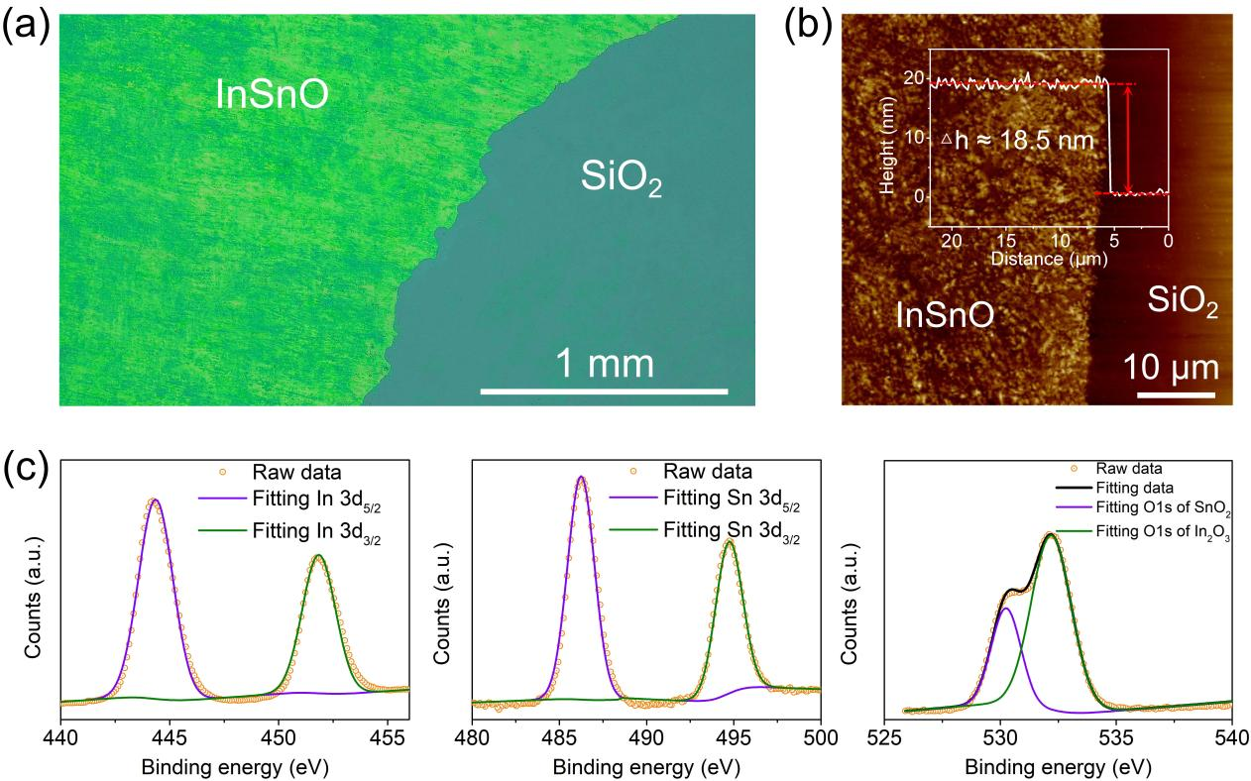
Supplementary figure 1. Characterization of printed InSnO film. (a-b) The optical and AFM image of obtained InSnO multilayers on SiO₂/Si substrate, respectively. (c) The In 3d, Sn 3d and O 1s XPS spectrums of the printed InSnO multilayers.

Supplementary Note 2: Hall effect measurements for the GaInSnO multilayers from the surface of galinstan alloys with different Ga concentration.
A Hall effect device with van der Pauw configuration based on the printed InSnO and GaInSnO films was fabricated, just as shown in Fig. 3e. In order to obtain the resistance, an electric current is applied in a pair of electrodes, such as electrode 1 and electrode 2. Then, the generating voltage between electrode 3 and electrode 4 was recorded. The resistance of R_{12, 34} can be calculated using the following formula:
$R_{12, 34}=\frac{V_{34}}{I_{12}}$ (S1)
Using the same calculation methods, we can obtain the R_{23, 41} by using formula S2:
$R_{23, 41}=\frac{V_{41}}{I_{23}}$ (S2)
The sheet resistivity (ρ) of the printed multilayers can be calculated using the following formula:
$ρ=\frac{πd}{ln2} \frac{R_{12, 34}+R_{23, 41}}{2} f(\frac{R_{12, 34}}{R_{23, 41}})$ (S3)
where, d is the thickness of printed multilayers; f represents the factor of van der Pauw, which is a function of R_{12, 34} / R_{23, 41}.
For the measurements of Hall coefficient (R_{H}), an electric current is applied in a pair of nonadjacent electrodes, such as electrode 1 and electrode 3. Then a magnetic field perpendicular to the multilayers was applied, and a voltage between electrode 2 and electrode 4 can be generated. The R_{H} can be calculated by using the following formula:
$R_{H}=\frac{d}{B} \frac{∆V_{24}}{I_{13}}$ (S4)
where, d is the thickness of printed multilayers; B represents the strength of magnetic field. The applied current and magnetic field strength is 60 nA-100 mA and 0.35 T-1 T, respectively.
The Hall charge density (n) of printed multilayers can be calculated by using the formula as follow:
$n=\frac{1}{\left|R_{H}\right|} q$ (S5)
where, the q is the charge of electron.
We can also obtain the Hall effect mobility (μ_{Hall}) by using the following formula:
$μ_{Hall}=\frac{\left|R_{H}\right|}{ρ}$ (S6)
Via the aforementioned calculated methods, we obtain the sheet resistivity of multilayers harvested from the surface of galinstan alloys with different Ga content, just as shown in supplement Fig. 2. We can see that the sheet resistivity of printed multilayers increase significantly with rising Ga concentration in galinstan alloys, implying the decrease of conductivity for these printed multilayers.
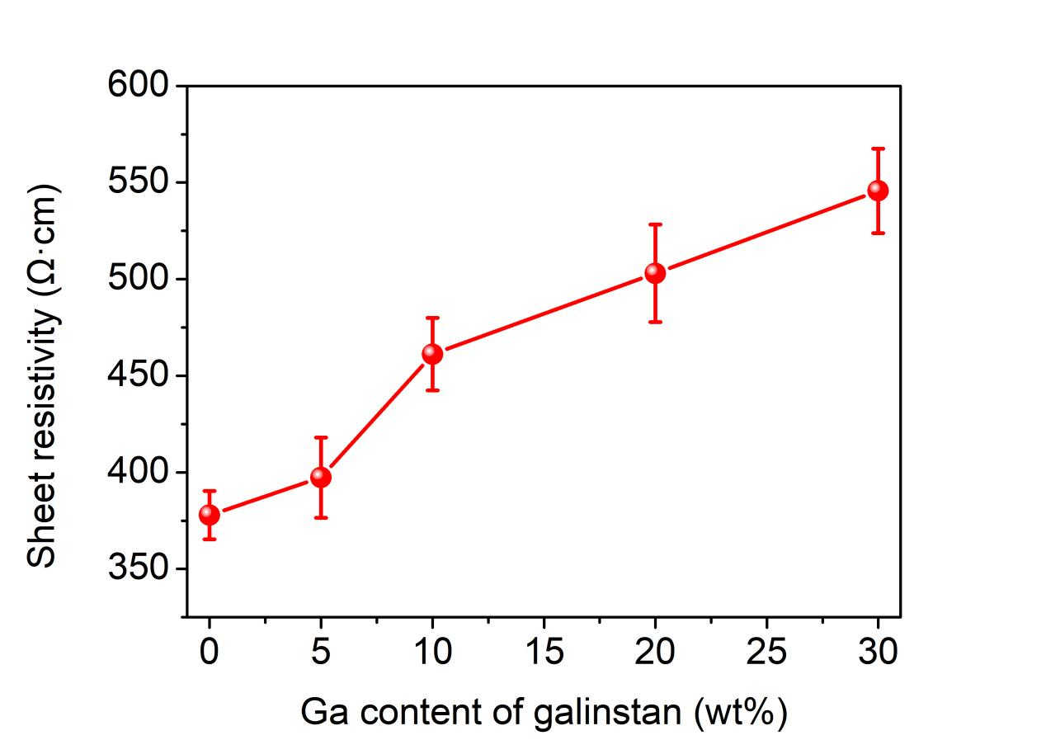
Supplementary figure 2. The sheet resistivity of multilayers obtained from the surface of galinstan alloys with different Ga content, each point and error bar are the averaged results from three different measured samples.
Supplementary Note 3: SEM observation and EDX analysis of the printed GaInSnO multilayers.
The results of SEM observation and EDX analysis for the GaInSnO multilayers from the surface of galinstan alloys with 30 wt% Ga, were presented in supplementary Fig. 3. The detected elements Ga, In and Sn uniformly distribute in the printed GaInSnO multilayers. In comparison to the printed GaInSnO multilayers obtained from the surface of galinstan alloys with 5 wt% Ga (Fig. 4), the Ga concentration in GaInSnO multilayers shown in supplementary Fig. 3a is higher, while the In and Sn concentrations are lower.

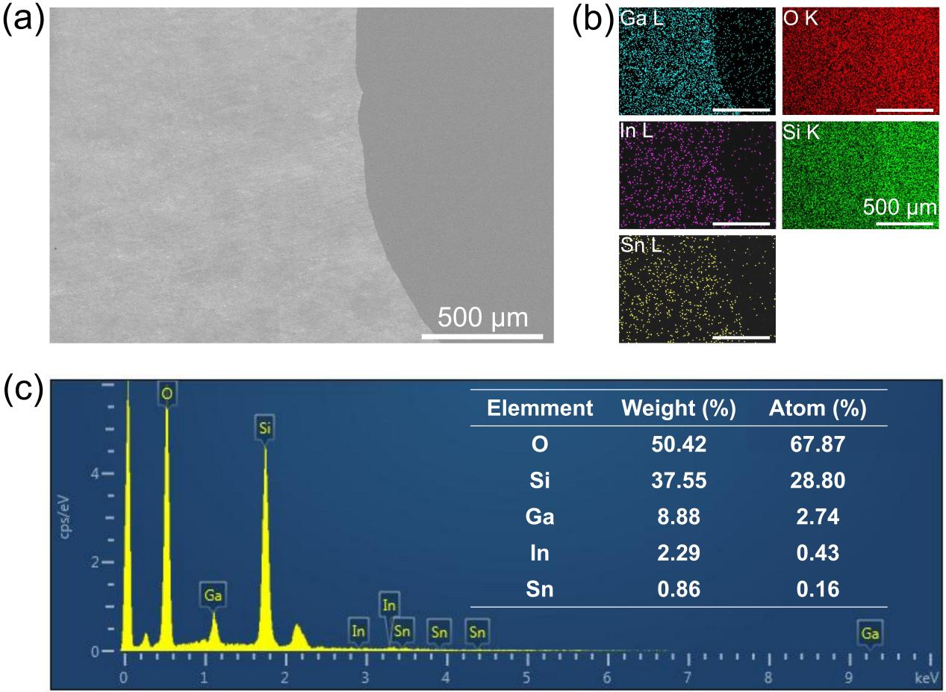
Supplementary figure 3. SEM observation and EDS analysis of GaInSnO multilayers from the surface of galinstan alloys with 30 wt% Ga. (a) Typical SEM image of printed GaInSnO multilayers. (b) EDS mapping images of element Ga, In, Sn, O and Si in GaInSnO multilayers, respectively. (c) Quantitative EDS analysis of printed GaInSnO multilayers.
Supplementary Note 4: characterization of crystal structures and optical property for the printed InSnO multilayers.
In order to characterize the crystal structures of printed InSnO multilayers, the TEM analysis was employed. Supplementary Fig. 4 shows the HRTEM and SAED images of the printed InSnO multilayers. We can see the crystal structures of In₂O₃ and SnO₂ in the InSnO nanosheets. The SAED patterns also indicate that the printed InSnO multilayers are consisted of In₂O₃ and SnO₂. The halo and diffuse ring observed in GaInSnO multilayers’ SAED patterns, are not seen in the SAED patterns of InSnO multilayers. This implies that there are no amorphous structures in the printed InSnO multilayers.
Supplementary Fig. 5 presents absorbance and bandgap for printed InSnO multilayers. The printed InSnO multilayers feature minimal absorption across the visible spectrum. Tauc plot analysis (inset in supplementary Fig. 4) show that the bandgap of obtained InSnO layers is about 4.21 eV, which is lower than that of obtained GaInSnO multilayers.

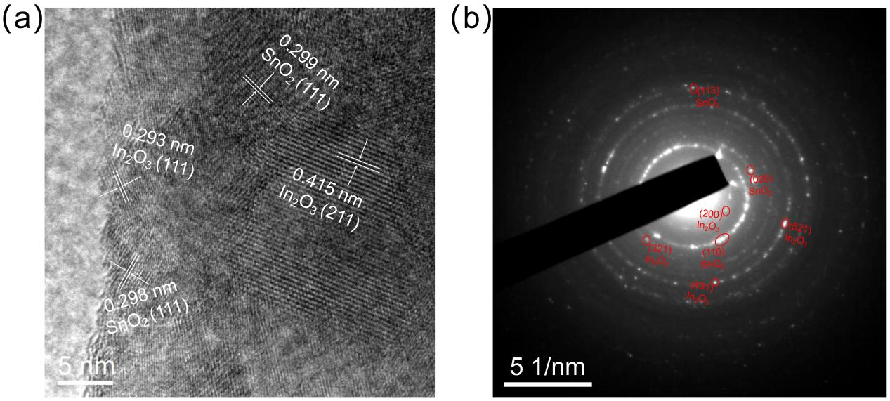
Supplementary figure 4. TEM characterization of printed InSnO multilayers. (a) The HRTEM image of InSnO multilayers. (b) The SAED patterns of InSnO multilayers.

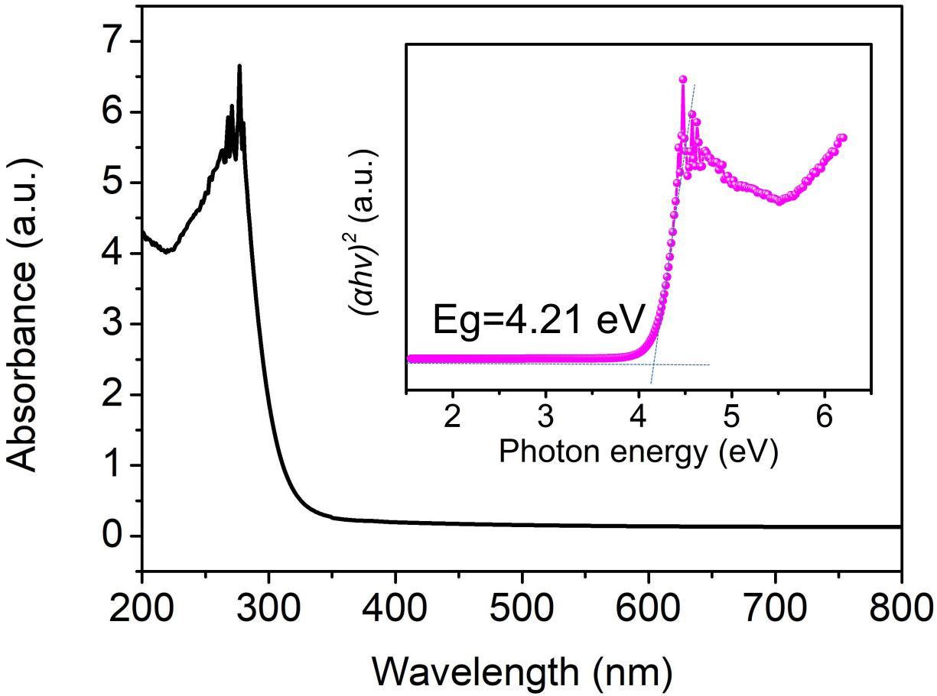
Supplementary figure 5. UV-vis absorption spectra of InSnO multilayers, the inset is the Tauc plot for the InSnO multilayers.
Supplementary Note 5: characterization of electrical performance for FET device based on printed InSnO multilayers.
The FET device based on printed InSnO multilayers was fabricated, the configuration of the FET device is the same to the schematic illustrated in Fig. 6a. Supplementary Fig. 6 shows the I_{ds}-V_{ds} curves of the FET devices without loading V_{gs}. The FET devices feature an obvious liner I_{ds}-V_{ds} curve, indicating the contact between Au/Cu electrodes and InSnO multilayers is ohmic. Notably, the I_{ds} at V_{ds} of 10 V for the FET device based on InSnO multilayers reaches ~5.4 mA, which is much higher than the I_{ds} of FET devices constructed by printed GaInSnO multilayers (Fig. 6c).

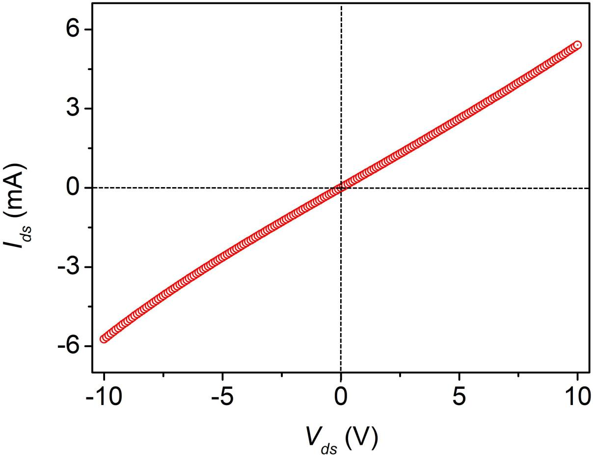
Supplementary figure 6. The linear I_{ds}-V_{ds} curves of FET devices based on the printed InSnO multilayers.
Supplementary Note 6: calculation methods for the field-effect mobility (μ_{eff}) and sub-threshold swing (SS) of FET devices.
In this work, the μ_{eff} of the FET devices was calculated using the following formula:
$μ_{eff}=\frac{dI_{ds}}{dV_{gs}}\frac{L}{WV_{ds}C_{ox}}$ (S7)
where, the I_{ds} and V_{ds} refer to the drain-source current and voltage, respectively. V_{gs} is the gate voltage. L and W are the length and width of the channel, respectively. The C_{ox} is the gate insulator capacitance (6.90×10⁻⁹ F cm⁻² for the thermally grown 500 nm thick SiO₂ on Si substrate).
The SS is the slopes of tangent for the curves of the V_{gs} to logarithmic I_{ds}, it can be calculated by using formula:
$SS=\frac{dV_{gs}}{d(logI_{ds})}$ (S8)

Supplementary Note 7: Comparison of printed GaInSnO multilayers with some reported Ga₂O₃ films.
The comparison of performance for the FET devices based on the printed GaInSnO multilayers and some reported Ga₂O₃ films, is illustrated in supplementary Table 1.

Table 1 Comparison of printed GaInSnO multilayers with reported Ga₂O₃ films.
Films type | Thickness | Method | μ_{eff} (cm² V⁻¹ s⁻¹) | SS (mV dec⁻¹) | I_{on}/I_{off} | Ref.
1# GaInSnO | 20 nm | Printing liquid galinstan | 50.62 ± 6.73 | 111.21 ± 8.23 | 10⁵ | This work
2# GaInSnO | 20 nm | Printing liquid galinstan | 33.21 ± 4.36 | 194.72 ± 8.41 | 10⁵ | This work
3# GaInSnO | 20 nm | Printing liquid galinstan | 14.46 ± 3.24 | 243.49 ± 7.25 | 10⁷ | This work
4# GaInSnO | 20 nm | Printing liquid galinstan | 2.02 ± 0.67 | 321.29 ±6.24 | 10⁶ | This work
β-Ga₂O₃ | 2.7~5.9 nm | Printing liquid EGaIn | 5~10 | －－ | 10³~10⁴ | 1
Si doped Ga₂O₃ | 20 nm | Molecular beam epitaxy | 55~95 | 300 | 10⁵ | 2
Sn doped Ga₂O₃ | 50~70 nm | Mechanical exfoliation | －－ | 150 | 10¹⁰ | 3
Cr doped Ga₂O₃ | 45~70 nm | Mechanical exfoliation | －－ | －－ | 10⁴~10⁵ | 4
β-Ga₂O₃ | 146 nm | Mechanical exfoliation | －－ | －－ | 10⁴ | 5
Sn doped Ga₂O₃ | 5 μm | Vapor phase epitaxy | －－ | －－ | 10³ | 6
Sn doped Ga₂O₃ | 70~100 nm | Mechanical exfoliation | 21.7~30.2 | 65 | 10⁹ | 7
β-Ga₂O₃ | 304~359 nm | Mechanical exfoliation | 45~52 | 116~141 | 10⁸~10⁹ | 8
β-Ga₂O₃ | 400 nm | Mechanical exfoliation | 1.77~4.87 | 348~502 | 10⁶~10⁷ | 9
Sn doped Ga₂O₃ | 68 nm | Mechanical exfoliation | ≤ 3.77 | －－ | 10⁸ | 10
Nb doped Ga₂O₃ | 160 nm | Mechanical exfoliation | 32.11~71.54 | 120 | 10⁸ | 11
β-Ga₂O₃ | 153 nm | Mechanical exfoliation | ≤ 43.15 | 250 | 10⁶ | 12
Note: 1# GaInSnO to 4# GaInSnO are obtained from the surface of liquid galinstan alloys with 5 wt% to 30 wt% Ga, respectively. EGaIn refers to Ga_{75.5}In_{24.5} (wt%) alloys.

Reference:
[1] Lin, J. et al. Printing of quasi‐2D semiconducting β‐Ga₂O₃ in constructing electronic devices via room‐temperature liquid metal oxide skin. Phys. Status. Solidi-R. 13, 1900271 (2019).
[2] Xia, Z. et al. Delta Doped β‐Ga₂O₃ Field Effect Transistors With Regrown Ohmic Contacts. IEEE. Electr. Device. L. 39, 568-571 (2018).
[3] Zhou, H., Maize, K., Qiu, G., Shakouri, A. & Ye, P. D. β‐Ga₂O₃ on insulator field-effect transistors with drain currents exceeding 1.5 A/mm and their self-heating effect. Appl. Phys. Lett. 111, 092102 (2017).
[4] Ge, L. et al. Enhancement mode Ga₂O₃ field effect transistor with local thinning channel layer. Crystals. 12, 897 (2022).
[5] Yan, X. D., Esqueda, I. S., Ma, J., Tice, J. & Wang, H. High breakdown electric field in β‐Ga₂O₃/graphene vertical barristor heterostructure. Appl. Phys. Lett. 112, 032101 (2018).
[6] Sasaki, K. et al. Depletion-mode vertical Ga₂O₃ trench MOSFETs fabricated using Ga₂O₃ homoepitaxial films grown by halide vapor phase epitaxy. Appl. Phys. Express. 10, 124201 (2017).
[7] Zhou, H., Maize, K., Noh, J., Shakouri, A. & Ye, P. D. Thermodynamic studies of β‐Ga₂O₃ nanomembrane field-effect transistors on a sapphire substrate. ACS Omega. 2, 7723-7729 (2017).
[8] Son, J., Kwon, Y., Kim, J. & Kim, J. Tuning the threshold voltage of exfoliated β‐Ga₂O₃ flake-based field-effect transistors by photo-enhanced H₃PO₄ wet etching. ECS J. Solid. State. Sc. 7, Q148 (2018).
[9] Kim, J., Mastro, M. A., Tadjer, M. J. & Kim, J. Quasi-two-dimensional h-BN/β‐Ga₂O₃ heterostructure metal-insulator-semiconductor field-effect transistor. ACS Appl. Mater. Interfaces. 9, 21322-21327 (2017).
[10] Kim, M. K. et al. (100) Plane β‐Ga₂O₃ Flake Based Field Effect Transistor and Its Hydrogen Response. ECS J. Solid. State. Sc. 10, 125004 (2021).
[11] Chen, J. X. et al. Fabrication of a Nb-doped β‐Ga₂O₃ nanobelt field-effect transistor and its low-temperature behavior. ACS Appl. Mater. Interfaces. 12, 8437-8445 (2020) .
[12] Chen, J. X. et al. Investigation of the Mechanism for Ohmic Contact Formation in Ti/Al/Ni/Au Contacts to β‐Ga₂O₃ Nanobelt Field-Effect Transistors. ACS Appl. Mater. Interfaces. 11, 32127-32134 (2019).

Reference:
[1] J. Lin et al., Phys. Status. Solidi-R. 13 (2019) 1900271.
[2] Z.B. Xia et al., IEEE. Electr. Device. L. 39 (2018) 568-571.
[3] H. Zhou et al., Appl. Phys. Lett. 111 (2017) 092102.
[4] L. Ge et al., Crystals. 12 (2022) 897.
[5] X.D. Yan et al., Appl. Phys. Lett. 112 (2018) 032101.
[6] K. Sasaki et al., Appl. Phys. Express. 10 (2017) 124201.
[7] H. Zhou et al., ACS Omega. 2 (2017) 7723-7729.
[8] J. Son et al., ECS J. Solid. State. Sc. 7 (2018) Q148.
[9] J. Kim et al., ACS Appl. Mater. Interfaces. 9 (2017) 21322-21327.
[10] M.K. Kim, et al., ECS J. Solid. State. Sc. 10 (2021) 125004.
[11] J.X. Chen et al., ACS Appl. Mater. Interfaces. 12 (2020) 8437-8445.
[12] J.X. Chen et al., ACS Appl. Mater. Interfaces. 11 (2019) 32127-32134.

