Supplementary Information to “Multiple trait approach to inform ecosystem service value of corals propagated for restoration on the Great Barrier Reef”

C. Isabel Nuñez Lendo¹*, Emma F. Camp¹, John Edmondson², David J. Hughes¹, Unnikrishnan Kuzhiumparambil¹, David Clases^{1,3}, Raquel Gonzalez de Vega^{1,3}, David J. Suggett^{1,4}

¹Climate Change Cluster, University of Technology Sydney, Ultimo, NSW 2007, Australia
²Wavelength Reef Cruises, Port Douglas, QLD, Australia
³TESLA-Analytical Chemistry, Institute of Chemistry, University of Graz, Austria
⁴KAUST Reefscape Restoration Initiative (KRRI) and Red Sea Research Centre (RSRC), King Abdullah University of Science and Technology, Thuwal, 23955, Saudi Arabia

*Corresponding author:
carmela.nunez@uts.edu.au, inezlendo@gmail.com

Supplementary Figure S1. Map of study site on Mojo, Opal Reef, Great Barrier Reef, Australia. Corals were collected from the reef patch adjacent to the coral nursery at 5-6 m in depth. Coral fragments were held on the coral nursery, which is located on the sand patch, suspended at 4–5 m in depth. Delineation of the management zones for Opal Reef is shown. Satellite image: Landsat 8 OLI, bathymetric composite RBG bands 431, acquired September 5th, 2021. Source: NASA/USGS/Pearce, S. 2021.

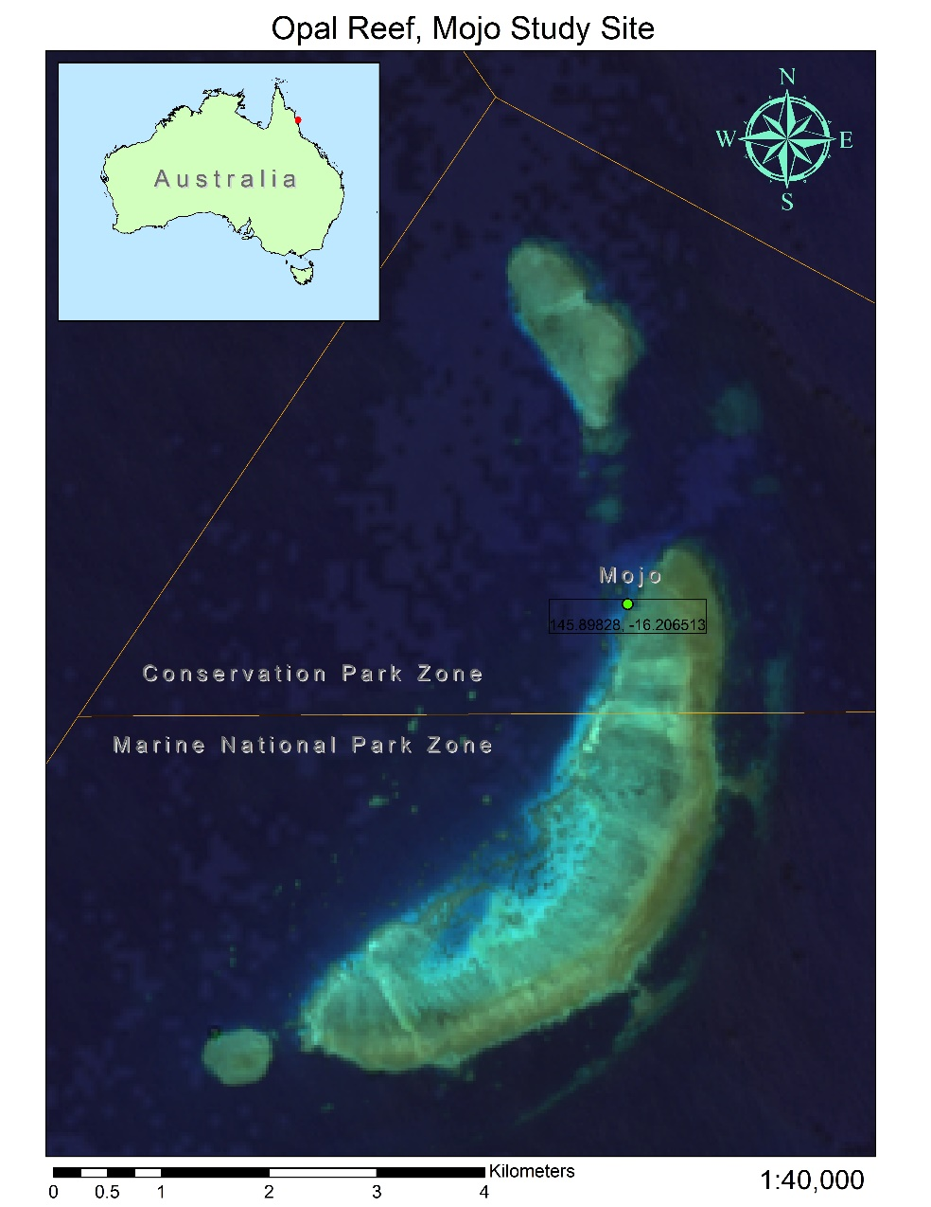

Supplementary Figure S2. Sea Surface Temperatures (SST, °C) for Opal Reef and Mojo nursery (mean ± SEM, n = 13 and 9 months, respectively). Satellite-derived data (MODIS-aqua) was extracted from the GIOVANNI online system maintained by NASA (https://giovanni.gsfc.nasa.gov/giovanni/). SST were obtained using monthly area-averaging bounded to 145° 53’ 53.8’’E, 16°12’ 23.4’’S between February 2020 and February 2021 (encompassing the entire Opal Reef of ca. 30km² for a year); black line. Imposed onto the SST are the mean monthly SST recorded by the HOBO logger (every 1 h) from February to September 2021 at the Mojo nursery; dashed line.

Supplementary Figure S3. A) Mean (± SEM) relative linear growth rate (% growth in cm yr⁻¹) of wild and nursery corals from 12 months propagation. All data are fragments of Acropora cf. hyacinthus (n = 6 for both groups). Means were compared by paired Student’s t-tests (see main text) where ** indicates a statistical significance of p ≤ 0.01. B) Nursery-grown coral derived from colony #1 with an initial area of 64.3 cm² in February 2020 (B) and 12 months post-fragmentation the same nursery coral was six times higher (394.8 cm²) compared to its initial size (C).

A)

B)
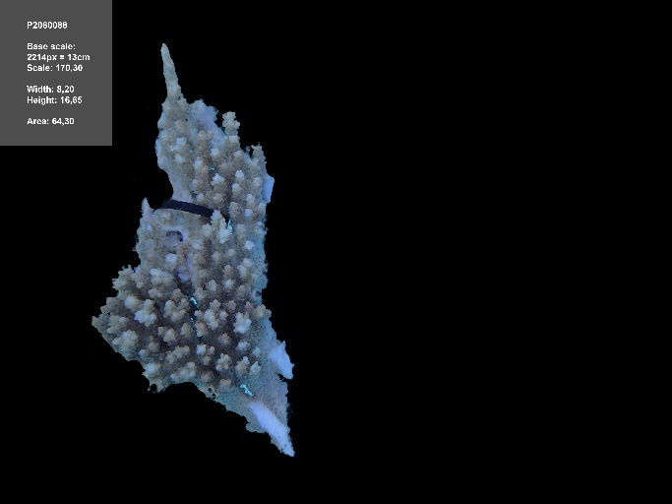
C)
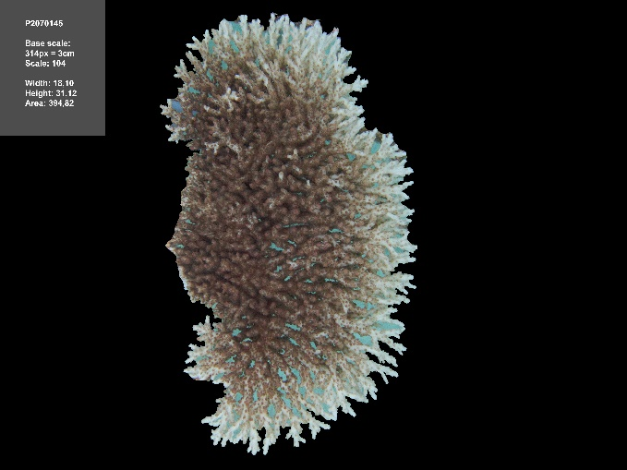

Supplementary Figure S4. Bio-physical colouration of wild and nursery corals. Traits encompass (a) red (R), b) green (G), (c) blue (B), (d) hue, (e) saturation, (f) brightness, and bleaching state. Significant differences in the RGB values among coral groups were revealed by a one-way RM ANOVA (F_{(1.9,9.5)} = 7.5, p = 0.0114 for R; F_{(1.8,8.8)}= 7.6, p = 0.0137 for G; and F_{(1.3,6.7)} = 21.0, p = 0.0021 for B). Tukey’s test revealed significant differences between WT12 and NT12 (p = 0.0247, 0.0126, and 0.0215 for R, G, and B, respectively), suggesting a different colouration between these two coral groups. Additional differences in B values among WT0 vs WT12, and WT0 vs NT12 (p = 0.0317 and 0.0077, respectively) were also found. Hue values were approximately doubled for WT0 (85.2 ± 44.4, n = 6) compared to WT12 (34.8 ± 1.2, n = 6) and NT12 (39.5 ± 6.5, n = 6). However, no significant differences in hue levels were detected among coral groups (one-way RM ANOVA, F_{(1.5,7.7)} = 0.2, p = 0.7972). Regarding the saturation levels, they approximately halved in WT0 (33.3 ± 4.4, n = 6) compared to WT12 and NT12 (70.0 ± 4.6, and 64.7 ± 3.6, respectively; n = 6), and significant differences were found among coral groups (one-way RM ANOVA, F_{(1.9,9.3)} = 19.0, p = 0.0006). Tukey’s test showed significant differences for WT0 vs WT12 (p = 0.0029) and WT0 vs NT12 (p= 0.0113). In general, brightness values were low among coral groups 41.7 ± 3.7, 54.5 ± 2.4, and 38.0 ± 2.2 for WT0, WT12, and NT12, respectively (n = 6 for each coral group). Significant differences in brightness levels were found (one-way RM ANOVA, F_{(2.0,9.9)} = 8.0, p = 0.0087), and Tukey’s test revealed to be between WT12 vs NT12 (p = 0.0257). Statistical significance is shown as ns (no statistical significance), * and ** (p ≤ 0.05 and 0.01, respectively).

Supplementary Figure S5. Predicted ITS2 type profiles for wild and nursery corals. Corresponding samples are visualised as a stacked bar chart with a single column representing a sample. The relative abundance of predicted ITS2 type profiles is plotted for each column in the stacked bar plots. All data are fragments of Acropora cf. hyacinthus (n = 4, 6, and 6 for W0, W12, and N12, respectively).

Supplementary Figure S6. Mean (± SEM) (a) carbohydrates, (b) soluble proteins, and (c) total lipids (mg per ash-free dry mass), and same biomolecule content normalised to mg per surface area (d-f) of the initial wild colonies (WT0) and wild and nursery corals from 12 months propagation (WT12 and NT12). All data are fragments of Acropora cf. hyacinthus (n = 4, 6, and 6 for WT0, WT12, and NT12, respectively). Means were compared by analysis of variance (ANOVA) with post hoc Tukey tests (see main text) where ns indicates no statistical significance, and * and ** indicates p ≤ 0.05 and 0.01, respectively.

Supplementary Figure S7. Mean (± SEM) of 19 fatty acid methyl esters (mg per dry mass) (A-S) of the initial wild colonies (WT0) and wild and nursery corals from 12 months propagation (WT12 and NT12). All data are fragments of Acropora cf. hyacinthus (n = 4, 6, and 6 for WT0, WT12, and NT12, respectively). Means were compared by analysis of variance (ANOVA) with post hoc Tukey tests (see main text) where ns indicates no statistical significance, and *, ** and *** indicates p ≤ 0.05, 0.01 and 0.001, respectively.

Supplementary Figure S8. Mean (± SEM) of (a) saturated fatty acids (SFA), (b) mono- and (c) poly-unsaturated fatty acids (MUFA and PUFA, respectively) (µg per dry mass) of the initial wild colonies (WT0) and wild and nursery corals from 12 months propagation (WT12 and NT12). All data are fragments of Acropora cf. hyacinthus (n = 4, 6, and 6 for WT0, WT12, and NT12, respectively). No significant differences in SFA were found (one-way ANOVA, F_{(2,13)} = 3.8, p = 0.0501), however, differences in MUFA and PUFA were detected among coral groups (p = 0.0324 and 0.0099, respectively). Tukey’s test revealed significant differences between WT0 and NT12 (p = 0.0287 and 0.0080, respectively). Statistical significance is shown as ns (no statistical significance), * and ** (p ≤ 0.05 and 0.01, respectively).

Supplementary Figure S9. Mean (± SEM) of 18 elements, (A) Carbon [C], (B) Nitrogen [N], (C) Magnesium [Mg], (D) Phosphorus [P], (E) Sulphur [S], (F) Potassium [K], (G) Calcium [Ca], (H) Vanadium [V], (I) Manganese [Mn], (J) Iron [Fe], (K) Nickel [Ni], (L) Copper [Cu], (M) Zinc [Zn], (N) Strontium [Sr], (O) Molybdenum [Mo], (P) Cadmium [Cd], (Q) Tim [Sn], and (R) Lead [Pb] — macronutrients (A-G) and micronutrients (H-R) in mmol or µmol (element) per dry mass, respectively; absolute values — of the initial wild colonies (WT0) and wild and nursery corals from 12 months propagation (WT12 and NT12). All data are fragments of Acropora cf. hyacinthus (n = 4, 6, and 6 for WT0, WT12, and NT12, respectively). Means were compared by analysis of variance (ANOVA) with post hoc Tukey tests, except for Cd and Pb (Kruskal-Wallis’s test followed by Dunn’s test) where ns indicates no statistical significance, and * and ** indicates p ≤ 0.05 and 0.01, respectively. Cobalt [Co] and Selenium [Se] values were negligible and hence not shown here.

Supplementary Figure S10. Examination of the traits per biological property. 1) Principal Component Analysis (PCA) biplot, including a cut-off for the cos2 = 0.5, and 2) the contribution of variables to dimensions (principal components, PC) 1 and 2, for the following seven biological properties: (A) physical appearance (tissue colouration), (B) photobiology, (C) metabolism, (D) energy reserves, (E) fatty acid methyl esters (FAME), (F) elementome, and (G) skeletal properties. In regard to the cut-off for the cos2 = 0.5, a good representation of the variable on the PC is indicated in solid line (>0.5). As opposed, <0.5 (dashed line) indicates that the variable is not perfectly represented by the PCs. (H) Contribution plot for the 14 (out of 90) selected traits used in the final PCA (the so-called multitraits).

A) Physical appearance
A.1) PCA biplot, including a cut-off for the cos2 = 0.5

A.2) Contribution of variables to PC1 and PC2

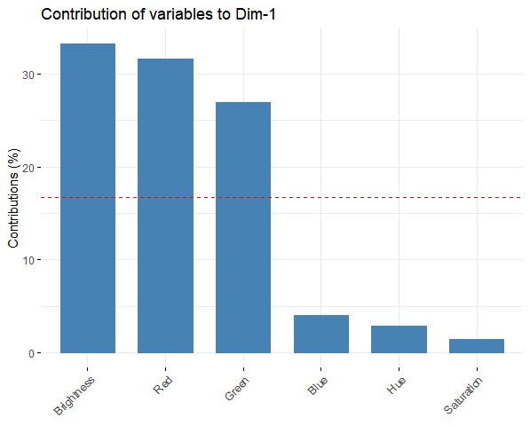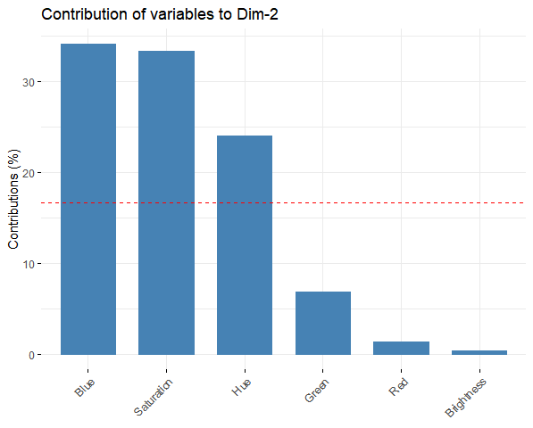

B) Photobiology
B.1) PCA biplot, including a cut-off for the cos2 = 0.5

B.2) Contribution of variables to PC1 and PC2

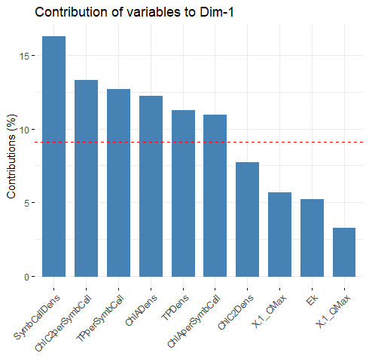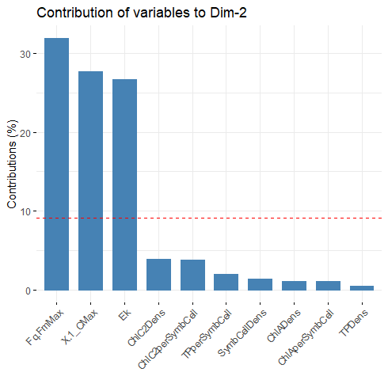

C) Metabolism
C.1) PCA biplot, including a cut-off for the cos2 = 0.5

C.2) Contribution of variables to PC1 and PC2

D) Energy reserves
D.1) PCA biplot, including a cut-off for the cos2 = 0.5

D.2) Contribution of variables to PC1 and PC2

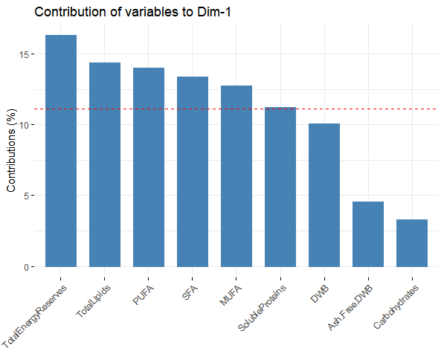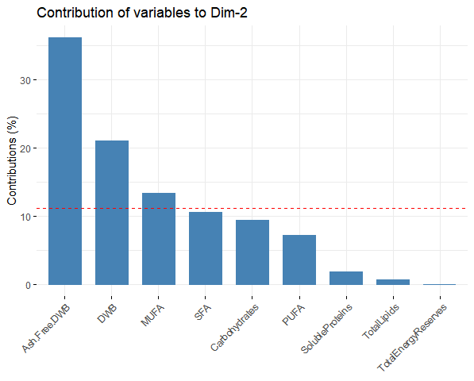

E) FAME
E.1) PCA biplot, including a cut-off for the cos2 = 0.5

E.2) Contribution of variables to PC1 and PC2

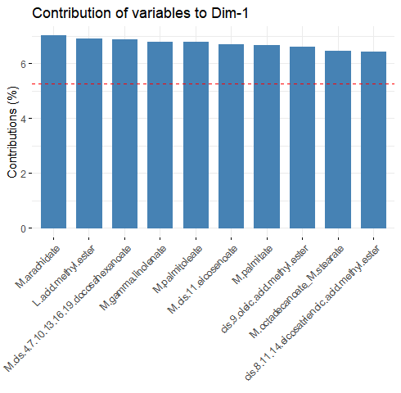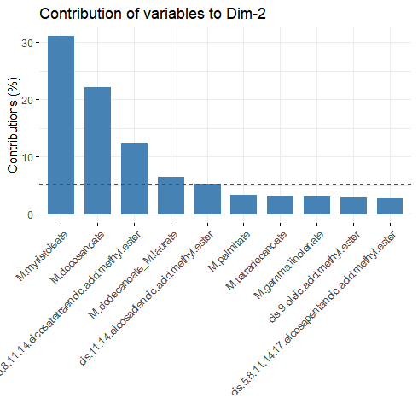

F) Elementome
F.1) PCA biplot, including a cut-off for the cos2 = 0.5

F.2) Contribution of variables to PC1 and PC2

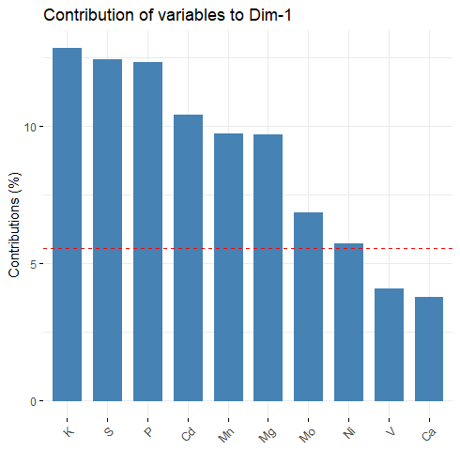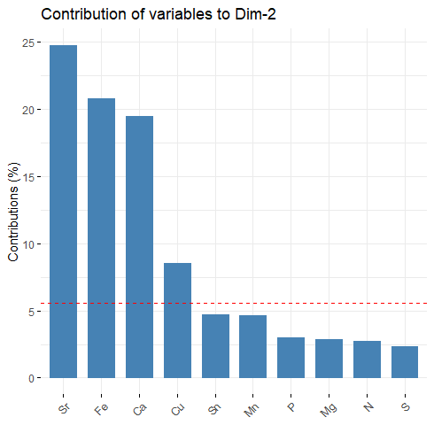

G) Skeletal properties
G.1) PCA biplot, including a cut-off for the cos2 = 0.5

F.2) Contribution of variables to PC1 and PC2

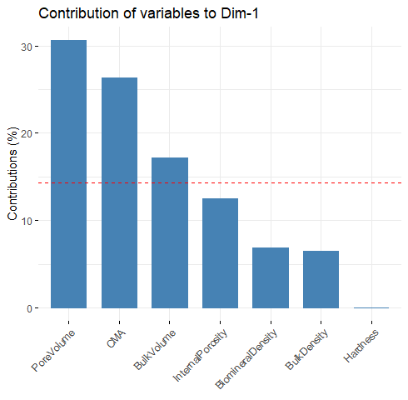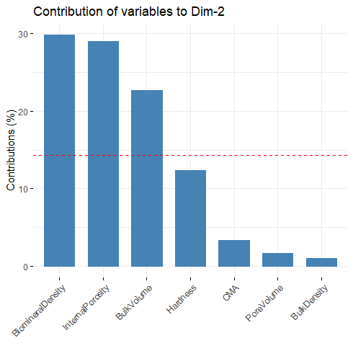

H) Multitraits
H.2) PCA biplot, including a cut-off for the cos2 = 0.5

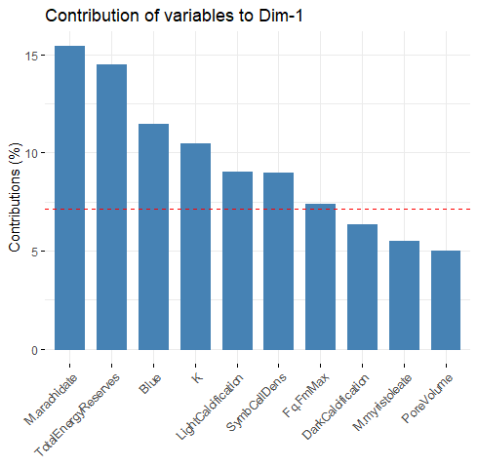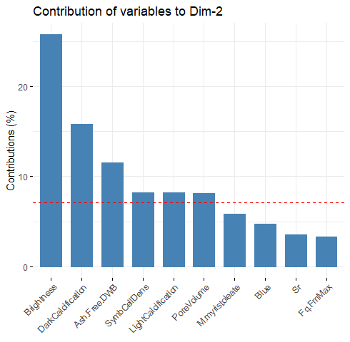

Supplementary Table 1. Potential traits relevant to restoration to understand coral biology. (A) Physical, (B) physiological, and (C) molecular coral traits commonly used in coral research and/or restoration are listed below. The details on how to measure a specific trait are classified in technique (the most common methodology); level (which part of the coral holobiont is targeted); type of replicates (minimum number of replicates, and information about if the destruction of the sample is required); and equipment (the most common equipment). Additionally, we added the feasibility for measuring a specific trait (in terms of costs, expertise, and time); and the type of trait (according to being desirable and measurable; desirable and less measurable; and measurable and less desirable). In italic, an alternative methodology to assess the same coral trait. From one to 17, some of the coral traits that have been selected for the multi-trait assessment approach. Additional information on certain techniques can be found in (D).
A)
Physical Trait | Technique | Level | Type of replicates. Are they destructive: Yes (Y) or No (N) | Equipment | Feasibility  (from more feasible (+) to less feasible (+++) | Type of trait: Desirable and measurable (DM), desirable and less measurable (DL), or measurable and less desirable (ML) | References
Survival (Survivorship) (1) | Underwater visual survey by taking photographs. | Coral colony and fragment | 1–2 photographs/colony or fragment – N | Underwater digital camera. | Cost +  Expertise +  Time + | DM | (Lirman, 2000; Putchim et al., 2008; Wright et al., 2019)(Lirman, 2000; Putchim et al., 2008; Wright et al., 2019)(Lirman, 2000; Putchim et al., 2008; Wright et al., 2019)(Lirman, 2000; Putchim et al., 2008; Wright et al., 2019)<sup>1–3</sup>
Growth rate (as linear extension rate) (2) | Underwater visual survey by taking photographs using a ruler for calibration. | Coral colony and fragment | 1–2 photographs/colony or fragment – N | Underwater digital camera and ruler. Image analysis using a specific software. | Cost +  Expertise +  Time ++ | DM | (Hughes, 1987; Lirman, 2000; Lizcano-Sandoval et al., 2018)
Growth rate (as 3D reconstruction) | Underwater visual survey by taking photographs using a ruler for calibration. | Coral colony and fragment | 50-100 photographs/colony or fragment – N | Underwater digital camera and ruler. Image analysis using a specific software. | Cost ++  Expertise ++  Time +++ | DL | (Gutierrez-Heredia et al., 2016; Gutiérrez-Heredia et al., 2015)
Growth rate (as weight gain) | Scale to obtain the buoyant weigh [1], wet weight or dry weight. | Coral fragment | 1 measurement/fragment – N | Scale. | Cost +  Expertise +  Time +++ | DL | (Spencer Davies, 1989; Wright et al., 2019)
Coral colour / Tissue colouration (a proxy for symbiont density) (3) | Underwater visual survey by taking photographs with a colour reference card. Quantification of RGB (R, red; G, green; B, blue) values. | Coral colony and fragment | 1–2 photographs/colony or fragment – N | Underwater digital camera and colour reference card [2]. Image analysis using a software (optional). | Cost +  Expertise ++  Time +++ | ML | (Siebeck et al., 2006; Wright et al., 2019)
Bleaching state (4) | Underwater visual survey by taking photographs with the Coral Health Chart. Manual categorisation [3]. | Coral colony and fragment | 1–2 photographs/colony or fragment – N | Underwater digital camera and Coral Health Chart. | Cost +  Expertise +  Time + | ML | (Siebeck et al., 2006; Wright et al., 2019)
Lesion progression / Tissue loss / Dead coral tissue | Photographs using a ruler for calibration and quantify or categorise % of tissue loss. | Coral colony and fragment | 1–2 photographs/colony or fragment – N | Underwater digital camera and ruler. | Cost +  Expertise +  Time ++ | ML | (Wright et al., 2019)
Skeletal surface (surface area, SA) (5) | Single paraffin wax dipping method. | Coral fragment | 1 measurement/fragment – Y | Paraffin wax. | Cost +  Expertise ++  Time ++ | DL | Veal et al 2010
Skeletal volume | Water displacement in a graduated cylinder. | Coral fragment | 1 measurement/fragment – N | Graduated cylinder. | Cost +  Expertise +  Time ++ | ML | Lavy et al 2015
(Skeletal) – bulk volume, biomineral density, bulk density, pore volume, apparent (internal) porosity (6) | Hydrostatic weight measurement. | Coral fragment | 1 measurement/fragment – Y | Sodium hypochlorite solution (1%), deionised water, oven, glass vessel in a 50°C water bath under vacuum, and paraffin wax. | Cost +  Expertise ++  Time +++ | DL | (Fantazzini et al., 2015)
Skeletal hardness (7) | Shore D Hardness Tester (TE-271). | Coral fragment | 1 measurement/fragment – Y | Sodium hypochlorite solution (1%), deionised water, oven, and hardness tester. | Cost +  Expertise +  Time + | DM | (Leggat et al., 2019)
Colony mass per area (8) | Scale and single paraffin wax dipping method to obtain weight and SA, respectively. | Coral fragment | 1 measurement/fragment – Y | Paraffin wax. | Cost +  Expertise ++  Time ++ | DL | (Madin et al., 2016)
(Skeletal) – interseptal volume fraction, (macro, micro and nano-) porosity, (micro and nano-) structure, stiffness, and hardness | µCT [4], TD-NMR [5], SAXS [6], SEM [7], AFM [8], and Nanoindentation Tester. | Coral fragment | 1–2 measurements/fragment – Y | Sodium hypochlorite solution (1%), deionised water, oven, microscope, mounting substrate, and specific equipment. | Cost +++  Expertise +++  Time +++ | DL | (Fantazzini et al., 2015)
(Skeletal) –crystallographic vital effects (CVE) (a proxy of physiological processes controlling biomineralisation) | SEM, EBSD [9], XRPD [10], and TGA [11]. | Coral fragment | 1–2 measurements/fragment – Y | Sodium hypochlorite (4%) solution, deionised water, diamond saw; mounting substrate (stain and epoxy resin), and specific equipment. | Cost +++  Expertise +++  Time +++ | DL | (Coronado et al., 2019)
Skeletal growth rate | Calcein dying or Calcein-Alizarin dying. | Coral fragment | 1–2 measurements/fragment – Y | Stain and electronic microscope. | Cost +++  Expertise +++  Time +++ | DL | (Holcomb et al., 2013)

B)
Physiological Trait | Technique | Level | Type of replicates. Are they destructive: Yes (Y) or No (N) | Equipment | Feasibility  (from more feasible (+) to less feasible (+++) | Type of trait: Desirable and measurable (DM), desirable and less measurable (DL), or measurable and less desirable (ML) | References
Photosynthesis – Net O₂ production (indicator of photosynthetic rate) (9a) | Photosynthesis vs. Respiration ratio. | Coral fragment | 1 measurement/fragment – N (5 cm) | Incubation chamber and O₂ logger. | Cost ++  Expertise +++  Time +++ | DL | (Camp et al., 2019, 2017, 2015; Gardner et al., 2017; Strahl et al., 2015; Wright et al., 2019)
Respiration – Net O₂ consumption (indicator of respiratory rate) (9b) | Photosynthesis vs. Respiration ratio. | Coral fragment | 1 measurement/fragment – N (5 cm) | Incubation chamber and O₂ logger. | Cost ++  Expertise +++  Time +++ | DL | (Camp et al., 2019, 2017, 2015; Gardner et al., 2017; Strahl et al., 2015; Wright et al., 2019)
Calcification – Total alkalinity (indicator of net calcification rate) (10) | Rates of light and dark calcification. | Coral fragment | 1 measurement/fragment – N (5 cm) | Incubation chamber and mercuric chloride (0.05% by volume) to fix the water samples. | Cost ++  Expertise +++  Time +++ | DL | (Camp et al., 2019, 2017, 2015; Gardner et al., 2017; Strahl et al., 2015; Wright et al., 2019)
Chlorophyll a fluorescence – (Non)photobiological traits (11) | E_{K} (light saturation coefficient), F_{q}´/F_{m}´_{MAX} (derived maximum photochemical efficiency), [1-C] (photochemical quenching), [1-Q] (non-photochemical quenching)  _{MAX}, F_{v}/F_{m} (maximum quantum yield of photosystem II). | Coral fragment | 1 fragment/colony – N (2 cm) | PAM fluorometer. | Cost ++  Expertise +++  Time ++ | DL | (Camp et al., 2019, 2017, 2015; Gardner et al., 2017; Strahl et al., 2015; Suggett et al., 2012; Wright et al., 2019)
Symbiont cell density (12) | Number of symbiont cells/coral surface area (cells cm⁻²). | Symbiont fraction | 1-cm fragment – Y | Haemocytometer and microscope. | Cost +  Expertise ++  Time +++ | DL | (Camp et al., 2016; Gardner et al., 2017; Hoogenboom et al., 2010)
Total pigment (Chlorophyll a and c2) content and ratio (13) | Identification and quantification. | Symbiont fraction | 1-cm fragment – Y | Stored in liquid nitrogen and then in −80°C, extraction of pigments and quantification by spectrophotometry. | Cost +  Expertise ++  Time +++ | DL | (Gardner et al., 2017; Wright et al., 2019)
Total protein content (14) | Identification and quantification. | Host and symbiont fractions | 1-cm fragment – Y | Stored in liquid nitrogen and then in −80°C, bicinchoninic method with bovine serum albumin as a standard. | Cost ++  Expertise +++  Time +++ | DL | (Gardner et al., 2017; Grottoli et al., 2018; Wright et al., 2019)
Total carbohydrate content (15) | Identification and quantification. | Host and symbiont fractions | 1-cm fragment – Y | Stored in liquid nitrogen and then in −80°C, phenol-sulfuric acid method with glucose as a standard. | Cost ++  Expertise +++  Time +++ | DL | (Grottoli et al., 2018; Wright et al., 2019)
Total lipid content (16) | Identification and quantification. | Host and symbiont fractions | 1-cm fragment – Y | Stored in liquid nitrogen and then in −80°C, 2:1 chloroform:methanol solution followed by washing steps. | Cost ++  Expertise +++  Time +++ | DL | (Grottoli et al., 2018, 2004; Padilla-Gamiño et al., 2013)
Catalase activity (CAT, a proxy for coral innate immune response) | Identification and quantification. | Host fraction | 1-cm fragment – Y | Stored in liquid nitrogen and then in −80°C, antioxidant assay, microplate reader. | Cost ++  Expertise +++  Time +++ | DL | (Gardner et al., 2017; Wright et al., 2019)
Non-fluorescent chromoprotein content [12] (a proxy for coral innate immune response) | Identification and quantification. | Host fraction | 1-cm fragment – Y | Stored in liquid nitrogen and then in −80°C, extraction of chromoproteins and quantification by spectrophotometry. | Cost ++  Expertise +++  Time +++ | DL | (Gardner et al., 2017; Wright et al., 2019)
Other antioxidant and enzyme activity (SOD [13], GSx [14], and CAT-like activity) | Identification and quantification. | Host fraction | 1-cm fragment – Y | Stored in liquid nitrogen and then in −80°C, antioxidant assay, microplate reader. | Cost ++  Expertise +++  Time +++ | DL | (Gardner et al., 2017; Wright et al., 2019)
N₂ fixation (related to nutrition) | Rates of light and dark calcification. | Coral fragment | 1 measurement/fragment – N (5 cm) | Incubation chamber and acetylene (C₂H₂) reduction assay. | Cost ++  Expertise +++  Time +++ | DL | (Bednarz et al., 2018, 2015)
Carbon acquisition (related to nutrition) | Identification and quantification. | Coral fragment | 1 measurement/fragment – Y (5 cm) | NaH₁₃CO₃ incubations followed by mass spectrometry coupled to a C/N analyser. | Cost +++  Expertise +++  Time +++ | DL | (Pupier et al., 2019)
Photoautotrophy vs. heterotrophy (related to nutrition) | Identification and quantification. | Coral host | 1 measurement/fragment – Y (5 cm) | Photoautotrophic labelling (DI-¹³C pulse-chase), and heterotrophic labelling (¹³C-rotifer pulse-chase). | Cost +++  Expertise +++  Time +++ | DL | (Baumann et al., 2014; Grottoli et al., 2006; Hughes et al., 2010)

C)
Molecular trait | Technique | Level | Type of replicates. Are they destructive: Yes (Y) or No (N) | Equipment | Feasibility  (from more feasible (+) to less feasible (+++) | Type of trait: Desirable and measurable (DM), desirable and less measurable (DL), or measurable and less desirable (ML) | References
Symbiont diversity (17) | ITS2 sequencing. | Symbiont fraction | 1-cm fragment – Y | Stored in liquid nitrogen and then in −80°C. DNA extraction protocol, and sequencing facility. | Cost +++  Expertise +++  Time +++ | DL | (Howe-kerr et al., 2019)
Coral diversity | Single nucleotide polymorphisms (SNP) markers (genotype). | Coral host | 1-cm fragment – Y | Stored in liquid nitrogen and then in −80°C, DNA extraction protocol, and sequencing facility. | Cost +++  Expertise +++  Time +++ | DL | (Kitchen, 2020)
Gene expression (including heat shock protein gene expression, and other gene markers) | RNA sequencing. | Coral host | 1 fragment (1–2 cm) – Y | Stored in RNAlater, RNA extraction protocol, and sequencing facility. | Cost +++  Expertise +++  Time +++ | DL | (Venn et al., 2009)
Microbial composition (diversity), relative abundance and function | 16S sequencing. | Coral fragment | 1 fragment (1–2 cm) – Y | Stored in RNAlater, DNA extraction protocol, and sequencing facility. | Cost +++  Expertise +++  Time +++ | DL | (Wegley et al., 2007)
DMSP / DMSO concentrations | Identification and quantification. | Coral fragment |  | Store in methanol at −20°C, determination by qNMR [15] or GC [16]. | Cost +++  Expertise +++  Time +++ | DL | (Deschaseaux et al., 2014; Gardner et al., 2017)

D)
Number | Additional information
[1] | Also called buoyant weight growth rate.
[2] | Also called colour standard, which consists of five coloured areas (black, white, red, green, and blue).
[3] | E.g. Either score from one to six or assign categories: (1) unbleached (normal coloration), (2) pale (lighter colour than usual for the time of year), (3) 0–20% of the surface bleached, (4) 20–50% bleached, (5) 50–80% bleached, and (6) 80–100% bleached.
[4] | Micro computed tomography.
[5] | Time-domain nuclear magnetic resonance.
[6] | Small-angle X-ray scattering.
[7] | Scanning electron microscopy.
[8] | Atomic force microscopy.
[9] | Electron backscatter diffraction.
[10] | X-ray powder diffraction (non-destructive).
[11] | Thermal gravimetric analysis.
[12] | Thought to play a role in photoprotection of the coral's resident symbiont microalgal photosystems from photoinhibition caused by high light levels found near the surface of coral reefs.
[13] | Superoxide dismutase enzyme.
[14] | Glutathione enzyme.
[15] | Quantitative ¹H nuclear magnetic resonance spectroscopy.
[16] | Gas-chromatography.

Supplementary Table S2. A total of 90 traits were selected for this study. Survival and growth are considered emergent properties. Seven biological properties were investigated to unveil the biological machinery underpinning coral survival and growth: physical appearance (tissue colouration), photobiology, metabolism, energy reserves, fatty acid methyl esters (FAME), elementome, and skeletal properties.

 | Variable | Biological property
1 | Individual survival success | Survival (emergent property) (1 trait)
2 | Relative linear growth rate | Growth (emergent property) (3 traits)
3 | Relative areal growth rate | Growth (emergent property) (3 traits)
4 | Relative increase in areal tissue | Growth (emergent property) (3 traits)
5 | Red [R] | Physical appearance (7 traits)
6 | Green [G] | Physical appearance (7 traits)
7 | Blue [B] | Physical appearance (7 traits)
8 | Hue [H] | Physical appearance (7 traits)
9 | Saturation [S] | Physical appearance (7 traits)
10 | Brightness [B] | Physical appearance (7 traits)
11 | Bleaching state | Physical appearance (7 traits)
12 | Light saturation coefficient [E_{K}] | Photobiology (13)
13 | Derived maximum photochemical efficiency [F_{q}´/F_{m}´_{MAX}] | Photobiology (13)
14 | Photochemical quenching [1-C]_{MAX} | Photobiology (13)
15 | Non-photochemical quenching [1-Q]_{MAX} | Photobiology (13)
16 | Symbiont cell density | Photobiology (13)
17 | Total pigment density | Photobiology (13)
18 | Chl a density | Photobiology (13)
19 | Chl c2 density | Photobiology (13)
20 | Total pigments per cell | Photobiology (13)
21 | Chl a per cell | Photobiology (13)
22 | Chl c2 per cell | Photobiology (13)
23 | a:c2 ratio | Photobiology (13)
24 | Symbiodiniaceae ITS2 identity | Photobiology (13)
25 | Gross Photosynthesis rate [P_{G}] | Metabolism (7 traits)
26 | Net Photosynthesis rate [P_{N}] | Metabolism (7 traits)
27 | Respiration rate [R] | Metabolism (7 traits)
28 | P_{G}:R ratio | Metabolism (7 traits)
29 | Light-dependent calcification [G_{L}] | Metabolism (7 traits)
30 | Dark-dependent calcification [G_{D}] | Metabolism (7 traits)
31 | G_{L}:G_{D} ratio | Metabolism (7 traits)
32 | Carbohydrates | Energy reserves (9 traits)
33 | Soluble proteins | Energy reserves (9 traits)
34 | Total lipids | Energy reserves (9 traits)
35 | Total energy reserves | Energy reserves (9 traits)
36 | Dry weight biomass [DW] | Energy reserves (9 traits)
37 | Ash-free dry weight biomass [AFDW] | Energy reserves (9 traits)
38 | Saturated fatty acids [SFA] | Energy reserves (9 traits)
39 | Mono-unsaturated fatty acids [MUFA] | Energy reserves (9 traits)
40 | Poly-unsaturated fatty acids [PUFA] | Energy reserves (9 traits)
41 | Methyl dodecanoate (Methyl laurate) | Fatty acid methyl esters  (19 traits)
42 | Methyl myristoleate | Fatty acid methyl esters  (19 traits)
43 | Methyl tetradecanoate | Fatty acid methyl esters  (19 traits)
44 | Methyl pentadecanoate | Fatty acid methyl esters  (19 traits)
45 | Methyl palmitoleate | Fatty acid methyl esters  (19 traits)
46 | Methyl palmitate | Fatty acid methyl esters  (19 traits)
47 | Methyl gamma-linolenate | Fatty acid methyl esters  (19 traits)
48 | Linolelaidic acid methyl ester | Fatty acid methyl esters  (19 traits)
49 | cis-9-Oleic acid methyl ester | Fatty acid methyl esters  (19 traits)
50 | trans-9-Elaidic acid methyl ester | Fatty acid methyl esters  (19 traits)
51 | Methyl octadecanoate (methyl stearate) | Fatty acid methyl esters  (19 traits)
52 | cis-5,8,11,14-Eicosatetraenoic acid methyl ester | Fatty acid methyl esters  (19 traits)
53 | cis-5,8,11,14,17-Eicosapentanoic acid methyl ester | Fatty acid methyl esters  (19 traits)
54 | cis-8,11,14-Eicosatrienoic acid methyl ester | Fatty acid methyl esters  (19 traits)
55 | cis-11,14-Eicosadienoic acid methyl ester | Fatty acid methyl esters  (19 traits)
56 | Methyl cis-11-eicosenoate | Fatty acid methyl esters  (19 traits)
57 | Methyl arachidate | Fatty acid methyl esters  (19 traits)
58 | Methyl cis-4,7,10,13,16,19-docosahexanoate | Fatty acid methyl esters  (19 traits)
59 | Methyl docosanoate | Fatty acid methyl esters  (19 traits)
60 | Carbon [C] | Elementome (24 traits)
61 | Nitrogen [N] | Elementome (24 traits)
62 | Phosphorus [P] | Elementome (24 traits)
63 | Magnesium [Mg] | Elementome (24 traits)
64 | Sulphur [S] | Elementome (24 traits)
65 | Potassium [K] | Elementome (24 traits)
66 | Calcium [Ca] | Elementome (24 traits)
67 | Vanadium [V] | Elementome (24 traits)
68 | Manganese [Mn] | Elementome (24 traits)
69 | Iron [Fe] | Elementome (24 traits)
70 | Nickel [Ni] | Elementome (24 traits)
71 | Copper [Cu] | Elementome (24 traits)
72 | Zinc [Zn] | Elementome (24 traits)
73 | Strontium [Sr] | Elementome (24 traits)
74 | Molybdenum [Mo] | Elementome (24 traits)
75 | Cadmium [Cd] | Elementome (24 traits)
76 | Tin (Sn) | Elementome (24 traits)
77 | Lead (Pb) | Elementome (24 traits)
78 | Cobalt [Co] | Elementome (24 traits)
79 | Selenium [Se] | Elementome (24 traits)
80 | C:N ratio | Elementome (24 traits)
81 | C:P ratio | Elementome (24 traits)
82 | N:P ratio | Elementome (24 traits)
83 | C:N:P ratio | Elementome (24 traits)
84 | Bulk volume | Skeletal properties (7 traits)
85 | Bulk density | Skeletal properties (7 traits)
86 | Biomineral density | Skeletal properties (7 traits)
87 | Pore volume | Skeletal properties (7 traits)
88 | Apparent (internal) porosity | Skeletal properties (7 traits)
89 | Hardness | Skeletal properties (7 traits)
90 | Colony mass per area [CMA] | Skeletal properties (7 traits)

Supplementary Table S3. (A) Contributions of traits to the first (PC1) and second (PC2) principal components (dimensions, Dim.), and (B) cumulative variance percent of PC1 and PC2 of the Principal Component Analysis (PCA) for all coral groups (WT0, WT12, and NT12) for the following seven biological properties: (1) physical appearance (tissue colouration), (2) photobiology, (3) metabolism, (4) energy reserves, (5) fatty acid methyl esters (FAME), (6) elementome, and (7) skeletal properties. Variables not considered in the PCA, followed by a brief rationale, are written in italic font.

(1) Physical appearance
A)
Variable | Dim.1 | Dim.2 | Dim.3 | Dim.4 | Dim.5
R | 31.6206 | 1.3084 | 1.9096 | 13.0399 | 19.0309
G | 26.9003 | 6.8402 | 0.0569 | 11.9012 | 46.7686
B | 3.9886 | 34.0950 | 4.4406 | 24.2456 | 31.1878
H | 2.8506 | 23.9952 | 70.5499 | 2.4823 | 0.0023
S | 1.4011 | 33.3520 | 22.6193 | 39.1327 | 2.8521
B | 33.2388 | 0.4092 | 0.4237 | 9.1983 | 0.1584
Bleaching state | Not considered in the PCA – Same mean among coral groups
Max | 33.2388 | 34.0950

B)
 | Eigenvalue | Variance percent | Cumulative variance percent
Dim.1 | 2.913796342 | 48.56327 | 48.56327
Dim.2 | 2.341441905 | 39.02403 | 87.5873
Dim.3 | 0.497617839 | 8.293631 | 95.88093
Dim.4 | 0.162169825 | 2.70283 | 98.58377
Dim.5 | 0.076554886 | 1.275915 | 99.85968
Dim.6 | 0.008419204 | 0.14032 | 100

(2) Photobiology
A)
Variable | Dim.1 | Dim.2 | Dim.3 | Dim.4 | Dim.5
E_{K} | 5.1987 | 26.6999 | 1.4242 | 0.0001 | 5.2212
F_{q}´/F_{m}´_{MAX} | 1.4808 | 31.9670 | 1.1472 | 0.4556 | 2.5874
[1-C]_{MAX} | 5.6758 | 27.6816 | 1.1604 | 1.8134 | 0.0906
[1-Q]_{MAX} | 3.2701 | 0.0498 | 11.4605 | 55.7836 | 26.3817
Symbiont cell density | 16.2934 | 1.3953 | 0.9728 | 0.0348 | 8.1392
Total pigments per cell | 12.6732 | 1.9627 | 15.8342 | 1.9703 | 0.4704
Chl a per cell | 10.9460 | 1.0385 | 18.3146 | 6.8279 | 5.6070
Chl c2 per cell | 13.2879 | 3.7717 | 9.1909 | 0.8278 | 5.7688
Total pigment density | 11.2486 | 0.4460 | 21.2471 | 0.0570 | 9.5985
Chl a density | 12.2270 | 1.1168 | 18.1577 | 1.5564 | 2.7992
Chl c2 density | 7.6984 | 3.8706 | 1.0902 | 30.6730 | 33.3359
a:c2 ratio | Not considered in the PCA – correlated variable
Symbiodiniaceae ITS2 identity | Not considered in the PCA – separated analysis
Max | 16.2934 | 31.9670

B)
 | Eigenvalue | Variance percent | Cumulative variance percent
Dim.1 | 5.5426 | 50.3868 | 50.3868
Dim.2 | 2.1633 | 19.6668 | 70.0536
Dim.3 | 1.4563 | 13.2390 | 83.2926
Dim.4 | 0.9174 | 8.3403 | 91.6329
Dim.5 | 0.5093 | 4.6298 | 96.2626
Dim.6 | 0.3281 | 2.9825 | 99.2452
Dim.7 | 0.0504 | 0.4585 | 99.7037
Dim.8 | 0.0216 | 0.1966 | 99.9003
Dim.9 | 0.0108 | 0.0978 | 99.9982
Dim.10 | 0.0002 | 0.0018 | 100
Dim.11 | 0.0000 | 0.0000 | 100

(3) Metabolism
A)
Variable | Dim.1 | Dim.2 | Dim.3 | Dim.4
P_{G} | 25.2170 | 15.7727 | 58.8025 | 0.2077
R | 22.8459 | 32.9157 | 38.9191 | 5.3194
G_{L} | 22.8623 | 42.1456 | 0.0145 | 34.9776
G_{D} | 29.0748 | 9.1660 | 2.2639 | 59.4953
P_{N} | Not considered in the PCA – correlated variable
P_{G:}R ratio | Not considered in the PCA – correlated variable
G_{L}:G_{D} ratio | Not considered in the PCA – correlated variable
Max | 29.0748 | 43.2690

B)
 | Eigenvalue | Variance percent | Cumulative variance percent
Dim.1 | 2.7954 | 69.8843 | 69.8843
Dim.2 | 0.6937 | 17.3420 | 87.2263
Dim.3 | 0.3151 | 7.8769 | 95.1031
Dim.4 | 0.1959 | 4.8969 | 100

(4) Energy reserves
A)
Variable | Dim.1 | Dim.2 | Dim.3 | Dim.4 | Dim.5
Carbohydrates | 3.2689 | 9.3847 | 80.7235 | 2.5182 | 1.3333
Soluble proteins | 11.2480 | 1.7960 | 0.3635 | 56.1005 | 5.0368
Total lipids | 14.4013 | 0.6165 | 2.2743 | 21.5480 | 17.3157
Total energy reserves | 16.3038 | 0.0155 | 0.1611 | 7.2519 | 13.1736
DW | 10.0800 | 21.0473 | 4.8151 | 0.0496 | 1.2671
AFDW | 4.5481 | 36.1047 | 10.5442 | 0.6925 | 24.9418
SFA | 13.3980 | 10.5302 | 0.6915 | 1.8248 | 13.8113
MUFA | 12.7655 | 13.3530 | 0.4101 | 0.0141 | 22.8679
PUFA | 13.9865 | 7.1521 | 0.0167 | 10.0004 | 0.2526
Max | 16.3038 | 36.1047

B)
 | Eigenvalue | Variance percent | Cumulative variance percent
Dim.1 | 5.7656 | 64.0623 | 64.0623
Dim.2 | 1.6886 | 18.7617 | 82.8239
Dim.3 | 0.7897 | 8.7748 | 91.5988
Dim.4 | 0.5422 | 6.0249 | 97.6236
Dim.5 | 0.1299 | 1.4429 | 99.0665
Dim.6 | 0.0416 | 0.4624 | 99.5289
Dim.7 | 0.0329 | 0.3656 | 99.8945
Dim.8 | 0.0095 | 0.1055 | 100
Dim.9 | 0.0000 | 0.0000 | 100

(5) FAME
A)
Variable | Dim.1 | Dim.2 | Dim.3 | Dim.4 | Dim.5
Methyl dodecanoate (Methyl laurate) | 4.5296 | 6.3910 | 8.2101 | 12.1580 | 5.7245
Methyl myristoleate | 1.1248 | 31.0531 | 15.5815 | 0.2351 | 2.1852
Methyl tetradecanoate | 6.2957 | 3.1204 | 1.1346 | 1.0295 | 0.1908
Methyl pentadecanoate | 3.3638 | 1.3373 | 15.5860 | 0.7500 | 43.3103
Methyl palmitoleate | 6.7975 | 1.7657 | 0.1563 | 0.2544 | 3.4341
Methyl palmitate | 6.6846 | 3.3675 | 0.0522 | 1.1446 | 0.0015
Methyl gamma-linolenate | 6.8010 | 3.0476 | 0.0342 | 0.1024 | 0.6519
Linolelaidic acid methyl ester | 6.9194 | 2.1673 | 0.0130 | 0.5957 | 0.2817
cis-9-Oleic acid methyl ester | 6.6072 | 2.8631 | 0.1934 | 1.2013 | 0.2376
trans-9-Elaidic acid methyl ester | 4.5489 | 0.0025 | 6.3168 | 23.2085 | 9.8063
Methyl octadecanoate (methyl stearate) | 6.4669 | 0.7402 | 0.8740 | 1.6713 | 1.2937
cis-5,8,11,14-Eicosatetraenoic acid methyl ester | 2.7717 | 12.3910 | 19.9539 | 6.8242 | 1.3452
cis-5,8,11,14,17-Eicosapentanoic acid methyl ester | 4.8286 | 2.6687 | 11.9613 | 14.1291 | 0.4607
cis-8,11,14-Eicosatrienoic acid methyl ester | 6.4285 | 0.8736 | 1.6020 | 1.8776 | 3.9898
cis-11,14-Eicosadienoic acid methyl ester | 4.0681 | 5.3021 | 5.4458 | 13.6460 | 8.8238
Methyl cis-11-eicosenoate | 6.7016 | 0.5646 | 0.9777 | 0.3517 | 0.0324
Methyl arachidate | 7.0173 | 0.2211 | 0.0674 | 0.0234 | 0.9073
Methyl cis-4,7,10,13,16,19-docosahexanoate | 6.8776 | 0.0167 | 0.0003 | 0.8352 | 0.7760
Methyl docosanoate | 1.1671 | 22.1064 | 11.8395 | 19.9621 | 16.5470
Max | 7.0173 | 31.0531

B)
 | Eigenvalue | Variance percent | Cumulative variance percent
Dim.1 | 13.7769 | 72.5101 | 72.5101
Dim.2 | 1.6666 | 8.7714 | 81.2815
Dim.3 | 1.3988 | 7.3619 | 88.6434
Dim.4 | 0.7310 | 3.8476 | 92.4910
Dim.5 | 0.5610 | 2.9528 | 95.4437
Dim.6 | 0.3666 | 1.9294 | 97.3731
Dim.7 | 0.2672 | 1.4062 | 98.7793
Dim.8 | 0.1146 | 0.6033 | 99.3826
Dim.9 | 0.0481 | 0.2533 | 99.6359
Dim.10 | 0.0305 | 0.1605 | 99.7964
Dim.11 | 0.0187 | 0.0982 | 99.8946
Dim.12 | 0.0092 | 0.0486 | 99.9432
Dim.13 | 0.0068 | 0.0358 | 99.9790
Dim.14 | 0.0031 | 0.0165 | 99.9956
Dim.15 | 0.0008 | 0.0044 | 100
Dim.16 | 0.0000 | 0.0000 | 100
Dim.17 | 0.0000 | 0.0000 | 100

(6) Elementome
A)
Variable | Dim.1 | Dim.2 | Dim.3 | Dim.4 | Dim.5
C | 2.6486 | 1.3640 | 26.0665 | 0.3851 | 1.0684
N | 1.1952 | 2.7462 | 24.1221 | 1.2097 | 0.0000
Mg | 9.7099 | 2.8341 | 0.0201 | 0.3247 | 13.3444
P | 12.3261 | 2.9743 | 0.2688 | 0.1815 | 0.4344
S | 12.4359 | 2.3319 | 0.2149 | 0.0710 | 4.0831
K | 12.8652 | 1.6407 | 0.7068 | 0.4213 | 0.6535
Ca | 3.7779 | 19.4596 | 3.5618 | 3.1166 | 0.5431
V | 4.0875 | 0.1406 | 9.7251 | 6.0440 | 0.2984
Mn | 9.7192 | 4.6204 | 0.8377 | 0.1391 | 0.1436
Fe | 1.7347 | 20.7758 | 5.1418 | 4.0856 | 0.0744
Ni | 5.7239 | 1.0432 | 2.8882 | 0.5712 | 1.8847
Cu | 3.0263 | 8.5536 | 7.5049 | 6.0276 | 0.0028
Zn | 0.5536 | 0.7571 | 0.5293 | 7.1245 | 62.4249
Sr | 2.0974 | 24.7451 | 1.9668 | 3.5381 | 0.0553
Mo | 6.8485 | 0.0187 | 3.1194 | 0.3931 | 12.1547
Cd | 10.4207 | 0.4837 | 5.3482 | 0.5565 | 0.0173
Sn | 0.7494 | 4.6955 | 0.2076 | 32.4132 | 2.6328
Pb | 0.0800 | 0.8154 | 7.7699 | 33.3973 | 0.1843
Co | Not considered in the PCA – negligible values
Se | Not considered in the PCA – negligible values
C:N ratio | Not considered in the PCA – correlated variable
C:P ratio | Not considered in the PCA – correlated variable
N:P ratio | Not considered in the PCA – correlated variable
C:N:P ratio | Not considered in the PCA – correlated variable
Max | 12.8652 | 24.7451

B)
 | eigenvalue | Variance percent | Cumulative variance percent
Dim.1 | 6.6577 | 36.9874 | 36.9874
Dim.2 | 2.9695 | 16.4970 | 53.4844
Dim.3 | 2.6163 | 14.5352 | 68.0196
Dim.4 | 1.4923 | 8.2908 | 76.3104
Dim.5 | 1.1061 | 6.1451 | 82.4555
Dim.6 | 1.0025 | 5.5695 | 88.0250
Dim.7 | 0.7559 | 4.1994 | 92.2244
Dim.8 | 0.5615 | 3.1197 | 95.3441
Dim.9 | 0.3185 | 1.7697 | 97.1137
Dim.10 | 0.2198 | 1.2210 | 98.3347
Dim.11 | 0.1602 | 0.8901 | 99.2248
Dim.12 | 0.0822 | 0.4569 | 99.6817
Dim.13 | 0.0337 | 0.1873 | 99.8690
Dim.14 | 0.0183 | 0.1019 | 99.9710
Dim.15 | 0.0052 | 0.0290 | 100
Dim.16 | 0.0000 | 0.0000 | 100
Dim.17 | 0.0000 | 0.0000 | 100

(7) Skeletal properties
A)
Variable | Dim.1 | Dim.2 | Dim.3 | Dim.4 | Dim.5
Bulk volume | 17.1538 | 22.7144 | 0.9498 | 4.6148 | 10.9643
Biomineral density | 6.8420 | 29.8519 | 12.7337 | 0.5533 | 4.4352
Bulk density | 6.5315 | 1.0573 | 38.4064 | 42.3730 | 11.2445
Apparent internal porosity | 12.4627 | 28.9573 | 2.7592 | 0.0639 | 8.4386
Pore volume | 30.6449 | 1.7048 | 4.8685 | 1.3828 | 10.7470
Hardness | 0.0173 | 12.3524 | 31.8928 | 50.6400 | 5.0352
CMA | 26.3478 | 3.3620 | 8.3896 | 0.3721 | 49.1353
Max | 30.6449 | 29.8519

B)
 | Eigenvalue | Variance percent | Cumulative variance percent
Dim.1 | 2.8077 | 40.1093 | 40.1093
Dim.2 | 1.9907 | 28.4380 | 68.5473
Dim.3 | 1.3188 | 18.8401 | 87.3874
Dim.4 | 0.6429 | 9.1849 | 96.5723
Dim.5 | 0.1471 | 2.1012 | 98.6735
Dim.6 | 0.0791 | 1.1294 | 99.8029
Dim.7 | 0.0138 | 0.1971 | 100

Supplementary Table S4. (A) Contributions of traits in the first (PC1) and second (PC2) principal components, and (B) cumulative variance percent of PC1 and PC2 of the Principal Component Analysis (PCA) for all coral groups (WT0, WT12, and NT12) for the following 14 traits: brightness, blue, symbiont cell density, maximum photochemical efficiency of PSII [F_{q}´/F_{m}´_{MAX}], dark and light calcifications [G_{D} and G_{L}, respectively) , total energy reserves, ash-free dry weight biomass (AFDW), methyl arachidate, methyl myristoleate, potassium [K], strontium [Sr], pore volume, and biomineral density (the so-called multitraits).

Multitraits
A)
Variable | Dim.1 | Dim.2 | Dim.3 | Dim.4 | Dim.5
Brightness | 0.2833 | 25.7740 | 0.2306 | 2.2163 | 2.2905
Blue | 11.4690 | 4.7036 | 0.5115 | 2.2645 | 6.0934
Symbiont cell density | 8.9553 | 8.2251 | 5.2107 | 6.1435 | 0.5043
F_{q}´/F_{m}´_{MAX} | 7.4004 | 3.3073 | 2.2258 | 7.9685 | 21.9005
G_{D} | 6.3396 | 15.7967 | 6.5647 | 0.0450 | 2.5363
G_{L} | 9.0069 | 8.1766 | 4.6114 | 2.2954 | 3.1284
Total energy reserves | 14.4930 | 0.5451 | 4.6535 | 0.6593 | 2.2232
AFDW | 3.2435 | 11.5057 | 1.0206 | 4.3227 | 36.5346
Methyl arachidate | 15.4141 | 1.3167 | 0.5815 | 5.8518 | 1.0506
Methyl myristoleate | 5.4729 | 5.8476 | 7.8773 | 24.7291 | 0.1513
K | 10.4707 | 2.2531 | 5.7307 | 5.5037 | 0.3124
Sr | 2.0983 | 3.5268 | 11.9187 | 26.2633 | 9.1224
Pore volume | 5.0154 | 8.1006 | 8.8985 | 5.8832 | 9.0851
Biomineral density | 0.3376 | 0.9210 | 39.9643 | 5.8534 | 5.0671
Max | 15.4141 | 25.7740

B)
 | Eigenvalue | Variance percent | Cumulative variance percent
Dim.1 | 4.8285 | 34.4891 | 34.4891
Dim.2 | 2.3888 | 17.0631 | 51.5522
Dim.3 | 1.9974 | 14.2674 | 65.8197
Dim.4 | 1.2469 | 8.9066 | 74.7262
Dim.5 | 0.9305 | 6.6465 | 81.3728
Dim.6 | 0.7767 | 5.5481 | 86.9208
Dim.7 | 0.6209 | 4.4348 | 91.3556
Dim.8 | 0.3677 | 2.6262 | 93.9817
Dim.9 | 0.3270 | 2.3355 | 96.3172
Dim.10 | 0.2993 | 2.1377 | 98.4549
Dim.11 | 0.1470 | 1.0499 | 99.5048
Dim.12 | 0.0455 | 0.3250 | 99.8298
Dim.13 | 0.0142 | 0.1011 | 99.9309
Dim.14 | 0.0097 | 0.0691 | 100.0000

Supplementary Table S5. Analysis of variance (ANOVA) and post hoc Tukey HSD to compare the extracted ordination axes (A) PC1 and (B) PC2 of Fig. 8 across coral groups, WT0, WT12, and NT12. Data were assessed for normality. Means were compared by one-way (repeated measures) analysis of variance (ANOVA) with post hoc Tukey tests, where ns indicates no statistical significance, and * indicates p ≤ 0.05.

A) PC1
Repeated measures ANOVA summary
Assume sphericity? | No
F | 6.167
P value | 0.0337
P value summary | *
Statistically significant (P < 0.05)? | Yes
Geisser-Greenhouse's epsilon | 0.719
R squared | 0.5523
Was the matching effective?
F | 1.67
P value | 0.2291
P value summary | ns
Is there significant matching (P < 0.05)? | No
R squared | 0.2721
ANOVA table | SS | DF | MS | F (DFn | DFd) | P value
Treatment (between columns) | 139290 | 2 | 69645 | F (1.438 | 7.190) = 6.167 | P=0.0337
Individual (between rows) | 94268 | 5 | 18854 | F (5 | 10) = 1.670 | P=0.2291
Residual (random) | 112928 | 10 | 11293
Total | 346487 | 17
Data summary
Number of treatments (columns) | 3
Number of subjects (rows) | 6
Number of missing values | 0

Post-hoc comparisons (Tukey’s test)
Number of families | 1
Number of comparisons per family | 3
Alpha | 0.05
Tukey's multiple comparisons test | Mean Diff. | 95.00% CI of diff. | Below threshold? | Summary | Adjusted P Value
Wild corals at T0 vs. Wild corals at T12 | -166.3 | -332.7 to 0.01167 | No | ns | 0.05 | A-B
Wild corals at T0 vs. Nursery corals at T12 | -201.8 | -366.5 to -37.10 | Yes | * | 0.0237 | A-C
Wild corals at T12 vs. Nursery corals at T12 | -35.45 | -290.0 to 219.1 | No | ns | 0.8952 | B-C
Test details | Mean 1 | Mean 2 | Mean Diff. | SE of diff. | n1 | n2 | q | DF
Wild corals at T0 vs. Wild corals at T12 | 126.4 | 292.8 | -166.3 | 51.12 | 6 | 6 | 4.601 | 5
Wild corals at T0 vs. Nursery corals at T12 | 126.4 | 328.2 | -201.8 | 50.61 | 6 | 6 | 5.638 | 5
Wild corals at T12 vs. Nursery corals at T12 | 292.8 | 328.2 | -35.45 | 78.21 | 6 | 6 | 0.641 | 5

B) PC2
Repeated measures ANOVA summary
Assume sphericity? | No
F | 21.94
P value | 0.0025
P value summary | **
Statistically significant (P < 0.05)? | Yes
Geisser-Greenhouse's epsilon | 0.6203
R squared | 0.8144
Was the matching effective?
F | 4.454
P value | 0.0214
P value summary | *
Is there significant matching (P < 0.05)? | Yes
R squared | 0.2925
ANOVA table | SS | DF | MS | F (DFn | DFd) | P value
Treatment (between columns) | 0.4375 | 2 | 0.2188 | F (1.241 | 6.203) = 21.94 | P=0.0025
Individual (between rows) | 0.2221 | 5 | 0.04442 | F (5 | 10) = 4.454 | P=0.0214
Residual (random) | 0.09973 | 10 | 0.009973
Total | 0.7594 | 17
Data summary
Number of treatments (columns) | 3
Number of subjects (rows) | 6
Number of missing values | 0

Post-hoc comparisons (Tukey’s test)
Number of families | 1
Number of comparisons per family | 3
Alpha | 0.05
Tukey's multiple comparisons test | Mean Diff. | 95.00% CI of diff. | Below threshold? | Summary | Adjusted P Value
Wild corals at T0 vs. Wild corals at T12 | 0.2665 | 0.04586 to 0.4872 | Yes | * | 0.025 | A-B
Wild corals at T0 vs. Nursery corals at T12 | -0.1036 | -0.1911 to -0.01609 | Yes | * | 0.027 | A-C
Wild corals at T12 vs. Nursery corals at T12 | -0.3701 | -0.5920 to -0.1482 | Yes | ** | 0.0067 | B-C
Test details | Mean 1 | Mean 2 | Mean Diff. | SE of diff. | n1 | n2 | q | DF
Wild corals at T0 vs. Wild corals at T12 | 0.6146 | 0.3481 | 0.2665 | 0.06782 | 6 | 6 | 5.558 | 5
Wild corals at T0 vs. Nursery corals at T12 | 0.6146 | 0.7182 | -0.1036 | 0.0269 | 6 | 6 | 5.448 | 5
Wild corals at T12 vs. Nursery corals at T12 | 0.3481 | 0.7182 | -0.3701 | 0.0682 | 6 | 6 | 7.676 | 5

Supplementary Table S6. PERMANOVA using Bray-Curtis dissimilarity to compare differences between coral groups (WT0, WT12, and NT12) at “Mojo” site at Opal reef on the Great Barrier Reef.

Permutation test for adonis under reduced model

Terms added sequentially (first to last)

Permutation: free

Number of permutations: 9999

adonis2(formula = multi.dist ~ Group, data = multi, permutations = 9999, method = "bray")
 | Df | SumOfSqs | R2 | F | Pr(>F)
Group | 2 | 23344.1 | 0.89567 | 64.385 | 0.3767
Residual | 15 | 2719.3 | 0.10433
Total | 17 | 26063.3 | 1.00000

