Supporting Information
Supplementary materials
Beyond Polyhedra in Mineralogy - Pressure Induced Quantitative Experimental Charge Density Redistribution for Ions in Hsianghualite

Marcin Stachowicz¹*, Roman Gajda², Agnieszka Huć¹ Jan Parafiniuk¹, Pierre Fertey³, Krzysztof Woźniak²*

¹Institute of Geochemistry, Mineralogy and Petrology, Department of Geology, University of Warsaw, Żwirki i Wigury 93, Warszawa 02-089, Poland,
²Biological and Chemical Research Centre, Department of Chemistry, University of Warsaw, Żwirki i Wigury 101, Warszawa 02-093, Poland,
³Synchrotron SOLEIL, L'Orme des Merisiers - Saint Aubin, B.P. 48, Gif-sur-Yvette Cedex 91 192, France

Contents

1. Experimental quantitative charge density studies – main ideas.
2. Topological analysis of electron density.
Table S1. The crystal information and details of X-ray diffraction data collection and refinement for hsianghualite.
Figure S1. The host rock containing transparent hsianghualite crystals. The mineral forms small, several millimetre in diameter, rounded crystals, sometimes with poorly developed dodecahedral faces or granular and compact aggregates.

Table S2. Fractional atomic coordinates, equivalent isotropic displacement parameters U_{eq}(Å²) and Atomic displacement parameters U^{ij}(Å²).
Table S3. Integrated charges and volumes of Bader atomic basins.
Table S4. List of bond/interatomic distances in hsiaghualite at various pressures.
3. Theoretical calculations
4. Visualisations of differences in the total electron densities of the central ion for two values of pressure applied for single crystal of hsianghualite

1. Experimental quantitative charge density studies – main ideas.
It is essential to collect accurate X-ray data to a sufficiently high resolution (high diffraction angle). Aspherical modelling brings up to 32 additional parameters per atom. Independent Atom Model (IAM) refines only 9, i.e. positions and atomic displacement parameters (ADPs), related to atomic thermal vibrations. High resolution is necessary to match a sufficient observation/parameter ratio and to properly deconvolute valence electron density from the thermal motions of atoms. High resolution reflections are strongly associated with nuclei positions (i.e. main contribution form the core electron density) and particularly with ADPs. The valence electron density contributes mostly to the low angle diffraction reflections. The data set should be sufficiently complete to avoid systematic effects in the refinement – ideally 100% complete, as for His Some very accurate and precise measurements of the intensities of the reflections are needed to minimize systematic effects such as absorption by the sample, extinction and, very importantly here, absorption by the apparatus itself, namely the diamonds and the metal gasket. Furthermore, the contribution of valence electron to the total reflection intensity never exceeds a few percent which reinforces the need for very accurate intensity measurements. Apart from accurate correction of the data, modern area detector technologies offer the possibility of improving the precision of the measurement by repeated collection of the same intensities.
The most common, aspherical quantitative model of experimental charge density, is based on a finite spherical harmonic expansion of the electronic part of the charge distribution about each atomic centre. An atomic expansion is called a pseudoatom. In the formalism of Hansen and Coppens^{1,2} the pseudoatom electron density is defined as:

where ρ_{c}(r) and ρ_{v}(r) are spherical core and valence densities, respectively. The third term contains the sum of the angular functions d_{lm±}(θ,ϕ) to take into account the aspherical deformations. The angular functions d_{lm±}(θ,ϕ) are real spherical harmonic functions. The coefficients P_{v} and P_{lm±} are populations for the valence and deformation density multipoles, respectively. κ and κ' are scaling parameters introduced to make valence and deformation densities expand or contract. In the Hansen-Coppens formalism, P_{v}, P_{lm±}, κ and κ' are refinable parameters together with the atomic coordinates and thermal coefficients. Least-squares refinements are performed against the measured intensities of reflections (i.e. F²(hkl)) obtained by single crystal X-ray diffraction. This requires a data resolution of 0.50 Å and full data completeness. Starting atomic coordinates and anisotropic displacement parameters are taken from the ordinary spherical refinement stage and freely refined. Each atom was assigned a core and spherical-valence scattering factors derived from the Su and Coppens wavefunctions³. A single-ζ Slater type radial function multiplied by density-normalized spherical harmonics was used for describing the valence deformation terms. The multipole expansion was truncated at the hexadecapole level for Si, F and O atoms. The radial fit of the valence density was optimized by refinement of the expansion-contraction parameter κ for these atoms. Ca, Li and Be were due to spherical valence s orbitals were refined to Pv, valence population level.
Once an aspherical atomic electron density ρ(r) was defined, then it could be used to obtain aspherical atomic form factors and aspherical structural factors for a given crystal. When hundreds of thousands of reflections (or sometimes even more than one million) were measured and used in the refinement, the previously mentioned parameters such as the populations of electrons, contraction/expansion coefficients could be obtained.
To acquire good charge density data some special requirements have to be fulfilled. These are: very good quality single crystals, high resolution (≥ 0.5Å) data to analyse even subtle changes of the electron density, low temperature measurements (100K or even 10K and lower when possible, although for many mineral crystals this requirement is less important), accurate and precise intensity measurements with errors small enough not to influence the bonding electron density and careful corrections for different technical effects such as absorption, extinction, background and thermal diffuse scattering (TDS), variation of incident beam intensity.
Experimental charge density studies of minerals are still very rare in the crystallographic and mineralogical communities. Up to our knowledge, the following minerals have been studied by applying multipolar refinements: diopside CaMgSi₂O₆⁴, α-spodumene LiAlSi₂O₆^{5,6}, natrolite Na₂Al₂Si₃O₁₀∙2H₂O⁷, scolecite CaAl₂Si₃O₁₀∙3H₂O⁸, phenakite Be₂SiO₄^{9,10}, coesite SiO₂¹¹, stishovite SiO₂¹², rutile TiO₂^{13,14}, azurite Cu₃(CO₃)₂(OH)₂¹⁵ and cuprite Cu₂O^{16,17}, topaz Al₂[SiO₄]F₂¹⁸, datolite Ca[BOH(SiO₄)]¹⁹, dioptase Cu₆[Si₆O₁₈]∙6H₂O²⁰, diaspore²¹ AlOOH, triphylite²² LiFe(PO₄), hematite²³ α-Fe₂O₃, nitratine²⁴ NaNO₃, mesolite²⁵ Na₂Ca₂[Al₂Si₃O₁₀]3∙8H₂O, α-Al₂O₃ corundum²⁶, periclase²⁷ MgO, magnesiowϋstite²⁷ (Mg,Fe)O, forsterite²⁸ Mg₂SiO₄, calcium silicide²⁹ CaSi, fluorite³⁰ CaF₂, niter³¹ KNO³, nitratine³¹ NaNO₃ and grossular³² Ca₃Al₂(SiO₄)₃.
Notably, there could also be a few more charge density studies of minerals accomplished in Russia (particularly, in the very active Tsirelson’s group in Moscow) which have been published in Russian journals which are not covered by common literature databases. Thus, these papers are difficult to identify and these data may not be on our list.
2. Topological analysis of electron density.
Once the quantitative electron density distribution in a mineral is established, different methods of electron density partitioning can be used to analyze the properties of the studied systems. These include such methods as the stockholder³³ pseudoatom partitioning, or - the most popular - Atoms-In-Molecules theory³⁴ (AIM) proposed by R. Bader. AIM theory^{35,36} offers a self-consistent way of partitioning any molecular or crystalline system into its atomic fragments, deduced from the first principles of Quantum Mechanics and Schwinger’s principle of stationary action³⁷. In AIM theory, a many electron system is separated into subsystems (atomic basins) by zero-flux surfaces (ZFSs). Any point on this surface satisfies the equation n•∇ρ(r) = 0, where ∇ρ(r) is the gradient vector field of the electron density, r is a point on the zero-flux surface that separates two fragments, and n is the vector normal to the surface at that point. Further analysis of the gradient vector field of electron density results in localization of the extremes of the electron density by finding critical points (CP) at which ∇ρ(r_{CP}) = 0. Particularly useful are bond critical points – the weakest points in bonds which define their properties. Integrating properties over atomic basins is one of the cornerstones of AIM theory because it yields valuable information such as the integrated charges, the volumes of atoms/ions, their energies, and electronic populations as well as higher multiple moments³⁵, polarizabilities³⁸, etc.
We have verified these using experimental data³⁹. The first four criteria concern bond critical point (BCP) properties: the existence of BCPs, charge density and Laplacian at BCPs and mutual penetration of interacting atoms. Four additional necessary criteria are based on the integrated properties of atoms and concern: loss of charge, destabilisation of atom, decrease of the dipolar depolarization and atomic volumes of the interacting atoms in relation to the non-interacting ones. All the above parameters of electron density are quantitative in nature and are useful descriptors to study electronic effects, intra and intermolecular interactions in minerals.
According to Pauling’s second rule⁴⁰, the ionic bond strength is related to an ion’s charge divided by its coordination number. The idea was followed inter alios by Brown⁴¹ with bond valence model, whose method is now widely used in the crystallography of minerals. The corresponding to strength, bond valence (S_{ij}) is quantitatively correlated to the bond distances of coordinated atoms i and j. S_{ij} = exp((R_{ij}-d_{ij})/b), where d_{ij} is the distance between atoms, R_{ij} is an average, empirically determined distance, b, usually equal to 0.37 is a constant determined by interpolation from a large dataset of crystal structures. Several sets of bond-valence parameters (R_{ij}, b) are often available for unique ion pairs, and there has been little comparison between different sets of parameters available to determine which is the most suitable for a given ion pair. The alternative approach presented in our work is universal and does not require any assumptions or interpolated parameters. This is essential for heteroanionic systems as in His.
Atomic/ionic basins. Atomic/ionic basins play, at the level of electron density, a similar role as polyhedra at the structural level. These are 3D boundaries of electron density associated with particular atoms/ions. For His, they are illustrated in Fig. 2a. These shapes reflect the interactions of neighbouring ions, displaying how the valence electron density in the space around them adopts. The coordinating ions influence the shape of central ions atomic basin (Fig. 2a). 3D video visualisations of all atomic basins are included in the Supporting Materials.
The main difference in polyhedral and atomic basin representations is that the first includes ligands surrounding central ion (Fig. 2b). The bond valence sum for a given ion corresponds to the integrated charge in the ionic basin. Advantage of the latter is the independence of any empirical constants such as R_{ij} or b. Polyhedra are complex figures as they contain some fragments of electron density associated with the central ions and small fragments of electron densities of the corner ions; atomic basins contain only the electron density associated with central ions. The aspherical shape of an atomic basin is associated with interactions to neighbouring ions. The overlap of the polyhedra in His and the corresponding atomic basins is illustrated in Fig. 2b.
The estimation of integration errors. The sum of integrated charges within atomic basins per formula unit Ca₃Li₂(Be₃Si₃O₁₂)F₂ is 0.21e, 0.18e and 0.16e for 1.1, 1.9 and 4.2 GPa, respectively (for DFT values are within 0.03-0.06e). Ideally values should equal 0. To estimate errors associated with the method we relate above values to 112 valence electrons per formula unit, for which populations were refined. We get errors of 0.19%, 0.16% and 0.14% respectively for all three experiments. The sum of atomic basins volumes differ from unit cell size by 0.07%, 0.04%, and 0.08%, respectively.
Changes of ionic volumes under pressure. High pressure leads to contraction of the unit cell and in most cases decrease in volume of atomic basins (Fig 5b). An excellent agreement between experiment and theory was found, except for Si(1). In experiment Si shows negative compressibility, increasing its volume with pressure. We defined the degree of compression (i.e. the softness or hardness of atomic basins) as an average of ΔV/ΔP, where ΔV is the change in atomic volume and ΔP, pressure difference. With this definition the hardest atom in His is Si(1), followed by (O1), both revealing expansion with pressure (O(1) from 1.1 GPa to 1.9 GPa, Si(1) in all ranges). This phenomenon is directly related to interatomic electron density redistribution. Both atomic basins gained electron density when expanded. The effect outweighed pressure compression. All the remaining anions are soft, the softest being fluorides with an average -0.19 Å³/GPa, -0.16 Å³/GPa for F(1) and F(2), respectively. The smallest change in either direction is shown by Li ions. Be(1), despite a relatively small average compression rate -0.04 Å³/GPa, decreased the most, from 1.1 GPa to 4.2 GPa by 6.4% overtaking F(1), F(2) with 4.2% and 4.1% compression, respectively. In absolute values anions compress to a greater extent than cations. With the increasing size of an ion it becomes it is more susceptible to compression.

Table S1. The crystal information and details of X-ray diffraction data collection and refinement for hsianghualite.
Crystal data | 1.1 GPa | 1.9 GPa |  | 4.2 GPa
4.2GPaChemical formula | Ca₃Li₂Be₃(SiO₄)₃F₂ | Ca₃Li₂Be₃(SiO₄)₃F₂ |  | Ca₃Li₂Be₃(SiO₄)₃F₂
M_{r} | 475.42 | 475.42 |  | 475.42
Crystal system, space group | Cubic, I2₁3 | Cubic, I2₁3 |  | Cubic, I2₁3
Temperature (K) | 293(1) | 293(1) |  | 293(1)
a (Å) | 12.82743 (2) | 12.80182 (2) |  | 12.71733 (4)
V (Å³) | 2110.66 (1) | 2098.04 (1) |  | 2056.78 (2)
Z | 8 | 8 |  | 8
Radiation type | synchrotron, λ = 0.41625 Å | synchrotron, λ = 0.41625 Å |  | synchrotron, λ = 0.41625 Å
µ (mm⁻¹) | 0.45 | 0.45 |  | 0.45
Crystal size (mm) | 0.08 × 0.08 × 0.08 | 0.08 × 0.08 × 0.08 |  | 0.04 × 0.04 × 0.04
Data collection
Diffractometer | Cristal Beamline, Soleil | Cristal Beamline, Soleil |  | Cristal Beamline, Soleil
Absorption correction | Multi-scan, SCALE3 ABSPACK | Multi-scan, SCALE3 ABSPACK |  | Multi-scan, SCALE3 ABSPACK
T_{min}, T_{max} | 0.739, 1.000 | 0.853, 1.000 |  | 0.874, 1.000
No. of measured, independent and  observed [I > 2σ(I)] reflections | 49140, 4915, 4863 | 54460, 7257, 6926 |  | 25118, 2998, 2952
R_{int} | 0.056 | 0.046 |  | 0.041
(sin θ/λ)_{max} (Å⁻¹) | 1.190 | 1.387 |  | 1.111
Refinement IAM
R[F² > 2σ(F²)], wR(F²), S | 0.020, 0.050, 1.11 | 0.020, 0.048, 1.07 |  | 0.017, 0.046, 1.08
No. of reflections | 4915 | 7257 |  | 2998
No. of parameters | 77 | 77 |  | 77
Δρ_{max}, Δρ_{min} (e Å⁻³) | 0.47, -0.46 | 0.47, -0.33 |  | 0.43, −0.39
Absolute structure parameter | 0.01 (2) | 0.042(17) |  | 0.02 (3)
Refinement AAM
R[F² > 2σ(F²)], wR(F²), S | 0.014, 0.034, 1.128 | 0.011, 0.028, 0.97 |  | 0.014, 0.034, 1.13
No. of reflections | 2965 missing (14,14,-14) (15,15,-14) | 2946 missing (14,14,-14), (14,15,-13), (15,15,-14), (16,14,-14), (15,16,-13), (16,15-13) |  | 2393
No. of parameters | 294 | 294 |  | 294
Δρ_{max}, Δρ_{min} (e Å⁻³) (denser sampling) | 0.389, -0.300 | 0.34, -0.267 |  | 0.351. -0.391

Table S2. Fractional atomic coordinates, equivalent isotropic displacement parameters U_{eq}(Å²) and Atomic displacement parameters U^{ij}(Å²).
P/ [GPa] | Atom/ion | x/a | y/b | z/c | U_{eq} | U¹¹ | U²² | U³³ | U¹² | U¹³ | U²³
1.1 | Ca(1) | 0.5 | 0.75 | 0.586428 (9) | 0.007 | 0.00723 (4) | 0.00645 (4) | 0.00731 (4) | −0.00173 (3) | 0 | 0
1.9 | Ca(1) | 0.5 | 0.75 | 0.586461 (7) | 0.007 | 0.00682 (3) | 0.00608 (3) | 0.00688 (3) | −0.00160 (2) | 0 | 0
4.2 | Ca(1) | 0.5 | 0.75 | 0.586612 (11) | 0.006 | 0.00639 (4) | 0.00576 (4) | 0.00629 (4) | −0.00140 (4) | 0 | 0
1.1 | Ca(2) | 0.155803 (9) | 0.5 | 0.75 | 0.007 | 0.00669 (4) | 0.00665 (4) | 0.00747 (4) | 0 | 0 | 0.00145 (3)
1.9 | Ca(2) | 0.155938 (7) | 0.5 | 0.75 | 0.006 | 0.00619 (3) | 0.00626 (3) | 0.00705 (3) | 0 | 0 | 0.00130 (2)
4.2 | Ca(2) | 0.156166 (11) | 0.5 | 0.75 | 0.006 | 0.00585 (4) | 0.00587 (4) | 0.00659 (4) | 0 | 0 | 0.00112 (4)
1.1 | Si(1) | 0.344767 (9) | 0.579562 (9) | 0.623785 (9) | 0.004 | 0.00402 (4) | 0.00417 (4) | 0.00430 (4) | −0.00006 (3) | −0.00003 (3) | 0.00018 (3)
1.9 | Si(1) | 0.344861 (7) | 0.579465 (7) | 0.623741 (7) | 0.004 | 0.00380 (3) | 0.00392 (3) | 0.00414 (3) | −0.00002 (2) | −0.00005 (2) | 0.00018 (2)
4.2 | Si(1) | 0.345090 (11) | 0.579232 (11) | 0.623655 (11) | 0.004 | 0.00355 (4) | 0.00375 (4) | 0.00402 (4) | −0.00010 (4) | −0.00003 (4) | 0.00018 (4)
1.1 | F(1) | 0.64542 (2) | 0.64542 (2) | 0.64542 (2) | 0.01 | 0.00993 (7) | 0.00993 (7) | 0.00993 (7) | −0.00020 (8) | −0.00020 (8) | −0.00020 (8)
1.9 | F(1) | 0.645407 (18) | 0.645407 (18) | 0.645407 (18) | 0.009 | 0.00942 (5) | 0.00942 (5) | 0.00942 (5) | −0.00017 (6) | −0.00017 (6) | −0.00017 (6)
4.2 | F(1) | 0.64548 (3) | 0.64548 (3) | 0.64548 (3) | 0.009 | 0.00873 (9) | 0.00873 (9) | 0.00873 (9) | −0.00024 (10) | −0.00024 (10) | −0.00024 (10)
1.1 | F(2) | 0.10462 (2) | 0.39538 (2) | 0.60462 (2) | 0.01 | 0.00953 (7) | 0.00953 (7) | 0.00953 (7) | 0.00003 (7) | −0.00003 (7) | 0.00003 (7)
1.9 | F(2) | 0.104720 (18) | 0.395280 (18) | 0.604720 (18) | 0.009 | 0.00890 (5) | 0.00890 (5) | 0.00890 (5) | 0.00008 (6) | −0.00008 (6) | 0.00008 (6)
4.2 | F(2) | 0.10477 (3) | 0.39523 (3) | 0.60477 (3) | 0.009 | 0.00856 (8) | 0.00856 (8) | 0.00856 (8) | 0.00013 (10) | −0.00013 (10) | 0.00013 (10)
1.1 | O(1) | 0.43340 (2) | 0.61697 (2) | 0.70712 (2) | 0.006 | 0.00553 (9) | 0.00807 (10) | 0.00490 (9) | −0.00070 (8) | −0.00035 (7) | −0.00053 (7)
1.9 | O(1) | 0.433823 (18) | 0.616813 (19) | 0.707007 (17) | 0.006 | 0.00547 (7) | 0.00779 (7) | 0.00434 (7) | −0.00072 (6) | −0.00047 (5) | −0.00041 (5)
4.2 | O(1) | 0.43511 (3) | 0.61650 (3) | 0.70679 (3) | 0.006 | 0.00490 (11) | 0.00749 (12) | 0.00438 (10) | −0.00038 (11) | −0.00027 (9) | −0.00053 (10)
1.1 | O(2) | 0.39710 (3) | 0.60581 (2) | 0.51177 (2) | 0.007 | 0.00848 (10) | 0.00733 (10) | 0.00475 (9) | 0.00022 (7) | 0.00067 (7) | 0.00141 (7)
1.9 | O(2) | 0.39708 (2) | 0.605402 (19) | 0.511388 (18) | 0.007 | 0.00832 (7) | 0.00698 (7) | 0.00446 (7) | 0.00043 (6) | 0.00081 (6) | 0.00143 (5)
4.2 | O(2) | 0.39738 (3) | 0.60435 (3) | 0.51055 (3) | 0.006 | 0.00818 (12) | 0.00680 (11) | 0.00413 (10) | 0.00059 (10) | 0.00082 (10) | 0.00142 (10)
1.1 | O(3) | 0.31693 (2) | 0.45685 (2) | 0.63375 (2) | 0.007 | 0.00656 (9) | 0.00431 (9) | 0.00869 (10) | −0.00027 (7) | −0.00102 (8) | 0.00041 (7)
1.9 | O(3) | 0.316429 (19) | 0.456684 (17) | 0.634052 (19) | 0.006 | 0.00609 (7) | 0.00411 (7) | 0.00822 (7) | −0.00018 (5) | −0.00094 (6) | 0.00031 (6)
4.2 | O(3) | 0.31527 (3) | 0.45636 (3) | 0.63481 (3) | 0.006 | 0.00552 (11) | 0.00384 (11) | 0.00800 (12) | −0.00024 (9) | −0.00090 (11) | 0.00018 (10)
1.1 | O(4) | 0.23865 (2) | 0.64264 (2) | 0.64973 (2) | 0.007 | 0.00487 (9) | 0.00691 (9) | 0.00868 (10) | 0.00154 (7) | −0.00074 (8) | −0.00069 (7)
1.9 | O(4) | 0.238883 (18) | 0.643118 (19) | 0.649745 (19) | 0.007 | 0.00442 (7) | 0.00686 (7) | 0.00825 (7) | 0.00147 (5) | −0.00071 (6) | −0.00049 (5)
4.2 | O(4) | 0.23946 (3) | 0.64427 (3) | 0.64981 (3) | 0.006 | 0.00440 (11) | 0.00637 (11) | 0.00796 (12) | 0.00159 (10) | −0.00061 (10) | −0.00044 (10)
1.1 | BE(1) | 0.40586 (4) | 0.37021 (4) | 0.66999 (4) | 0.006 | 0.00625 (16) | 0.00621 (16) | 0.00588 (16) | −0.00002 (13) | 0.00000 (13) | −0.00035 (14)
1.9 | BE(1) | 0.40585 (3) | 0.37023 (3) | 0.67014 (3) | 0.006 | 0.00606 (12) | 0.00596 (13) | 0.00589 (13) | −0.00016 (10) | 0.00021 (10) | −0.00029 (11)
4.2 | BE(1) | 0.40580 (5) | 0.37007 (5) | 0.67034 (5) | 0.006 | 0.00619 (19) | 0.0063 (2) | 0.00556 (19) | −0.00050 (19) | −0.00001 (18) | −0.00022 (19)
1.1 | LI(1) | 0.72985 (8) | 0.72985 (8) | 0.72985 (8) | 0.011 | 0.0114 (3) | 0.0114 (3) | 0.0114 (3) | 0.0007 (3) | 0.0007 (3) | 0.0007 (3)
1.9 | LI(1) | 0.72980 (6) | 0.72980 (6) | 0.72980 (6) | 0.011 | 0.01061 (19) | 0.01061 (19) | 0.01061 (19) | 0.0010 (2) | 0.0010 (2) | 0.0010 (2)
4.2 | LI(1) | 0.72957 (9) | 0.72957 (9) | 0.72957 (9) | 0.01 | 0.0098 (3) | 0.0098 (3) | 0.0098 (3) | 0.0008 (3) | 0.0008 (3) | 0.0008 (3)
1.1 | LI(2) | 0.02206 (8) | 0.47794 (8) | 0.52206 (8) | 0.011 | 0.0113 (3) | 0.0113 (3) | 0.0113 (3) | 0.0005 (3) | −0.0005 (3) | 0.0005 (3)
1.9 | LI(2) | 0.02199 (6) | 0.47801 (6) | 0.52199 (6) | 0.011 | 0.0108 (2) | 0.0108 (2) | 0.0108 (2) | 0.0005 (2) | −0.0005 (2) | 0.0005 (2)
4.2 | LI(2) | 0.02249 (9) | 0.47751 (9) | 0.52249 (9) | 0.01 | 0.0099 (3) | 0.0099 (3) | 0.0099 (3) | −0.0002 (3) | 0.0002 (3) | −0.0002 (3)

Table S3. Integrated charges and volumes of Bader atomic basins.
P | atom | q | Vtot_A3 | Lagran.
1.1 | Ca(1) | 1.60 | 12.45 | 2.89E-03
1.9 | Ca(1) | 1.62 | 12.38 | 2.52E-03
4.2 | Ca(1) | 1.66 | 12.12 | 2.23E-03
1.1 | Ca(2) | 1.63 | 12.45 | 2.75E-03
1.9 | Ca(2) | 1.64 | 12.40 | 2.47E-03
4.2 | Ca(2) | 1.66 | 12.15 | 2.03E-03
1.1 | Si(1) | 3.35 | 2.59 | 2.13E-03
1.9 | Si(1) | 3.31 | 2.60 | 2.03E-03
4.2 | Si(1) | 3.30 | 2.69 | 2.11E-03
1.1 | F(1) | -0.67 | 13.90 | 1.83E-03
1.9 | F(1) | -0.56 | 13.65 | 1.76E-03
4.2 | F(1) | -0.57 | 13.32 | 1.68E-03
1.1 | F(2) | -0.63 | 13.52 | 1.91E-03
1.9 | F(2) | -0.57 | 13.36 | 1.81E-03
4.2 | F(2) | -0.57 | 12.96 | 1.78E-03
1.1 | O(1) | -1.70 | 14.52 | 2.52E-03
1.9 | O(1) | -1.73 | 14.61 | 1.95E-03
4.2 | O(1) | -1.78 | 14.38 | 1.33E-03
1.1 | O(2) | -1.66 | 15.40 | 3.32E-03
1.9 | O(2) | -1.69 | 15.33 | 2.85E-03
4.2 | O(2) | -1.64 | 14.98 | 2.93E-03
1.1 | O(3) | -1.66 | 14.37 | 2.91E-03
1.9 | O(3) | -1.67 | 14.23 | 2.82E-03
4.2 | O(3) | -1.72 | 13.93 | 1.96E-03
1.1 | O(4) | -1.72 | 15.72 | 3.26E-03
1.9 | O(4) | -1.71 | 15.59 | 3.06E-03
4.2 | O(4) | -1.68 | 15.22 | 2.38E-03
1.1 | BE(1) | 1.70 | 1.66 | 8.56E-04
1.9 | BE(1) | 1.71 | 1.59 | 1.57E-03
4.2 | BE(1) | 1.71 | 1.55 | 1.85E-03
1.1 | LI(1) | 0.87 | 3.05 | 5.59E-04
1.9 | LI(1) | 0.87 | 3.07 | 5.03E-04
4.2 | LI(1) | 0.87 | 2.99 | 4.19E-04
1.1 | LI(2) | 0.87 | 3.05 | 6.86E-04
1.9 | LI(2) | 0.88 | 3.06 | 6.32E-04
4.2 | LI(2) | 0.88 | 2.99 | 5.60E-04

Table S4. List of bond/interatomic distances in hsiaghualite at various pressures.
Bond | 1.1 GPa | 1.9 Gpa | Δ_{1.1-1.9} | 4.2 Gpa | Δ_{1.1-4.2} | Shrink%( from 1.1 to 4.2Gpa)
Ca(1)-F(1)x2 | 2.4201(3) | 2.4141(3) | 0.0114 | 2.3981(4) | 0.0274 | 1.13%
Ca(1)-O(1)x4 | 2.4595(3) | 2.4599(3) | 0.0083 | 2.4329(4) | 0.0353 | 1.43%
Ca(1)-O(2)x2 | 2.4668(4) | 2.4699(3) | -0.0017 | 2.4643(4) | 0.0039 | 0.16%
Ca(2)-F(2)x2 | 2.3898(3) | 2.3846(3) | 0.0111 | 2.3696(4) | 0.0261 | 1.09%
Ca(2)-O(3)x4 | 2.6124(3) | 2.6011(3) | 0.0239 | 2.5625(4) | 0.0625 | 2.38%
Ca(2)-O(4)x2 | 2.4773(3) | 2.4763(3) | 0.0044 | 2.472(4) | 0.0087 | 0.35%
Si(1)-O(1) | 1.6344(3) | 1.6323(3) | 0.0078 | 1.6313(5) | 0.0088 | 0.54%
Si(1)-O(2) | 1.6219(4) | 1.6207(3) | 0.0051 | 1.6172(5) | 0.0086 | 0.53%
Si(1)-O(3) | 1.621(3) | 1.6194(3) | 0.0029 | 1.6148(5) | 0.0075 | 0.46%
Si(1)-O(4) | 1.6184(3) | 1.6246(3) | -0.0014 | 1.6132(5) | 0.01 | 0.62%
Be(1)-O(1) | 1.6238(6) | 1.6221(6) | 0.006 | 1.616(8) | 0.0121 | 0.74%
Be(1)-O(2) | 1.6265(6) | 1.6242(5) | 0.0057 | 1.6131(8) | 0.0168 | 1.03%
Be(1)-O(3) | 1.6601(6) | 1.6576(5) | 0.0036 | 1.6533(8) | 0.0079 | 0.48%
Be(1)-O(4) | 1.608(6) | 1.6067(5) | 0.0062 | 1.598(8) | 0.0149 | 0.92%
Li(1)-F(1) | 1.8758(11) | 1.8717(10) | 0.018 | 1.8521(13) | 0.0376 | 1.99%
Li(1)-O(4)x3 | 1.9747(11) | 1.9642(10) | 0.0156 | 1.9401(13) | 0.0397 | 2.01%
Li(2)-F(2) | 1.8342(11) | 1.8343(10) | 0.0118 | 1.8113(13) | 0.0348 | 1.89%
Li(2)-O(2)x3 | 1.9891(11) | 1.9793(10) | 0.018 | 1.9545(13) | 0.0428 | 2.14%
F(1)…O(1) | 2.8584(4) | 2.8455(4) | 0.0216 | 2.8118(6) | 0.0553 | 1.93%
F(2)…O(3) | 2.8618(4) | 2.8498(4) | 0.0199 | 2.8146(6) | 0.0551 | 1.92%

Table S5. Bond critical point parameters and corresponding electronegativity. rho – electron density in e⋅Å⁻³ d2rho – laplacian of electron density in e⋅Å⁻⁵. distances, Rij and bonded radii in Å.
bond | id | rho | d2rho | Rij | 1st atom  bonded radius | 2nd atom  bonded radius | Cation electronegativity  (Boyd 1988)
Ca(1)-F(1)_x2 | exp1.1GPa | 0.164 | 3.575 | 2.4201 | 1.2444 | 1.1757 | 1.089441387
Ca(1)-O(1)_x4 | exp1.1GPa | 0.19 | 3.624 | 2.4595 | 1.2338 | 1.2257 | 1.123112696
Ca(1)-O(2)_x2 | exp1.1GPa | 0.195 | 3.502 | 2.4668 | 1.234 | 1.2328 | 1.12964054
Ca(2)-F(2)_x2 | exp1.1GPa | 0.176 | 3.95 | 2.3898 | 1.2289 | 1.1609 | 1.108880388
Ca(2)-O(3)_x4 | exp1.1GPa | 0.135 | 2.314 | 2.6124 | 1.3035 | 1.3089 | 1.029688519
Ca(2)-O(4)_x2 | exp1.1GPa | 0.183 | 3.319 | 2.4773 | 1.2433 | 1.234 | 1.112742534
Si(1)-O(1) | exp1.1GPa | 1.07 | 10.103 | 1.6344 | 0.6893 | 0.9451 | 1.983308545
Si(1)-O(2) | exp1.1GPa | 0.938 | 16.963 | 1.6219 | 0.6851 | 0.9368 | 1.919587272
Si(1)-O(3) | exp1.1GPa | 0.938 | 17.737 | 1.621 | 0.6815 | 0.9396 | 1.917888071
Si(1)-O(4) | exp1.1GPa | 1.028 | 14.294 | 1.6184 | 0.6847 | 0.9337 | 1.964666404
Be(1)-O(1) | exp1.1GPa | 0.439 | 14.034 | 1.6238 | 0.5639 | 1.06 | 1.294468151
Be(1)-O(2) | exp1.1GPa | 0.442 | 14.031 | 1.6265 | 0.5629 | 1.0636 | 1.296114935
Be(1)-O(3) | exp1.1GPa | 0.407 | 11.987 | 1.6601 | 0.5742 | 1.0858 | 1.269569657
Be(1)-O(4) | exp1.1GPa | 0.432 | 14.258 | 1.608 | 0.5646 | 1.0434 | 1.291211652
Li(1)-F(1) | exp1.1GPa | 0.181 | 5.69 | 1.8758 | 0.7299 | 1.1459 | 0.886562319
Li(1)-O(4)_x3 | exp1.1GPa | 0.165 | 4.557 | 1.9747 | 0.751 | 1.2237 | 0.86317314
Li(2)-F(2) | exp1.1GPa | 0.202 | 6.593 | 1.8342 | 0.7153 | 1.1189 | 0.911572103
Li(2)-O(2) | exp1.1GPa | 0.158 | 4.331 | 1.9891 | 0.7567 | 1.2324 | 0.853900257
F(1)…O(1) | exp1.1GPa | 0.073 | 0.877 | 2.8584 | 1.3913 | 1.467
F(2)…O(3) | exp1.1GPa | 0.07 | 0.896 | 2.8618 | 1.3927 | 1.4691
Ca(1)-F(1)_x2 | exp1.9GPa | 0.164 | 3.634 | 2.4141 | 1.2427 | 1.1715 | 1.089740288
Ca(1)-O(1)_x4 | exp1.9GPa | 0.188 | 3.597 | 2.4599 | 1.2366 | 1.2233 | 1.120738066
Ca(1)-O(2)_x2 | exp1.9GPa | 0.19 | 3.457 | 2.4699 | 1.2391 | 1.2308 | 1.123131617
Ca(2)-F(2)_x2 | exp1.9GPa | 0.177 | 3.966 | 2.3846 | 1.2274 | 1.1573 | 1.110711159
Ca(2)-O(3)_x4 | exp1.9GPa | 0.137 | 2.407 | 2.6011 | 1.2994 | 1.3016 | 1.033809532
Ca(2)-O(4)_x2 | exp1.9GPa | 0.175 | 3.231 | 2.4763 | 1.2526 | 1.2237 | 1.102565637
Si(1)-O(1) | exp1.9GPa | 1.083 | 10.697 | 1.6323 | 0.6882 | 0.9441 | 1.989197158
Si(1)-O(2) | exp1.9GPa | 0.967 | 16.044 | 1.6207 | 0.6863 | 0.9344 | 1.935150411
Si(1)-O(3) | exp1.9GPa | 0.978 | 16.064 | 1.6194 | 0.6821 | 0.9374 | 1.938689695
Si(1)-O(4) | exp1.9GPa | 1.085 | 11.215 | 1.6246 | 0.6878 | 0.9367 | 1.991680035
Be(1)-O(1) | exp1.9GPa | 0.437 | 14.428 | 1.6221 | 0.563 | 1.0591 | 1.292926036
Be(1)-O(2) | exp1.9GPa | 0.428 | 13.694 | 1.6242 | 0.5657 | 1.0585 | 1.286810556
Be(1)-O(3) | exp1.9GPa | 0.403 | 12.201 | 1.6576 | 0.5741 | 1.0835 | 1.266630646
Be(1)-O(4) | exp1.9GPa | 0.438 | 14.644 | 1.6067 | 0.5623 | 1.0444 | 1.295102828
Li(1)-F(1) | exp1.9GPa | 0.169 | 5.457 | 1.8717 | 0.7383 | 1.1334 | 0.873392404
Li(1)-O(4)_x3 | exp1.9GPa | 0.164 | 4.578 | 1.9642 | 0.7514 | 1.2128 | 0.862641342
Li(2)-F(2) | exp1.9GPa | 0.196 | 6.451 | 1.8343 | 0.7188 | 1.1155 | 0.905422318
Li(2)-O(2) | exp1.9GPa | 0.158 | 4.437 | 1.9793 | 0.7558 | 1.2235 | 0.854393677
F(1)…O(1) | exp1.9GPa | 0.075 | 0.96 | 2.8455 | 1.3745 | 1.471
F(2)…O(3) | exp1.9GPa | 0.071 | 0.911 | 2.8498 | 1.3835 | 1.4663
Ca(1)-F(1)_x2 | exp4.2GPa | 0.168 | 3.883 | 2.3981 | 1.2347 | 1.1634 | 1.096409527
Ca(1)-O(1)_x4 | exp4.2GPa | 0.192 | 3.794 | 2.4329 | 1.2289 | 1.2041 | 1.128006282
Ca(1)-O(2)_x2 | exp4.2GPa | 0.197 | 3.621 | 2.4643 | 1.2281 | 1.2361 | 1.131483965
Ca(2)-F(2)_x2 | exp4.2GPa | 0.175 | 4.084 | 2.3696 | 1.227 | 1.1426 | 1.109352878
Ca(2)-O(3)_x4 | exp4.2GPa | 0.143 | 2.678 | 2.5625 | 1.2851 | 1.2774 | 1.04595456
Ca(2)-O(4)_x2 | exp4.2GPa | 0.185 | 3.398 | 2.472 | 1.2402 | 1.2318 | 1.115673115
Si(1)-O(1) | exp4.2GPa | 1.046 | 10.718 | 1.6313 | 0.693 | 0.9383 | 1.974711403
Si(1)-O(2) | exp4.2GPa | 0.959 | 17.353 | 1.6172 | 0.683 | 0.9343 | 1.930139751
Si(1)-O(3) | exp4.2GPa | 1.051 | 13.435 | 1.6148 | 0.6816 | 0.9332 | 1.97473748
Si(1)-O(4) | exp4.2GPa | 1.126 | 10.437 | 1.6132 | 0.6851 | 0.9281 | 2.011347093
Be(1)-O(1) | exp4.2GPa | 0.43 | 13.986 | 1.616 | 0.5662 | 1.0499 | 1.289310901
Be(1)-O(2) | exp4.2GPa | 0.461 | 15.065 | 1.6131 | 0.5578 | 1.0553 | 1.309692076
Be(1)-O(3) | exp4.2GPa | 0.43 | 13.101 | 1.6533 | 0.5672 | 1.086 | 1.28577153
Be(1)-O(4) | exp4.2GPa | 0.454 | 15.333 | 1.598 | 0.5587 | 1.0393 | 1.306606266
Li(1)-F(1) | exp4.2GPa | 0.177 | 5.76 | 1.8521 | 0.7326 | 1.1194 | 0.883978613
Li(1)-O(4)_x3 | exp4.2GPa | 0.174 | 4.949 | 1.9401 | 0.7436 | 1.1965 | 0.875771052
Li(2)-F(2) | exp4.2GPa | 0.197 | 6.65 | 1.8113 | 0.7182 | 1.0931 | 0.908316634
Li(2)-O(2) | exp4.2GPa | 0.175 | 5.023 | 1.9545 | 0.7414 | 1.2131 | 0.875628007
F(1)…O(1) | exp4.2GPa | 0.075 | 1.04 | 2.8118 | 1.3594 | 1.4524
F(2)…O(3) | exp4.2GPa | 0.074 | 1.057 | 2.8146 | 1.3706 | 1.444
Ca(1)-F(1)_x2 | Teor0GPa | 0.137 | 3.569 | 2.4248 | 1.2536 | 1.1712 | 1.043001524
Ca(1)-O(1)_x4 | Teor0GPa | 0.182 | 3.966 | 2.4329 | 1.2251 | 1.2078 | 1.112156818
Ca(1)-O(2)_x2 | Teor0GPa | 0.16 | 3.329 | 2.4878 | 1.2568 | 1.231 | 1.077765598
Ca(2)-F(2)_x2 | Teor0GPa | 0.149 | 3.753 | 2.398 | 1.2439 | 1.1541 | 1.066103068
Ca(2)-O(3)_x4 | Teor0GPa | 0.122 | 2.626 | 2.5854 | 1.2963 | 1.2891 | 1.005150273
Ca(2)-O(4)_x2 | Teor0GPa | 0.154 | 3.195 | 2.4903 | 1.2638 | 1.2265 | 1.068755256
Si(1)-O(1) | Teor0GPa | 0.984 | 8.984 | 1.6719 | 0.7061 | 0.9657 | 1.942709223
Si(1)-O(2) | Teor0GPa | 0.998 | 8.235 | 1.6481 | 0.7043 | 0.9437 | 1.953840153
Si(1)-O(3) | Teor0GPa | 1.044 | 7.735 | 1.6468 | 0.7013 | 0.9456 | 1.974609119
Si(1)-O(4) | Teor0GPa | 1.127 | 4.769 | 1.645 | 0.7051 | 0.9399 | 2.015263234
Be(1)-O(1) | Teor0GPa | 0.449 | 14.174 | 1.6255 | 0.5615 | 1.064 | 1.300897902
Be(1)-O(2) | Teor0GPa | 0.453 | 14.196 | 1.6295 | 0.5604 | 1.0691 | 1.303030014
Be(1)-O(3) | Teor0GPa | 0.429 | 12.599 | 1.6663 | 0.5684 | 1.0979 | 1.284037443
Be(1)-O(4) | Teor0GPa | 0.465 | 14.915 | 1.6075 | 0.5574 | 1.0501 | 1.313006351
Li(1)-F(1) | Teor0GPa | 0.163 | 5.648 | 1.8706 | 0.7365 | 1.1342 | 0.865248683
Li(1)-O(4)_x3 | Teor0GPa | 0.163 | 4.898 | 1.9502 | 0.7471 | 1.2031 | 0.861511301
Li(2)-F(2) | Teor0GPa | 0.182 | 6.197 | 1.8374 | 0.7243 | 1.113 | 0.889663694
Li(2)-O(2) | Teor0GPa | 0.156 | 4.642 | 1.957 | 0.7533 | 1.2038 | 0.852719966
F(1)…O(1) | Teor0GPa | 0.05 | 0.996 | 2.8403 | 1.3819 | 1.4584
F(2)…O(3) | Teor0GPa | 0.055 | 0.998 | 2.8467 | 1.3822 | 1.4646
Ca(1)-F(1)_x2 | Teor2.5GPa | 0.151 | 3.82 | 2.4077 | 1.2415 | 1.1663 | 1.067933102
Ca(1)-O(1)_x4 | Teor2.5GPa | 0.191 | 4.053 | 2.4179 | 1.2203 | 1.1976 | 1.126315975
Ca(1)-O(2)_x2 | Teor2.5GPa | 0.173 | 3.559 | 2.4678 | 1.2432 | 1.2246 | 1.098251885
Ca(2)-F(2)_x2 | Teor2.5GPa | 0.159 | 4.043 | 2.3802 | 1.2321 | 1.1481 | 1.082964833
Ca(2)-O(3)_x4 | Teor2.5GPa | 0.126 | 2.71 | 2.5701 | 1.2911 | 1.279 | 1.013785858
Ca(2)-O(4)_x2 | Teor2.5GPa | 0.166 | 3.475 | 2.4706 | 1.2487 | 1.2219 | 1.087869807
Si(1)-O(1) | Teor2.5GPa | 0.991 | 11.247 | 1.6475 | 0.6987 | 0.9488 | 1.947596491
Si(1)-O(2) | Teor2.5GPa | 1 | 10.976 | 1.6343 | 0.6974 | 0.9369 | 1.954243613
Si(1)-O(3) | Teor2.5GPa | 1.02 | 11.433 | 1.6321 | 0.6936 | 0.9385 | 1.962450384
Si(1)-O(4) | Teor2.5GPa | 1.063 | 10.035 | 1.6287 | 0.6957 | 0.933 | 1.98471255
Be(1)-O(1) | Teor2.5GPa | 0.453 | 14.692 | 1.6132 | 0.5599 | 1.0533 | 1.304607476
Be(1)-O(2) | Teor2.5GPa | 0.461 | 14.936 | 1.6183 | 0.5578 | 1.0605 | 1.309136117
Be(1)-O(3) | Teor2.5GPa | 0.426 | 12.77 | 1.6537 | 0.5686 | 1.0851 | 1.283112255
Be(1)-O(4) | Teor2.5GPa | 0.481 | 16.031 | 1.5959 | 0.5528 | 1.0431 | 1.323983582
Li(1)-F(1) | Teor2.5GPa | 0.176 | 6.088 | 1.8593 | 0.7276 | 1.1317 | 0.88117113
Li(1)-O(4)_x3 | Teor2.5GPa | 0.171 | 5.12 | 1.9383 | 0.7418 | 1.1965 | 0.871766006
Li(2)-F(2) | Teor2.5GPa | 0.187 | 6.55 | 1.8263 | 0.7207 | 1.1057 | 0.895833683
Li(2)-O(2) | Teor2.5GPa | 0.164 | 4.924 | 1.9456 | 0.7473 | 1.1983 | 0.863183949
F(1)…O(1) | Teor2.5GPa | 0.058 | 1.051 | 2.8223 | 1.3754 | 1.4469
F(2)…O(3) | Teor2.5GPa | 0.056 | 1.044 | 2.826 | 1.3741 | 1.4519
Ca(1)-F(1)_x2 | Teor4.75GPa | 0.157 | 3.978 | 2.394 | 1.2348 | 1.1592 | 1.07850351
Ca(1)-O(1)_x4 | Teor4.75GPa | 0.198 | 4.203 | 2.4037 | 1.2145 | 1.1892 | 1.136831581
Ca(1)-O(2)_x2 | Teor4.75GPa | 0.18 | 3.697 | 2.4536 | 1.237 | 1.2166 | 1.109422917
Ca(2)-F(2)_x2 | Teor4.75GPa | 0.165 | 4.199 | 2.3666 | 1.2259 | 1.1407 | 1.093249434
Ca(2)-O(3)_x4 | Teor4.75GPa | 0.132 | 2.823 | 2.5552 | 1.2846 | 1.2706 | 1.025853456
Ca(2)-O(4)_x2 | Teor4.75GPa | 0.173 | 3.613 | 2.4565 | 1.2418 | 1.2147 | 1.099221646
Si(1)-O(1) | Teor4.75GPa | 0.989 | 12.665 | 1.638 | 0.6952 | 0.9428 | 1.946885497
Si(1)-O(2) | Teor4.75GPa | 0.998 | 12.444 | 1.625 | 0.6939 | 0.931 | 1.95356336
Si(1)-O(3) | Teor4.75GPa | 1.021 | 12.687 | 1.6226 | 0.6908 | 0.9317 | 1.96363611
Si(1)-O(4) | Teor4.75GPa | 1.054 | 11.655 | 1.6195 | 0.6927 | 0.9268 | 1.980991763
Be(1)-O(1) | Teor4.75GPa | 0.461 | 15.199 | 1.6041 | 0.5579 | 1.0462 | 1.31069701
Be(1)-O(2) | Teor4.75GPa | 0.467 | 15.371 | 1.6091 | 0.5563 | 1.0528 | 1.313899822
Be(1)-O(3) | Teor4.75GPa | 0.434 | 13.266 | 1.6442 | 0.5663 | 1.078 | 1.289358244
Be(1)-O(4) | Teor4.75GPa | 0.491 | 16.609 | 1.5868 | 0.5506 | 1.0362 | 1.331123312
Li(1)-F(1) | Teor4.75GPa | 0.182 | 6.304 | 1.8487 | 0.7241 | 1.1246 | 0.888721023
Li(1)-O(4)_x3 | Teor4.75GPa | 0.177 | 5.297 | 1.9271 | 0.7382 | 1.1888 | 0.879466016
Li(2)-F(2) | Teor4.75GPa | 0.192 | 6.757 | 1.816 | 0.7177 | 1.0982 | 0.902027096
Li(2)-O(2) | Teor4.75GPa | 0.17 | 5.113 | 1.9345 | 0.7432 | 1.1913 | 0.871009027
F(1)…O(1) | Teor4.75GPa | 0.061 | 1.1 | 2.8061 | 1.3674 | 1.4387
F(2)…O(3) | Teor4.75GPa | 0.058 | 1.09 | 2.8099 | 1.3664 | 1.4435
Ca(1)-F(1)_x2 | Teor7.5GPa | 0.154 | 4.114 | 2.3763 | 1.2321 | 1.1443 | 1.074792265
Ca(1)-O(1)_x4 | Teor7.5GPa | 0.209 | 4.608 | 2.3756 | 1.2009 | 1.1747 | 1.152461405
Ca(1)-O(2)_x2 | Teor7.5GPa | 0.168 | 3.512 | 2.4764 | 1.2482 | 1.2282 | 1.090370897
Ca(2)-F(2)_x2 | Teor7.5GPa | 0.17 | 4.286 | 2.3503 | 1.223 | 1.1273 | 1.102798377
Ca(2)-O(3)_x4 | Teor7.5GPa | 0.154 | 3.366 | 2.4918 | 1.2551 | 1.2367 | 1.066703629
Ca(2)-O(4)_x2 | Teor7.5GPa | 0.166 | 3.393 | 2.4745 | 1.2529 | 1.2216 | 1.088366077
Si(1)-O(1) | Teor7.5GPa | 1.009 | 10.215 | 1.6584 | 0.7009 | 0.9574 | 1.955199122
Si(1)-O(2) | Teor7.5GPa | 1.038 | 8.354 | 1.6346 | 0.7006 | 0.934 | 1.974186071
Si(1)-O(3) | Teor7.5GPa | 1.096 | 7.61 | 1.6364 | 0.6969 | 0.9395 | 1.998838514
Si(1)-O(4) | Teor7.5GPa | 1.181 | 4.63 | 1.6306 | 0.7006 | 0.93 | 2.039917284
Be(1)-O(1) | Teor7.5GPa | 0.476 | 15.486 | 1.6048 | 0.5554 | 1.0494 | 1.320374574
Be(1)-O(2) | Teor7.5GPa | 0.487 | 15.792 | 1.6051 | 0.5527 | 1.0524 | 1.327057551
Be(1)-O(3) | Teor7.5GPa | 0.452 | 13.62 | 1.6466 | 0.563 | 1.0837 | 1.301292015
Be(1)-O(4) | Teor7.5GPa | 0.501 | 16.651 | 1.5808 | 0.5495 | 1.0313 | 1.338173755
Li(1)-F(1) | Teor7.5GPa | 0.186 | 6.572 | 1.8233 | 0.7212 | 1.1022 | 0.89497441
Li(1)-O(4)_x3 | Teor7.5GPa | 0.199 | 6.073 | 1.8836 | 0.7238 | 1.1598 | 0.906049413
Li(2)-F(2) | Teor7.5GPa | 0.209 | 7.198 | 1.791 | 0.709 | 1.0821 | 0.921587853
Li(2)-O(2) | Teor7.5GPa | 0.187 | 5.783 | 1.8878 | 0.7311 | 1.1567 | 0.893154225
F(1)…O(1) | Teor7.5GPa | 0.058 | 1.274 | 2.7461 | 1.3358 | 1.4103
F(2)…O(3) | Teor7.5GPa | 0.068 | 1.27 | 2.7521 | 1.3385 | 1.4136

3. Theoretical calculations.
Experimental X-ray measurements under pressure were accompanied by theoretical calculations. We produced lists of theoretical structure factors, which were further used for multipole model refinement against theoretical data. The approach provides benchmark values and cross-check for multipole model refined on pure experimental data collected at the synchrotron. We have used CRYSTAL17^{50,51} software which is devoted to periodic systems calculations and allows also for charge density topological analysis. In our calculations we have used B3LYP^{52,53} exchange-correlation functional corrected for dispersion by Grimme's D3⁵⁴ correction in conjunction with the pob_TZVP_rev2 basis sets.⁵⁵ Atomic positions and unit cell parameters were refined under several pressures in range from 0 to 7.5 GPa and theoretical dynamic structure factors were calculated in CRYSTAL17⁵⁶. Then used to refine a multipolar model of the electron density using the XD2016 program package in identical steps as the experimental data.⁵⁷

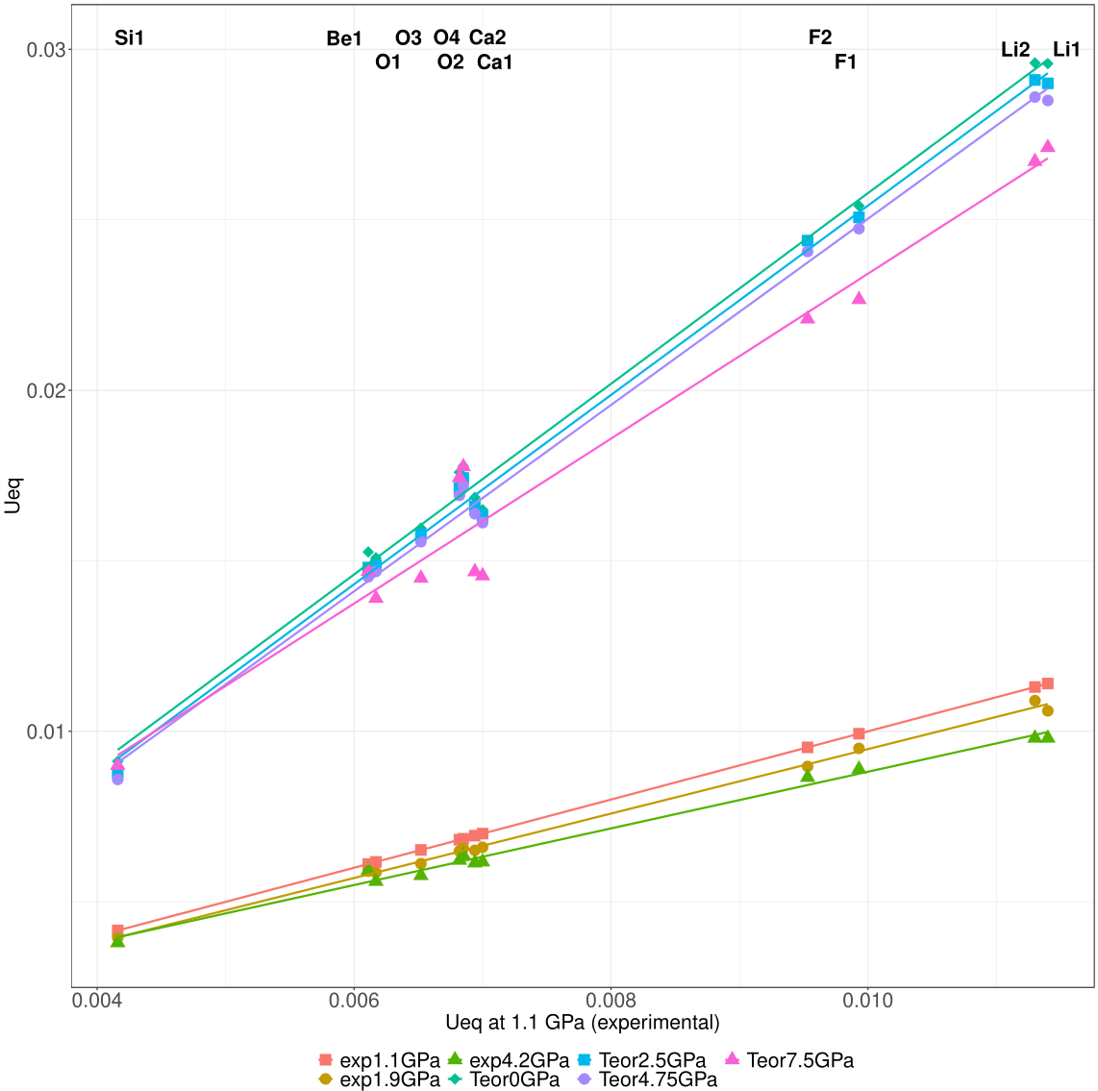
Figure S2. The equivalent isotropic values (Ueq) of displacement parameters for all atoms plotted vs. Ueq at 1.1 GPa. The points are presented for atoms in the following order starting from left: Si1, Be1, O1, O3, O4, O2, Ca2, Ca1, F2, F1, Li2, Li1.

Atomic nasins overlay and visualisations of differences in the total electron densities of the central ions in hsianghualite 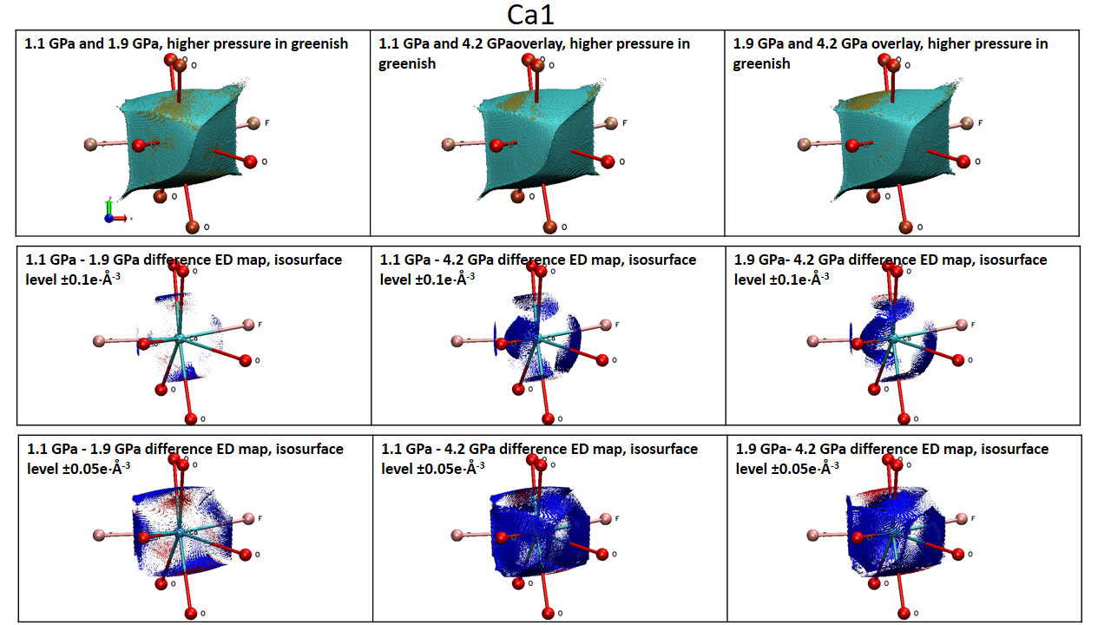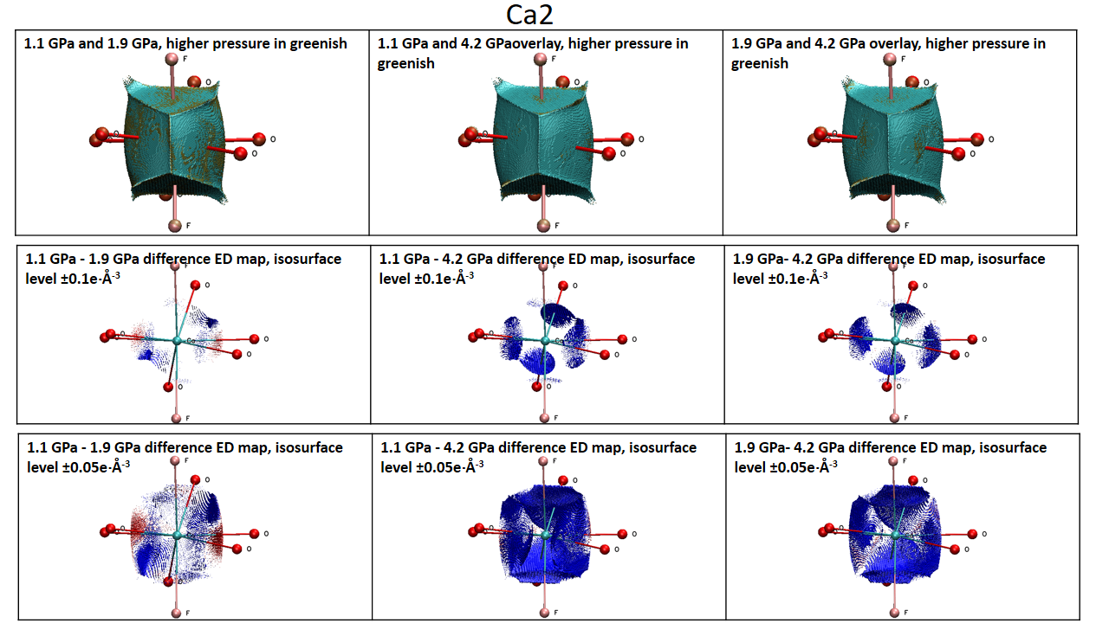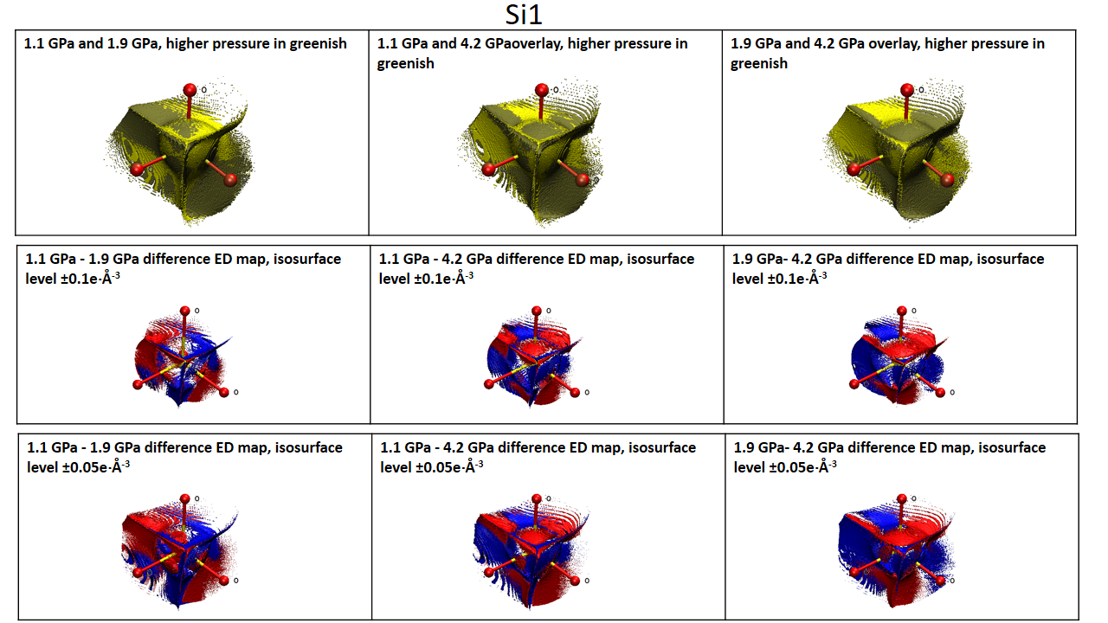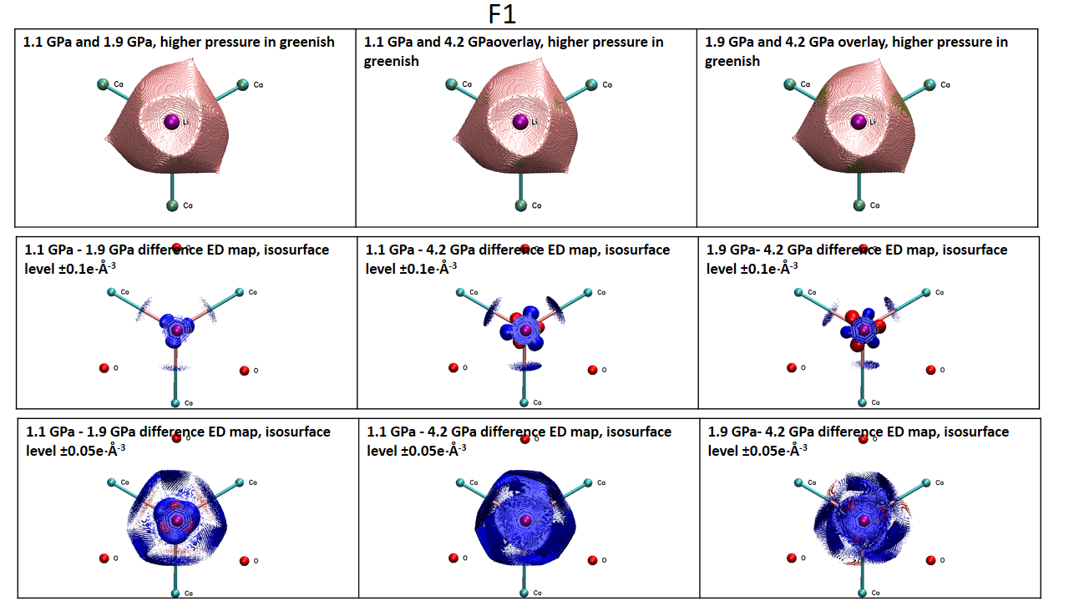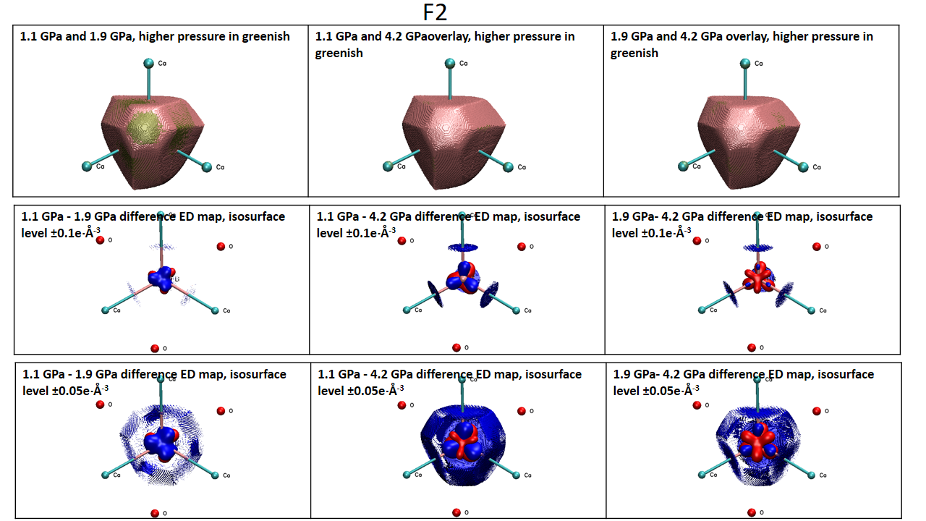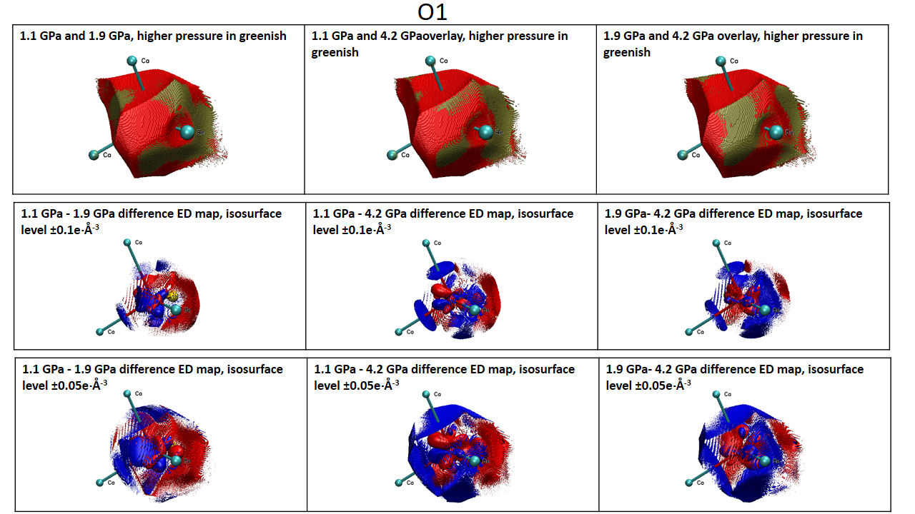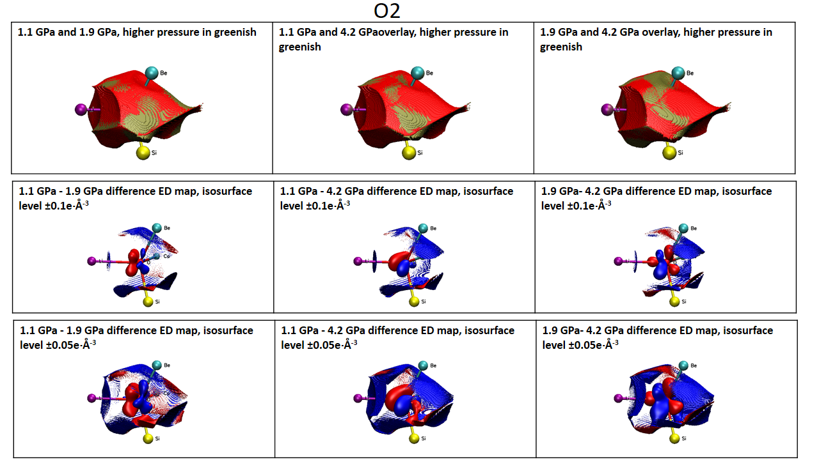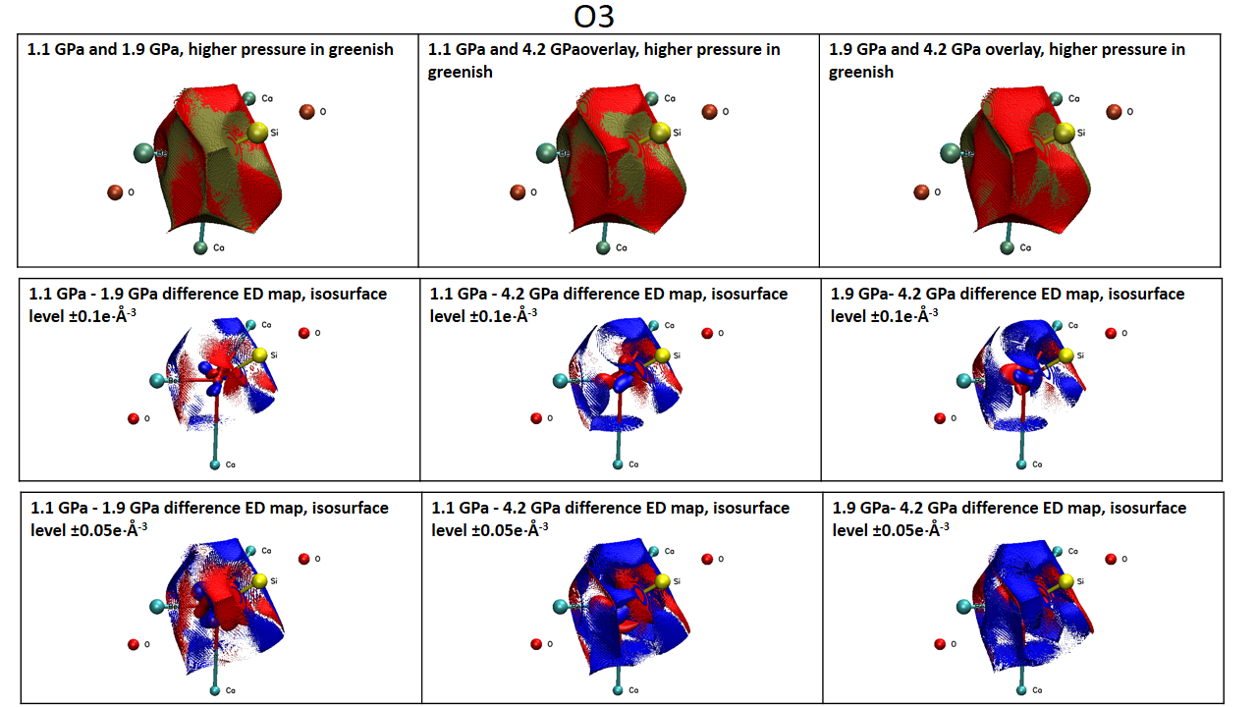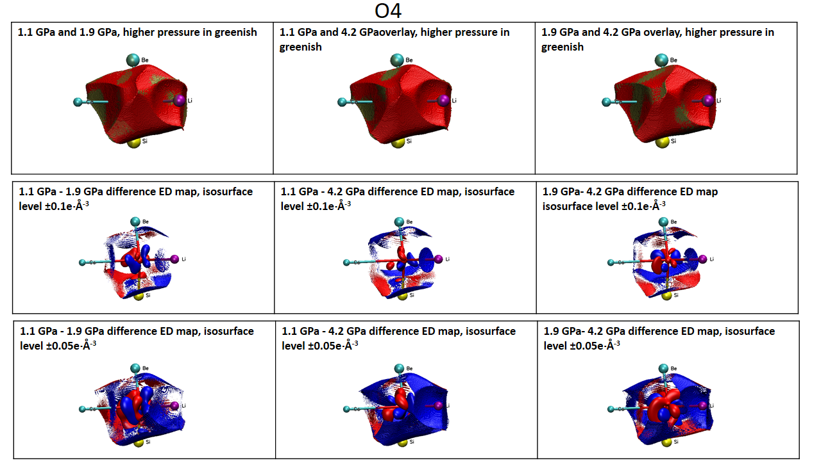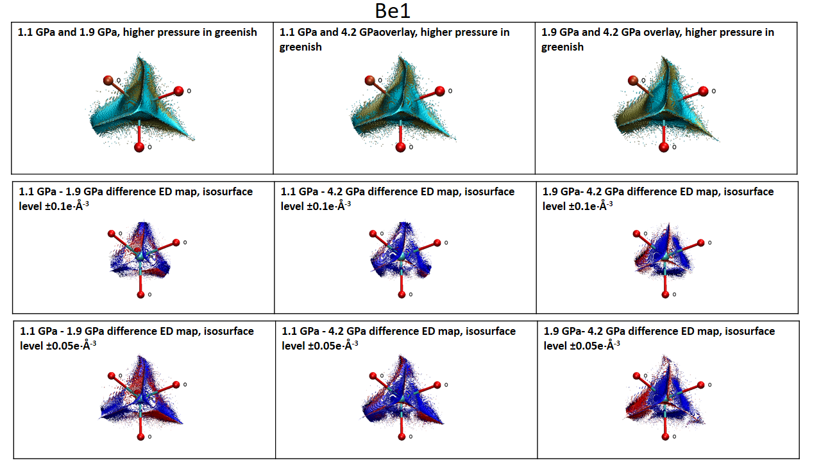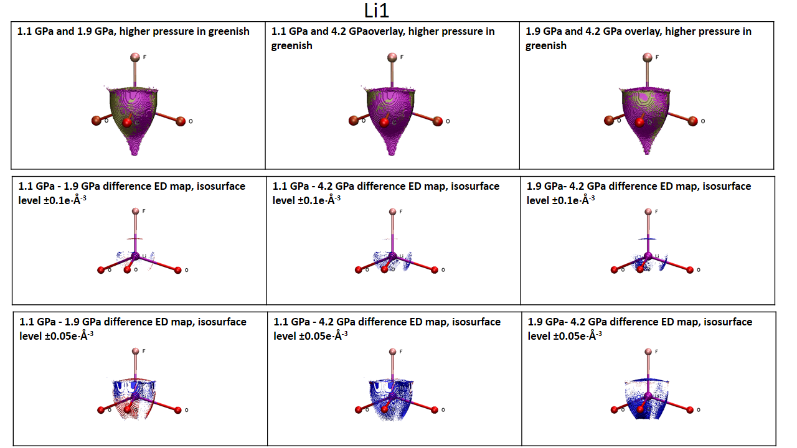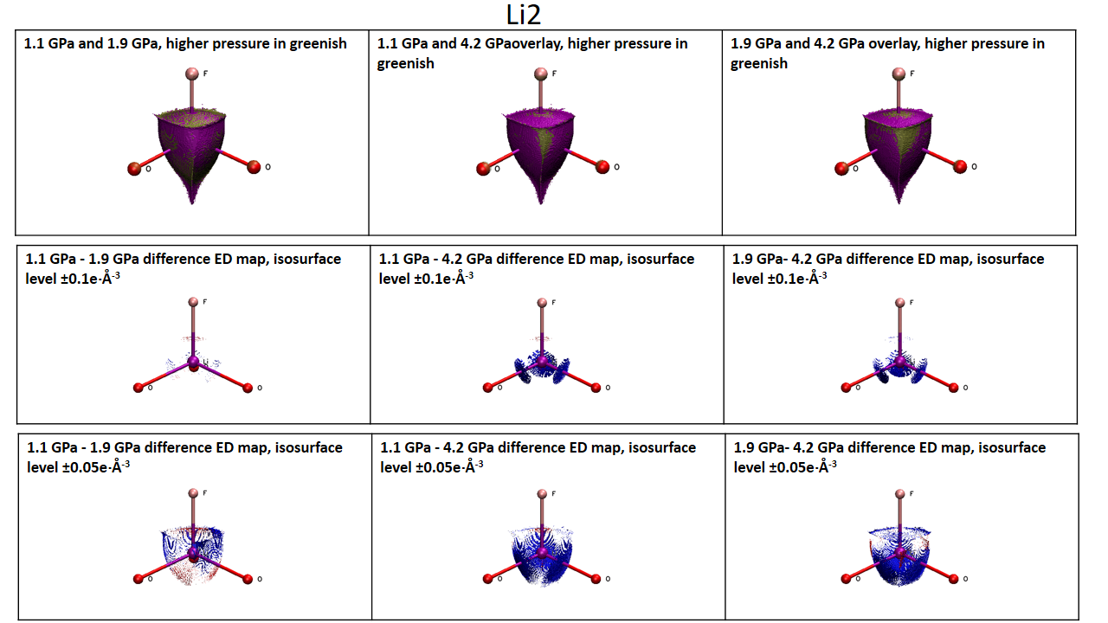

1. Hansen, N. K. & Coppens, P. Testing aspherical atom refinements on small-molecule data sets. Acta Crystallographica Section A: Crystal Physics, Diffraction, Theoretical and General Crystallography 34, 909–921 (1978).
2. Koritsanszky, T. S. & Coppens, P. Chemical applications of X-ray charge-density analysis. Chemical reviews 101, 1583–1628 (2001).
3. Su, Z. & Coppens, P. Nonlinear Least-Squares Fitting of Numerical Relativistic Atomic Wave Functions by a Linear Combination of Slater-Type Functions for Atoms with Z = 1–36. Acta Crystallographica Section A Foundations of Crystallography 54, 646–652 (1998).
4. Bianchi, R., Forni, A. & Oberti, R. Multipole-refined charge density study of diopside at ambient conditions. Phys Chem Minerals 32, 638–645 (2005).
5. Kuntzinger, S. & Ghermani, N. E. Electron density distribution and Madelung potential in α-spodumene, LiAl(SiO3)2, from two-wavelength high-resolution X-ray diffraction data. Acta Crystallographica Section B Structural Science 55, 273–284 (1999).
6. Kuntzinger, S., Dahaoui, S., Ghermani, N. E., Lecomte, C. & Howard, J. A. K. The use of CCD area detectors in charge-density research. Application to a mineral compound: the α-spodumene LiAl(SiO ₃ ) ₂. Acta Crystallographica Section B Structural Science 55, 867–881 (1999).
7. Ghermani, N. E., Lecomte, C. & Dusausoy, Y. Electrostatic properties in zeolite-type materials from high-resolution x-ray diffraction: The case of natrolite. Phys. Rev. B 53, 5231–5239 (1996).
8. Kuntzinger, S., Ghermani, N. E., Dusausoy, Y. & Lecomte, C. Distribution and Topology of the Electron Density in an Aluminosilicate Compound from High-Resolution X-ray Diffraction Data: the Case of Scolecite. Acta Crystallographica Section B Structural Science 54, 819–833 (1998).
9. Downs, J. W. & Gibbs, G. V. An exploratory examination of the electron density and electrostatic potential of phenakite. American Mineralogist 72, 769–777 (1987).
10. Tsirelson, V. G., Evdokimova, O. A., Belokoneva, E. L. & Urusov, V. S. Electron Density distribution and bonding in silicates. Physics and Chemistry of Minerals 17, 275–292 (1990).
11. Gibbs, G. V. et al. An Exploration of Theoretical and Experimental Electron Density Distributions and SiO Bonded Interactions for the Silica Polymorph Coesite. J. Phys. Chem. B 107, 12996–13006 (2003).
12. Kirfel, A., Krane, H. G., Blaha, P., Schwarz, K. & Lippmann, T. Electron-density distribution in stishovite, SiO2: a new high-energy synchrotron-radiation study. Acta Crystallogr., A, Found. Crystallogr. 57, 663–677 (2001).
13. Jiang, B., Zuo, J. M., Jiang, N., O’Keeffe, M. & Spence, J. C. H. Charge density and chemical bonding in rutile, TiO₂. Acta Crystallographica Section A Foundations of Crystallography 59, 341–350 (2003).
14. Restori, R., Schwarzenbach, D. & Schneider, J. R. Charge density in rutile, TiO ₂. Acta Crystallographica Section B Structural Science 43, 251–257 (1987).
15. Belokoneva, E. L., Gubina, Y. K. & Forsyth, J. B. The charge density distribution and antiferromagnetic properties of azurite Cu3[CO3]2(OH)2. Phys Chem Min 28, 498–507 (2001).
16. Restori, R. & Schwarzenbach, D. Charge density in cuprite, Cu ₂ O. Acta Crystallographica Section B Structural Science 42, 201–208 (1986).
17. Zuo, J. M., Kim, M., O’Keeffe, M. & Spence, J. C. H. Direct observation of d-orbital holes and Cu–Cu bonding in Cu2O. Nature 401, 49–52 (1999).
18. Ivanov, Yu. V., Belokoneva, E. L., Protas, J., Hansen, N. K. & Tsirelson, V. G. Multipole Analysis of the Electron Density in Topaz Using X-ray Diffraction Data. Acta Crystallographica Section B Structural Science 54, 774–781 (1998).
19. Ivanov, Yu. V. & Belokoneva, E. L. Multipole refinement and electron density analysis in natural borosilicate datolite using X-ray diffraction data. Acta Crystallographica Section B 63, 49–55 (2007).
20. Belokoneva, E. L., Gubina, Yu. K., Forsyth, J. B. & Brown, P. J. The charge-density distribution, its multipole refinement and the antiferromagnetic structure of dioptase, Cu6[Si6O18]·6H2O. Physics and Chemistry of Minerals 29, 430–438 (2002).
21. Hill, R. J. Crystal structure refinement and electron density distribution in diaspore. Physics and Chemistry of Minerals 5, 179–200 (1979).
22. Streltsov, V. A., Belokoneva, E. L., Tsirelson, V. G. & Hansen, N. K. Multipole analysis of the electron density in triphylite, LiFePO4, using X-ray diffraction data. Acta Crystallographica Section B: Structural Science 49, 147–153 (1993).
23. Maslen, E. N., Streltsov, V. A., Streltsova, N. R. & Ishizawa, N. Synchrotron X-ray study of the electron density in α-Fe2O3. Acta Crystallographica Section B: Structural Science 50, 435–441 (1994).
24. Gonschorek, W., Schmahl, W. W., Weitzel, H., Miehe, G. & Fuess, H. Anharmonic motion and multipolar expansion of the electron density in NaNO₃. Zeitschrift für Kristallographie-Crystalline Materials 210, 843–849 (1995).
25. Kirfel, A. & Gibbs, G. V. Electron density distributions and bonded interactions for the fibrous zeolites natrolite, mesolite and scolecite and related materials. Physics and Chemistry of Minerals 27, 270–284 (2000).
26. Pillet, S. et al. Recovering experimental and theoretical electron densities in corundum using the multipolar model: IUCr multipole refinement project. Acta Crystallographica Section A: Foundations of Crystallography 57, 290–303 (2001).
27. Merli, M., Pavese, A. & Ranzini, M. Study of the electron density in MgO,(Mg_{0. 963}Fe_{0. 037})O and Cu₂O by the maximum entropy method and multipole refinements: comparison between methods. Physics and chemistry of minerals 29, 455–464 (2002).
28. Kirfel, A. et al. Electron density distribution and bond critical point properties for forsterite, Mg₂SiO₄, determined with synchrotron single crystal X-ray diffraction data. Physics and chemistry of minerals 32, 301–313 (2005).
29. Kurylyshyn, I. M. et al. Probing the Zintl–Klemm concept: a combined experimental and theoretical charge density study of the Zintl phase CaSi. Angewandte Chemie International Edition 53, 3029–3032 (2014).
30. Stachowicz, M., Malinska, M., Parafiniuk, J. & Woźniak, K. Experimental observation of charge-shift bond in fluorite CaF₂. Acta Crystallographica Section B Structural Science, Crystal Engineering and Materials 73, 643–653 (2017).
31. Nelyubina, Y. V., Korlyukov, A. A., Lyssenko, K. A. & Fedyanin, I. V. Transferable Aspherical Atom Modeling of Electron Density in Highly Symmetric Crystals: A Case Study of Alkali-Metal Nitrates. Inorganic Chemistry 56, 4688–4696 (2017).
32. Gajda, R. et al. Experimental charge density of grossular under pressure – a feasibility study. IUCrJ 7, (2020).
33. Hirshfeld, F. L. Bonded-atom fragments for describing molecular charge densities. Theoret. Chim. Acta 44, 129–138 (1977).
34. Bader, R. F. W. Atoms in Molecules: A Quantum Theory. (Clarendon Press, 1994).
35. Popelier, P. L. A. Integration of atoms in molecules: a critical examination. Molecular Physics 87, 1169–1187 (1996).
36. Gatti, C. Chemical bonding in crystals: new directions. Zeitschrift für Kristallographie - Crystalline Materials 220, 399–457 (2005).
37. Coppens, P. et al. Net atomic charges and molecular dipole moments from spherical-atom X-ray refinements, and the relation between atomic charge and shape. Acta Crystallographica Section A: Crystal Physics, Diffraction, Theoretical and General Crystallography 35, 63–72 (1979).
38. Ángyán, J. G., Jansen, G., Loss, M., Hättig, C. & Heß, B. A. Distributed polarizabilities using the topological theory of atoms in molecules. Chemical Physics Letters 219, 267–273 (1994).
39. Dominiak, P. M. et al. Continua of interactions between pairs of atoms in molecular crystals. Chemistry–A European Journal 12, 1941–1949 (2006).
40. Pauling, L. The principles determining the structure of complex ionic crystals. Journal of the american chemical society 51, 1010–1026 (1929).
41. Brown, I. D. The Chemical Bond in Inorganic Chemistry: The Bond Valence Model. (International Union of Crystallography Monographs on Crystallography 12, 2001).

