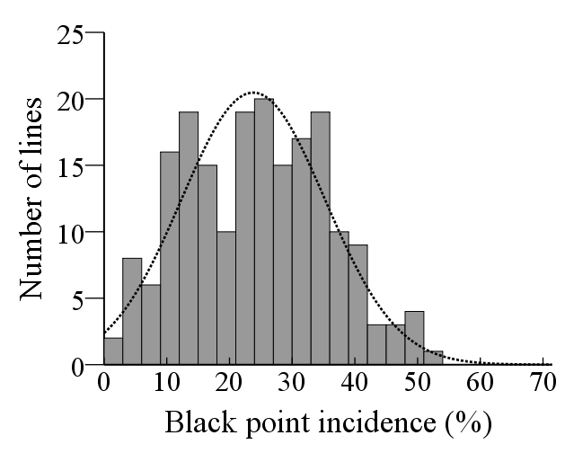
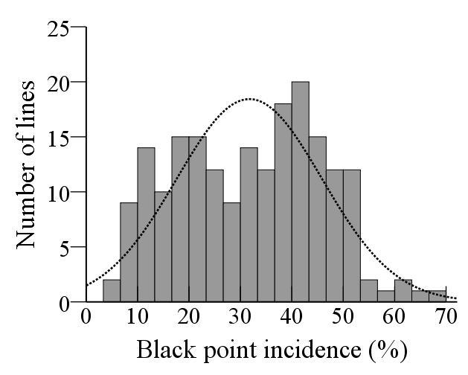
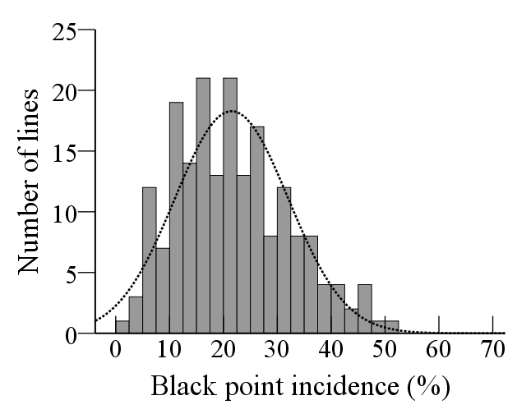
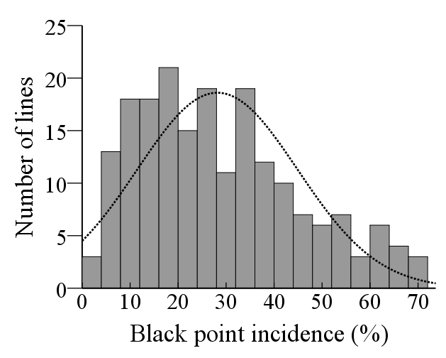
a b
c d
Mean = 23.8
S. D. = 11.4
N = 196

Mean = 28.1
S. D. = 16.7
N = 196

Mean = 21.5
S. D. = 10.7
N = 196

Mean = 31.7
S. D. = 14.1
N = 196

R
S
R
S
R
S
S
R

Fig. S1 Histograms of black point incidence in PZSCL6 / Yuyou1 RIL population inoculated with Bipolaris sorokiniana at four environments
(a) Xingyang 2020; (b) Xingyang 2021; (c) Neihuang 2021; (d) Shangshui 2021. Incidence of slightly susceptible (Yuyou 1) and highly susceptible (PZSCL6) parents is indicated by the arrows R and S, respectively.

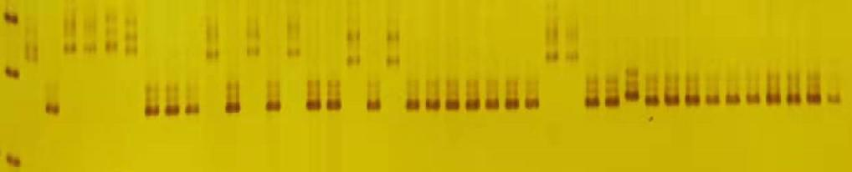
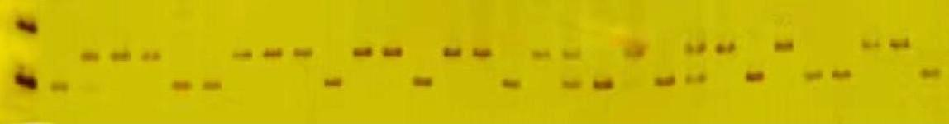
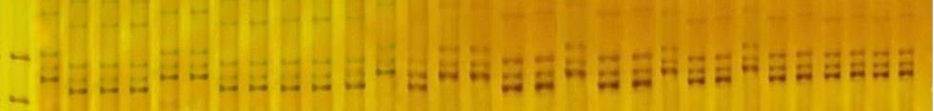
200 bp
150 bp
M R S 1 2 3 4 5 6 7 8 9 10 11 12 13 14 15 16 17 18 19 20 21 22 23 24 25 26 27 28
a
250 bp
200 bp

M R S 1 2 3 4 5 6 7 8 9 10 11 12 13 14 15 16 17 18 19 20 21 22 23 24 25 26 27 28
c
500 bp
400 bp

M R S 1 2 3 4 5 6 7 8 9 10 11 12 13 14 15 16 17 18 19 20 21 22 23 24 25 26 27 28
b

Fig. S2 PCR amplification profiles of polymorphic SSR markers Xwmc654 (a), Xgwm174 (b) and dCAPS marker BP-5B-d12 (c) in some RILs from cross PZSCL6 / Yuyou1 RIL population
M, DNA ladder; R and S, slightly susceptible and highly susceptible parent, respectively; lanes 1–28, lines from the RIL population. Arrows indicate polymorphic DNA fragments between the slightly susceptible and highly susceptible parents.

