Appendix 1:
To understand the application of HYBRID, the basics of BEM formulation will be noted here:
The governing equation for an elastic, isotropic, and homogeneous body with a small amplitude displacement field can be written as:
(1)
In which, $u_{i}$denotes the displacement and $b_{i}$is body force. $c_{1 }$and $c_{2 }$represent the compressional and shear wave velocities, respectively. The corresponding governing boundary integral equation for an elastic, isotropic, homogeneous body can be obtained using the well-known weighted residual method (Brebbia and Dominguez 1994) as:
(2)
$G_{ij}$and $F_{ij}$ are the fundamental solutions of displacement and tractions, which, respectively, represent the displacements and tractions at a point x at time t due to a unit point force applied at ξ and the preceding time τ ≤ t. The terms $G_{ij}* t_{i}$and $F_{ij}* u_{i}$are related to the Riemann convolution integrals. $t_{i}$ is traction and $c_{ij }$ shows the well-known discontinuity term due to the singularity of the${ F}_{ij}$ fundamental solutions. In the case of seismic loading,
assuming that the total displacement can be split into the incident ${(u}_{i}^{inc})$and scattered ${(u}_{i}^{sc})$components, the above-mentioned governing boundary integral equation should be modified as follows (Kawase 1988; Hadley et al. 1989) :
(3)
In order to implement the mentioned formulation, approximation in both temporal and spatial variations of the field variables is needed. For temporal integration, the time axis is divided into N equal steps, which means the total time would be equal to T=N.Δt, using a linear time variation of the field variables, the displacements and tractions can be defined as:
u_{i} (x,τ)=M₁ (τ) u_{i}^{n} (x)+M₂ (τ) u_{i} ^{(n-1)} (x) (4)
t_{i} (x,τ)=M₁ (τ) t_{i}^{n} (x)+M₂ (τ) t_{i} ^{(n-1)} (x) (5)
where M₁ (τ) and M₂ (τ) are linear temporal shape functions given by:
T _{(n-1)} <τ< T_{n}
M₁ (τ)= (τ-T _{(n-1)})/Δt , M₂ (τ)=(T_{n-τ})/Δt (6)
1 and 2 refer to the forward and backward temporal nodes, respectively, during a time step. Thus, the time integration involves only the kernels and is expressed by:
$G_{ij1}^{N+1-n}=\int_{\left(n-1\right)Δt}^{nΔt}{G_{ij}\left(r.t-τ\right)M_{1}\left(τ\right)dt}$ (7)
$G_{ij2}^{N+1-n}=\int_{(n-1)Δt}^{nΔtSubscripts }{G_{ij}\left(r.t-τ\right)M_{2}\left(τ\right)dt}$ (8)
Combining this and a similar expression for the $F$ kernels in Eq. (2), after spatial discretization and some rearrangements, the convoluted BEM equation for linear temporal variation could be written as:
$c_{ij}u_{i}^{N}\left(ξ\right)=\sum_{n=1}^{N}{\sum_{q=1}^{Q}{\left\{\begin{aligned} \\ T_{ik}^{n}\int_{Γ_{q}}^{ }{G_{ij}^{N+1-n}\left(r\right)L_{k}dΓ_{q}-} \\ U_{ik}^{n}\int_{Γ_{q}}^{ }{F_{ij}^{N+1-n}\left(r\right)L_{k}dΓ_{q}+u_{j}^{inc}(ξ.t)} \\ \end{aligned}\right.}}$ $(9)$
In which
$G_{ij}^{N+1-n}\left(r\right)=G_{ij1}^{N+1-n}\left(r\right)+G_{ij2}^{N-n}\left(r\right)$ (10)
$F_{ij}^{N+1-n}\left(r\right)=F_{ij1}^{N+1-n}\left(r\right)+F_{ij2}^{N-n}\left(r\right)$ (11)
N denotes the last time step, Q shows the total number of boundary elements and L represents the interpolation function of a boundary element. $G_{ij}^{N+1-n}\left(r\right)$and $F_{ij}^{N+1-n}\left(r\right)$are the elasto-dynamic displacement and traction kernels, respectively, derived upon their corresponding fundamental solutions $F_{ij}$ and $G_{ij}$, presented in (Kamalian et al. 2003a)
By sequentially writing Eq. (9) for each boundary node at time $t+Δt$and by transferring all known terms to the right side, the assembled system of equation takes the following matrix form:
$F^{1}.U^{N}=G^{1}.T^{N}+Z^{N}$ (12)
$Z^{N}=\sum_{n=1}^{N-1}{(}G_{ }^{N+1-n}.T^{N}-F_{ }^{N+1-n}.U^{N})+U^{{inc}^{N}}$ (13)
U^{N} and T^{N} denote the nodal displacement and traction vectors at the current time node, respectively. Z^{N} includes both effects of the past dynamic history and of the incident motion on the current time node. It should be mentioned that the spatial integrals in Equations 12 and 13 could be performed easily using the Gaussian normal quadrature rule, provided an intelligent sub segmentation with suitable mapping is adopted to make the kernel-shape Function-Jacobian product well behaved over each sub-segment. Strongly singular blocks in F1 could be evaluated indirectly using the concept of rigid body motion (Brebbia and Dominguez 1994). As this technique is valid only for problems with closed boundaries, the unbounded boundaries of half-plane problems should be enclosed with fictitious ones named as enclosing elements (Ahmad and Banerjee 1988; Israil and Banerjee 1990).
The mentioned BEM formulation has been applied in a general-purpose two-dimensional linear/nonlinear code, named as HYBRID,(Kamalian et al. 2006). To assess the accuracy and efficiency of this BE algorithm in analyzing the seismic behavior of topographic structures, several examples including site response analysis of half-plane, horizontally layered sites, canyons, alluvial valleys, and ridge sections subjected to incident P and SV waves have been solved (Kamalian et al. 2007b, 2008).
The incident wave has been considered to be vertically propagating SV waves of Ricker wave type (Figure.1) which could be defined with the following equation:
(14)
In this equation fp is the predominant frequency and t0 is an appropriate time shift parameter. In the case of SV waves, f(t) designates the horizontal component of the incident motion while the vertical component is zero. The maximum amplitude of the incident motion is defined to be 0.001m, however the results are valid in all range of linear behavior of the environment.

Appendix 2:

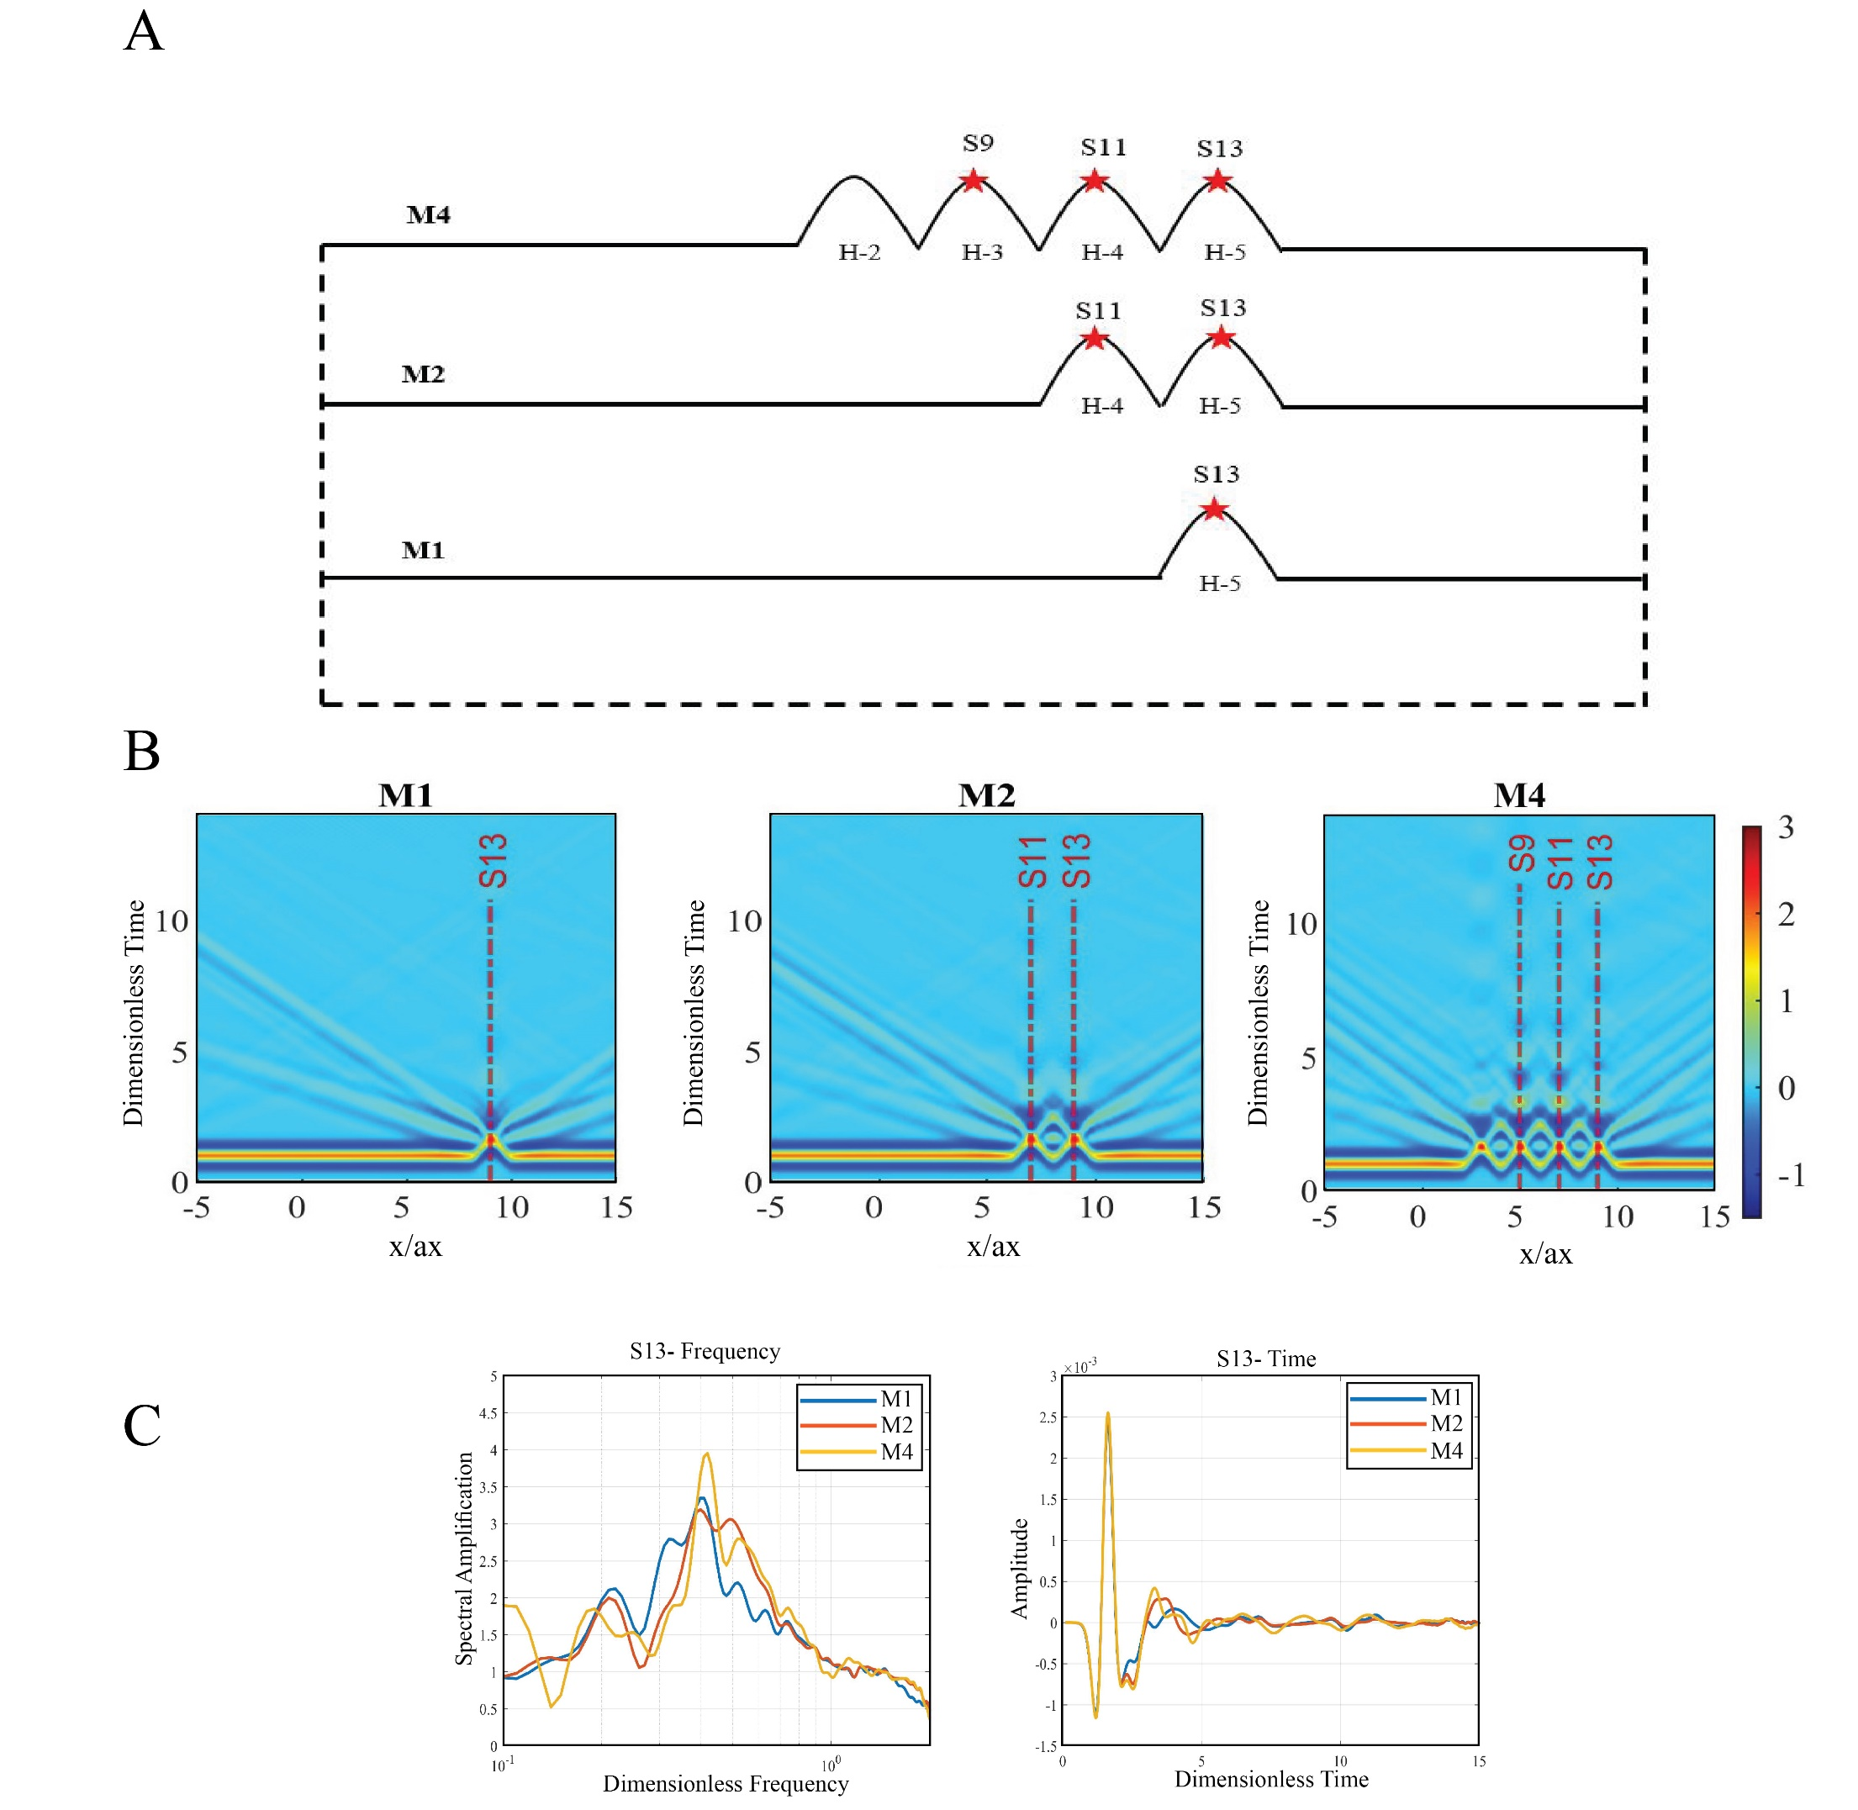
Fig A-1 A) schematic geometry of Model M1, M2, and M4, B) Seismic responses of models M1, M2, and M4 in time domain, C) Spectral amplification and Time duration of S13 in M1, M2, and M4

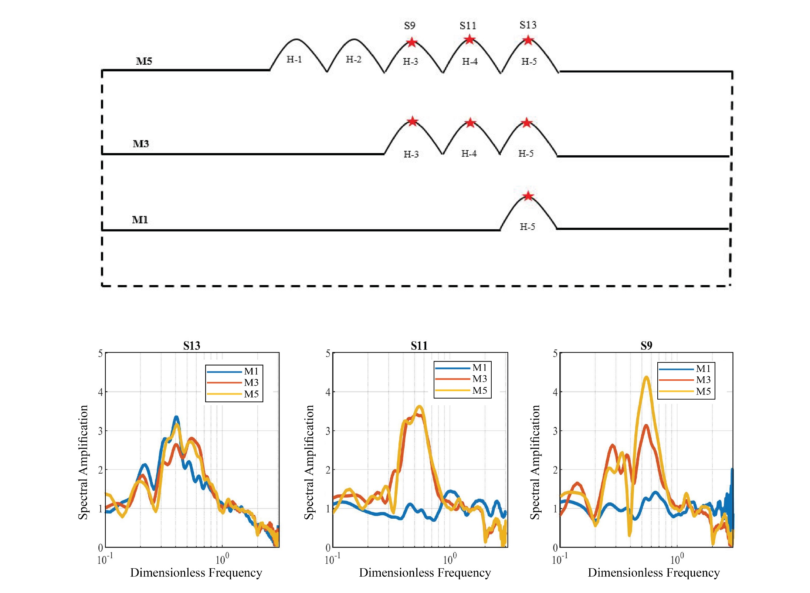
Fig A-2 Schematic geometry of M1, M3, and M5, and Compare the spectral amplification and frequency content of S13, S11, and S9 in three model M1, M3, M5

