Additional File 1
Supporting Information

Silica-coated magnetic nanoparticles activate microglia and induce neurotoxic D-serine secretion

Tae Hwan Shin^{1#}, Da Yeon Lee^{1#}, Balachandran Manavalan¹, Shaherin Basith¹, Yun-Cheol Na², Cheolho Yoon³, Hyeon-Seong Lee⁴, Man Jeong Paik⁴, Gwang Lee^{1,5*}

¹Department of Physiology, Ajou University School of Medicine, Suwon, Republic of Korea
²Western Seoul Center, Korea Basic Science Institute, Seoul, Republic of Korea
³Seoul Center, Korea Basic Science Institute, Seoul, Republic of Korea
⁴College of Pharmacy, Sunchon National University, Suncheon, Republic of Korea
⁵Department of Molecular Science and Technology, Ajou University, Suwon, Republic of Korea

#These authors contributed equally to this work.

*Corresponding author: Gwang Lee
Professor, Department of Physiology
Ajou University School of Medicine, World cup-ro,
Yeongtong-gu, Suwon, 16499, Republic of Korea.
Tel : +82-31-219-4554
Fax: +82-31-219-5049
E-mail : glee@ajou.ac.kr
Supplementary Tables
Supplementary Table 1. Quantitative real-time PCR primer sequences for genes encoding transcriptomic network related genes
Gene Name | Symbol | NCBI Ref. seq | Direction | Primer sequence (5’-3’)
chemokine (C-C motif) receptor 1 | Ccr1 | BC011092.1 | Forward | GAAGCCTACCCCACAACTAC
chemokine (C-C motif) receptor 1 | Ccr1 | BC011092.1 | Reverse | AGAATCACTAGGACATTGCCC
chemokine (C-X-C motif) ligand 3 | Cxcl3 | BC117014.1 | Forward | TTTGAGACCATCCAGAGCTTG
chemokine (C-X-C motif) ligand 3 | Cxcl3 | BC117014.1 | Reverse | CCTTGAGAGTGGCTATGACTTC
formyl peptide receptor 1 | Fpr1 | NM_013521.2 | Forward | TCATATCCACAATCCAAGTCCG
formyl peptide receptor 1 | Fpr1 | NM_013521.2 | Reverse | GTCTTTCTCTGAAGTCCTGGC
serine (or cysteine) peptidase inhibitor, clade F, member 1 | Serpinf1 | BC019852.1 | Forward | ACATCCACAGCACCTACAAG
serine (or cysteine) peptidase inhibitor, clade F, member 1 | Serpinf1 | BC019852.1 | Reverse | ATTCTGGAAGCACTCTTGAGG
glyceraldehyde-3-phosphate dehydrogenase | Gapdh | NM_001289726.1 | Forward | GAAGACTGTGGATGGCCC
glyceraldehyde-3-phosphate dehydrogenase | Gapdh | NM_001289726.1 | Reverse | CCATGCCAGTGAGCTTCC
Ref. seq.: Reference sequence
Supplementary Table 2. Quantitative real-time PCR primer sequences for genes encoding combined transcriptome and amino acid profiles network related genes
Gene Name | Symbol | NCBI Ref. seq | Direction | Primer sequence (5’-3’)
aryl-hydrocarbon receptor | Ahr | BC040248.1 | Forward | TCCCAGAAACCTCCACAATG
aryl-hydrocarbon receptor | Ahr | BC040248.1 | Reverse | TGCAGCGTAATGGACATAGG
cystathionine beta-synthase (-like protein) | Cbs/Cbsl | BC013480.1 | Forward | GAGTATGGAGAAGGTGGATGTG
cystathionine beta-synthase (-like protein) | Cbs/Cbsl | BC013480.1 | Reverse | GGGAATCAAATCTGGCATTGG
130 kDa myosin light chain kinase | Mylk | AY237727.2 | Forward | AGAGAAACCTGAAGAGCCAAAG
130 kDa myosin light chain kinase | Mylk | AY237727.2 | Reverse | AATTTCCCAGATCCTAGTCGC
solute carrier family 1 (glutamate/neutral amino acid transporter), member 4 | Sls1a4 | BC043483.1 | Forward | ACCTGTTCCCTTCCAATCTTG
 | Sls1a4 | BC043483.1 | Reverse | TGTTCATCCCTTCCACATCTG
solute carrier family 6 (neurotransmitter transporter, glycine), member 9 | Sls6a9 | BC021828.1 | Forward | CATCTATGGGCACCGTAACTAC
 | Sls6a9 | BC021828.1 | Reverse | CTGGATCACCGTGAAGATGAG
glyceraldehyde-3-phosphate dehydrogenase | Gapdh | NM_001289726.1 | Forward | GAAGACTGTGGATGGCCC
glyceraldehyde-3-phosphate dehydrogenase | Gapdh | NM_001289726.1 | Reverse | CCATGCCAGTGAGCTTCC
Ref. seq.: Reference sequence

Supplementary Table 3. Ingenuity Pathway Analysis-based profiles of transcriptome of BV2 cells treated with MNPs@SiO₂(RITC)
Entrez gene name | Symbol | Location | Signal fold changeª
Entrez gene name | Symbol | Location | 0.01 μg/μl | 0.1 μg/μl
ATP binding cassette subfamily D member 2 | ABCD2 | Cytoplasm | 1.00 | -2.04
arginase 1 | ARG1 | Cytoplasm | 1.00 | -1.84
complement C1q A chain | C1QA | Extracellular Space | 1.00 | -2.20
C-C motif chemokine ligand 2 | CCL2 | Extracellular Space | 1.00 | 2.45
C-C motif chemokine receptor 1 | CCR1 | Plasma Membrane | 1.00 | 1.67
CD83 molecule | CD83 | Plasma Membrane | 1.00 | -2.35
C-type lectin domain family 12 member A | CLEC12A | Plasma Membrane | 1.00 | -1.67
ceruloplasmin (ferroxidase) | CP | Extracellular Space | 1.00 | -3.92
colony stimulating factor 3 | CSF3 | Extracellular Space | 1.00 | 2.25
colony stimulating factor 3 receptor | CSF3R | Plasma Membrane | 1.00 | -1.57
C-X-C motif chemokine ligand 10 | CXCL10 | Extracellular Space | 1.00 | 1.53
C-X-C motif chemokine ligand 3 | CXCL3 | Extracellular Space | 1.68 | 2.64
cytochrome P450 family 11 subfamily A member 1 | CYP11A1 | Cytoplasm | 1.00 | 2.10
DNA damage inducible transcript 4 | DDIT4 | Cytoplasm | 1.00 | -2.13
FosB proto-oncogene, AP-1 transcription factor subunit | FOSB | Nucleus | 0.74 | -2.19
formyl peptide receptor 1 | FPR1 | Plasma Membrane | 1.00 | -4.08
glycerol-3-phosphate acyltransferase 3 | GPAT3 | Cytoplasm |  | 1.56
G protein-coupled receptor 183 | GPR183 | Plasma Membrane | 1.00 | -1.62
haptoglobin | HP | Extracellular Space | 1.00 | -2.62
interleukin 1 receptor type 1 | IL1R1 | Plasma Membrane | 1.17 | -2.01
interleukin 1 receptor antagonist | IL1RN | Extracellular Space | 1.00 | 1.66
integrin subunit alpha L | ITGAL | Plasma Membrane | 1.00 | -2.20
notch 1 | NOTCH1 | Plasma Membrane | 1.00 | -1.72
nuclear protein 1, transcriptional regulator | NUPR1 | Nucleus | 1.00 | -1.87
purinergic receptor P2Y13 | P2RY13 | Plasma Membrane | 1.16 | -2.08
PR domain 1 | PRDM1 | Nucleus | 1.12 | -1.51
Rab interacting lysosomal protein | RILP | Cytoplasm | 1.35 | 1.88
serpin family F member 1 | SERPINF1 | Extracellular Space | 1.08 | -1.56
sialic acid binding Ig like lectin 9 | SIGLEC9 | Plasma Membrane | 1.00 | -1.95
solute carrier family 13 member 3 | SLC13A3 | Plasma Membrane | 1.02 | -1.75
solute carrier family 36 member 2 | SLC36A2 | Plasma Membrane | 1.00 | -2.50
thromboxane A synthase 1 | TBXAS1 | Plasma Membrane | 1.06 | -1.56
toll-like receptor 12 | TLR12 | Other | -1.80 | -2.36
TNF receptor superfamily member 4 | TNFRSF4 | Plasma Membrane | 1.65 | 1.77
tribbles pseudokinase 3 | TRIB3 | Nucleus | 1.00 | -1.64
thioredoxin interacting protein | TXNIP | Cytoplasm | 1.00 | 1.66
ªNormalized signal fold change of signal in treated groups with MNPs@SiO₂(RITC) to corresponding signal of in control group
Supplemenatary Table 4. Amino acid amount in cell mass of MNPs@SiO₂(RITC)-treated BV2 cells
 |  | amount (ng/4 × 10⁵ cells, ± standard deviation)ª
 |  |  | MNPs@SiO₂(RITC)-treated group (n = 3) |  |  | Ratio value^{e}
No. | Analyte | Control  (n = 3) | 0.01 µg/µl | 0.1 µg/µl | p value^{d} | 0.01 µg/µl | 0.1 µg/µl
1 | Alanine | 44.7 ± 3.0 | 48.7 ± 5.1 (0.547)^{b} | 51.5 ± 5.1 (0.232)^{c} | 0.745 | 1.09 | 1.15
2 | Glycine | 80.8 ± 5.1 | 80.9 ± 10.7 (1.000) | 80.3 ± 5.0 (0.996) | 0.995 | 1.00 | 0.99
3 | Valine | 14.8 ± 0.8 | 15.1 ± 0.6 (0.962) | 17.4 ± 1.6 (0.065) | 0.092 | 1.02 | 1.17
4 | Leucine | 20.8 ± 0.7 | 20.5 ± 0.2 (0.922) | 25.0 ± 1.7 (0.007) | 0.005 | 0.98 | 1.20
5 | Isoleucine | 18.2 ± 0.8 | 18.5 ± 0.4 (0.972) | 22.1 ± 2.6 (0.059) | 0.078 | 1.02 | 1.21
6 | Proline | 51.2 ± 3.5 | 54.5 ± 5.7 (0.621) | 46.9 ± 2.4 (0.446) | 0.137 | 1.06 | 0.91
7 | Pyroglutamic acid | 189.2 ± 12.8 | 168.6 ± 27.7 (0.422) | 120.9 ± 10.9 (0.010) | 0.047 | 0.89 | 0.64
8 | 4-Hydroxyproline | 1.5 ± 0.3 | 1.9 ± 0.3 (0.140) | 1.6 ± 0.1 (0.679) | 0.405 | 1.25 | 1.06
9 | Serine | 28.6 ± 4.3 | 36.9 ± 11.9 (0.480) | 40.4 ± 6.5 (0.262) | 0.863 | 1.29 | 1.41
10 | Threonine | 18.8 ± 3.7 | 55.4 ± 57.0 (0.448) | 41.8 ± 17.8 (0.709) | 0.882 | 2.94 | 2.22
11 | r-Aminobutric acid | 6.3 ± 0.9 | 6.9 ± 1.5 (0.881) | 6.7 ± 1.8 (0.948) | 0.984 | 1.09 | 1.06
12 | Phenylalanine | 12.4 ± 0.1 | 12.0 ± 0.8 (0.616) | 14.8 ± 0.3 (0.003) | 0.001 | 0.97 | 1.19
13 | Cysteine | 6.2 ± 1.2 | 6.9 ± 0.6 (0.771) | 10.4 ± 1.6 (0.013) | 0.029 | 1.11 | 1.67
14 | Aspartic acid | 65.1 ±5.5 | 82.8 ± 10.4 (0.205) | 86.5 ± 15.3 (0.124) | 0.917 | 1.27 | 1.33
15 | Glutamic acid | 145.1 ± 8.8 | 171.6 ± 35.1 (0.505) | 171.5 ± 31.0 (0.508) | 1.000 | 1.18 | 1.18
16 | Asparagine | 60.9 ± 19.4 | 117.9 ± 46.5 (0.174) | 141.7 ± 28.7 (0.058) | 0.677 | 1.94 | 2.33
17 | Glutamine | 11.5 ± 1.7 | 17.5 ± 2.7 (0.339) | 25.7 ± 7.5 (0.024) | 0.161 | 1.51 | 2.22
18 | Lysine | 39.9 ± 6.1 | 55.3 ± 8.7 (0.275) | 101.9 ± 15.9 (0.001) | 0.005 | 1.39 | 2.56
19 | Tryptophane | 8.2 ± 1.1 | 12.5 ± 2.3 (0.327) | 19.5 ± 5.3 (0.016) | 0.103 | 1.53 | 2.38
ªValues as each analyte amount (ng/4 × 10⁵ cells). ^{b}One way ANOVA comparing the mean values of control group and treated group with MNPs@SiO₂(RITC) of 0.01 μg/μl. ^{c}One way ANOVA comparing the mean values of control group and treated group with MNPs@SiO₂(RITC) of 0.1 μg/μl. ^{d}One way ANOVA comparing the mean values of group with MNPs@SiO₂(RITC) of 0.01 μg/μl and treated group with MNPs@SiO₂(RITC) of 0.1 μg/μl. ^{e}Ratio values of analyte in treated groups with MNPs@SiO₂(RITC) to corresponding mean values in the control group.

Supplementary Table 5. Ingenuity Pathway Analysis-based profiles of transcriptome and amino acids of BV2 cells treated with MNPs@SiO₂(RITC)
Entrez gene name | Symbol | Location | Signal fold changeª
Entrez gene name | Symbol | Location | 0.01 μg/μl | 0.1 μg/μl
aryl hydrocarbon receptor | AHR | Nucleus | 2.22 | 3.46
cystathionine-beta-synthase | CBS/CBSL | Cytoplasm | 2.06 | 2.79
growth hormone inducible transmembrane protein | GHITM | Cytoplasm | -1.04 | -1.26
G protein-coupled receptor kinase 1 | GRK1 | Plasma Membrane | 6.23 | 2.04
mitogen-activated protein kinase 10 | MAPK10 | Cytoplasm | -1.01 | 3.25
myosin light chain kinase | MYLK | Cytoplasm | 1.28 | 1.30
purinergic receptor P2Y12 | P2RY12 | Plasma Membrane | -1.27 | -1.39
purinergic receptor P2Y13 | P2RY13 | Plasma Membrane | 1.08 | -2.08
phosphoenolpyruvate carboxykinase 2, mitochondrial | PCK2 | Cytoplasm | -1.06 | -1.77
serine incorporator 2 | SERINC2 | Plasma Membrane | -2.46 | -4.72
serum/glucocorticoid regulated kinase 1 | SGK1 | Cytoplasm | -1.05 | -1.45
solute carrier family 1 member 4 | SLC1A4 | Plasma Membrane | -1.03 | -1.52
solute carrier family 36 member 2 | SLC36A2 | Plasma Membrane | -1.06 | -2.50
solute carrier family 39 member 4 | SLC39A4 | Plasma Membrane | 1.01 | -1.31
solute carrier family 6 member 9 | SLC6A9 | Plasma Membrane | 1.01 | -1.40
SRC proto-oncogene, non-receptor tyrosine kinase | SRC | Cytoplasm | 1.04 | 1.42
teneurin transmembrane protein 1 | TENM1 | Plasma Membrane | 2.03 | 2.04
 | asparagine | Other | 1.93 | 2.46
 | aspartic acid | Other | 1.27 | 1.31
 | cysteine | Other | 1.04 | 1.55
 | glutamine | Other | 1.47 | 2.07
 | lysine | Other | 1.28 | 2.31
 | serine | Other | 1.16 | 1.27
 | threonine | Other | 2.25 | 1.79
ªNormalized signal fold change of signal in treated groups with MNPs@SiO₂(RITC) to corresponding signal of in control group
Supplemenatary Table 6. Concentrations of secreted amino acids in media of MNPs@SiO₂(RITC)-treated BV2 cells
 |  | concentration (μg/ml, ± standard deviation)ª
 |  |  | MNPs@SiO₂(RITC)-treated group (n = 3) |  |  | Ratio value^{e}
No. | Analyte | Control  (n = 3) | 0.01 µg/µl | 0.1 µg/µl | p value^{d} | 0.01 µg/µl | 0.1 µg/µl
1 | Alanine | 46.93 ± 3.93 | 44.99 ± 1.79 (0.819)^{b} | 47.39 ± 3.83 (0.386)^{c} | 0.183 | 1.09 | 1.15
2 | Glycine | 44.44 ± 2.05 | 42.95 ± 1.47 (0.842) | 35.7 ± 2.86 (<0.001) | <0.001 | 0.97 | 0.80
3 | Valine | 22.35 ± 1.15 | 21.81 ± 0.95 (0.861) | 23.40 ± 0.70 (0.006) | 0.011 | 1.02 | 1.17
4 | Leucine | 22.89 ± 1.50 | 22.53 ± 1.51 (0.959) | 23.68 ± 1.09 (0.288) | 0.205 | 0.98 | 1.20
5 | Isoleucine | 52.86 ± 3.37 | 50.74 ± 2.46 (0.655) | 54.6 ± 1.28 (<0.001) | <0.001 | 1.02 | 1.21
6 | Proline | 24.37 ± 1.54 | 24.27 ± 0.98 (0.997) | 18.8 ± 0.16 (<0.001) | <0.001 | 1.00 | 0.77
7 | Pyroglutamic acid | 109.7 ± 3.58 | 109.6 ± 0.16 (1.000) | 110.7 ± 1.65 (0.180) | 0.174 | 0.89 | 0.64
8 | 4-Hydroxyproline | 0.08 ± 0.03 | 0.10 ± 0.01 (0.858) | 0.09 ± 0.01 (<0.001) | <0.001 | 1.25 | 1.06
9 | Serine | 0.90 ± 0.12 | 1.02 ± 0.10 (0.999) | 1.40 ± 0.24 (<0.001) | <0.001 | 1.14 | 1.56
10 | Threonine | 14.51 ± 1.25 | 17.15 ± 0.95 (0.948) | 18.80 ± 1.22 (0.040) | 0.059 | 1.18 | 1.29
11 | r-Aminobutric acid | 0.10 ± 0.03 | 0.10 ± 0.02 (1.000) | 0..06 ± 0.03 (0.001) | 0.001 | 1.09 | 1.06
12 | Phenylalanine | 11.32 ± 0.72 | 10.75 ± 0.93 (0.607) | 11.12 ± 0.50 (0.002) | 0.001 | 0.97 | 1.19
13 | Cysteine | 6.24 ± 0.39 | 6.25 ± 0.74 (1.000) | 4.85 ± 0.56 (0.007) | 0.007 | 1.00 | 0.78
14 | Aspartic acid | 25.01 ± 1.36 | 24.99 ± 0.71 (1.000) | 21.7 ± 1.10 (<0.001) | <0.001 | 1.00 | 0.87
15 | Glutamic acid | 81.23 ± 4.11 | 83.28 ± 4.46 (0.990) | 75.2 ± 2.40 (0.002) | 0.002 | 1.03 | 0.93
16 | Asparagine | 87.84 ± 9.97 | 100.7 ± 8.36 (0.679) | 77.59 ± 5.84 (0.026) | 0.074 | 1.94 | 2.33
17 | Glutamine | 2.46 ± 0.57 | 2.65 ± 0.58 (0.998) | 4.24 ± 2.59 (0.001) | 0.002 | 1.51 | 2.22
18 | Lysine | 51.85 ± 1.78 | 51.18 ± 3.23 (0.996) | 50.76 ± 2.11 (0.002) | 0.001 | 1.39 | 2.56
19 | Tryptophane | 10.57 ± 0.29 | 10.12 ± 1.58 (0.983) | 9.59 ± 0.57 (0.033) | 0.027 | 0.96 | 0.91
ªValues as each analyte concentration (μg/ml). ^{b}One way ANOVA comparing the mean values of control group and treated group with MNPs@SiO₂(RITC) of 0.01 μg/μl. ^{c}One way ANOVA comparing the mean values of control group and treated group with MNPs@SiO₂(RITC) of 0.1 μg/μl. ^{d}One way ANOVA comparing the mean values of group with MNPs@SiO₂(RITC) of 0.01 μg/μl and treated group with MNPs@SiO₂(RITC) of 0.1 μg/μl. ^{e}Ratio values of analyte in treated groups with MNPs@SiO₂(RITC) to corresponding mean values in the control group.

Supplementary Figures
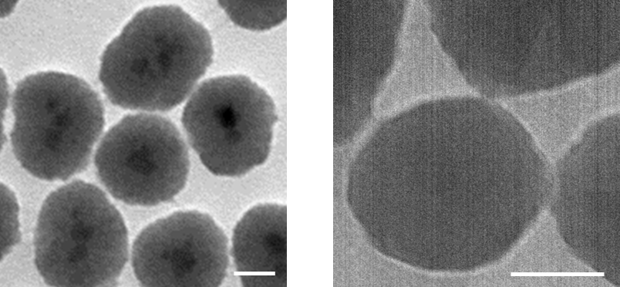
Supplementary Figure 1. Transmission electron microscope images for MNPs@SiO₂(RITC). Scale bar = 20 nm.
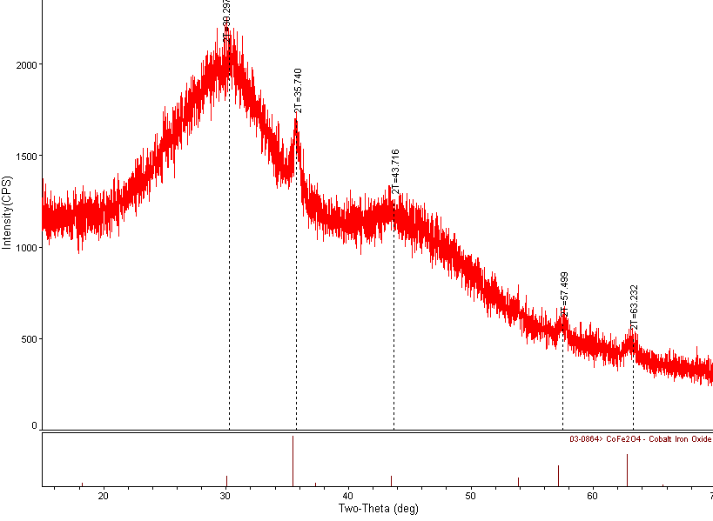
Supplementary Figure 2. XRD spectrum of MNPs@SiO₂(RITC). Peaks in 30º, 36º, 44º, 57º and 64 º are specific patterns of cobalt ferrite and the broad peak between 20º and 40º indicate the amorphous silica beads.
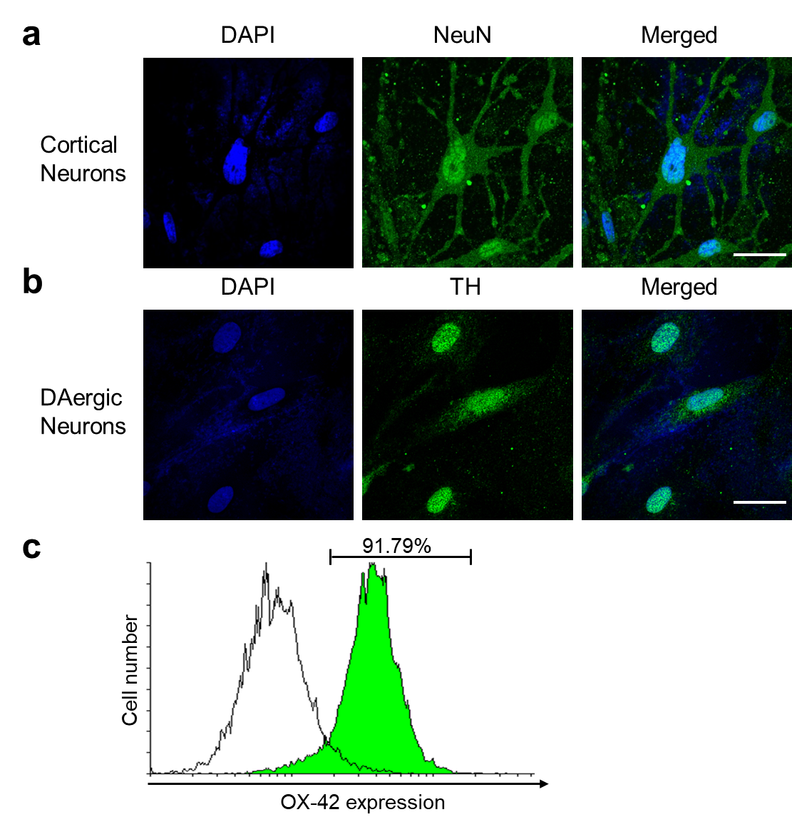
Supplementary Figure 3. Characterization of primary rat neuronal cells and microglia. a Immunofluorescence of cortical neurons stained with anti-NeuN antibody. b Immunofluorescence of dopaminergic neurons stained with anti-TH antibody. Scale bar = 10 μm. c FACS analysis for OX-42 expression in primary rat microglia. Percentage indicates positively stained population of cells.
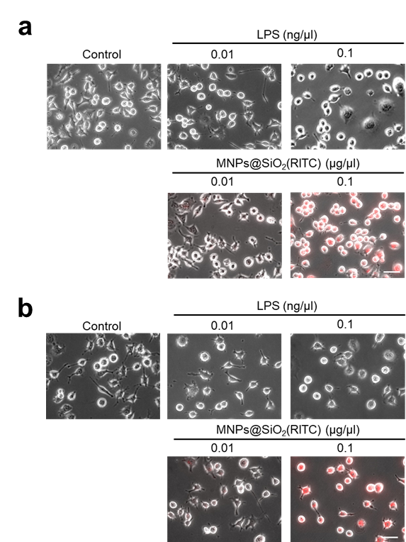
Supplementary Figure 4. Microglia activation after MNPs@SiO₂(RITC) treatment. Morphological analysis of a BV2 and b primary rat microglia. Scale bar = 50 μm. Red; MNPs@SiO₂(RITC).

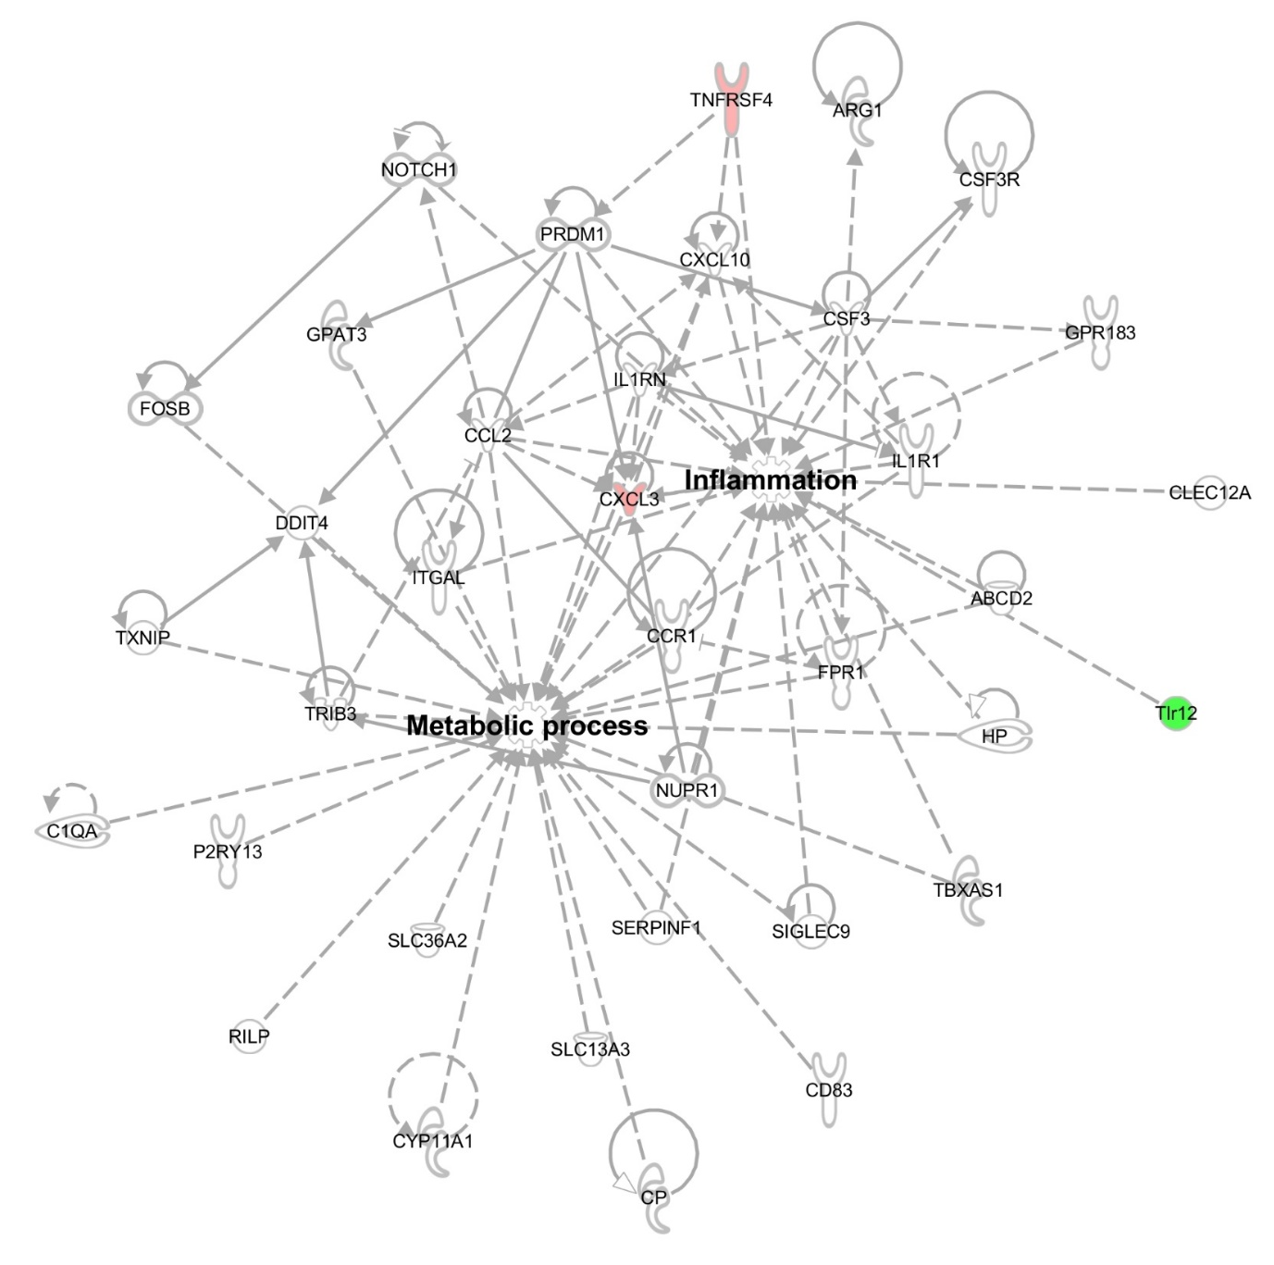
Supplementary Figure 5. Transcriptomic network of 0.01 μg/μl treated BV2 cells. Metabolism and inflammation related genes and network of 0.01 μg/μl treated BV2 cells was constructed algorithmically by IPA. Red and green areas indicate up- and downregulated genes, respectively.
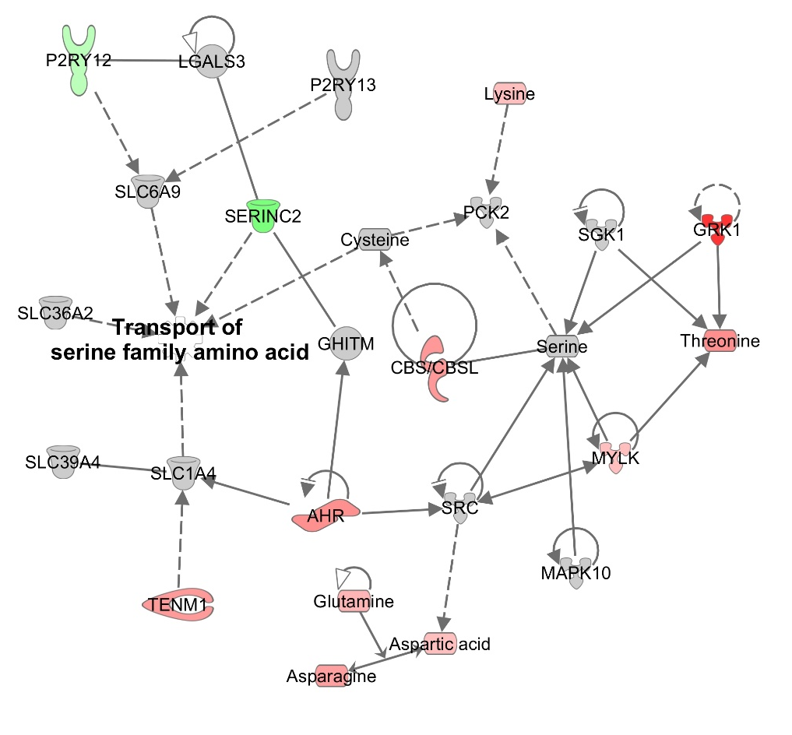
Supplementary Figure 6. Combinatorial analysis of RNA-seq and intracellular amino acid profiles 0.01 μg/μl MNPs@SiO₂(RITC) treated BV2. Transcriptome combined with amino acids profiles network were constructed algorithmically by IPA in 0.01 μg/μl MNPs@SiO₂(RITC) treated BV2. Red and green areas indicate up- and downregulated genes, respectively. Cut off fold change ±1.5 for genes and ±1.2 for amino acids were used.
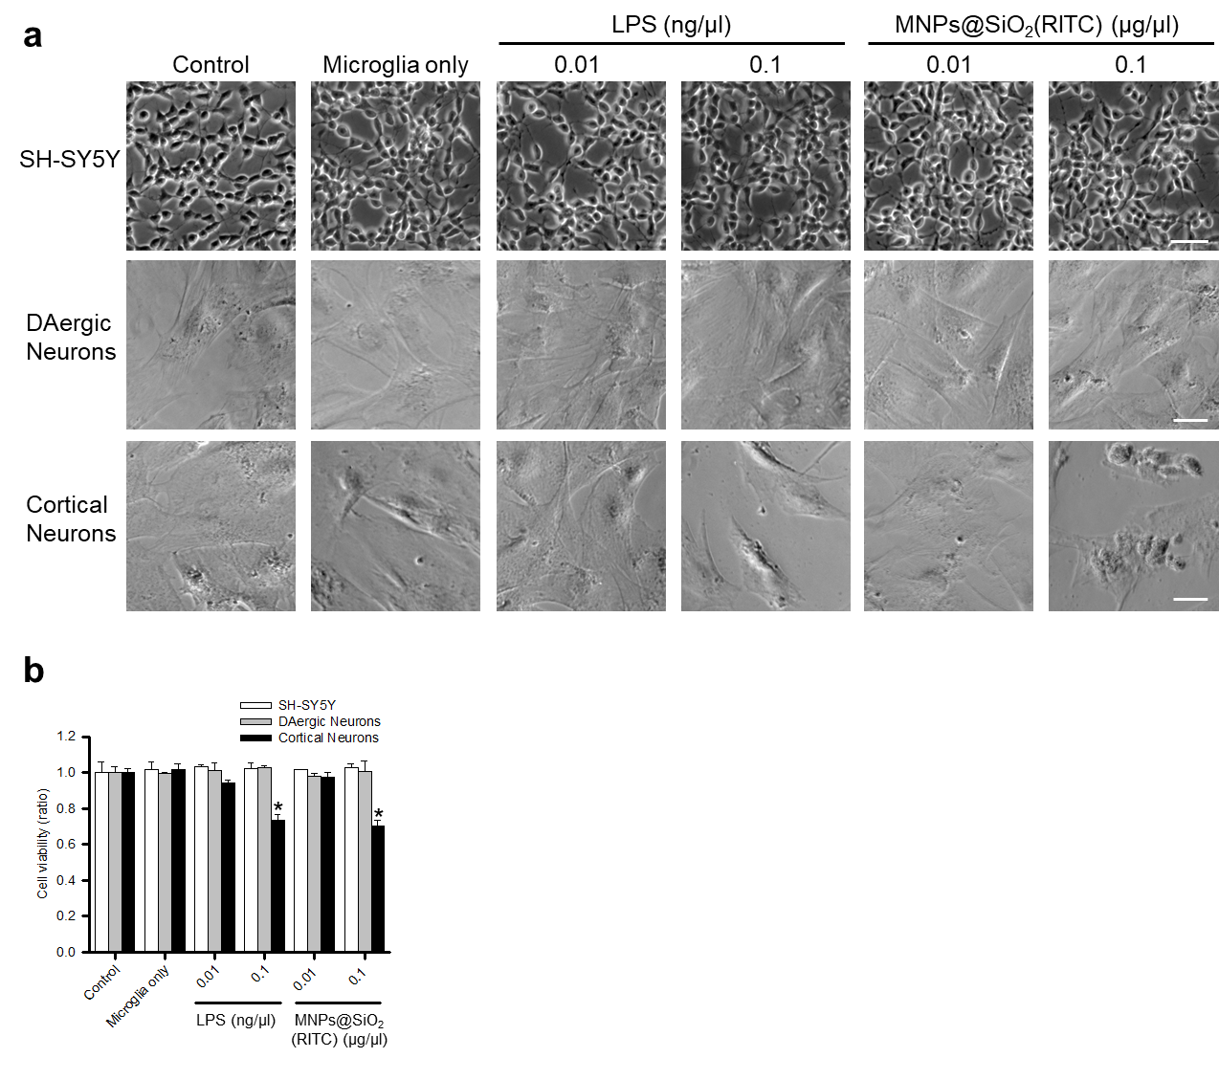
Supplementary Figure 7. Evaluation of cytotoxicity on neuronal cells in co-culture system with activated microglia. a Morphological analysis and cell density observation of SH-SY5Y, DAergic (dopaminergic), and cortical neurons. Scale bar = 50 µm. b MTS assay for evaluation of co-cultured neurons viability. Data were normalized with non-treated control and represent mean ± SD of three independent experiments. *p < 0.05 vs non-treated control.
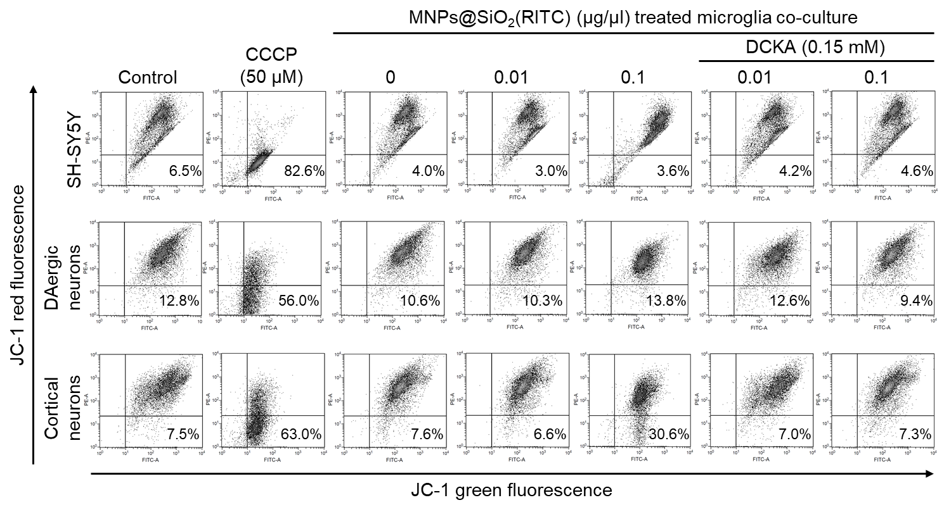
Supplementary Figure 8. Evaluation of changes in mitochondria membrane potential in MNPs@SiO₂(RITC) treated primary rat microglia co-cultured neuronal cells. mitochondria membrane potentials were analyzed using 5,5',6,6'-tetrachloro-1,1',3,3'- tetraethylbenzimidazolyl carbocyanine iodide (JC-1). Red fluorescence (high membrane potential) and green fluorescence (low membrane potential) were measured by fluorescence-activated cell sorting (FACS). Percentage indicates the portion of cells with low mitochondria membrane potential. Carbonyl cyanide m-chlorophenyl hydrazine (CCCP) were used as positive control for decreasing mitochondria membrane potential.
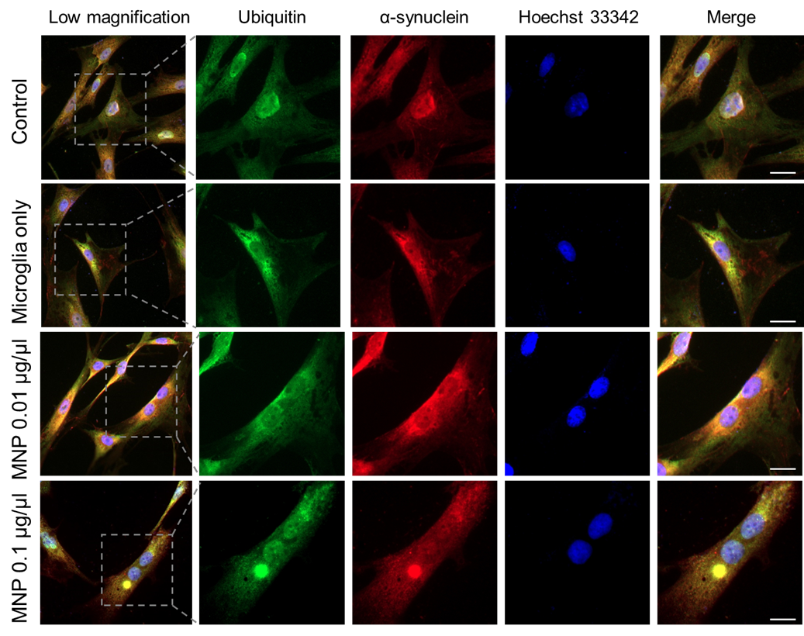
Supplementary Figure 9. Inclusion body formation in MNPs@SiO₂(RITC) treated microglia co-cultured dopaminergic neurons. Images of inclusion body formation were acquired by immunostaining with ubiquitin (green), α-synuclein (red), and nucleus (blue) Scale bar = 10 μm.

Supplementary Figure 10. Inclusion body formation in MNPs@SiO₂(RITC) treated mice brains. Images of inclusion body formation were acquired by immunostaining with ubiquitin (green), MNPs@SiO₂(RITC) (red), and nucleus (blue). Black scale bar = 100 μm. White scale bar = 10 µm. White arrowhead indicates inclusion body without colocalized to MNPs@SiO₂(RITC) and black arrowhead indicates inclusion body with colocalized to MNPs@SiO₂(RITC).
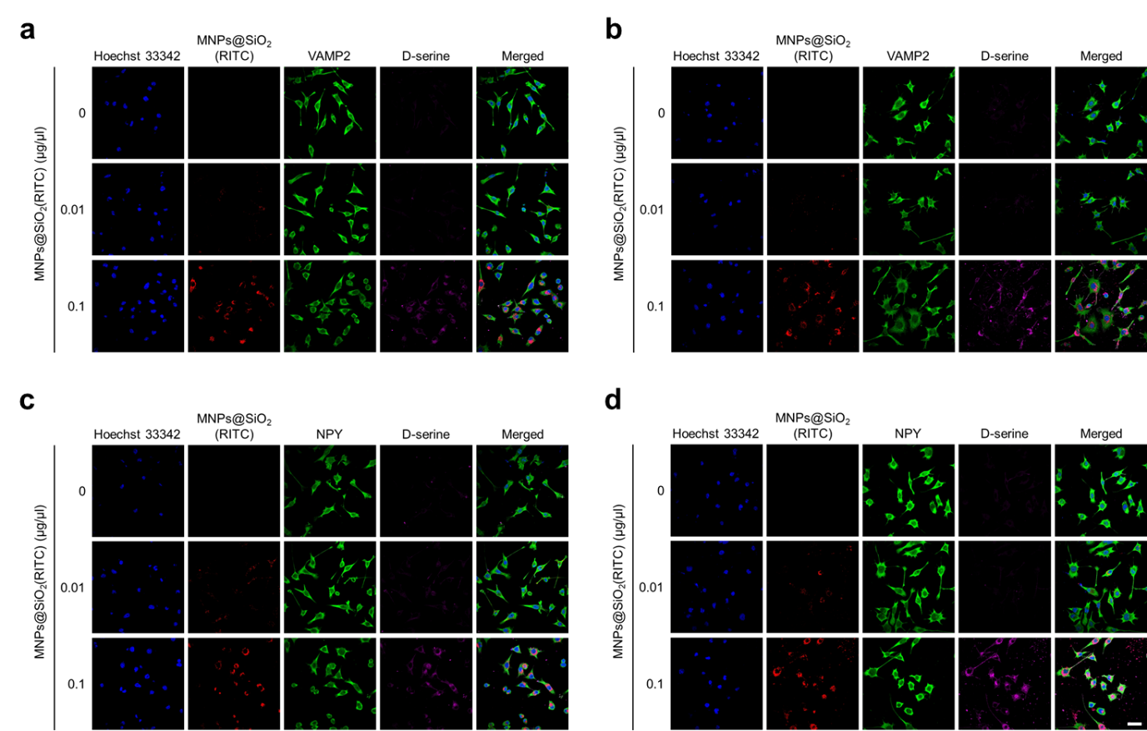
Supplementary Figure 11. Immunostaining analysis for exocytic vesicle marker and D-serine in MNPs@SiO₂(RITC) treated microglia. Images of exocytic vesicle marker and D-serine were acquired by immunostaining with MNPs@SiO₂(RITC) (red), VAMP2 or NPY (green), D-serine (violet), and nucleus (blue). Stained with VAMP2 in a BV2 and b primary rat microglia and stained with NPY in c BV2 and d primary rat microglia were analysed. Scale bar = 20 μm.

