Table 2 The top 10 active components in degree value.
ID | Components | 2D Structure | PubChem CID | Degree value
MOL000449 | stigmasterol | 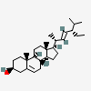 | 5280794 | 62
MOL000358 | beta-sitosterol | 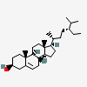 | 222284 | 50
MOL001546 | zizyphusine | 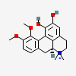 | 102063083 | 37
MOL005317 | 3(R)-Deoxyharringtonine | 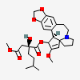 | 56840949 | 33
MOL005356 | Girinimbin | 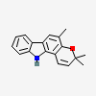 | 96943 | 31
MOL005314 | Celabenzine | 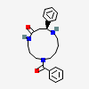 | 442847 | 30
MOL001522 | (S)-Coclaurine | 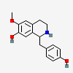 | 281691 | 30
MOL001539 | sanjoinenine | 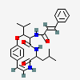 | 14729078 | 29
HBIN014399 | acetic acid | 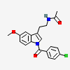 | 86086004 | 28
HBIN044939 | Stigmasterol-beta-D-glucoside | 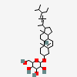 | 73072970 | 27

