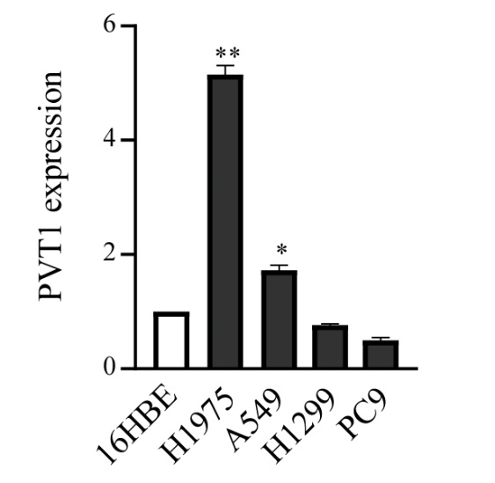

Fig. S1 The expression of PVT1 was measured by qRT-PCR in four lung cancer cell lines (A549, H1299, H1975, PC9) and human bronchial epithelial cell 16HBE. *: P < 0.05, **: P < 0.01.

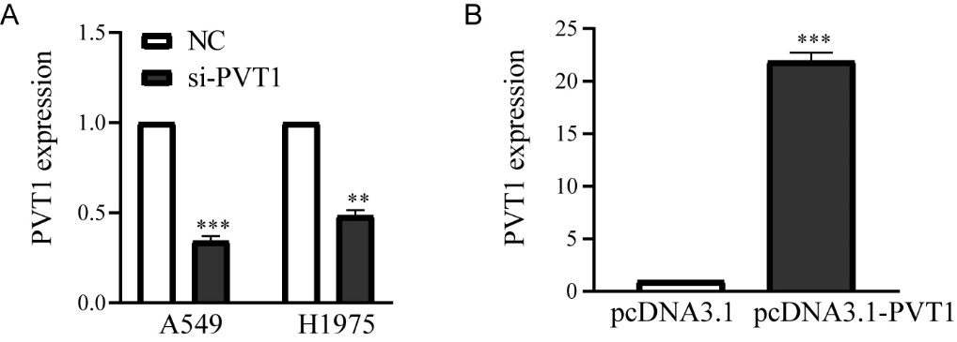
Fig.S2 A The knockdown efficiency of PVT1 in A549 and H1975 cells after transfection with si-PVT1 or NC was detected by qRT-PCR. B The overexpression efficiency of PVT1 in A549 cells after transfection with the plasmid pcDNA3.1-PVT1 or pcDNA3.1 was detected by qRT-PCR. **: P < 0.01, ***: P < 0.001.

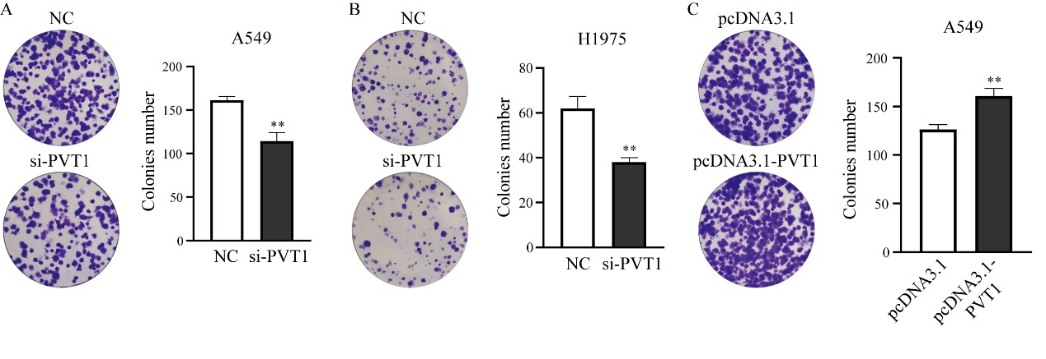

Fig. S3 Colony formation assays were performed to evaluate the cell proliferation of lung cancer cells when knocking-down in A549 (A) or H1975 (B), or overexpressing PVT1 in A549 (C). **: P < 0.01.

