Supplementary Information for
Interfacial Nanobubbles’ Growth at the Initial Stage of Electrocatalytic Hydrogen Evolution

Jinwen Yu¹, Kadi Hu², Zhengyi Zhang¹, Liang Luo¹*, Yiwei Liu¹, Daojin Zhou¹, Yun Kuang¹, Haijun Xu¹, Hui Li²*, Haohong Duan³, and Xiaoming Sun¹*
*Correspondence and requests for materials should be addressed to Liang Luo. (luoliang@mail.buct.edu.cn), Hui Li. (hli@mail.buct.edu.cn) or Xiaoming Sun. (sunxm@mail.buct.edu.cn).

Supplementary Experimental Procedures
The relationship between i_{NB} and i_{substrate}
On the basis of the experiments and simulations, a time-dependent bubble-current model is proposed to quantify the relation between the residue current and NBs’ morphology and coverage (Fig. 5D). On one hand, at a certain overpotential, the interfacial NBs form and the coverage rapidly increases after the nucleation (t₀). A supersaturated gradient (Fig. 5E) would form nearby the surface of each generated NB, expressed as (C_{s}-C₀)/L, where C_{s} is the surface concentration of NB, C₀ is the concentration of gradient boundary, and L is the thickness of the diffusion layer. As mentioned above, in our open system, the supersaturated gradients nearby NBs would inevitably release H₂ molecules into the bulk solution, and the outflux of a single NB can be expressed by Fick’s Law, j = -D(C_{s}-C₀)/L, where D is the gas diffusion coefficient. By assuming the same concentration gradient nearby each NB, the total diffusion of H₂ molecules into the bulk solution on the whole electrode is also determined by the number of NBs besides the supersaturated gradient, namely, the coverage. To maintain the dynamic equilibrium, more electrochemically generated molecules are required to replenish the diffusion loss. Therefore, the diffusion current can be further expressed as,
$i_{NB}$∝ $-zFDρ\left(C_{s}-C_{0}\right)/L$(1)
where z is the electron transfer number, F is the Faraday constant, and ρ is the coverage of NBs. Thus, as the reaction continues (t1), ρ increases and the number of diffusion points increases, as well as increasing CA and decreasing r (Fig. 4B). Namely, higher supersaturated gradients “(C_{s}-C₀)/L”, and the diffusion current (Fig. 5D, red line) correspondingly increases. When the reaction prolongs to equilibrium state (t_{eq}), ρ approaches to a maximum value and r decreases to a minimum value without further variation over time, the diffusion current reaches the maximum value.
At the very beginning (t₀), there are no NBs formed on the electrode, i is of the largest value, as well as the largest value of dρ/dt (nearly the slope of reflectivity). After this time, with the free nucleation and a number of NBs generated (t₁), the unblocked area continuously reduces. It is worth noting that the electrochemically generated H₂ molecules based on such unblocked area might contribute for new nucleation of NBs, and/or growth of already formed NBs and even the replenishment of above-mentioned NB diffusion. According to the experimental observations, fresh nucleation becomes harder and harder, as steady coverage is approached with decreasing variation rate of coverage (dρ/dt) till 0 at the equilibrium state (t_{eq}) (Supplementary Fig. 9). We define such part of current except the diffusion part as i_{substrate} (Fig. 5D, green line), namely the contribution part of new nucleation of NBs, and/or growth of already formed NBs, which is found to be of opposite trend to i_{NB}, and proportional to the time-dependent variation rate of coverage, and can be expressed as,
$i_{substrate}∝{dρ}/{dt}$ (2)
At the equilibrium state (t_{eq}), both the NB coverage and the supersaturated gradients remain unchanged and can be approximately regarded a “honeycomb structure” (Fig. 5E).

The relationship between equilibrium current and overpotential
From Fick's Law 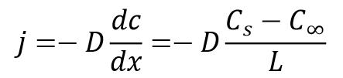 (3)
Where diffusion flux, j, represents the gas concentration gradient, D is the diffusion coefficient, Cs and C0 are the gas concentration on the electrode surface and in the bulk solution, respectively, and L is the thickness of the diffusion layer, that is, the distance between Cs and C0. The current density can be obtained by the equation i=zFj, where z is the number of electron transfers, and F is the Faraday constant. Thus, i can be expressed as,
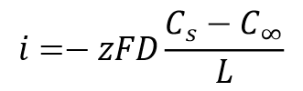 (4)
According to Nernst equation and Henry's law， the overpotential can be described as, 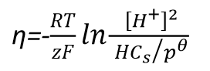 (5)
Here, T represents the temperature, R is constant, [H+] is the hydrogen ion concentration, and H is the Henry's coefficient. Substituting Equation 3 into Equation 2, the current density, i, as a function of overpotential (η) is expressed as,
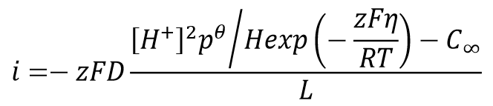 (6)

Supplementary Fig. 1. The CV curve of [Fe (CN)₆]³⁻ ↔ [Fe (CN)₆]⁴⁻ at different wettability electrodes.
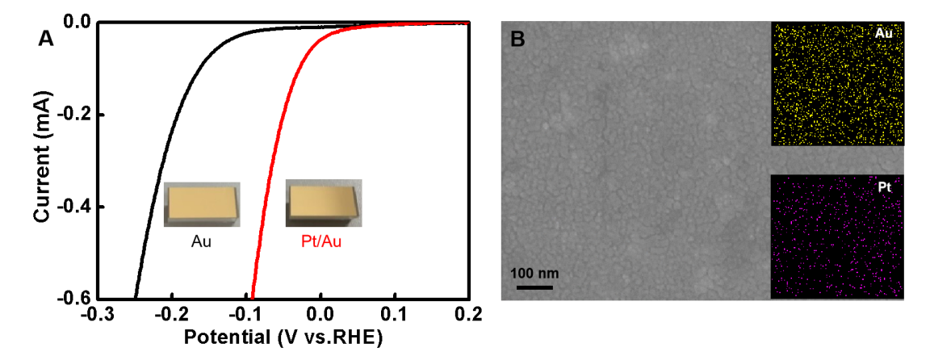
Supplementary Fig. 2. (A) Linear sweep voltammetry curve of hydrogen evolution reaction (HER) before and after platinum plating and (B) is the corresponding element distribution after platinum plating.

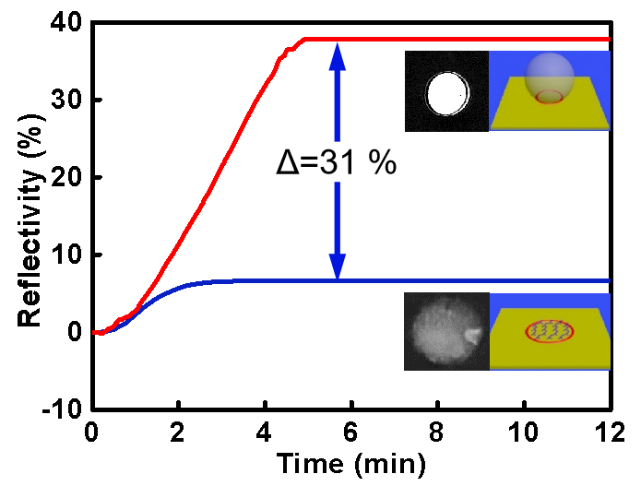
Supplementary Fig. 3. Time-dependent reflectivity curves of single bubble evolution (36%) and reference DNA molecules binding (7%), inset: differential images and the side-view schemes of the contact area of single bubble and the binding area of DNA molecules.
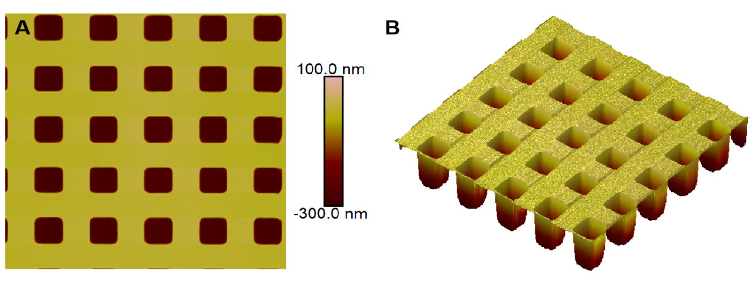
Figure S4. Tip correction of AFM.

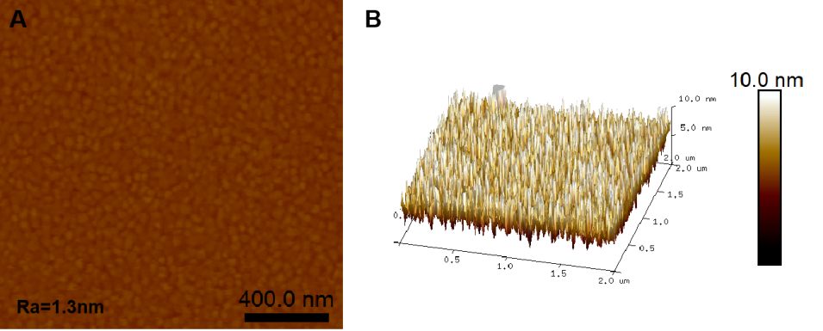
Figure S5. AFM and 3D view images after platinum plating in A and B.

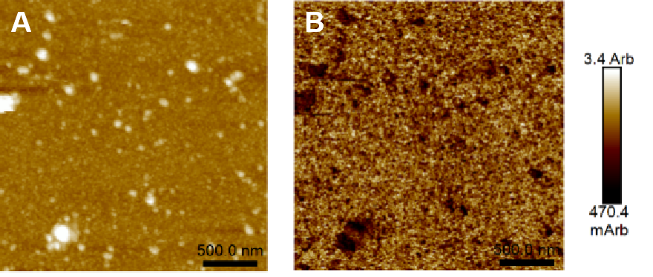
Figure S6. (A) AFM image of nanobubbles and (B) DMT Modulus (contact force) test.
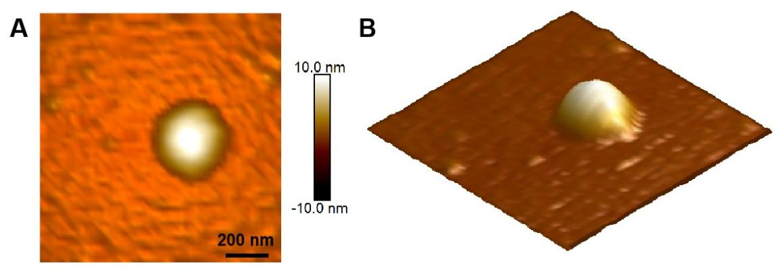
θ=15°
Figure S7. AFM and 3D view images of nanobubble pancake appeared on the electrode surface after 10 minutes of HER.
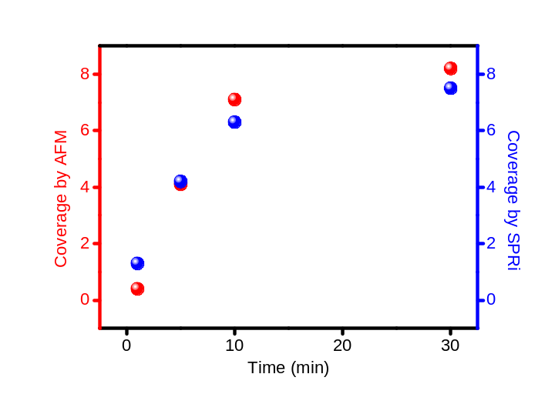
Figure S8. The comparison of time-dependent variations of nanobubble coverage by AFM and SPRi.

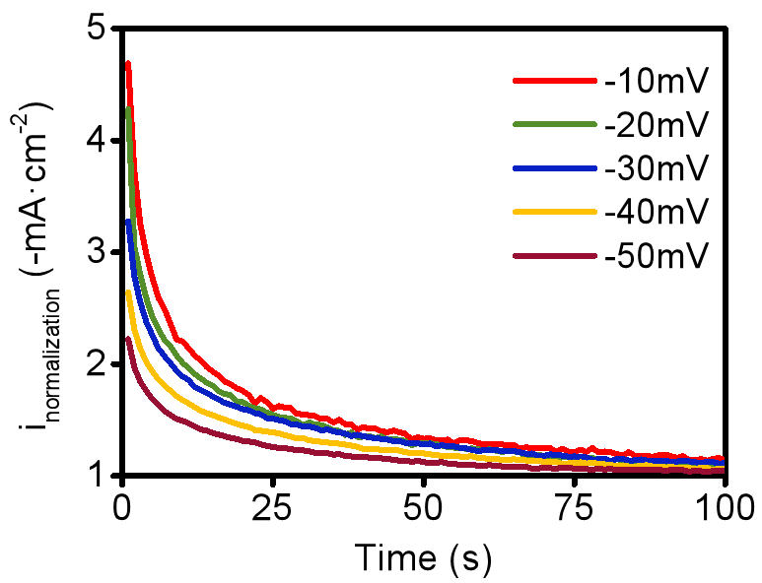
Figure S9. Normalized time-dependent current variations at different overpotentials.
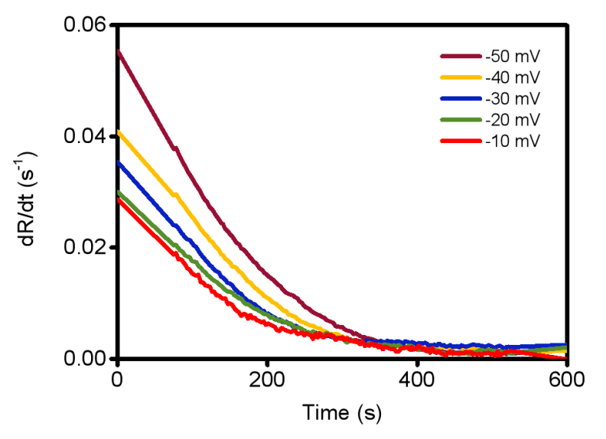
Figure S10. Differential curves of reflectivity at different overpotentials.

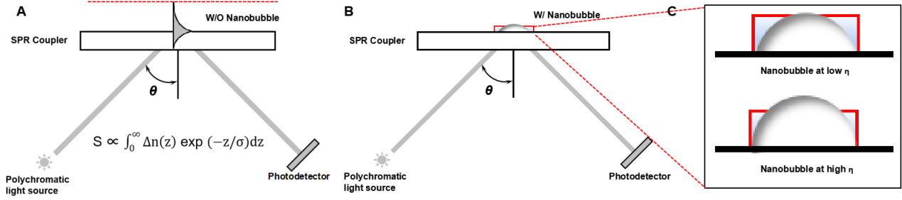
Figure S11. Longitudinal variation of the evanescent wave on the electrode surface: A) without nanobubbles; B) with nanobubbles; C) nanobubbles with different geometries
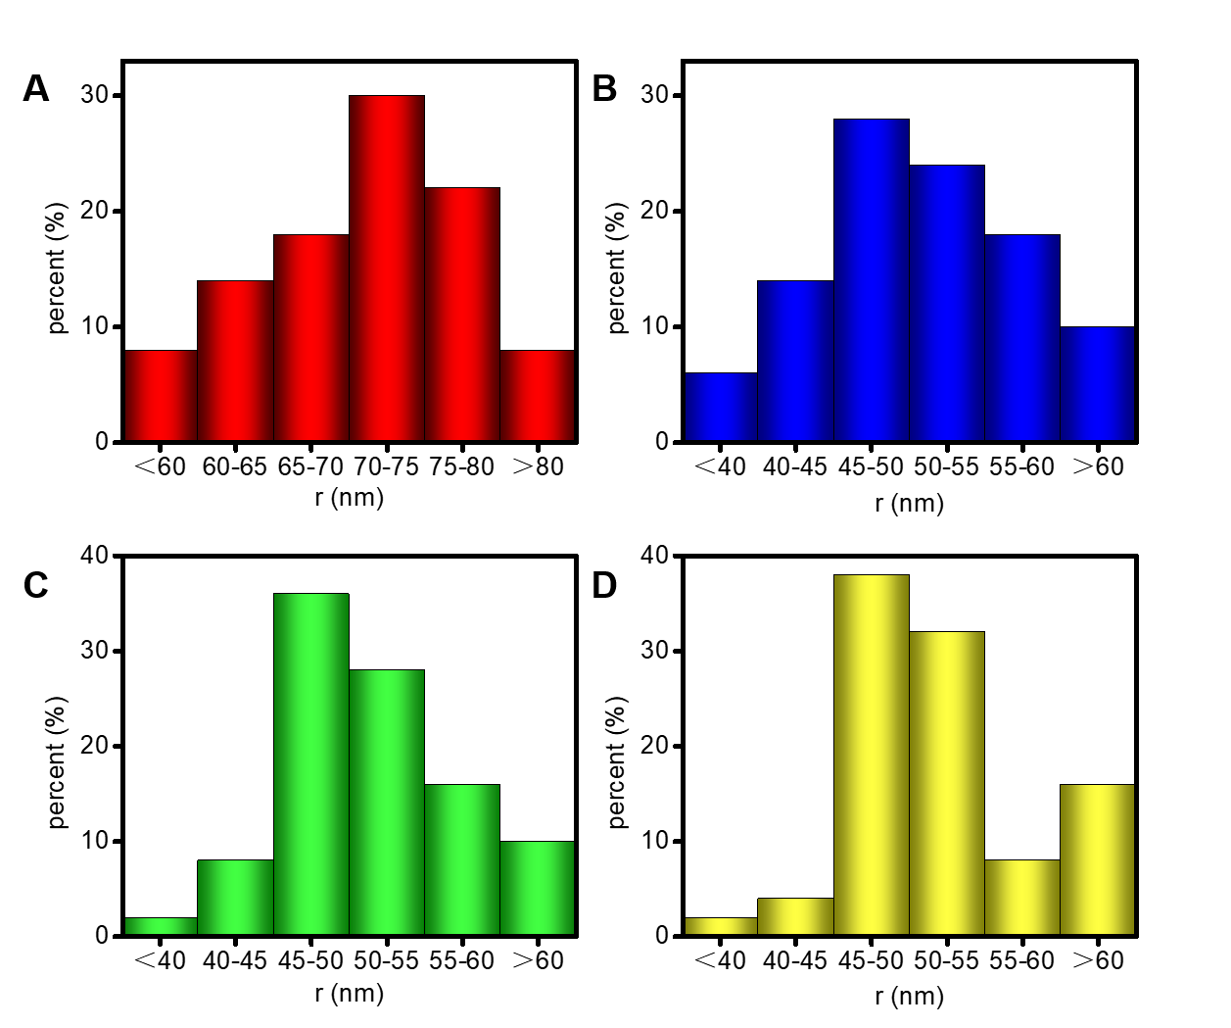
Figure S12. Size distribution of nanobubbles at (A) 1 min, (B) 5 min, (C) 10 min and (D) 30 min.

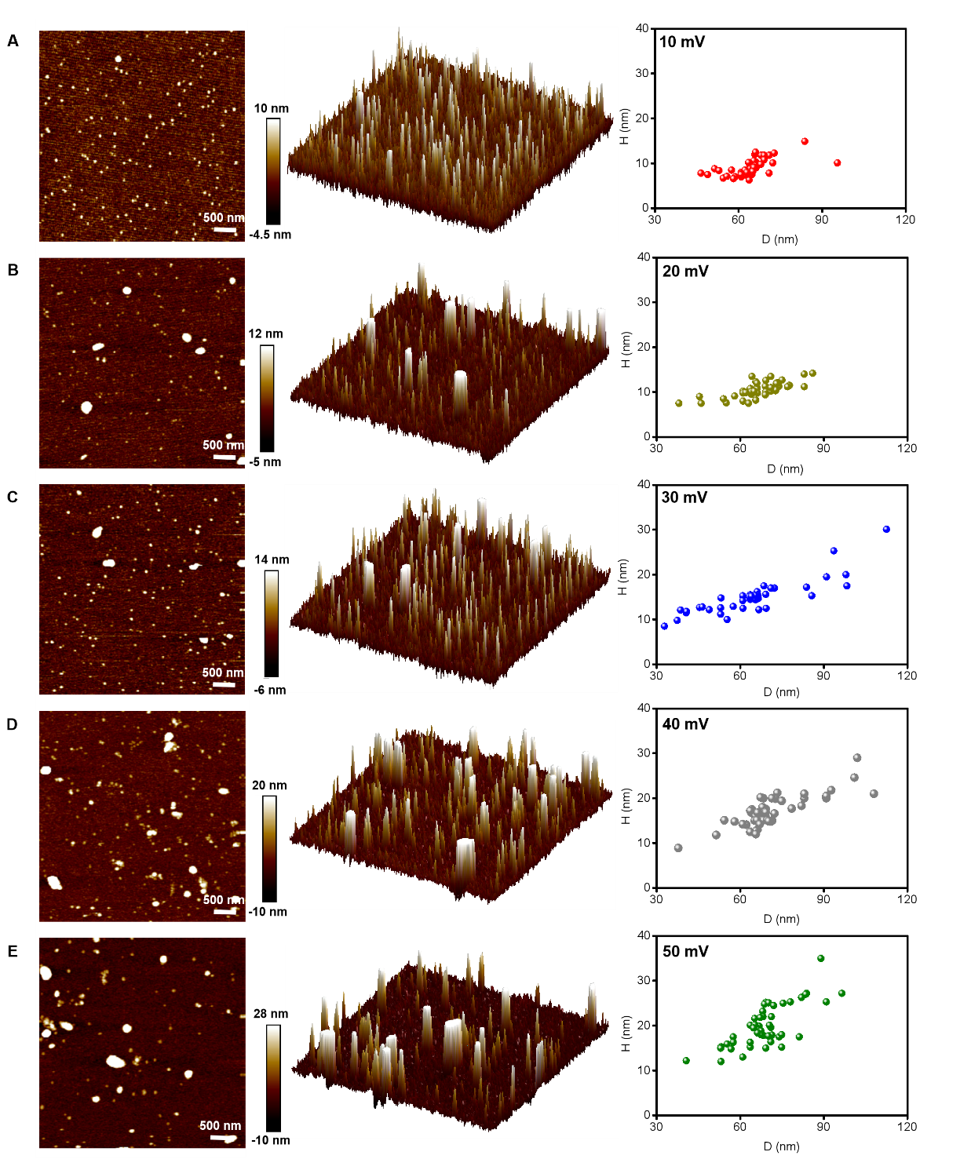
Figure S13. Size distribution of nanobubbles under different overpotentials.
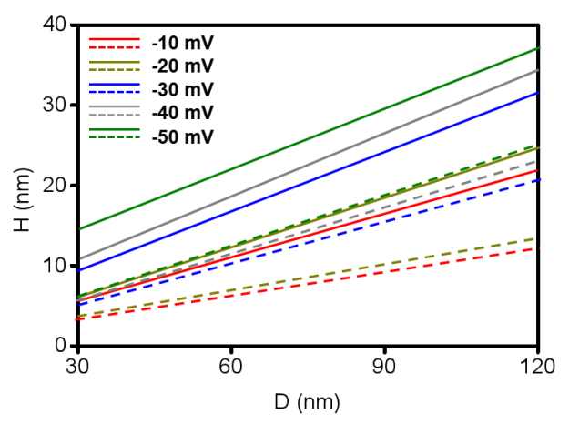
Figure S14. Distribution range of nanobubbles at different overpotentials
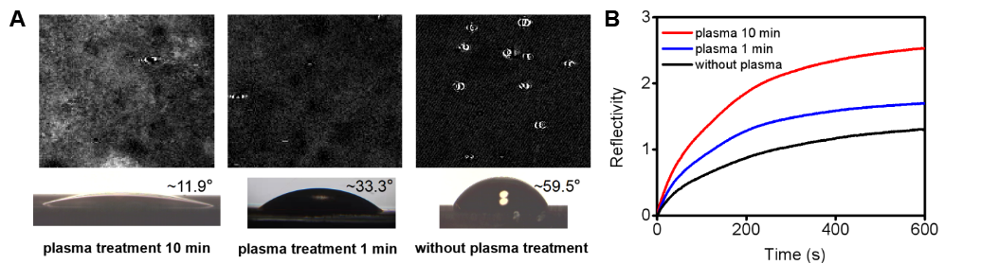
Figure S15. Under 50 mV overpotential, the nanobubbles generated(A) and reflectivity (B) in the electrode after different plasma treatment time.
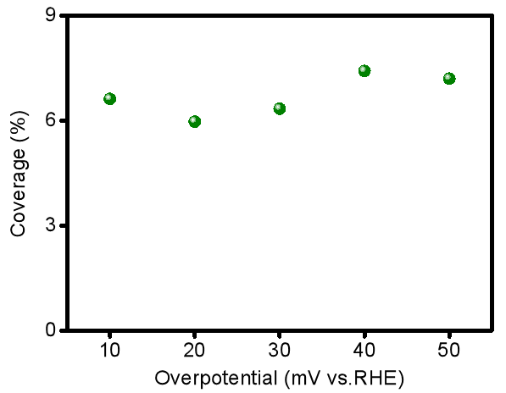
Figure S16. Coverage of nanobubbles under different overpotentials.
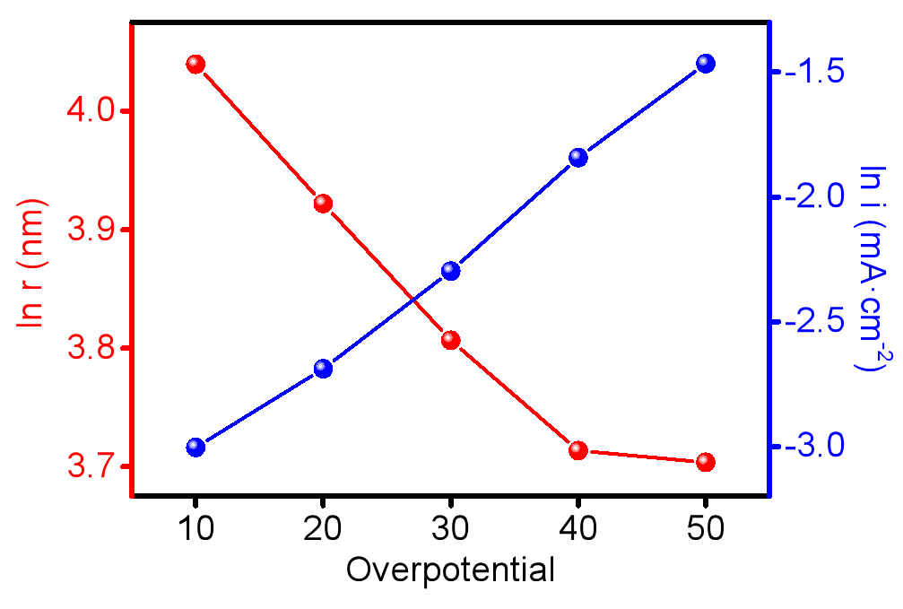
Figure S17. Variation curve of ln(r) and ln(i) with overpotential.
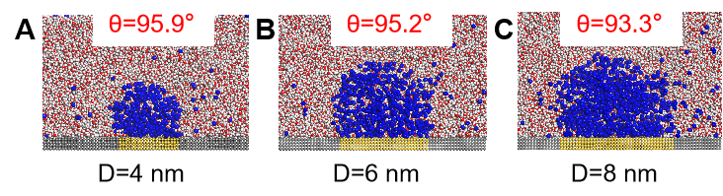
Figure S18. Nanobubble equilibrium size at different sizes of electrode.
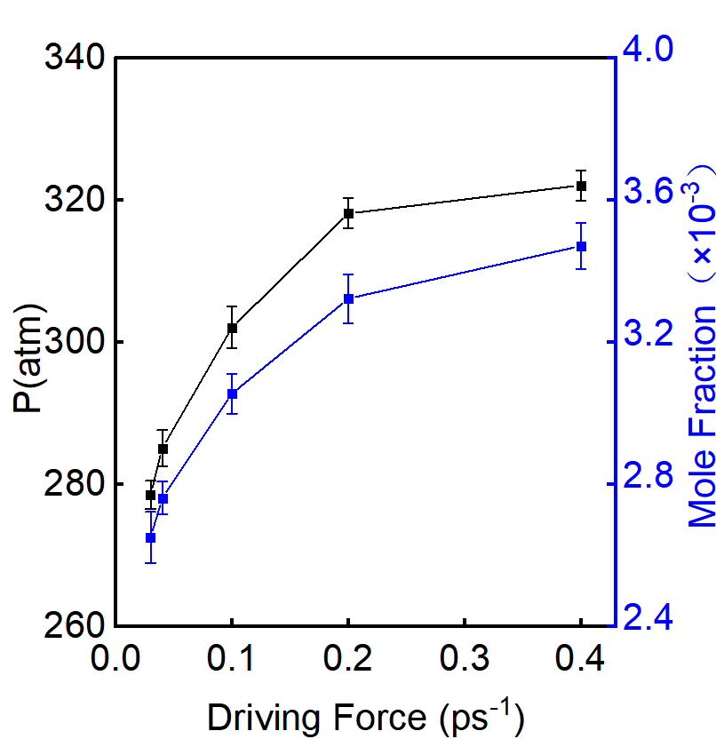
Figure S19. The pressure of nanobubble and the molar fraction of the gas in solution corresponding to the different driving forces.
Supplementary Fig. 20. AFM and 3D view images after platinum plating in A and B.
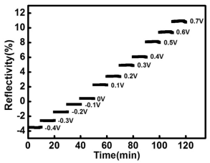
Supplementary Fig. 21. The change of reflectivity for 10 minutes at each potential in -0.4V to 0.7 V is in the SPRi baseline test.

