Details of propensity score matching (PSM)
In the original manuscript, we used follow-up time as the adjustment variable for PSM. This resulted in a significantly higher risk ratio of HD versus PD in the PSM-multivariate Cox regression model of >70 years of age. After consulting with statisticians, we believed that follow-up time was an important outcome parameter of the Cox regression model, it was not appropriate to use follow-up time as the adjustment variable of PSM, so we adjusted the characteristics of PSM. After the adjustment of PSM, the results of the multivariate Cox regression model did not changed (Table 3).
We used MatchIt package in R language for propensity score matching. The matching ratio for propensity score matching is 1:1. The characteristics are selected according to the difference in the baseline state. The matching method was nearest neighbor match. The characteristics used in PSM included sex, age of dialysis initiation, diabetes mellitus, cerebrovascular disease, congestive heart failure, chronic pulmonary disease, cardiovascular diseases, CCI, primary disease of renal failure (glomerulonephritis or polycystic kidney disease), body mass index, plasma albumin, cholesterol, and hemoglobin. Above characteristics were mainly determined by the difference in baseline status. The sample size of ≤60-years-old group changed from 233 in the HD group and 352 in the PD group to 226 in both groups. The sample size of >70-years-old group changed from 92 in the HD group and 48 in the PD group to 42 in both groups.

Summary of balance of <60-years-old group
 | Summary of balance for all data: |  |  |  | Summary of balance for matched data:
 | Means Treated | Means Control | SD Control | Std. Mean Diff. | Means Treated | Means Control | SD Control | Std. Mean Diff.
distance | 0.4314 | 0.3753 | 0.0939 | 0.4212 | 0.4206 | 0.4026 | 0.1019 | 0.1353
sex | 0.3863 | 0.4306 | 0.4959 | -0.0908 | 0.3894 | 0.4027 | 0.4915 | -0.0272
DM | 0.3133 | 0.2635 | 0.4411 | 0.1072 | 0.3053 | 0.2832 | 0.4515 | 0.0476
Congestive_heart_failure | 0.2704 | 0.2295 | 0.4211 | 0.0919 | 0.2699 | 0.2832 | 0.4515 | -0.0298
CCI_without_age | 3.2833 | 3.0708 | 1.2192 | 0.1442 | 3.2345 | 3.1637 | 1.284 | 0.0481
Cerebrovascular_disease | 0.1288 | 0.0453 | 0.2083 | 0.2486 | 0.1018 | 0.0708 | 0.2571 | 0.0923
Chronic_pulmonary_disease | 0.0558 | 0.0453 | 0.2083 | 0.0455 | 0.0531 | 0.0442 | 0.2061 | 0.0385
CAD_heart | 0.0773 | 0.0708 | 0.2569 | 0.024 | 0.0796 | 0.0752 | 0.2643 | 0.0165
BMI | 22.9711 | 22.3634 | 3.5419 | 0.1348 | 22.9309 | 22.722 | 3.7291 | 0.0463
TC | 4.417 | 4.5885 | 1.3949 | -0.1403 | 4.424 | 4.4901 | 1.3205 | -0.054
ALB | 35.8727 | 34.986 | 5.2236 | 0.1505 | 35.8271 | 35.3342 | 5.3101 | 0.0837
Hb | 87.0279 | 81.5959 | 18.595 | 0.2577 | 85.8916 | 84.7582 | 19.3052 | 0.0538
dialysis_begin_age | 45.2618 | 44.5751 | 10.5769 | 0.0608 | 45.0708 | 44.4646 | 10.7959 | 0.0537
The propensity score of <60-years-old group:
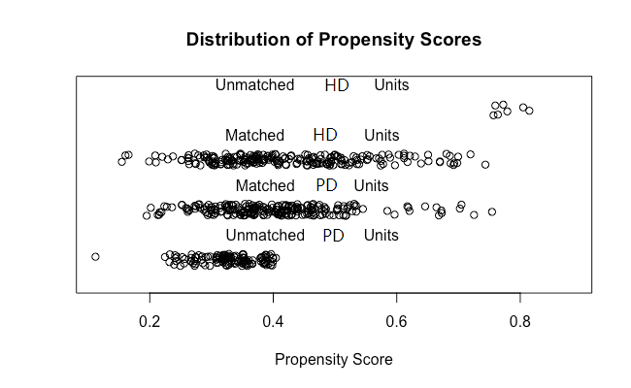
Summary of balance of >70-years-old group
 | Summary of balance for all data: |  |  |  | Summary of balance for matched data:
 | Means Treated | Means Control | SD Control | Std. Mean Diff. | Means Treated | Means Control | SD Control | Std. Mean Diff.
distance | 0.4288 | 0.3042 | 0.1515 | 0.7364 | 0.3855 | 0.3805 | 0.1376 | 0.0298
sex | 0.4082 | 0.6196 | 0.4882 | -0.4257 | 0.4524 | 0.4762 | 0.5055 | -0.0479
DM | 0.5306 | 0.5326 | 0.5017 | -0.004 | 0.5238 | 0.5714 | 0.5009 | -0.0944
Congestive_heart_failure | 0.4286 | 0.5 | 0.5027 | -0.1429 | 0.4286 | 0.5476 | 0.5038 | -0.2381
CCI_without_age | 4.4694 | 4.413 | 1.4537 | 0.0379 | 4.4286 | 4.619 | 1.1884 | -0.1281
Cerebrovascular_disease | 0.3061 | 0.3913 | 0.4907 | -0.1829 | 0.3571 | 0.4762 | 0.5055 | -0.2557
Chronic_pulmonary_disease | 0.1633 | 0.1304 | 0.3386 | 0.0879 | 0.1429 | 0.1429 | 0.3542 | 0
CAD_heart | 0.3469 | 0.2935 | 0.4579 | 0.1112 | 0.3095 | 0.3571 | 0.485 | -0.099
BMI | 22.7049 | 23.2929 | 3.8943 | -0.1925 | 22.9189 | 22.3562 | 3.5457 | 0.1842
TC | 4.3298 | 4.3628 | 1.0358 | -0.0242 | 4.3481 | 4.3609 | 1.0949 | -0.0094
ALB | 34.0102 | 35.8438 | 4.4112 | -0.3755 | 34.9119 | 33.9508 | 3.6894 | 0.1968
Hb | 83.0612 | 87.1998 | 21.3746 | -0.2149 | 83.9048 | 83.294 | 19.2273 | 0.0317
dialysis_begin_age | 75.9388 | 77.4891 | 4.4905 | -0.4075 | 76.1429 | 76.2619 | 4.3227 | -0.0313
The propensity score of older than 70 years old group:
