Table 3
Bayesian regularisation | Lavenberg- Marquardt
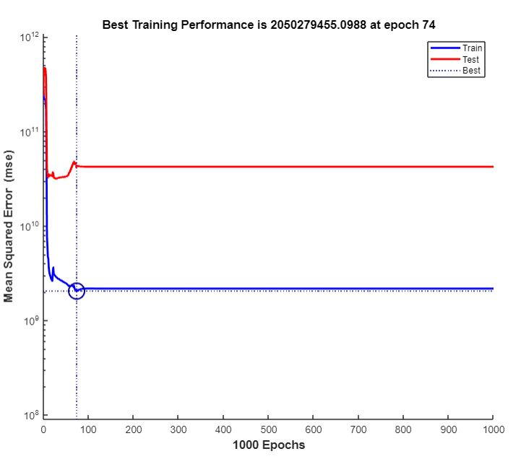 | 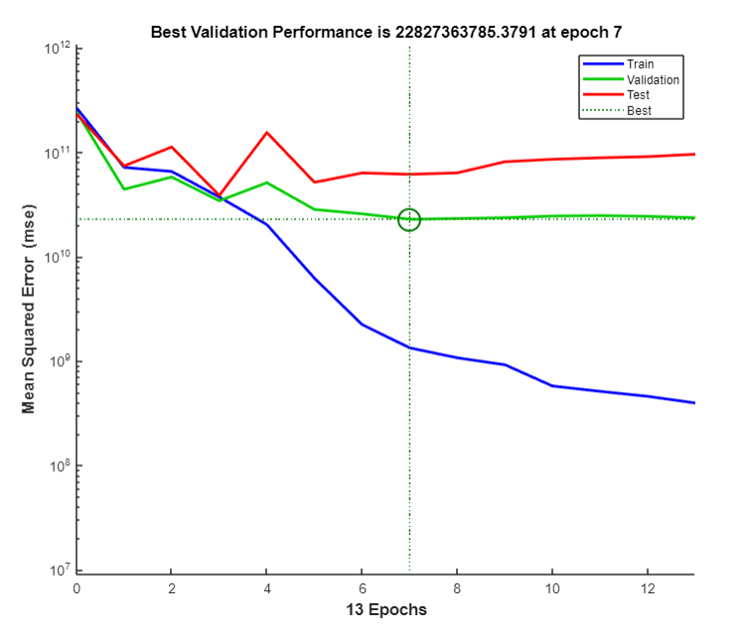

Table 4
Bayesian Regularisation:  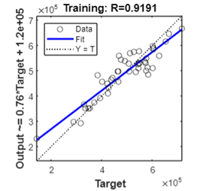 | Scaled Conjugate Gradient 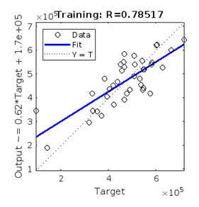

Lavenberg- Marquardt
