Supplemental material

AN INTERPRETATION OF CRUSTAL STRUCTURE AND HYDROCARBON EVOLUTION OF THE SOUTH CASPIAN AND KURA BASINS, AZERBAIJAN

N. R. Abdullayev¹ *, Sh. M. Huseynova¹, A. Javadova¹ , F. A. Kadirov¹, M. Maharramov², A. Mukhtarov³

The offshore South Caspian Basin, South Caspian, Lower and onshore Azerbaijan, and Georgia Upper Kura Basins are a genetically linked basin system created in a Mesozoic extensional setting with a complex Cenozoic sediment fill history. Delineating these basins shed new light on understanding the complex geodynamic history of the region between the Black Sea and the Caspian Sea and elucidate the petroleum prospectivity of the region.
Key data used for basin analysis were a series of regional isopach maps, temperature measurements from over 150 onshore and offshore boreholes in Azerbaijan, derived geothermal gradient data, and published surface heat flow data. Analysis of these data allowed us to put some constraints on the crustal structure of an area where accurate measurements of these parameters are limited. An integrated set of offshore and onshore regional isopach maps for key stratigraphic units from Jurassic to Pleistocene were created and validated the depth to basement estimates and the crustal thickness across the four seismic cross-sections, the longest of which is around 700 kilometers, via interpretation of isopach maps and gravity and magnetic modeling.
The results encompass the area from the onshore Kura Basin in eastern Georgia to the offshore South Caspian. A number of several specific regions were differentiated, including a “cold” region in the South Caspian Basin SCB where the sedimentary cover is over 20 km thick sedimentary cover and geothermal gradients vary from 15 to 18°C/km, and the Lower Kura Basin, where geothermal gradients average 20°C/km, and the Upper Kura Basin close to the Lesser Caucasus, with here geothermal gradients vary between 26 and 40°C/km. A reasonable correlation was established between basement depth, crustal thicknesses, and geothermal gradients.
On seismic profiles, the depth to basement in the central part of the Kura Basin (the Yevlakh Agjabedi depression) reaches 14 km. The consolidated extended continental crust of the onshore Kura Basin is 20 to 25 km thick. and is interpreted to be the extended continental crust. By contrast, the offshore South Caspian Basin sediment is over 25 km thick and while the thickness of the “oceanic affinity” crust is only 5-10 km thick. The tectonic boundary between these two basins controls the geothermal gradient change and therefore the hydrocarbon potential.
The western margin of the South Caspian Basin represents a long-standing crustal boundary between the SCB oceanic crust of the SCB and the thicker crust of the Kura basin of the island-arc origin Kura Basin crust. The Mesozoic evolution of these basins started as a result of an island arc extension in Mesozoic, followed by Cenozoic flexural overprint with rapid burial and significant sediment flux, thus creating suitable conditions for the development of a dynamic petroleum system. in the South Caspian Basin.
The hydrocarbon potential is high in the offshore South Caspian Basin where prolific Oligo-Miocene source rocks of Maikop and Diatom groups continue to generate hydrocarbons, at depths greater than 13 km, making it the world’s deepest active petroleum system. This petroleum system is a result of the rapid Neogene sedimentation, low-temperature gradients, delayed petroleum generation, reservoir diagenetic processes, and regionally continuous Pliocene Productive Series reservoir systems folded in large anticlines.
Onshore Kura Basin potential is limited, as the sedimentary cover is thin, source rocks are diluted by coarser clastics, and reservoir systems are less regionally continuous than the offshore system. The difference between the onshore Kura Basin and offshore South Caspian is linked to inherited their basin geometries and crustal boundaries which exert fundamental control of sediment deposition.

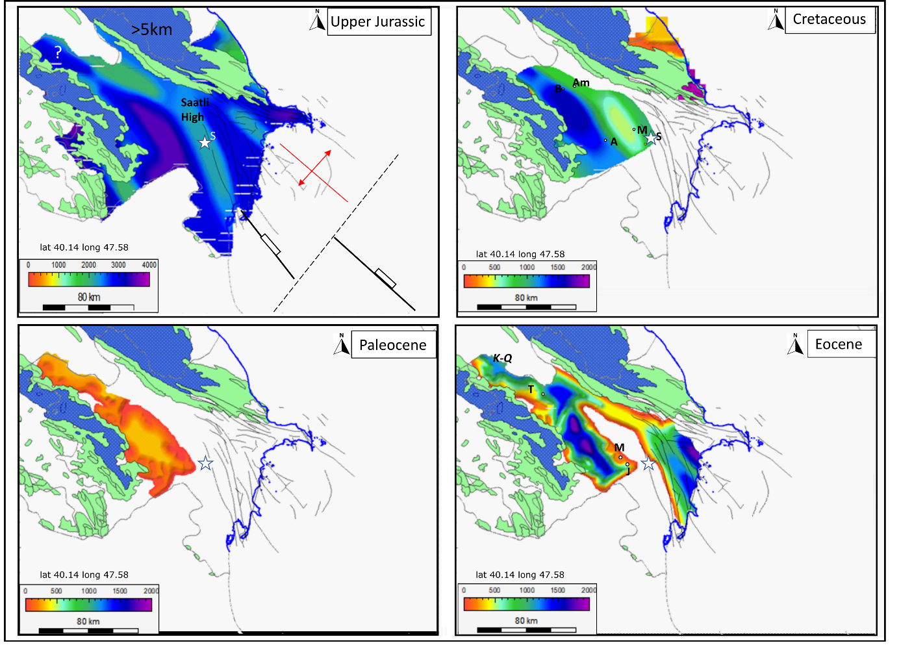
Figure 1s. Isopach maps of eastern Azerbaijan and the adjacent offshore showing the thickness (m) of Upper Jurassic, Cretaceous, Paleocene, and Eocene intervals, based on Salmanov et al., (2015). The star indicates the location of the superdeep Saatly well. Abbreviations: A, Agzibirchala; Ag, Agjebedi; B, Borsunlu; Y, Yalama; Am, Amirarkh; M, Muradkhanli; J, Jarly; S, Sorsor; K-Q, Kura-Qabirri interfluve; T, Tarsdallar;

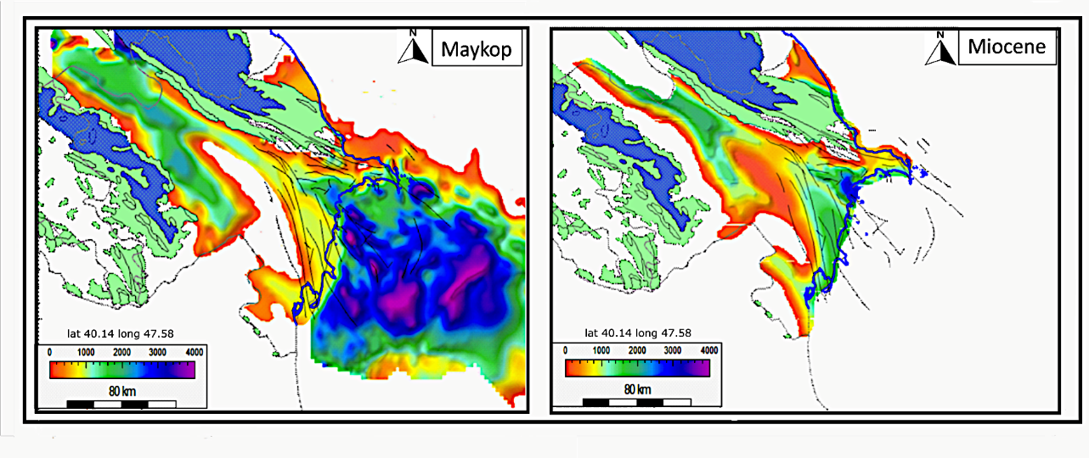
Figure 2s. Isopach maps of eastern Azerbaijan and the adjacent offshore showing the thickness (m) of (A) the Oligocene-Miocene Maikop Group, and (B) the Miocene interval, modified from Salmanov et al., (2015).

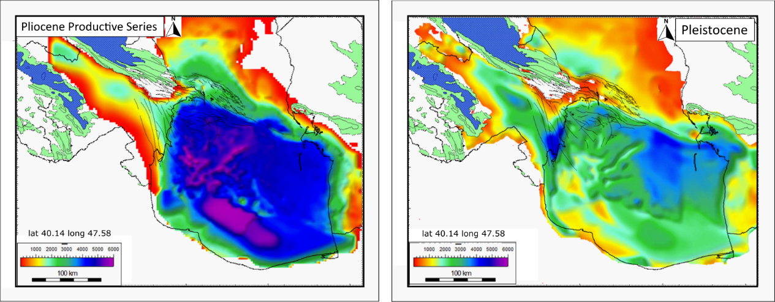
Figure 3s. Isopach maps of eastern Azerbaijan and the adjacent offshore showing the thickness (m) of the Pliocene Productive Series and the Pleistocene based on (Abdullayev et al., 2012a; Salmanov et al., 2015).
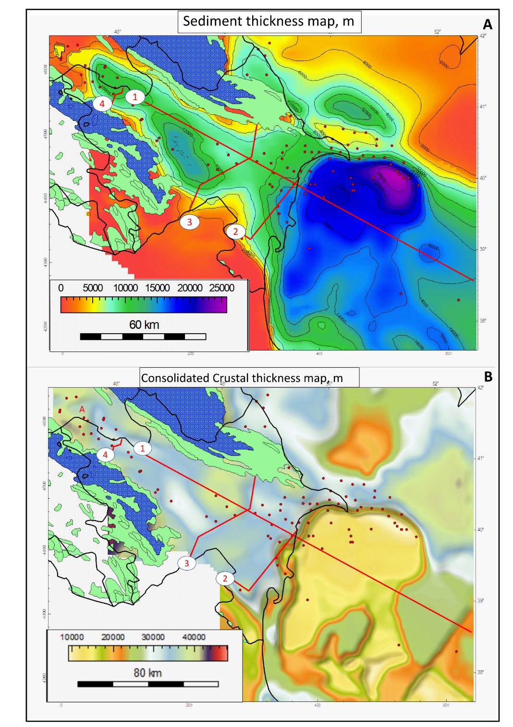
Figure 4s. Surface heat flow map of Azerbaijan and surrounding territories, modified from (Aliyev and Aliyev, 1995; Alizadeh et al., 2017; Tomara, 1979; Zui and Mansouri Far, 2019). Locations of 4 modeled regional cross-sections are shown (1 to 4), from Salmanov et al. (2015), (B) crustal thickness (modified from Glumov et al., (2004). Red dots designate locations of averaged geothermal gradient measurements derived from well data from Mukhtarov et al. (2018)
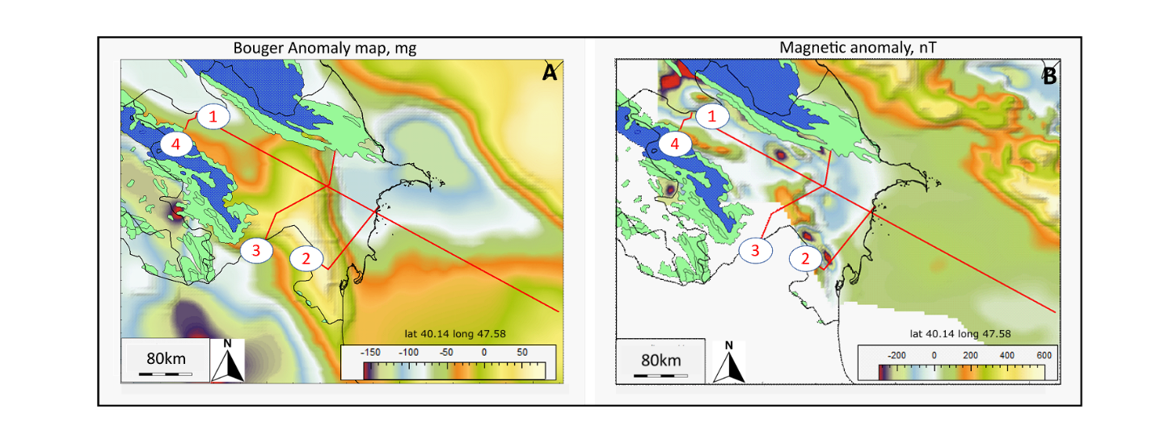
Figure 5s. Potential fields maps of Azerbaijan and the adjacent offshore areas of SCB: (A) Bouguer anomaly map (mgal), based on Kadirov et al.,(2000); and (B) magnetic anomaly map (nT) (Glumov et al., 2004).
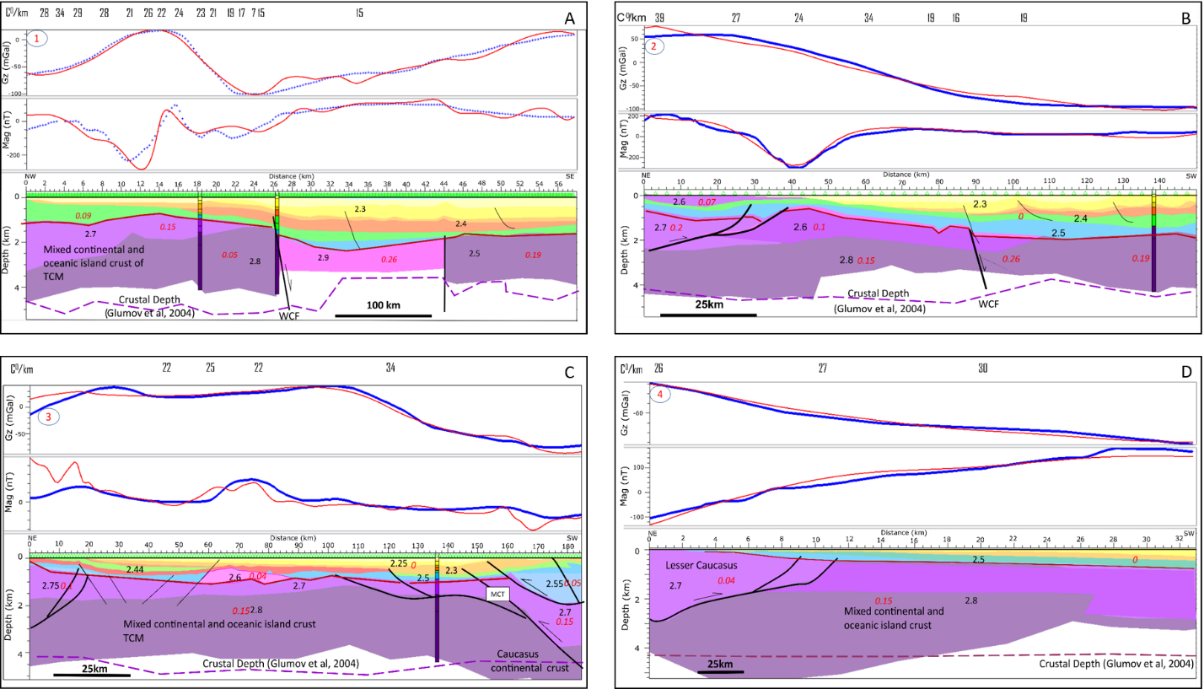
Figure 6s. (A) Regional NW-SE 560 km long seismic section 1 extending through the Kura and SCB. (B) Regional seismic NE-SW 150km long section 2 extending through the Lower Kura Basin. (C) Regional seismic NE-SW 190km long section 3 extending through the Middle Kura Basin. (D) Regional seismic NE-SW 32km long section 4 extending through the Upper Kura Basin.
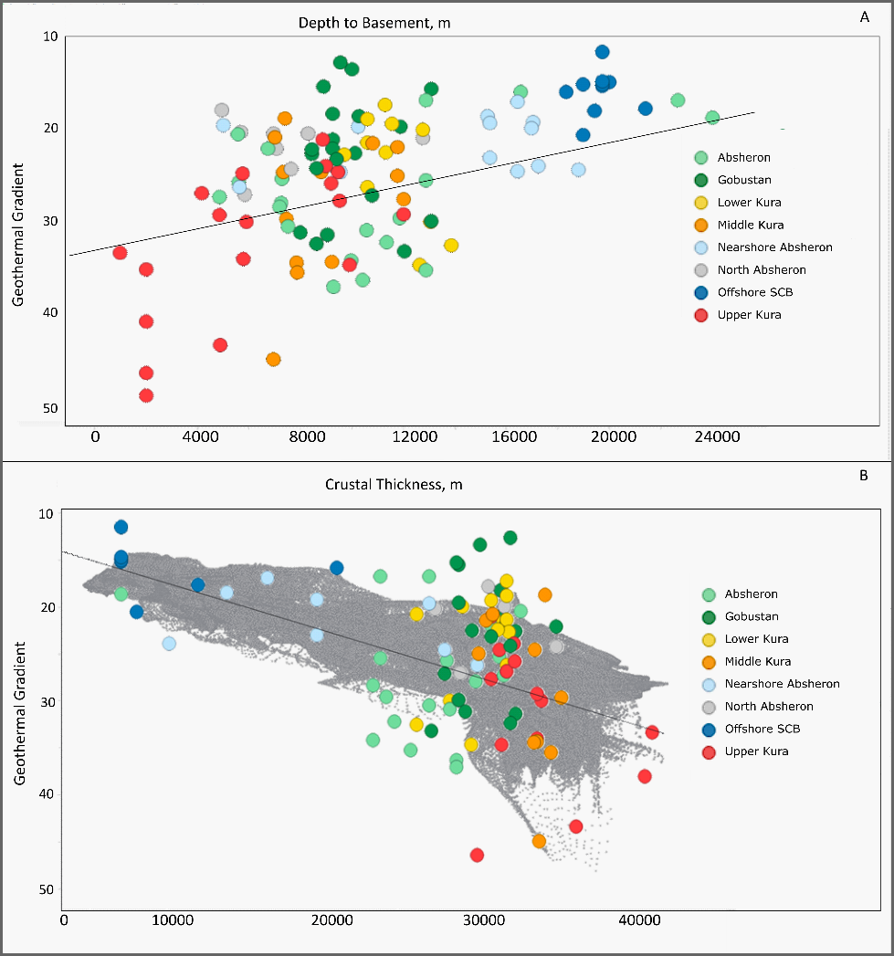
Figure 7s. Cross-plots of basement depth (A) and crustal thickness (B) versus geothermal gradient measured at wells. Grey circles represent modeled geothermal gradients derived from the conversion of depths to temperatures using maps, whereas actual measurements are shown by the colored circles.
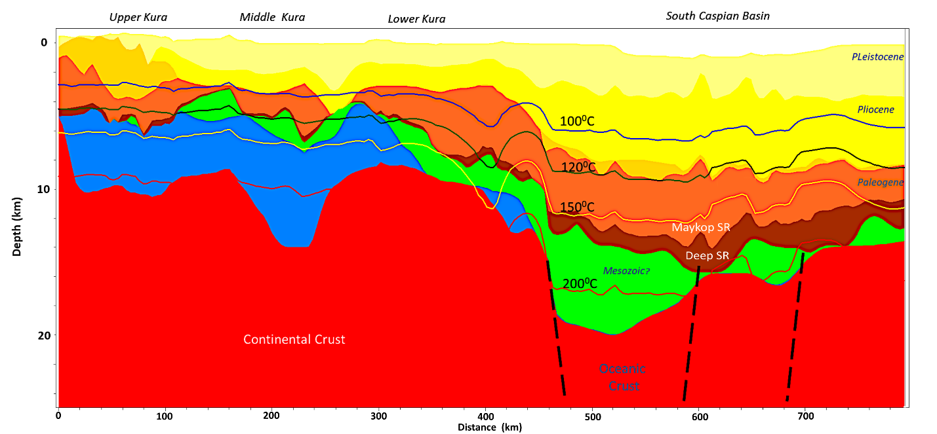
Figure 8s. NW-SE oriented 700 km geogeoseismic cross-section extending from the Upper Kura basin to the offshore SCB with isothermal depth overlays (cross-section location in Fig. 1).
Figure 9s. (A) Tectonic and basin framework overlaid on isothermal depth for 150°C. Geoseismic cross-section 1 from (B) Faults (brown rectangles) delineate the tectonic boundary of the SCB and Greater Caucasus. Orange diamonds represent axes of the Mesozoic basins. Purple triangles represent regional thrust faults delineating the Caspian modern-day compressional boundary. Black dashed faults represent possible transform boundaries.

