Supporting Information for
Observations of up-to-fivefold reverberating waves through the Earth’s center: distinctly anisotropic innermost inner core
Thanh-Son Phạm¹ and Hrvoje Tkalčić¹
¹Research School of Earth Sciences, The Australian National University, Canberra ACT, Australia

Contents of this file

Figures S1 to S8

Introduction
Supplementary figures S1 to S8 further demonstrate briefly discussed points in the main text.

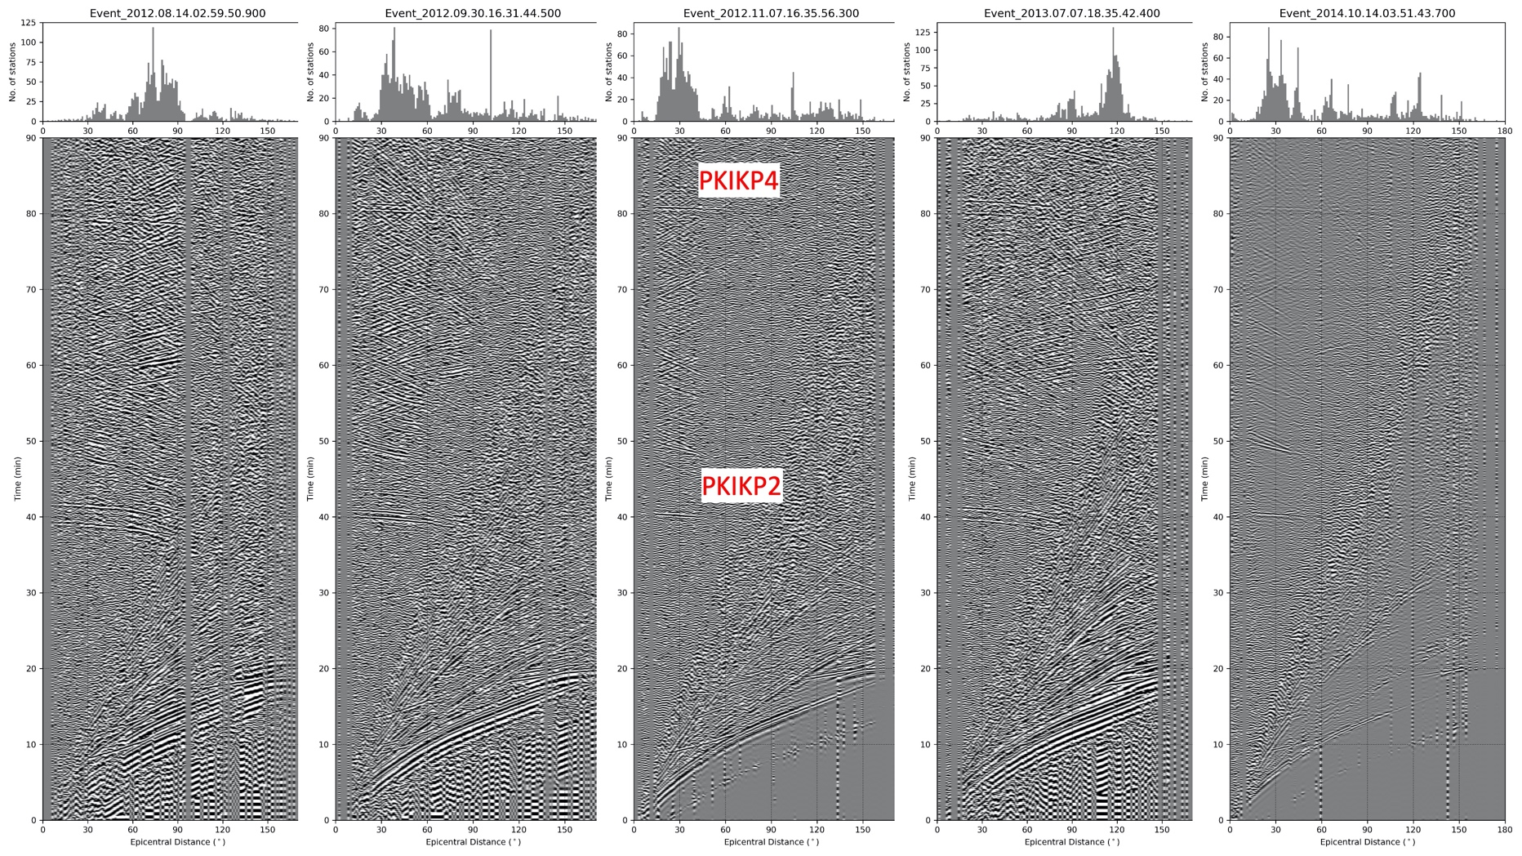
Figure S1. Global stack examples express clear exotic podal and antipodal reverberations. Panel titles note event origin times.
Figure S2. Theoretical reflection coefficients at major Earth’s internal interfaces as function of epicentral distances: upper reflection at CMB (PcP), upper reflection at ICB (PKiKP), under-side reflection at ICB (PKIIKP), under-side reflection at the CMB (PKIKKIKP), under-side reflection at the Earth’s surface (PKIKPPKIKP).
Figure S3. Attenuation operators using the absorption band method (Li & Cormier, 2002) convolved with a given wavelet having 10 s central period. The travel distance is comparable to the diameter of the inner core. Amplitudes are normalized to the incident wavelet. $τ_{1}$ represents the lower end of the absorption band, while $q_{1}$ is the inverted value of the quality factor $Q_{1}$ corresponding to $τ_{1}$. (Readers are referred to the original reference for the complete mathematical representation). Unless the extreme value for $τ_{1}$, the long-period signal (10 s) only weakly attenuates while propagating in the inner core.
Figure S4. Location maps for 16 high-events satisfying the epicentral conditions (<40° for PKIKP4-PKIKP2 pair, and >160° for PKIKP3-PKIKP1 pairs).

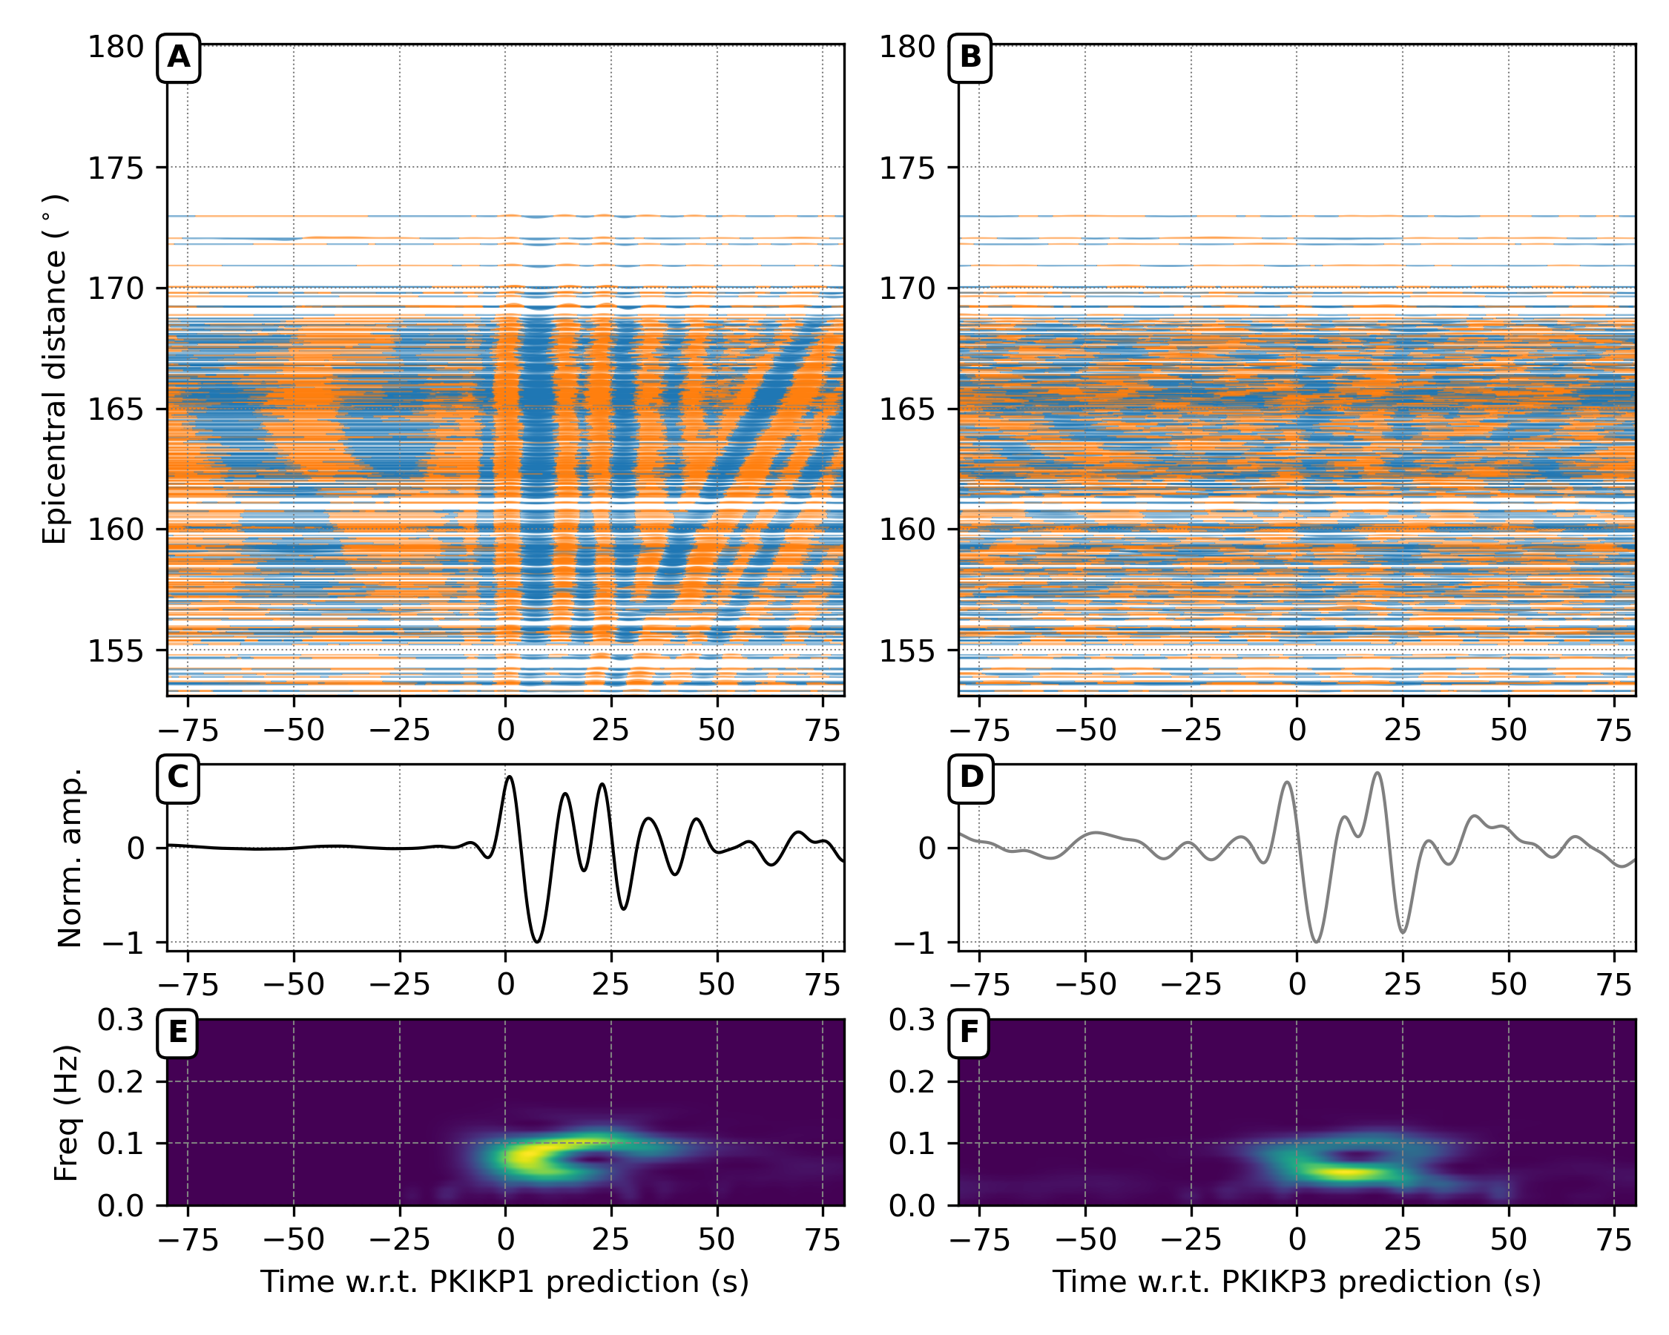
Figure S5. Observations of PKIKP2 and PKIKP4 phases in the seismic wavefield from Mw 6.9 Tonga region, 19/06/2019. (A) Seismic records from the Alaskan network are aligned predictions of PKIKP1 arrivals, corrected by the Earth’s ellipticity (Kennett & Gudmundsson, 1996). The waveforms are bandpass filtered in the period band of 7–13 seconds. (B) Linear stack of individual waveforms. (C) The spectrograms of stacked waveforms prior to filtering show the frequency content variation as a function of time. (D, E, F) Similar to A), B), C) but for the PKIKP1 arrivals.
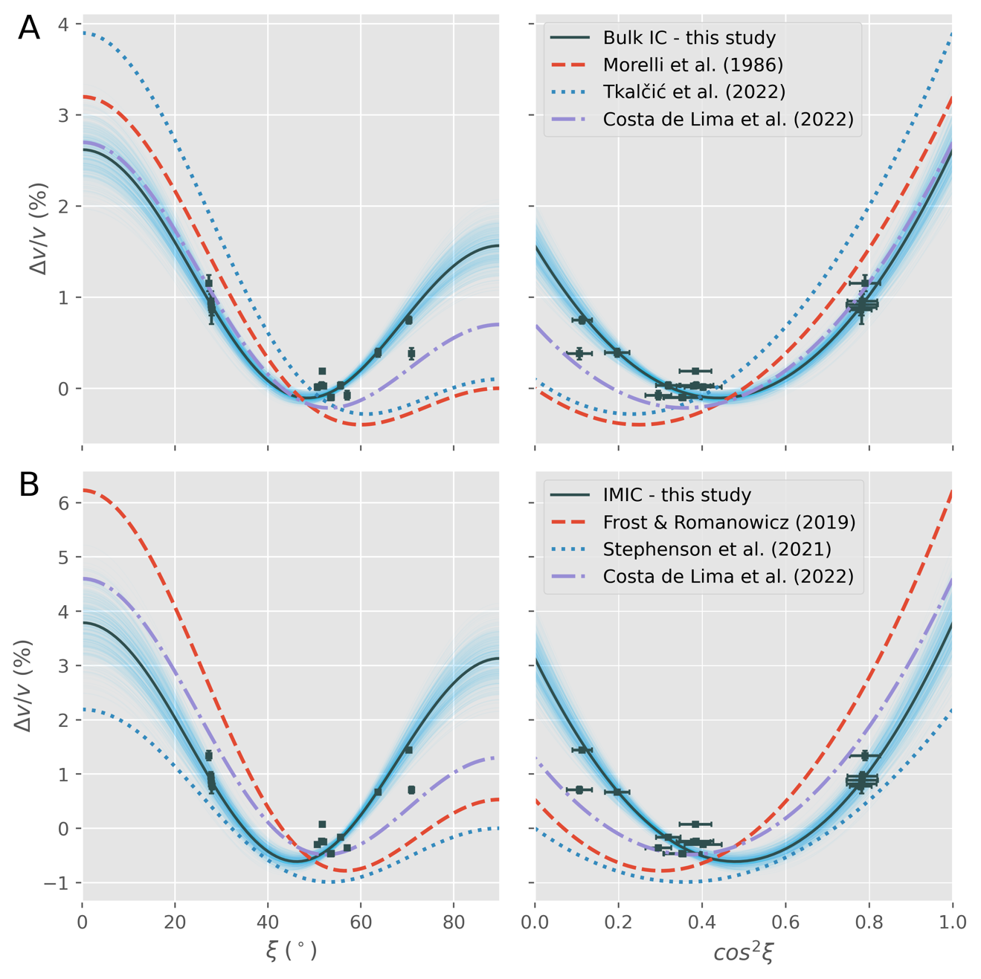
Figure S6. Cylindrically anisotropic model of Earth’s inner core inferred from exotic PKIKP multiples. In the left-hand-side panel, measurements and anisotropic models are plotted as a function of $ξ$, the angle of the ray path to the rotation axis. The mathematically convenient dependent variable, $\cos^{2}{ξ}$, is used in the right-hand-side panels. In all panels, differential residual measurements, where mantle heterogeneities are corrected for using the LLNL_G3Dv3 model (Simmons et al., 2012), with associated uncertainties are plotted by dark squares with error bars. Dark solid lines are the optimal anisotropic models parameterized in Equation 4, and light blue opaque lines represent the uncertainty surrounding the optimal model. Various broken lines show models from previous studies included in the legends. The top row (A) compares our inferred bulk IC model, while the bottom row (B) compares our inferred IMIC model with its predecessors.

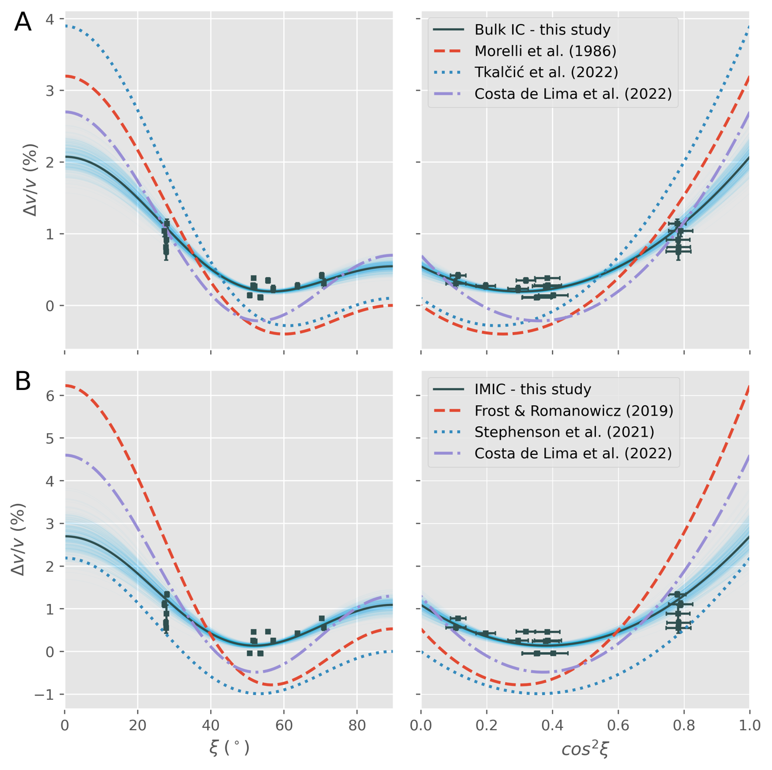
Figure S7. Similar to Figure S6, mantle heterogeneities are corrected for using the MIT-P08 model (C. Li et al., 2008).

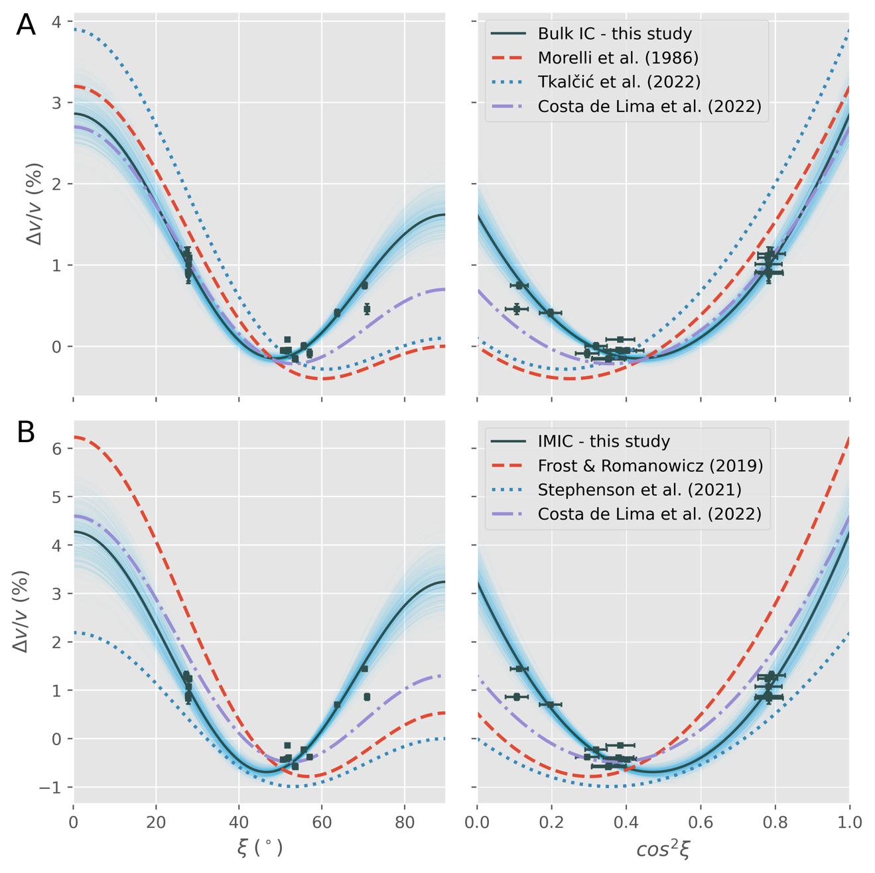
Figure S8. Similar to Figure S6, but mantle heterogeneities are not considered in this case.

