Supplementary Data

Table S1. Description of the antibodies used for immunofluorescence in this study
Antibody | Dilution | Source
Rabbit anti-DNMT2 | 1/100 | Abcam
Rabbit anti-WTAP | 1/50 | Abcam
Rabbit anti-MBD2 | 1/250 | Novus Biologicals
Rabbit anti-YTHDF2 | 1/50 | Proteintech
Chicken anti-FMRP #C10 | 1/100 | Kindly provided by Dr. E.W. Khandjian (El Fatimy et al., 2012)
Rabbit anti-ALKBH5 | 1/100 | Sigma-Aldrich
Rabbit anti-FTO | 1/200 | OriGene
Alexa-fluor 488 anti-rabbit | 1/1000 | Invitrogen
Alexa-fluor 488 anti-chicken | 1/1000 | Biotium

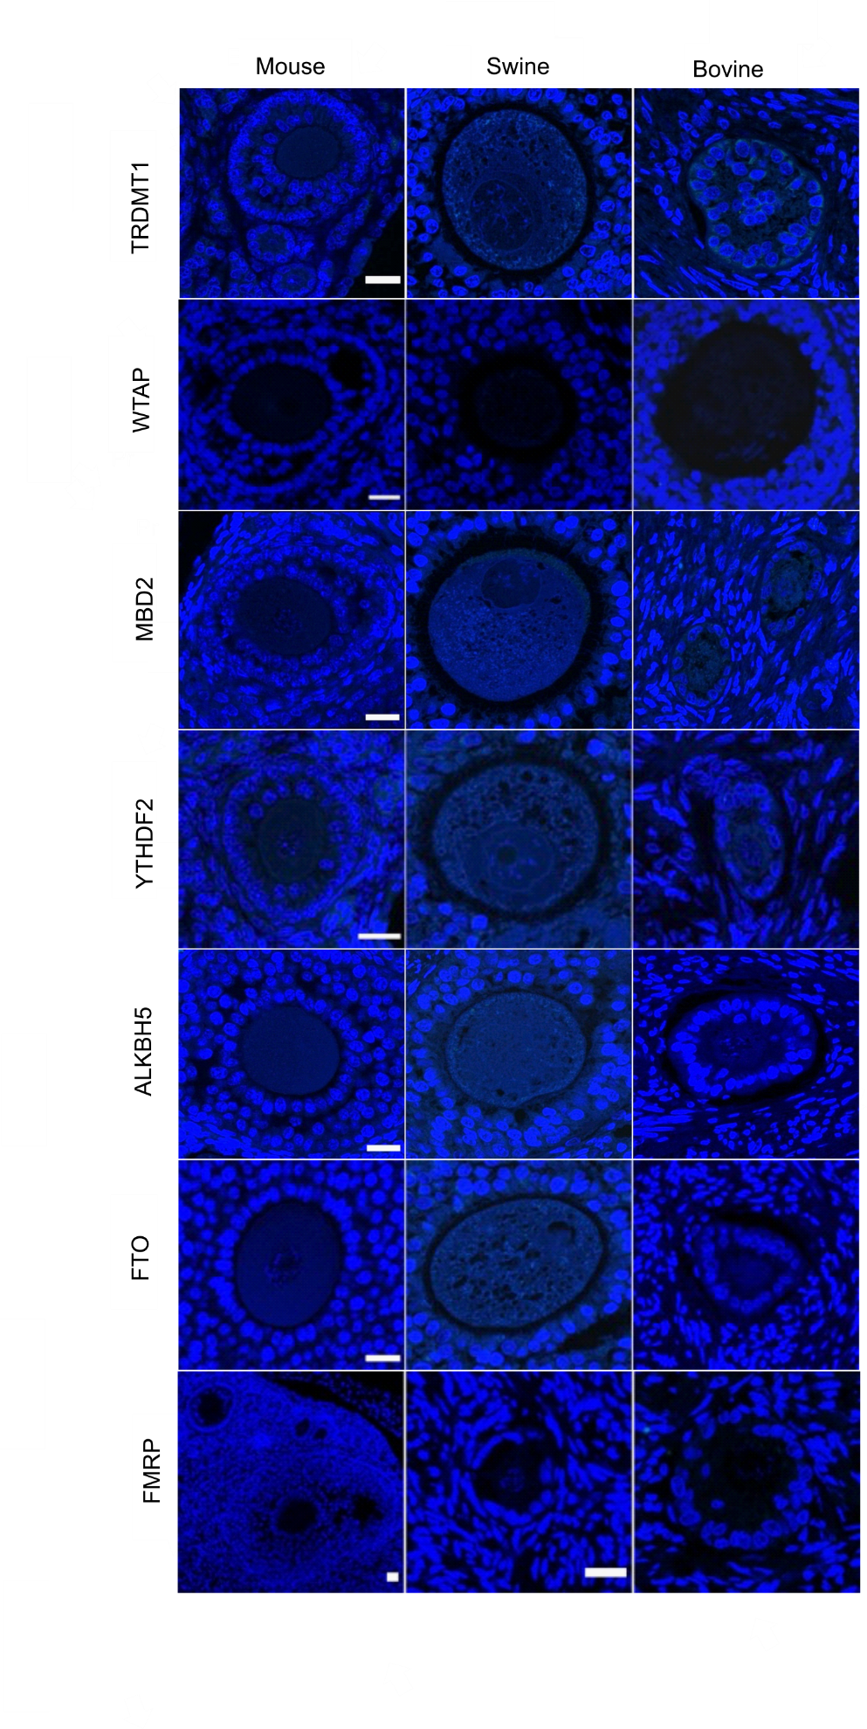
Fig. S1. Ovarian section in paraffin, negative control without primary antibody, showing no specific staining by the secondary antibody. DNA is stained with Hoescht 33342 (blue). Bar = 20 µm.

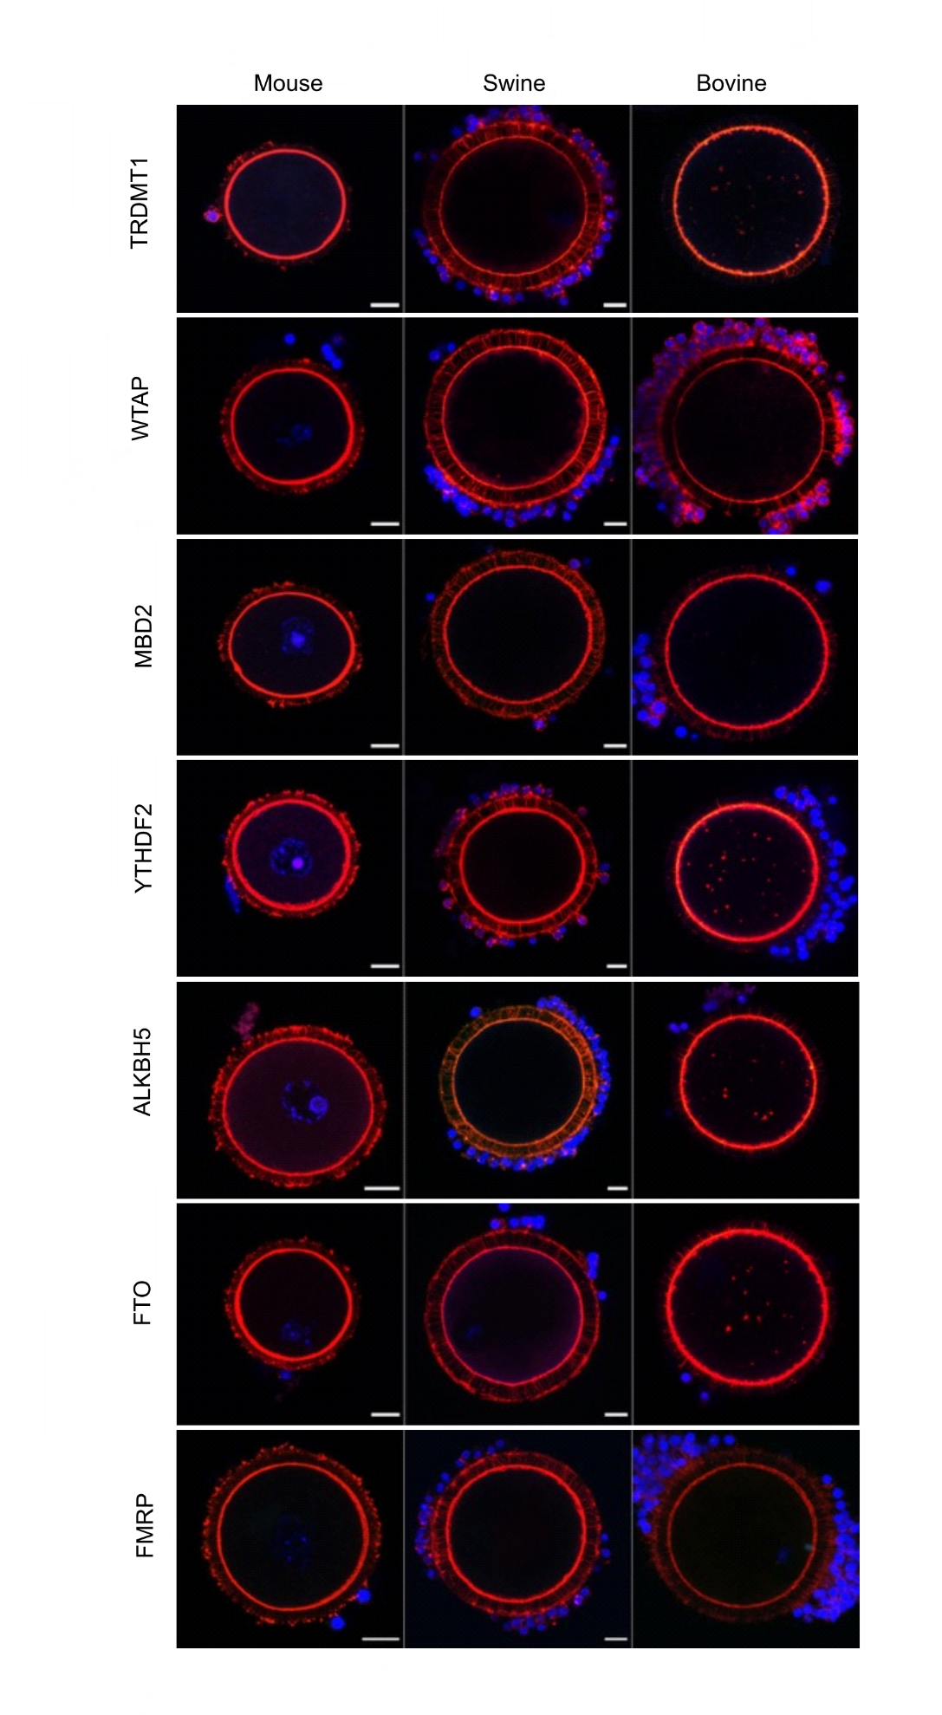
Fig. S2. Oocyte whole mount, negative control without primary antibody, showing no specific staining by the secondary antibody. DNA is stained with Hoescht 33342 (blue) and actin with Acti-stain 555 phalloidin (red). Bar = 20 µm (same magnification was used for swine and bovine).

