Supplementary Material
- Supplementary Figure 1

- Prognostic analysis of CCDC103 in generalized carcinoma.
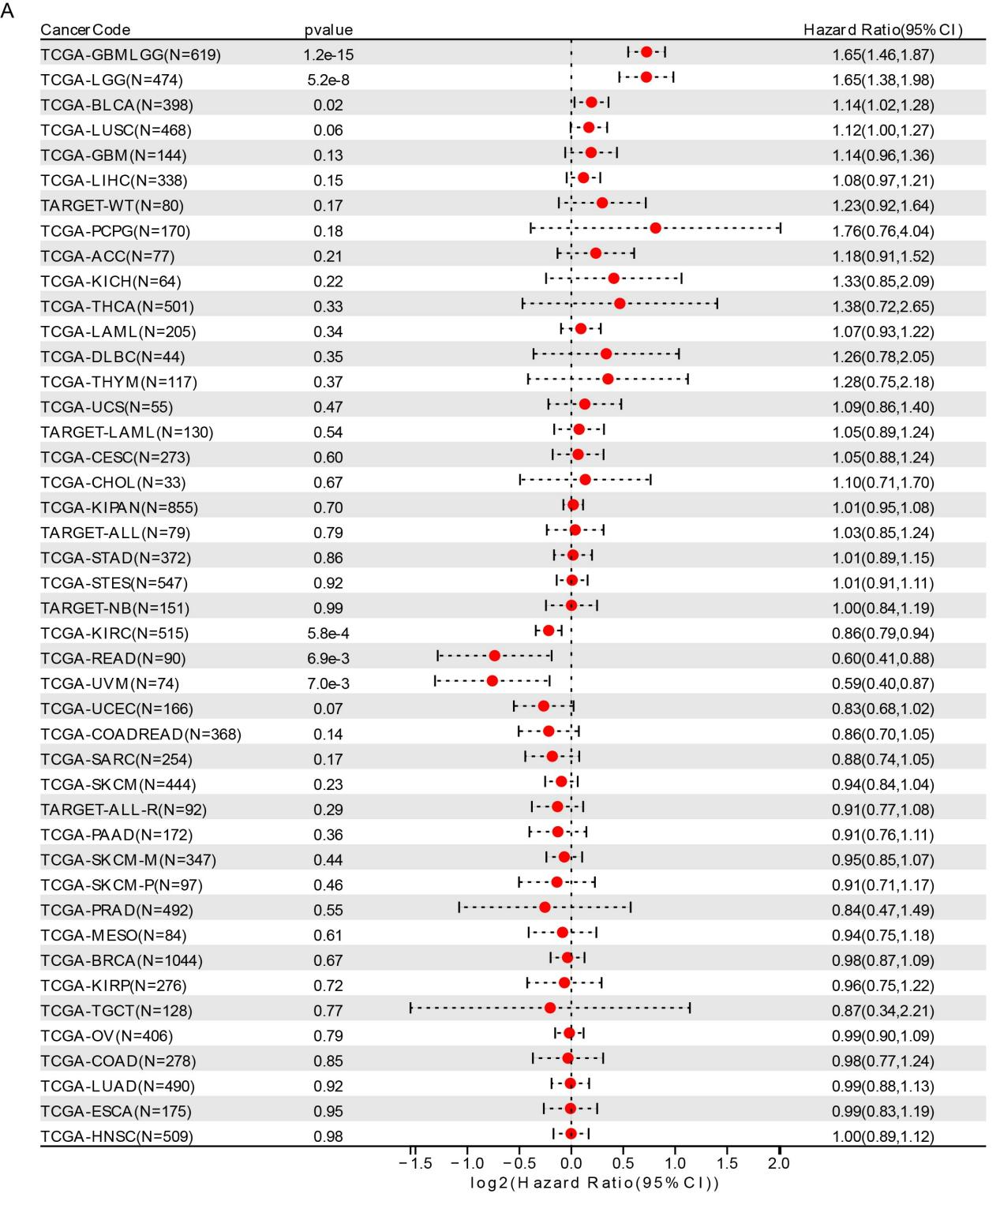
- Supplementary Figure 2
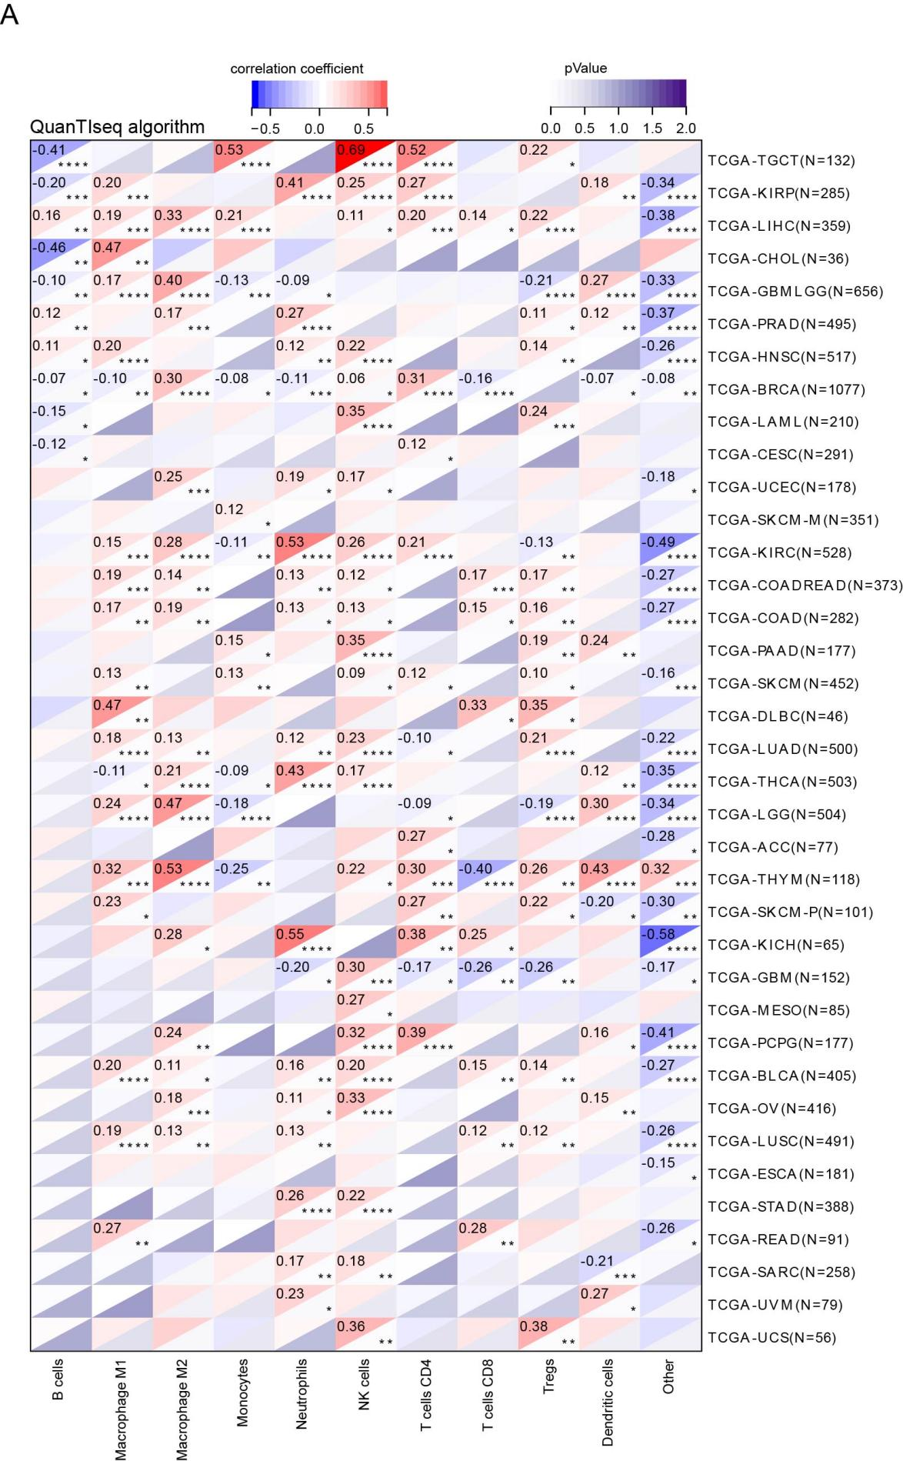
- The correlation between CCDC103 and immune infiltration in generalized carcinoma was analyzed based on QuanTIseq algorithm.

- Supplementary Figure 3
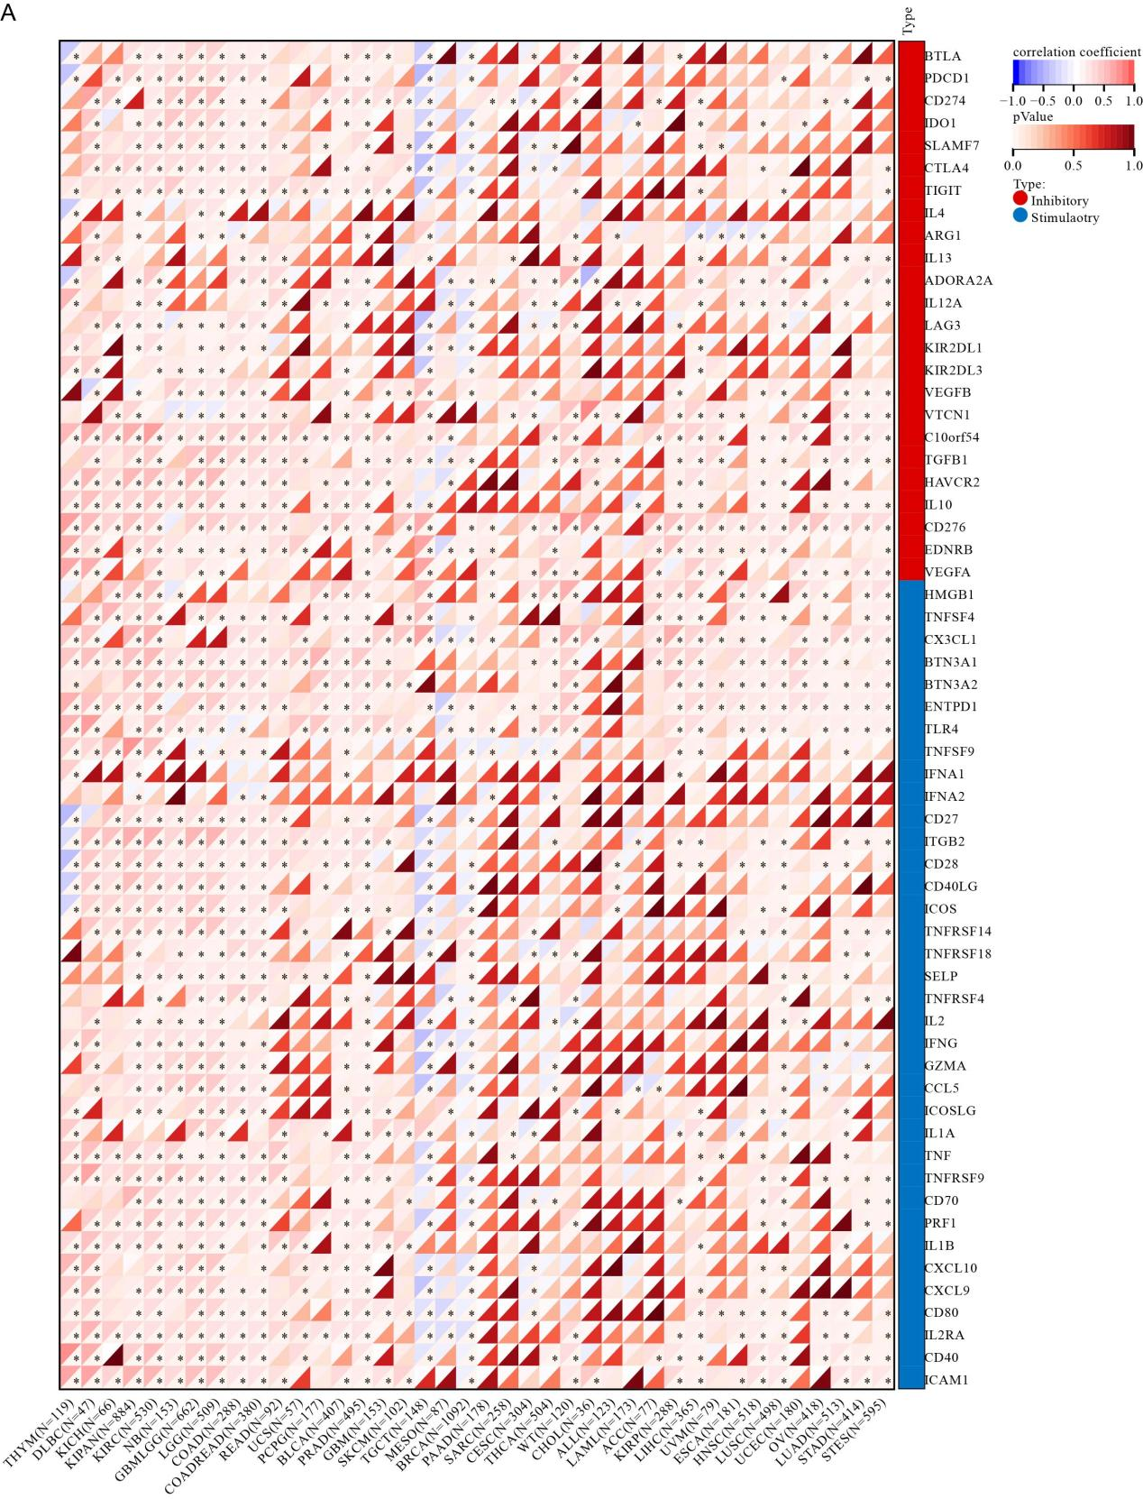
- The correlation between CCDC103 and immune checkpoint molecules in generalized carcinoma.

