IQI 11 composite Models:

- HGLR selected Features included in the interaction logistic regression model
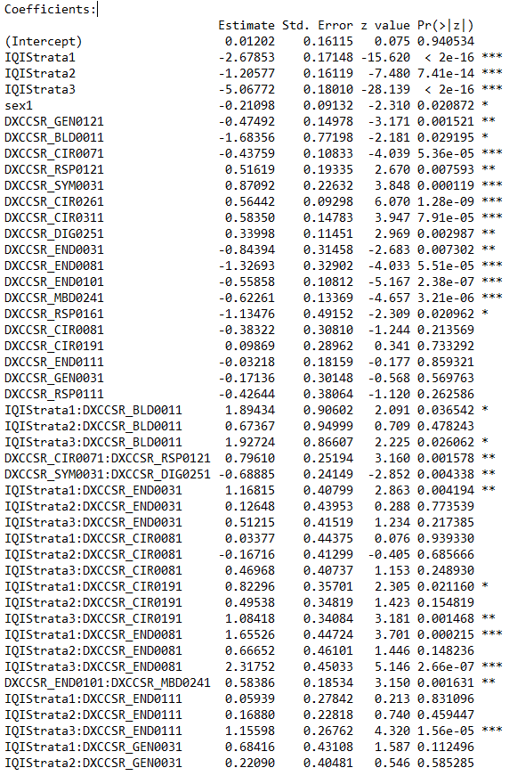

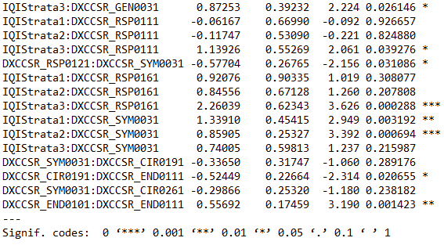

- LASSO selected Features included in the interaction logistic regression model

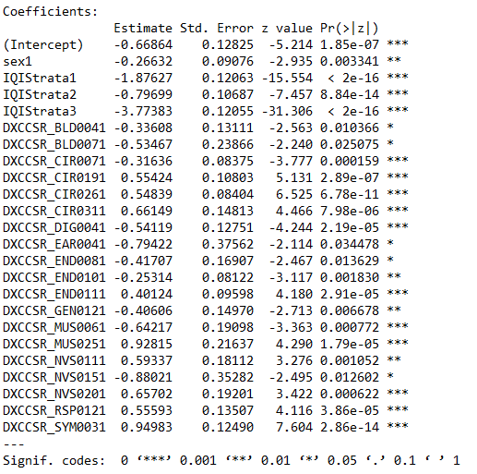

IQI 09 composite Models:

- HGLR selected Features included in the interaction logistic regression model
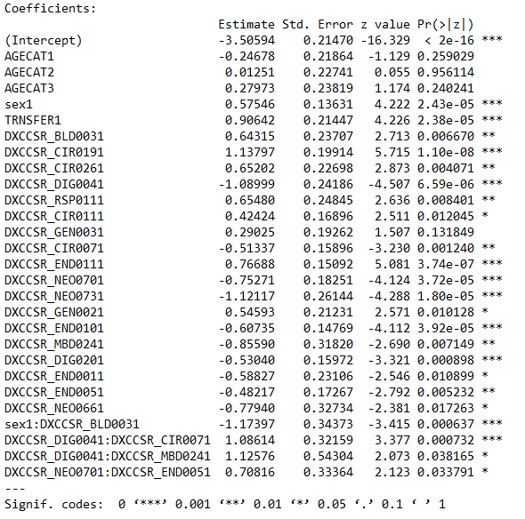

- LASSO selected Features included in the interaction logistic regression model

