Cellulosic biomass-derived carbon quantum dots: "On-off-on" nanosensor for rapid detection of multi-metal ions and green photocatalytic CO₂ reduction in water

Sebastian Raja^{a,b}*, Gelson T.S.T. da Silvaª, Sellamuthu Anbu^{c}, Caue Ribeiro^{a,b} Luiz H. C. Mattosoª

ªNational Nanotechnology Laboratory for Agribusiness (LNNA), Embrapa Instrumentação, São Carlos-SP, 13560-970, Brazil
^{b}Department of Chemistry, Federal University of São Carlos (UFSCar), 13565-905, São Carlos, São Paulo, Brazil
^{c}Depts. of Chemistry and Biomedical Sciences, University of Hull, Cottingham Road, Hull, HU6 7RX, UK.

*Email: sebastianrajaorg@gmail.com.

CONTENTS
Fig. S1 Photostability test of macaúba derived CQDs
Fig. S2 Physicochemical characterisations of CQDs
Fig. S3 Ionic stability of CQDs
Table S1 Comparison of the present study with other reported CQDs for Cu²⁺ detection.
Table S2 Comparison of the present study with other reported CQDs for Hg²⁺ detection.
Fig. S4 Fluorescence "on-off-on" profiles of CQDs
Fig. S5 The light spectrum of the fluorescence lamp used in the photoreduction of CO₂.
References

Fig. S1 Photostability test of macaúba derived CQDs (A) and Rhodamine B (B) at constant illumination of UV light at various time points.

Fig. S2 Physicochemical characterisations of CQDs. (A) Normalized PL emission spectra of CQDs (excitation wavelengths ranging from 340 nm to 520 nm). . B) Zeta potential of CQDs concerning various pH ranges.

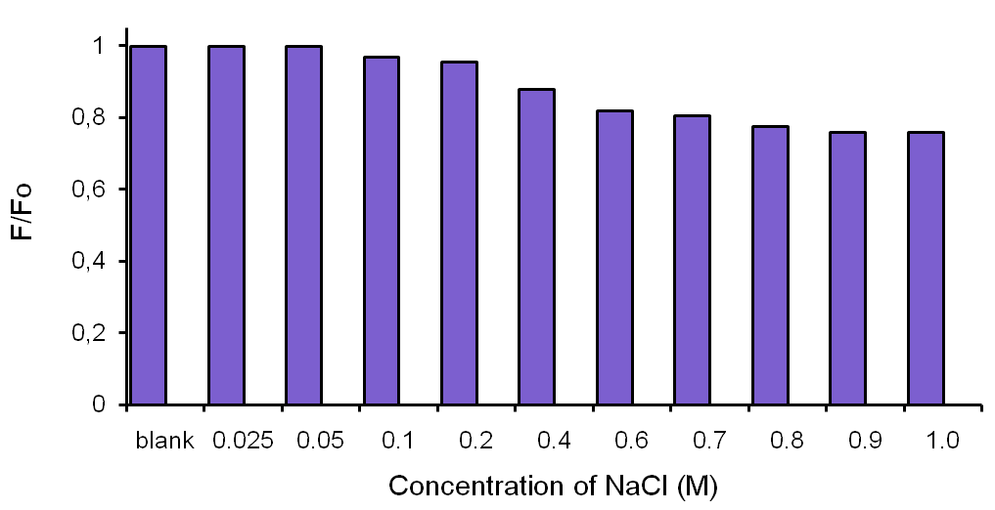

Fig. S3 Ionic stability of CQDs (50 μgmL⁻¹) at various molar (M) concentration of NaCl under PL spectroscopy.

Table S1 Detection of Cu²⁺ ions by representative CQDs derived from various natural sources.
Carbon source | Passivating agent | Linear range (µM) | LOD (µM) | Reference
Acacia Concinna | - | 0.01- 10 | 0.0043 | Bhamore et al. 2017
Lily Bulbs | - | 0.05–2.0 | 0.0012 | Gu et al. 2018
Spirulina powder | - | 0.01–0.1 | 0.011 | Emami et al. 2018
Coccinia Indica | L-cysteine | 0-0.025 | 0.045 | Radhakrishnan et al. 2018
CitricAcid | PEI | 0.37–2.5 | 0.63 | Salinas-Castillo et al. 2018
Acrocomia Aculeate | - | 0-25 | 0.99 | This work

Table S2. Detection of Hg²⁺ ions by representative CQDs derived from various natural sources.
Carbon source | Passivating agent | Linear range (µM) | LOD (µM) | Reference
Psidium Guajava | - | 6-38 | 82 | Khose et al. 2018
Citric Acid | melamine | 2-14 | 0.44 | Pajewska-Szmyt et al. 2018
Hongcaitai | - | 0.2 - 15 | 0.06 | Li et al. 2018
Cellulose | Ionic liquid | 6–80 | 1.6 | Wang et al. 2018
oil palm empty fruit | diethylenetriamine | 0–50 | 0.01 | Issa et al. 2018
Highland Barley | ethanediamine | 10–160 | 0.48 | Xie et al. 2018
Acrocomia Aculeate | - | 0-60 | 0.25 | This work

Fig. S4 Fluorescence "on-off-on" profiles of CQDs (50 μg mL⁻¹). (A) Titration profiles of CQDs (50 μg mL⁻¹) with AA (0-100 μM) in water. (B) Linear relationship of the change in the PL intensity at 452 nm versus the concentration of AA.
Fig. S5 The light spectrum of the fluorescence lamp used in the photoreduction of CO₂.

References
Bhamore JR, Jha S, Park TJ, Kailasa SK (2017) Fluorescence sensing of Cu²⁺ ion and imaging of fungal cell by ultra-small fluorescent carbon dots derived from Acacia concinna seeds. Sens Actuators B 277: 47–54.
Gu D, Zhang P, Zhang L, Liu H, Pu Z, Shang S (2018) Nitrogen and phosphorus co-doped carbon dots derived from lily bulbs for copper ion sensing and cell imaging. Optical Materials 83: 272–278.
Emami E, Mousazadeh MH J (2021) Green synthesis of carbon dots for ultrasensitive detection of Cu²⁺ and oxalate with turn on-off-on pattern in aqueous medium and its application in cellular imaging. Photochem Photobiol 418: 113443.
Radhakrishnan K, Panneerselvam P, Marieeswaran M (2019) A green synthetic route for the surface-passivation of carbon dots as an effective multifunctional fluorescent sensor for the recognition and detection of toxic metal ions from aqueous solution. Anal Methods 11: 490–506.
Salinas-Castillo A, Morales DP, Lapresta-Fernandez A, Ariza-Avidad M, Castillo E, Martınez-Olmos A, Palma AJ, Capitan-Vallvey LF (2016) Evaluation of a reconfigurable portable instrument for copper determination based on luminescent carbon dots. Anal Bioanal Chem 408: 3013–3020.
Khose RV, Chakraborty G, Bondarde MP, Wadekar PH, Ray AK, Som S (2021) Red-fluorescent graphene quantum dots from guava leaf as a turn-off probe for sensing aqueous Hg(ii). New J Chem 45: 4617–4625.
Pajewska-Szmyt M, Buszewski B, Gadzała-Kopciuch R (2020) Carbon dots as rapid assays for detection of mercury(II) ions based on turn-off mode and breast milk. Spectrochim Acta A Mol Biomol Spectrosc 236: 118320.
Li L-S, Jiao X-Y, Zhang Y, Cheng C, Huang K, Xu L (2018) Green synthesis of fluorescent carbon dots from Hongcaitai for selective detection of hypochlorite and mercuric ions and cell imaging. Sens Actuator B Chem 263: 426–435.
Wang CY, Wang CF, Xu PP, Li AQ, Chen YJ, Zhuo KL (2016) Synthesis of cellulose-derived carbon dots using acidic ionic liquid as a catalyst and its application for detection of Hg²⁺. J Mater Sci 51: 861–867.
Issa, MA, Zentou H, Jabbar ZH, Abidin ZZ, Harun H, Halim NAA, Alkhaded MM, Pudza MY (2022) Ecofriendly adsorption and sensitive detection of Hg (II) by biomass-derived nitrogen-doped carbon dots: process modelling using central composite design. Environ Sci Pollut Res https://doi.org/10.1007/s11356-022-21844-0.
Xie Y, Cheng D, Liu X, Han A (2019) Green Hydrothermal Synthesis of N-doped Carbon Dots from Biomass Highland Barley for the Detection of Hg²⁺. Sensors 19: 3169.

