Supplemental Table S1. Variations in the 16S ribosomal RNA operon copy number in genomes

Name of Mycoplasma, Ureaplasma and other bacteria | 16S ribosomal RNA  operon copy number
Bacillus cereus | 13
Clostridium difficile | 12
Aeromonas hydrophila | 10
Clostridium perfringens | 10
Enterobacter aerogenes | 8
Enterobacter cloacae | 8
Klebsiella pneumoniae | 8
Bacteroides vulgatus | 7
Escherichia coli | 7
Streptococcus agalactiae | 7
Bacteroides fragilis | 6
Enterococcus faecium | 6
Bacteroides distasonis | 5
Staphylococcus aureus | 5
Staphylococcus epidermidis | 5
Staphylococcus haemolyticus | 5
Staphylococcus lugdunensis | 5
Enterococcus faecalis | 4
Lactobacillus acidophilus | 4
Lactobacillus crispatus | 4
Paptostreptococcus magnus | 4
Paptostreptococcus prevotii | 4
Pseudomonas aeruginosa | 4
Streptococcus mitis | 4
Eubacterium lentum | 3
Campylobacter jejuni | 3
Propionibacterium acnes | 3
Acinetobacter calcoaceticus | 2
Gardnerella vaginalis | 2
Ureaplasma parvum | 2
Ureaplasma urealyticum | 2
Mycoplasma hominis | 2
Mycoplasma genitalium | 1
Mycoplasma pneumoniae | 1

(Copyright: Ueno T. et al. PLoS One. 2015 Jun 4;10(6):e0129032.)
Supplemental Table S2. Validation of the measurement errors among 10 different quantification trials using the same Escherichia coli (ATCC25922) solution

Trial No. | Bacterial count  /PCR tube | Difference from the average | Measurement error  from the average (%)
1 | 304 | -14.1 | -4.43
2 | 311 | -7.1 | -2.39
3 | 326 | 7.9 | 2.48
4 | 325 | 6.9 | 2.17
5 | 303 | -15.1 | -4.75
6 | 311 | -7.1 | -2.23
7 | 322 | 3.9 | 1.23
8 | 322 | 3.9 | 1.23
9 | 333 | 14.9 | 4.68
10 | 324 | 5.9 | 1.85
average | 318.1
range | 303 to 333 | -15.1 to 14.9 | -4.75 to 4.68

Supplemental Table S3. Interpretative criteria for the Tm mapping method

Difference Value (D) | Suitability for identification | Identification | Interpretation
0.0 ≤ D ≤ 0.28 | High | All identification results within this range have the same possibility of being the bacterial isolate | Matched the bacteria registered in the database
0.28 < D ≤ 0.5 | Medium  to  Low | The identification result with the lowest Difference Value is highly likely to be the bacterial isolate | Mutant strain, or  Polymicrobial infection*¹
0.5 < D | Not suitable | Does NOT identify the bacterial isolate | Polymicrobial infection*², or  Not registered in the database, or Under the limit of identification*³

(Copyright: Niimi H. et al. Scientific Reports, 2015 Jul 28; 5:12543)

*1: Polymicrobial infection with one dominant bacterial species
*2: Polymicrobial infection with no dominant bacterial species
*3: Under the limit of identification but over or equal to the limit of detection

Supplemental Table S4. A comparison of the identification results between the original protocol for the Tm mapping method and the modified protocol for the Tm mapping quantification method

 | Using the original protocol  for the Tm mapping method |  |  |  | Using the modified protocol  for the Tm mapping quantification method
DNA template | 2 μL |  |  |  | 10 μL
1st PCR | 40 cycles |  |  |  | 30 cycles
Dilution | 1/ 500 |  |  |  | 1/ 100
2nd PCR | 30 cycles |  |  |  | 35 cycles
Trials | Tm values of 1st trial | Tm values of 2nd trial | Tm values of 3rd trial | Tm values of NC | Tm values of 1st trial | Tm values of 2nd trial | Tm values of 3rd trial | Tm values of NC
Region 1 | 89.50 | 89.60 | 89.50 | N.D | 89.60 | 89.60 | 89.75 | N.D.
Region 2 | 88.85 | 88.85 | 88.60 | N.D. | 88.85 | 88.85 | 88.90 | N.D.
Region 3 | 89.75 | 90.00 | 89.65 | N.D. | 89.90 | 89.90 | 89.85 | N.D.
Region 4 | 90.25 | 90.25 | 90.15 | N.D. | 90.25 | 90.25 | 90.25 | N.D.
Region 5 | 86.75 | 86.75 | 86.40 | N.D. | 86.75 | 86.75 | 86.65 | N.D.
Region 6 | 88.10 | 88.15 | 87.85 | N.D. | 88.10 | 88.10 | 88.15 | N.D.
Region 7 | 87.75 | 87.90 | 87.90 | N.D. | 88.00 | 87.90 | 88.25 | N.D.
Identification results | E. coli | E. coli | E. coli | N.D. | E. coli | E. coli | E. coli | N.D.
Diff. Value | 0.24 | 0.26 | 0.19 | - | 0.25 | 0.19 | 0.24 | -

We checked the difference between the identification results using the original protocol for the Tm mapping method and the modified protocol for the Tm mapping quantification method. As a result, no significant differences were observed between the original and modified protocols.
NC = negative control, Diff. Value = Difference Value, N.D. = not detected

Supplemental Figure S1. Bacterial contamination in vacuum blood collection tubes

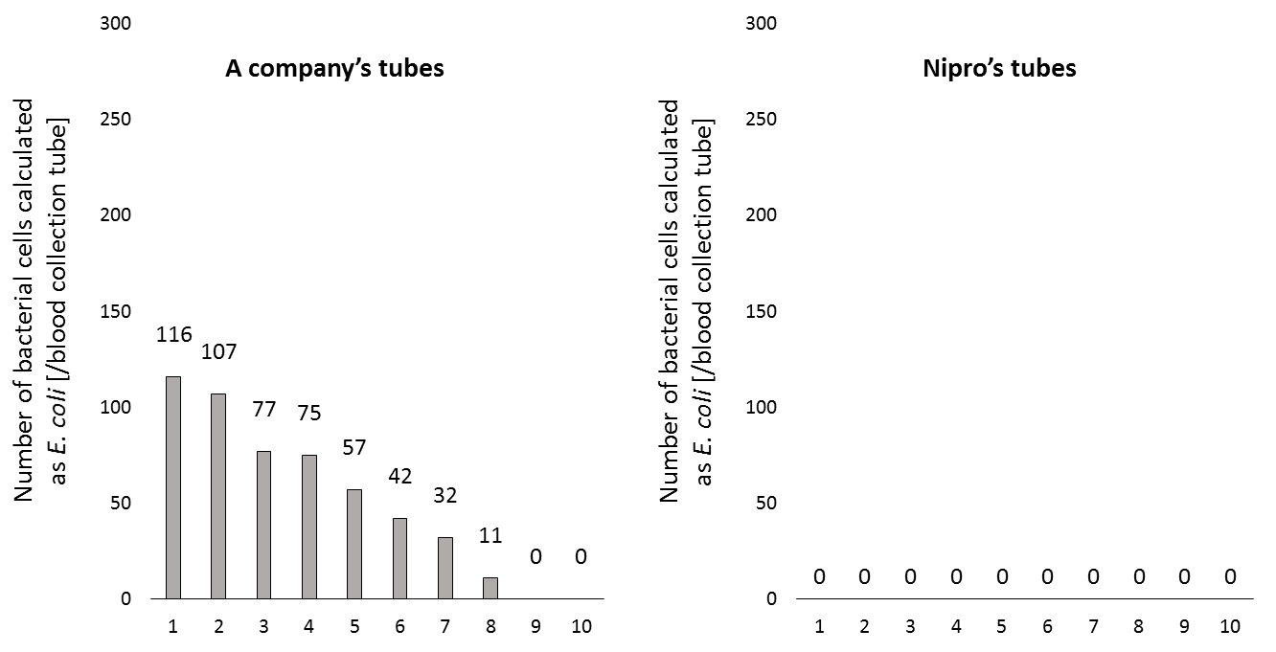
Vacuum blood collection tubes (n = 10)
Vacuum blood collection tubes (n = 10)

To check whether or not vacuum blood collection tubes were contaminated with bacterial DNA, we added 2 mL each of molecular-grade distilled water to 10 vacuum blood collection tubes (EDTA-2K) and tried to detect and quantify the bacterial DNA in the tubes. We performed pelletizing, DNA extraction, and a quantitative polymerase chain reaction assay according to the protocol described in the Methods section. As a result, bacterial DNA were detected in 8 of the 10 commercially available tubes. Those bacteria could not be identified using the Tm mapping method (Diff. Value > 0.5) as they were not registered in the database, so the bacterial concentrations were quantified as Escherichia coli. The average number of bacteria was 65/blood collection tube. In contrast, no bacteria were detected in any of Nipro′s tubes (OP-BF0205-1; bacterial DNA contamination-free vacuum blood collection tubes). Error bars indicate triplicate testing.

