Archives of Microbiology
Supplementary Material

Methylobrevis albus sp. nov., isolated from fresh water lake sediment

Qi-Hang Zou¹, Xi Feng¹, Tao-Jie Wang¹ and Zong-Jun Du^{1,2}
¹Marine College, Shandong University, Weihai, Shandong, 264209, PR China
²State Key Laboratory of Microbial Technology, Shandong University, Qingdao, Shandong, 266237, PR China

Author for correspondence:
Zong-Jun Du, Email: duzongjun@sdu.edu.cn
Tel and Fax: +86-631-5688303
ORCID ID: 0000-0002-7886-5667

Fig. S1. Phylogenetic analysis of 16S rRNA gene sequences of performed with the NJ tree showing the phylogenetic position of strain L22^{T} among closely related taxa. Escherichia coli KCTC 2441^{T} was used as an outgroup.
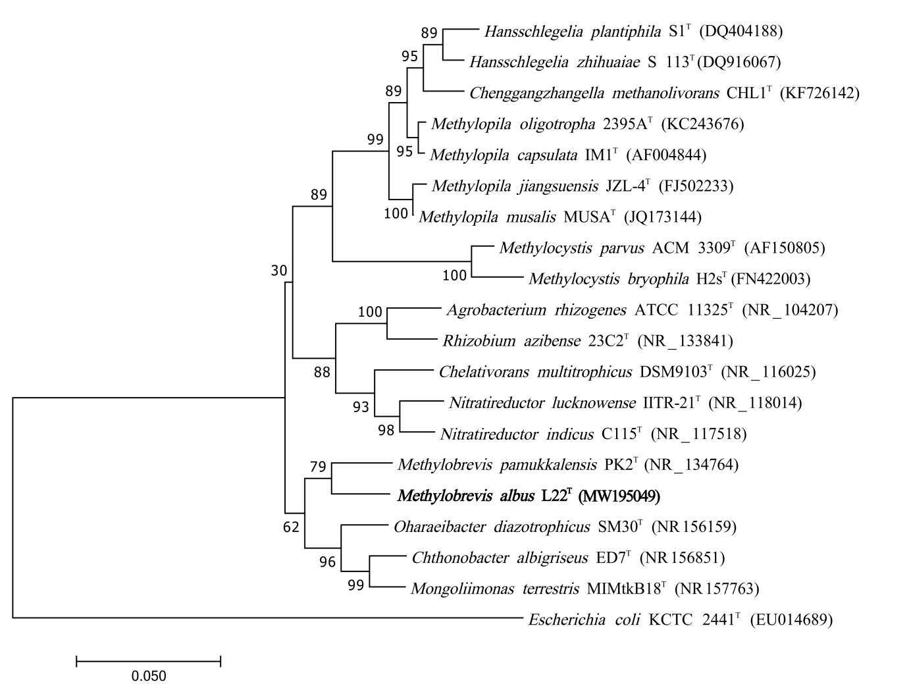

Fig. S2. Transmission electron micrograph of cells of strains L22^{T}.
Cells were grown on R₂A at 30 °C for 3 days. Bar, 0.5 μm.
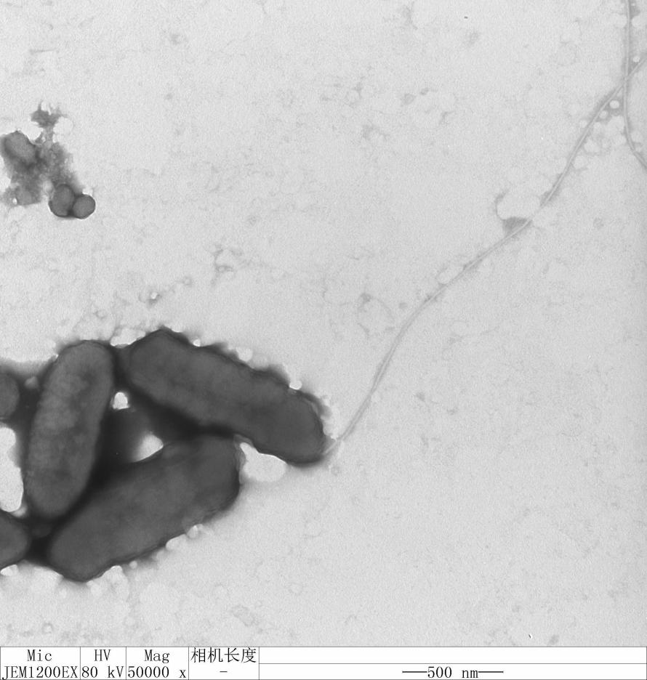

Fig. S3. Polar lipid profiles of strain L22^{T} and its related strain after two-dimensional TLC and detection with molybdphosphoric acid.
Strains: (a) L22^{T}; (b) M. Methylobrevis JCM 30229^{T}.
The polar lipids were identified as follows: phosphomonoester (PME); phosphatidylethanolamine (PE); phosphatidylglycerol (PG); phosphatidylcholine (PC); unidentified lipids (L); unidentified phospholipids (PL); unidentified glycolipids (GL).
