Bombax Ceiba Flower Extract Induced Surface Groups on to Enhance Antibacterial Activity and Urea Detection
Muhammad Waqasª, Sidra Aslamª, Misbah Akramª, Adnan Khaliq^{b}, Samreen Ahsan^{b}, Atif Liaqat^{b}, Misbah Mirza^{c}, Muhammad Safdarª*, Waseem Akhtar Qureshi*^{d}
ªInstitute of Chemistry, Khwaja Fareed University of Engineering and Information Technology, Rahimyar Khan,Pakistan,
bDepartment of food sciences and engineering, Khwaja Fareed University of Engineering and Information Technology, Rahimyar Khan,Pakistan
^{c}Department of Physics, The Women University Multan. Pakistan
^{d}Department of Forestry, Range and Wildlife Management, Baghdad–ul–Jadeed Campus, The Islamia University of Bahawalpur-63100, Pakistan
*Corresponding Authors: safdarsami@yahoo.com, waseemfo@yahoo.com, waseem.akhtar@iub.edu.pk

Supplementary Data

The milk samples were prepared using the following steps:

Removal of fat and protein
Milk contains numerous biological components which may interact with the synthesized nanoparticles. To remove this uncertainty, milk fat and protien was separated from test sample for accurate results. For this purpose, 10 mL of raw milk was transferred into centrifuge tube along with 2.5mL of Potassium hexacyanoferrate (K₄Fe (CN)_{6.}H₂O and 2.5mL of Zinc Sulphate Zn(SO₄). The complete solution was then subjected to mixing/shaking for 1-2 minutes.
Figure S1: Preparation of milk sample

The final milk solution obtained was centrifuged twice at 4500 rpm for 5 minutes and at 10500 rpm for 10 minutes. The centrifuged sample was filtered through a 0.22 μM filter paper and supernatant was separated by the help of syringe in a clean beaker and again filtered with Whatman filter paper.
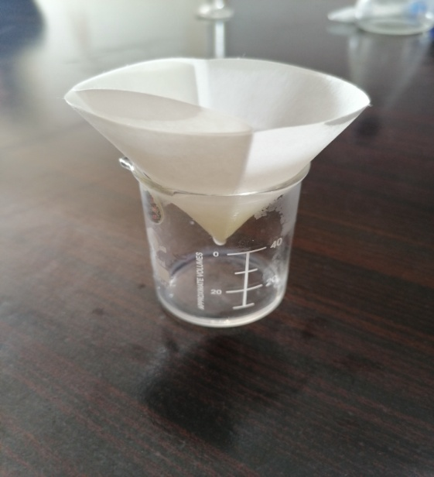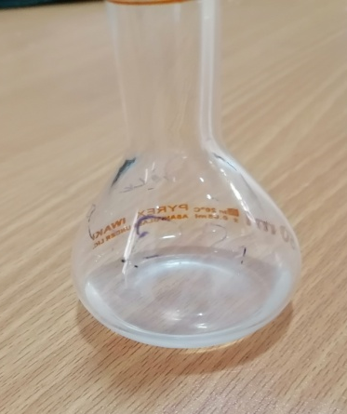
a
b
Figure S2: (a) Filtration of milk sample; (b) Filtered sample

pH adjustment
The pH of filtered samples was adjusted to 8.0 by using 1 mM solution of HCL/NaOH as shown in Figure. 3.8. After that, It was stored at 4⁰C for further use. The final prepared solution was then used for the detection of adulterant by using selenium nanoparticles.
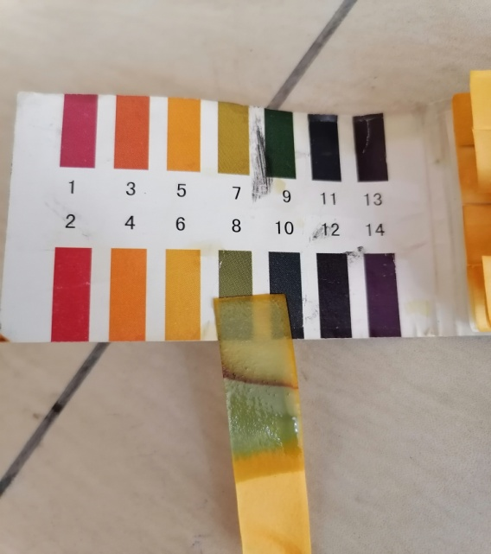
Figure S3: pH adjustment to 8.0

Solution preparation for Adulterants
The 5mL of urea was added intentionally into milk solution in order to confirm potential of Se nanoparticles to detect adulterant. Stock solution was prepared in distilled water. Different standard stock of urea was prepared by varying the amount at concentration of 10, 20, 30, 40mM.

Preparation of adulterated milk
2mL milk sample was incorporated with 50µL of SeNps solution, following by dropwise addition of sub-stock solutions containing urea with vigorous mixing. However, control examination was carried out by using dual distilled water in spite of milk so that this can be examined using UV–Vis spectrophotometer. This sample was carried out with exact moderate ratio but at this time the results were recorded in the format of UV–visible spectroscopy graphs.

Urea identification in pure milk
Figure S4: Urea identification in pure milk (treated)

