Supplementary Material

for the manuscript entitled
Two-Step Approaches to Overcome Data Imbalance in the Development of an Electrocardiography Data Quality Assessment Algorithm: A Real-World Data Challenge

S. Jayakumar Venkat,¹ Hyoung Woo Chang,¹ Hyun Joo Kim,² Yang Hyun Cho,³ Jee Yang Lee,¹ Kyunghee Koo,¹

¹Department of Thoracic and Cardiovascular Surgery, Seoul National University Bundang Hospital, Gyeonggi-do, Republic of Korea
²Department of Anesthesiology and Pain Medicine, Anesthesia and Pain Research Institute, Yonsei University College of Medicine, Seoul, Republic of Korea
³Department of Thoracic and Cardiovascular Surgery, Samsung Medical Center, Seoul, Republic of Korea

Table of Contents

Section 1. Examples of each quality class
S1a. acceptable class segments
S1b. unacceptable class segments
S1c. uncertain class segments

Section 2. Fundamentals of feature extraction

Section 3. Feature extraction algorithms
S3a. Algorithms to extract time domain features (pseudocode)
S3b. Algorithms to extract frequency domain features (pseudocode)

Section 4. Loss graphs of the 2D CNN approaches
S4a. Loss graphs of the one-step three-class 2D CNN
(acceptable, unacceptable and uncertain)
S4b. Loss graphs of the first-step binary 2D CNN classifier of the two-step approach
(acceptable vs. unacceptable + uncertain)
S4c. Loss graphs of the second-step binary 2D CNN classifier of the two-step approach
(unacceptable vs. uncertain)

Section 5. Confusion matrices of the raw test data for the four approaches: 3 ✕ 3 and 2 ✕ 2
S5a. The one-step three-class random forest approach
S5b. The one-step three-class 2D CNN approach
S5c. The two-step binary sequential random forest approach
S5d. The two-step binary sequential 2D CNN approach

Section 1. Examples of each quality class
S1a. acceptable class segments
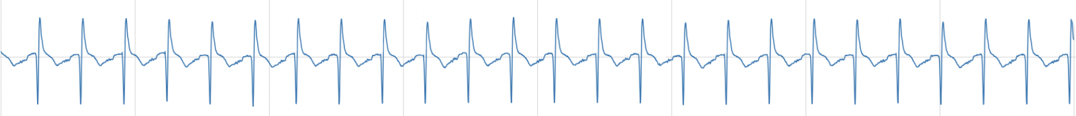
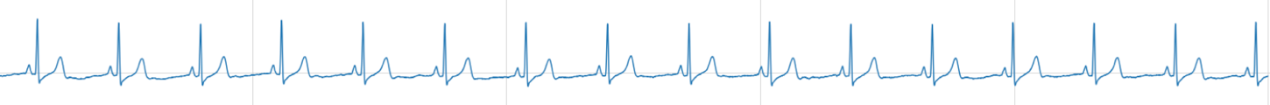

S1b. unacceptable class segments
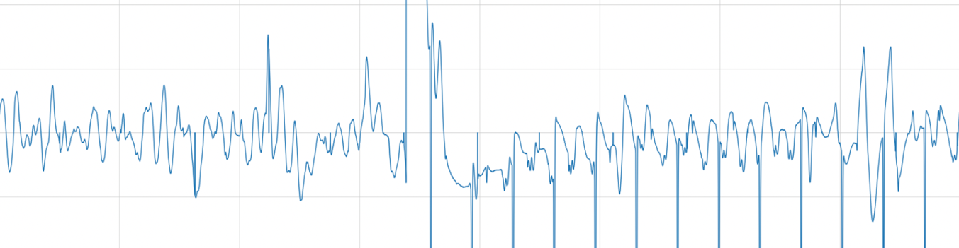
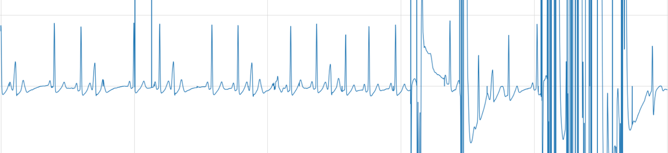

S1c. uncertain class segments
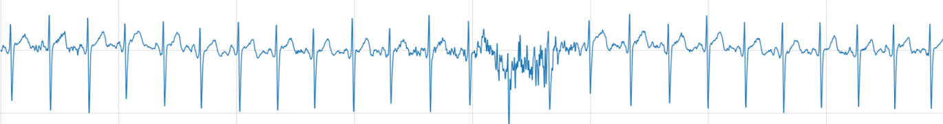
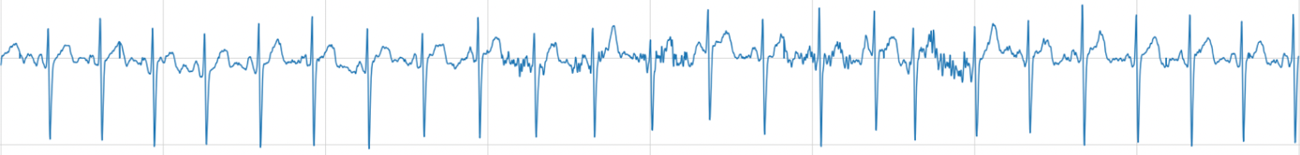

Section 2. Fundamentals of feature extraction
- Slope—The slope of the rising edge (Q-R) of the ECG signal is calculated using the peaks of the signal and the peaks of the negated signal. The slope calculation is shown in Section 3 (lines 35-40).
- Peak amplitude—Peak amplitudes are obtained using the heartpy peak detection routine from the filtered signal. The same process is used to obtain peaks from the negated signal.
- Z score—The Z score is computed for the peak amplitudes obtained from the filtered signal. It is also computed for the peak amplitudes obtained from the negated signal.
- Signal-to-noise ratio—The SNR is computed as the ratio of the mean to the standard deviation of the signal.
- Auto Correlation—The statsmodel python package is used to compute the auto correlation for every 1000 samples of the signal. The same process is applied to the negated signal. Lags is set to 3.
- Cross correlation—To extract the amount of similarity between 2 time series, the scipy.signal.correlate package is used to compute cross correlations between 2 nonoverlapping subsegments with 1000 samples from the signal. The same process is also applied to the negated signal.
- Skew—The skew is computed from the filtered signal using the scipy.stats package.
- Kurtosis—Kurtosis is computed from the signal as well as the negated signal using the scipy.stats package.
- Dynamic Time Warping—The dtaidistance package is used to compute the dynamic time warped distance between 2 nonoverlapping subsegments with 1000 samples from the signal. The same process is also applied to the negated signal.
- Hurst exponent—The Hurst exponent shows the degree of persistence or anti-persistence of a time series. The Hurst Python package is used to compute the Hurst exponent of the signal. The Hurst exponent is also calculated for the negated signal.
- maxpower—From every 1000 samples of the signal, the maximum power is obtained after a Fourier transformation. The same process is applied to the negated signal. The MaxPower computation is shown in Figure 2.
- maxpowerdiff—Power values obtained from every 1000 samples of the signal are sorted in descending order. The difference between the first 5 power values is obtained to capture information in the power signatures of acceptable, unacceptable, and uncertain signals. This is shown in Section S3b.
- meanfreqdiff—Frequency windows with the maximum power in every 1000 samples are obtained. The meanfreqdiff computation is shown in Section S3b.
- Short-time Fourier transforms (STFT) are computed using scipy.signal.stft to convert the signal into the time-frequency domain.
- Spectral Entropy—The Neurokit2 python package is used to compute spectral entropy. The signal’s normalized power distribution in the frequency domain is treated as a probability distribution, and its Shannon entropy is computed. Similarly, spectral entropy is computed for the negated signal.
- First derivative—The first derivative of the ECG signal is a popular feature to detect the rate of change. Sharp peaks and notches result in large fluctuations in the derivative.
- Second derivative—The second derivative of the ECG signal is also taken, although applications of this derivative in ECG analysis or classification are less than those of the first derivative.

Section 3. Feature extraction algorithms

S3a. Algorithms to extract time domain features (pseudocode)
1: N = 5000
2: sf = 250
3: x = 1000
4: i = 0
5: j = 1000
6: signalfiltered ← filter(signal, ”bandpass”, [0.5, 8])
7: negsignalfiltered ← filter(−signal, ”bandpass”, [0.5, 8])
8: peaktimes, peakamplitudes ← getpeaks(signalfiltered)
9: peaktimesneg, peakamplitudesneg ← getpeaktimes(negsignalfiltered)
10: zscoretime ← zscore(peaktimes)
11: zscorenegtime ← zscore(peaktimesneg)
12: zscore ← zscore(peakamplitudes)
13: zscoreneg ← zscore(peakamplitudesneg)
14: meanpeakamplitudestotal ← []
15: maxpeakamplitudestotal ← []
16: minpeakamplitudestotal ← []
17: meanpeakintervalstotal ← []
18: maxpeakintervalstotal ← []
19: minpeakintervalstotal ← []
20: meanpeakamplitudesnegtotal ← []
21: maxpeakamplitudesnegtotal ← []
22: minpeakamplitudesnegtotal ← []
23: meanpeakintervalsnegtotal ← []
24: maxpeakintervalsnegtotal ← []
25: minpeakintervalsnegtotal ← []
26: slopes ← []
27: f′ ← gradient(signalfiltered)
28: f′′ ← gradient(f′)
29: acf ← autocorr(signalfiltered)
30: acfneg ← autocorr(negsignalfiltered)
31: skew ← skew(signalfiltered)
32: skewneg ← skew(negsignalfiltered)
33: kurtosis ← kurtosis(signalfiltered)
34: kurtosisneg ← kurtosis(negsignalfiltered)
35: snr ← mean(signalfiltered)/stddev(signalfiltered)
36: snrneg ← mean(negsignalfiltered)/stddev(negsignalfiltered)
37: he ← HurstExponent(signalfiltered)
38: heneg ← HurstExponent(negsignalfiltered)
39: crosscorr ← []
40: dtw ← []
41: skewchange ← []
42: skewchangeneg ← []
43: kurtochange ← []
44: kurtohangeneg ← []
45: for peaktime in peaktimes do
46: y ← getamplitudes(peaktime)
47: x ← max(peaktimesneg[peaktimesneg < peaktime])
48: y2 ← peakamplitudesneg(x)
49: slopes.insert((y − y2)/(peaktime − x))
50: end for
51: for i<N do
52: meanpeakamplitudestotal.insert(mean(peakamplitudes (i:i+x))
53: maxpeakamplitudestotal.insert(max(peakamplitudes (i:i+x)))
54: minpeakamplitudestotal.insert(min(peakamplitudes (i:i+x)))
55: meanpeakamplitudesnegtotal.insert(mean(peakamplitudesneg(i:i+x)) )
56: maxpeakamplitudesnegtotal.insert(max(peakamplitudesneg(i:i+x))) )
57: minpeakamplitudesnegtotal.insert(min(peakamplitudesneg(i:i+x)) )
58: meanpeakintervals.insert(mean(diff(peaktimes(i:i+x))) )
59: maxpeakintervals.insert(max(diff(peaktimes(i:i+x))) )
60: minpeakintervals.insert(min(diff(peaktimes(i:i+x))) )
61: meanpeakintervalsnegtotal.insert(mean(diff(peaktimesneg(i:i+x))) )
62: maxpeakintervalsnegtotalnegtotal.insert(max(diff(peaktimesneg(i:i+x))) )
63: minpeakintervalsnegtotal.insert(min(diff(peaktimesneg(i:i+x))) )
64: amplitudeskew.insert(skew(peakamplitudes(i:i+x)) )
65: amplitudeskewneg.insert(skew(peakamplitudesneg(i:i+x)) )
66: amplitudekurtosis.insert(kurtosis(peakamplitudes(i:i+x)) )
67: amplitudekurtosisneg.insert(kurtosis(peakamplitudesneg(i:i+x)) )
68: timeskew.insert(skew(peaktimes(i:i+x)) )
69: timeskewneg.insert(skew(peaktimesneg(i:i+x)) )
70: timekurtosis.insert(kurtosis(peaktimes(i:i+x)) )
71: timekurtosisneg.insert(kurtosis(peaktimesneg(i:i+x)) )
72: i = i + x
73: end for
74: i=0
75: for i<N do
76: for j+1000<5000 do
77: crosscorr.insert(crosscorr(signal[i : j]filtered, signal[j : j +1000]filtered))
78: crosscorrneg.insert(crosscorr(negsignal[i : j]filtered, negsignal[j : j + 1000]filtered))
79: dtw.insert(dynamicTimeWarping(signal[i : j]filtered, signal[j : j+1000]filtered))
80: dtwneg.insert(dynamicTimeWarping(negsignal[i :j]filtered, negsignal[j : j + 1000]filtered))
81: end for
82: i=j
83: j=j+1000
84: end for
85: featurespre ← [meanpeakamplitudestotal, maxpeakamplitudestotal, minpeakamplitudestotal, meanpeakamplitudesnegtotal, maxpeakamplitudesnegtotal, minpeakamplitudesnegtotal, meanpeakintervalstotal, maxpeakintervalstotal, minpeakintervalstotal, meanpeakintervalsnegtotal, maxpeakintervalsnegtotal, minpeakintervalsnegtotal, zscore, zscoreneg, zscoretime, zscorenegtime, slopes, crosscorr, dtw, crosscorrneg, dtwneg, f′, f′′, acf, acfneg, snr, snrneg, amplitudeskew, amplitudeskewneg, amplitudekurtosis, amplitudekurtosisneg, timeskew, timeskewneg, timekurtosis, timekurtosisneg]
86: for feature in featurespre do
87: features.insert(mean(feature))
88: features.insert(std(feature))
89: end for
90: features.insert(max(zscore))
91: features.insert(min(zscoreneg))
92: features.insert(he)
93: features.insert(heneg)

S3b. Algorithms to extract frequency domain features (pseudocode)
1: N = 5000
2: sf = 250
3: x = 1000
4: i = 0
5: freqwindow ← [1, 2, ...8]
6: meanfreqdiff ← []
7: meanpowerdiff ← []
8: maxpower ← []
9: stdpower ← []
10: stftneg ← abs(STFT(negsignalfiltered))
11: stft ← abs(STFT(signalfiltered))
12: seneg ← SpectralEntropy(negsignalfiltered)
13: se ← SpectralEntropy(signalfiltered)
14: for i<N do
15: powersample ← abs(FFT(signali:i+x))
16: maxpower.insert(max(powersample)
17: maxfreqbywindow ← []
18: for f in freqwindow do
19: r ← [f − 1, ..., f − .2, f − .1, f]
20: for s in r do
21: if powersample(s) == max(powersample) : maxfreqbywindow.insert(s)
22: end for
23: end for
24: meanfreqdiff.insert(mean(diff(maxfreqbywindow)))
25: meanpowerdiff.insert(mean(diff(sortdesc(maxpower)[:5])))
26: i ← i + x
27: end for
28: features.insert(stddev(meanfreqdiff))
29: features.insert(stddev(meanpowerdiff))
30: features.insert(mean(maxpower))
31: features.insert(stddev(maxpower))
32: features.insert(mean(stft))
33: features.insert(std(stft))
34: features.insert(mean(stftneg))
35: features.insert(std(stftneg))
36: features.insert(mean(seneg))
37: features.insert(std(seneg))
38: features.insert(mean(se))
39: features.insert(std(se))

Section 4. Loss graphs of the 2D CNN approaches

S4a. Loss graphs of the one-step three-class 2D CNN (acceptable, unacceptable, and uncertain)
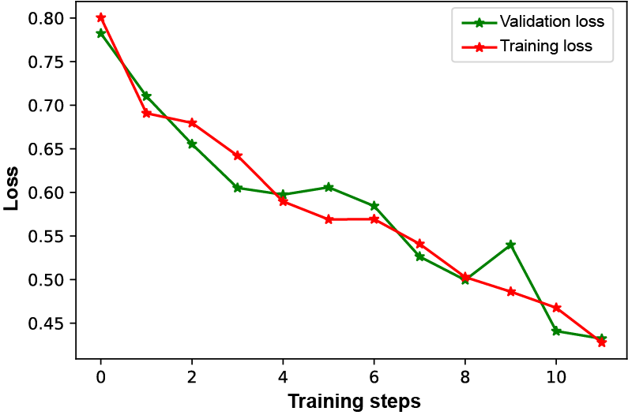

S4b. Loss graphs of the first-step binary 2D CNN classifier in the two-step approach (acceptable vs. the others (unacceptable + uncertain))
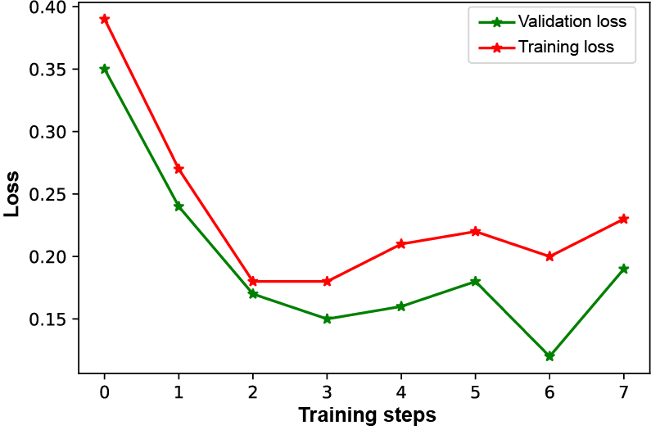

S4c. Loss graphs of the second-step binary 2D CNN classifier in the two-step approach (unacceptable vs. uncertain)
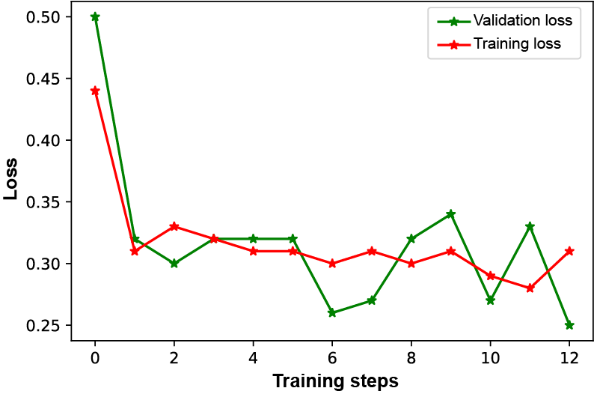

Section 5. Confusion matrices of the raw test data for the four approaches: 3 ✕ 3 and 2 ✕ 2

S5a. The one-step three-class random forest approach
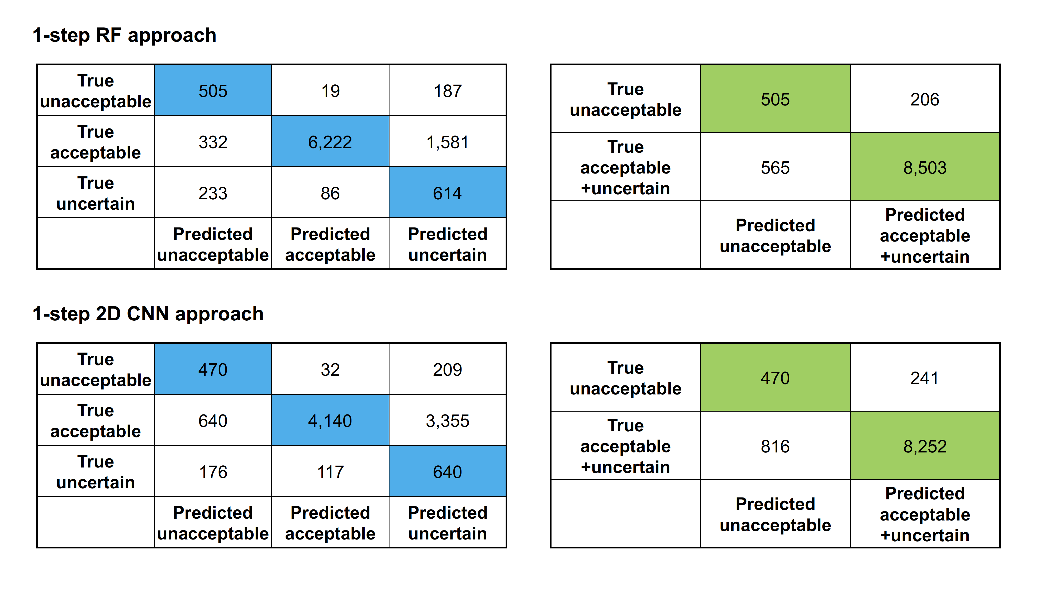

S5b. The one-step three-class 2D CNN approach

S5c. The two-step binary sequential random forest approach
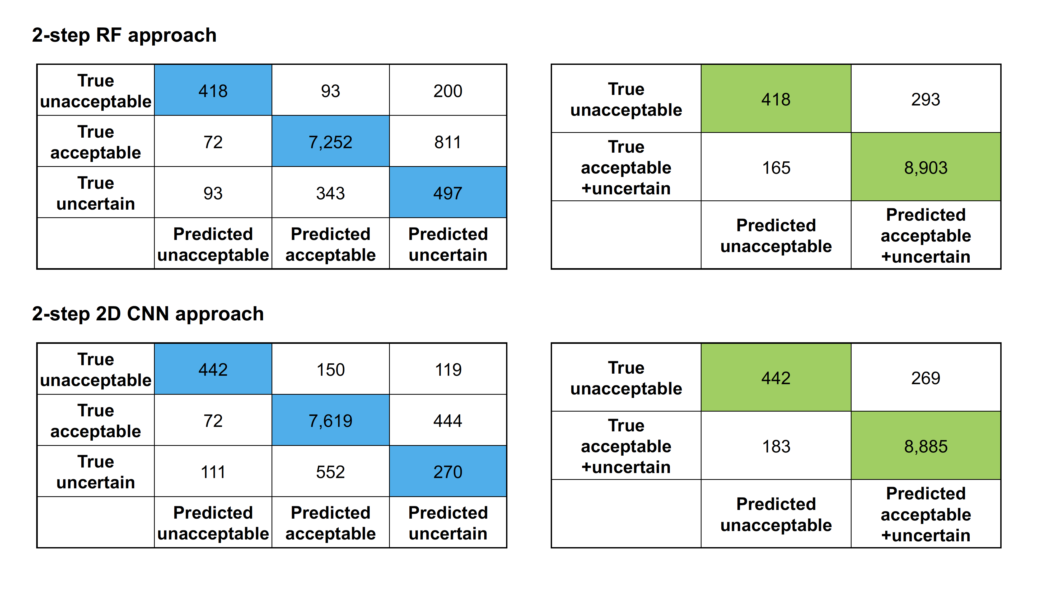

S5d. The two-step binary sequential 2D CNN approach

