Supplementary Materials for

Next generation pan-cancer blood proteome profiling using proximity extension assay

María Bueno Álvez¹, Fredrik Edfors¹, Kalle von Feilitzen¹, Martin Zwahlen¹, Adil Mardinoglu^{1,2}, Per-Henrik Edqvist³, Tobias Sjöblom³, Emma Lundin³, Natallia Rameika³, Tomas Axelsson⁴, Mikael Åberg⁴, Jessica Nordlund⁴, Wen Zhong⁵, Max Karlsson¹, Ulf Gyllensten³, Fredrik Ponten³, Linn Fagerberg¹ and Mathias Uhlén^{1,6*}

¹Science for Life Laboratory, Department of Protein Science, KTH-Royal Institute of Technology, Stockholm, Sweden; ²Kings College, UK, ³Department of Immunology, Genetics and Pathology, Uppsala University, Sweden; ⁴Department of Medical Sciences, Uppsala University, Sweden, ⁵Linköping University, Sweden and ⁶Department of Neuroscience, Karolinska Institutet, Stockholm, Sweden.

* Corresponding author

This PDF file includes:
Figures S1 to S7
Captions for Data S1 to S4

Other Supplementary Materials for this manuscript include the following:
Data S1 to S4

Figure S1
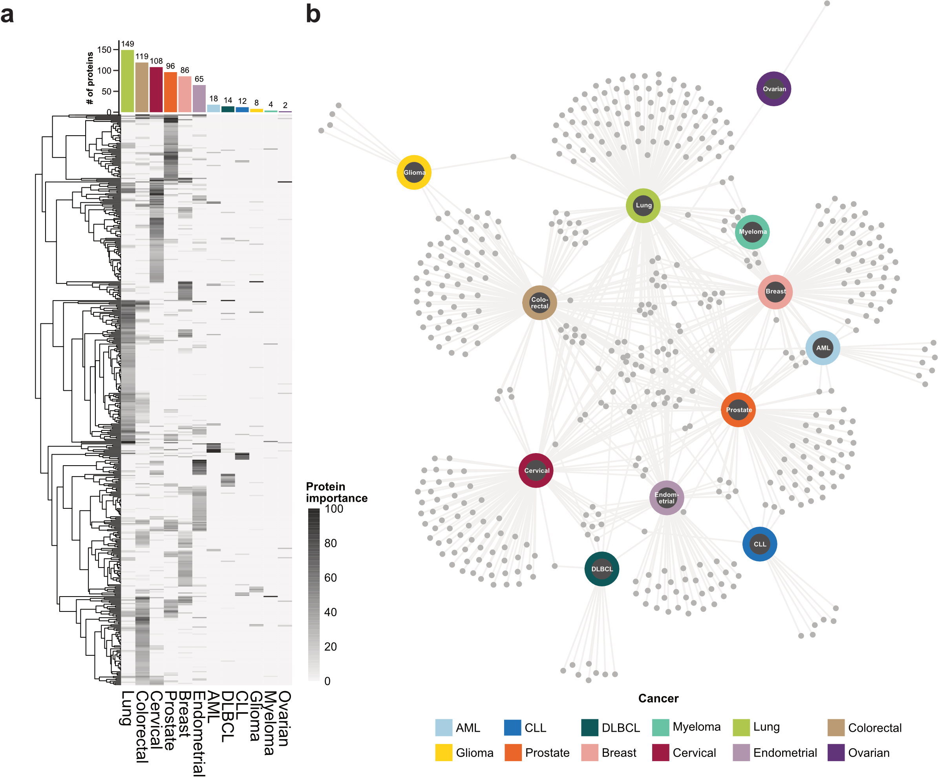
Fig S1 | Protein importance in the glmnet cancer prediction models. a, Heatmap visualization of importance score across cancers for proteins with > 25% importance in one cancer (n=486), where each row represents one protein. The barplot shows the number of proteins with >25% importance in each of the cancers. b, Network visualization of importance score across cancers for proteins with > 25% importance in one cancer (n=486), where each grey dot represents a protein.

Figure S2
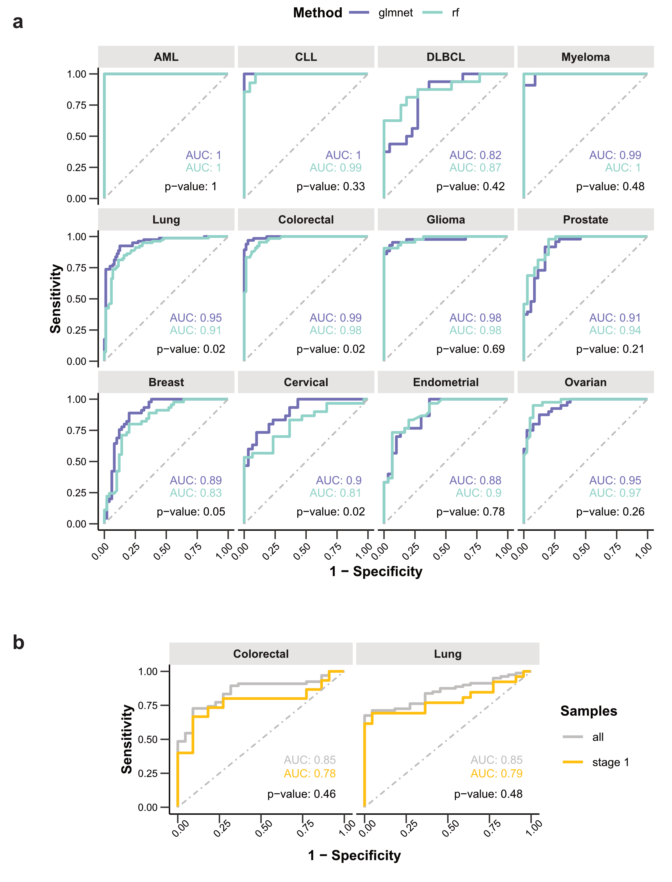
Fig. S2 | ROC curves for the prediction of the 12 cancer types based on all measured proteins (n = 1,463). a, A ROC curve is shown for the glmnet and random forest prediction model built for each cancer. The corresponding AUC is shown, together with the p-value from a paired DeLong test. b, ROC curves for colorectal and lung cancer based on samples from all stages and only stage 1 samples. The p-value is calculated using unpaired DeLong’s test.
Figure S3
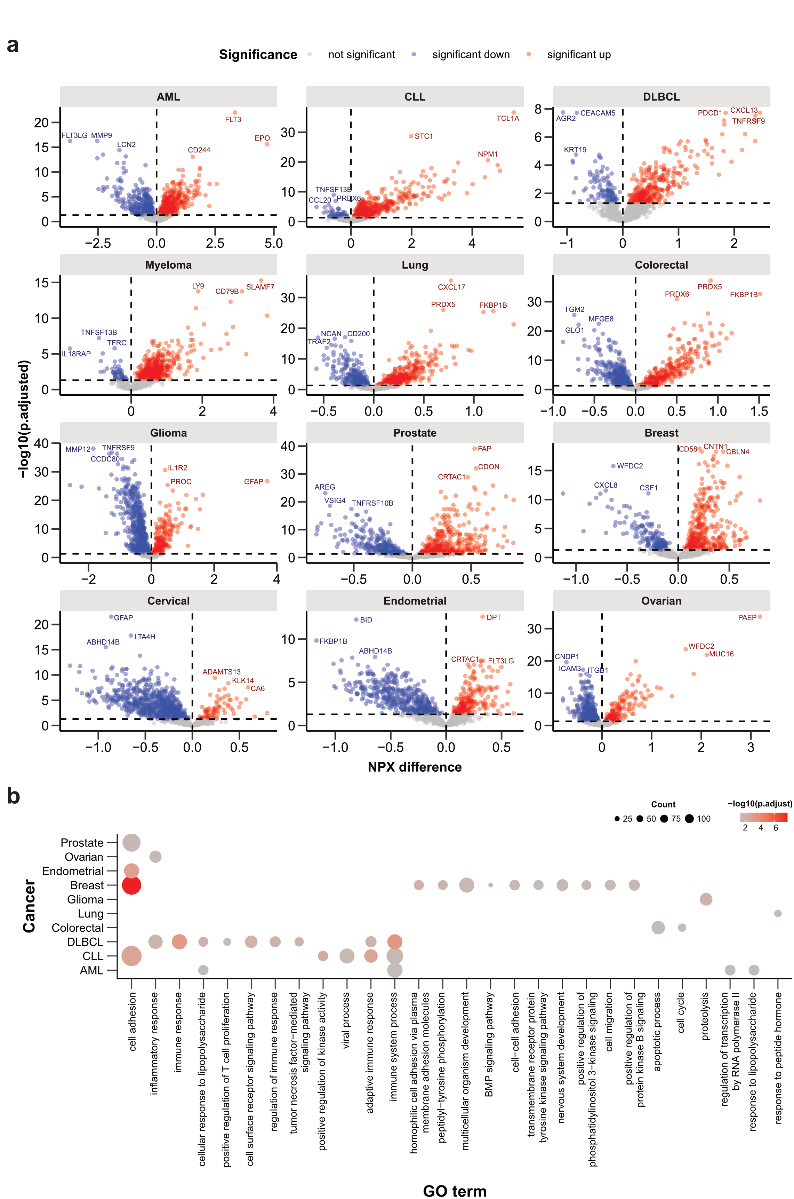
Fig. S3 | Differential expression and GO enrichment analysis for each cancer. a, Volcano plots based on differential expression analysis for each cancer against all other cancers. The y-axis corresponds to the adjusted p-value, while the x-axis shows the difference in average protein expression (NPX) in a specific cancer compared to all other cancers. b, GO enrichment analysis based on upregulated proteins per cancer. The plot shows Biological Processes (BP) terms enriched in each of the upregulated protein sets. The dot size is proportional to the number of genes associated to a specific GO term while the color indicates the significance of the association.

Figure S4
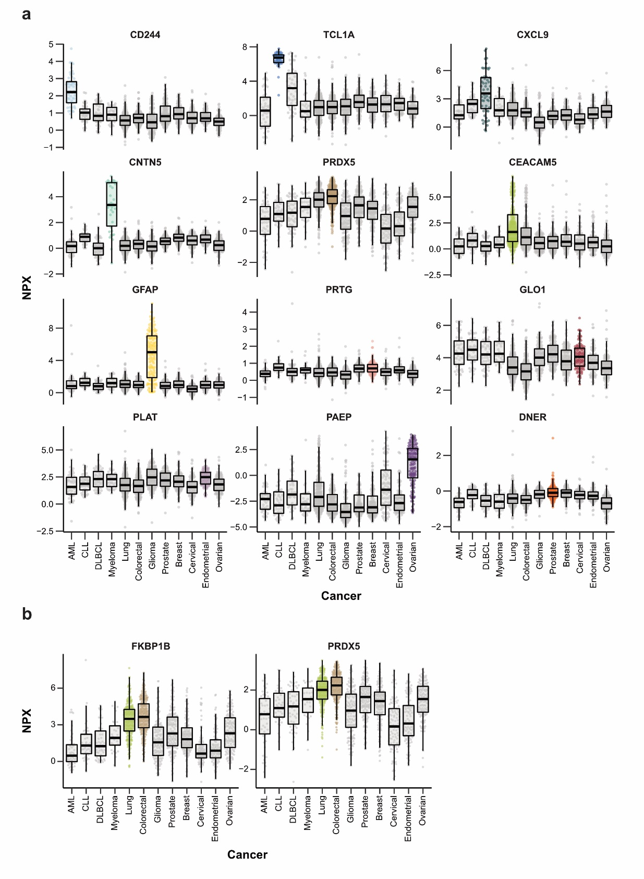
Fig. S4 | Pan-cancer expression profiles for selected panel proteins. a, The boxplots show the NPX values of the most important protein in the panel for each of the cancers across all cancer patients. The cancer where the protein has been identified to be of highest importance is highlighted. b, The boxplots show the NPX values of the two proteins selected for more than one cancer (FKBP1B and PRDX5) across all cancer patients.
Figure S5

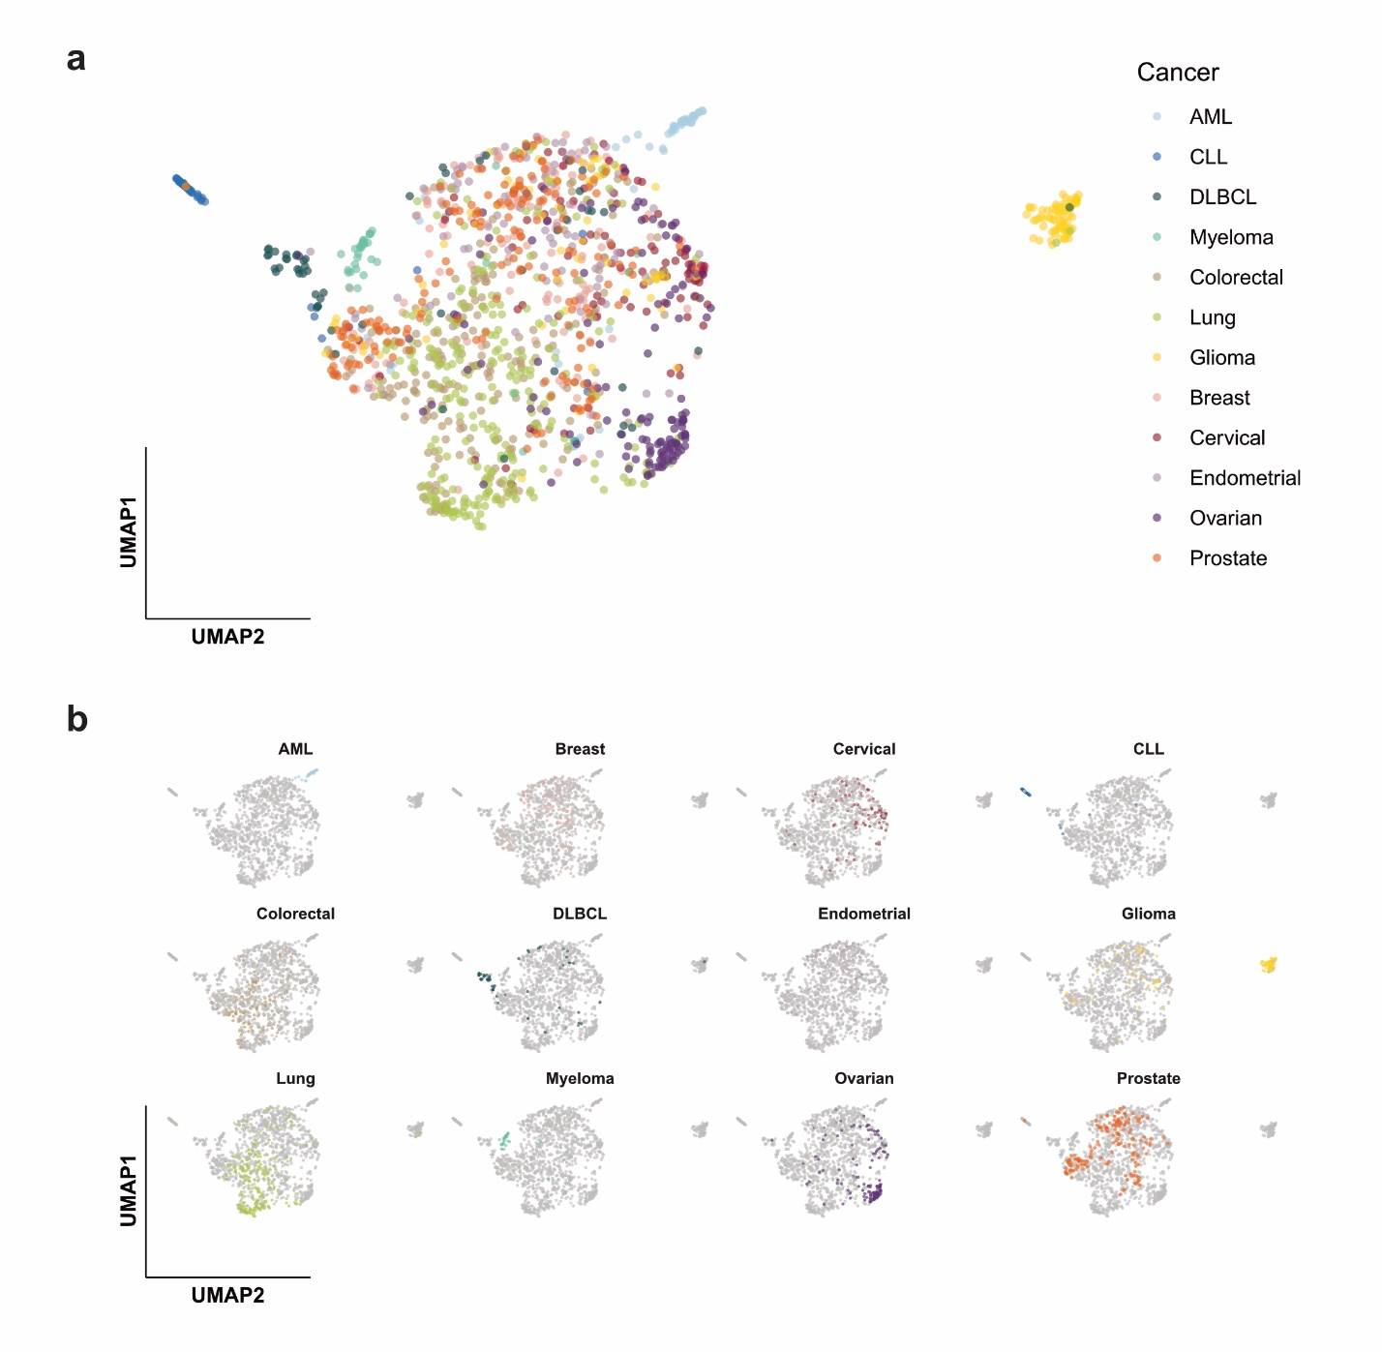
Fig. S5 | UMAP visualization of all samples based on expression profiles of the 83 panel proteins. a, The samples (n = 1,477) are colored according to the cancer type. b, UMAP highlighting samples from the specific cancers.

Figure S6
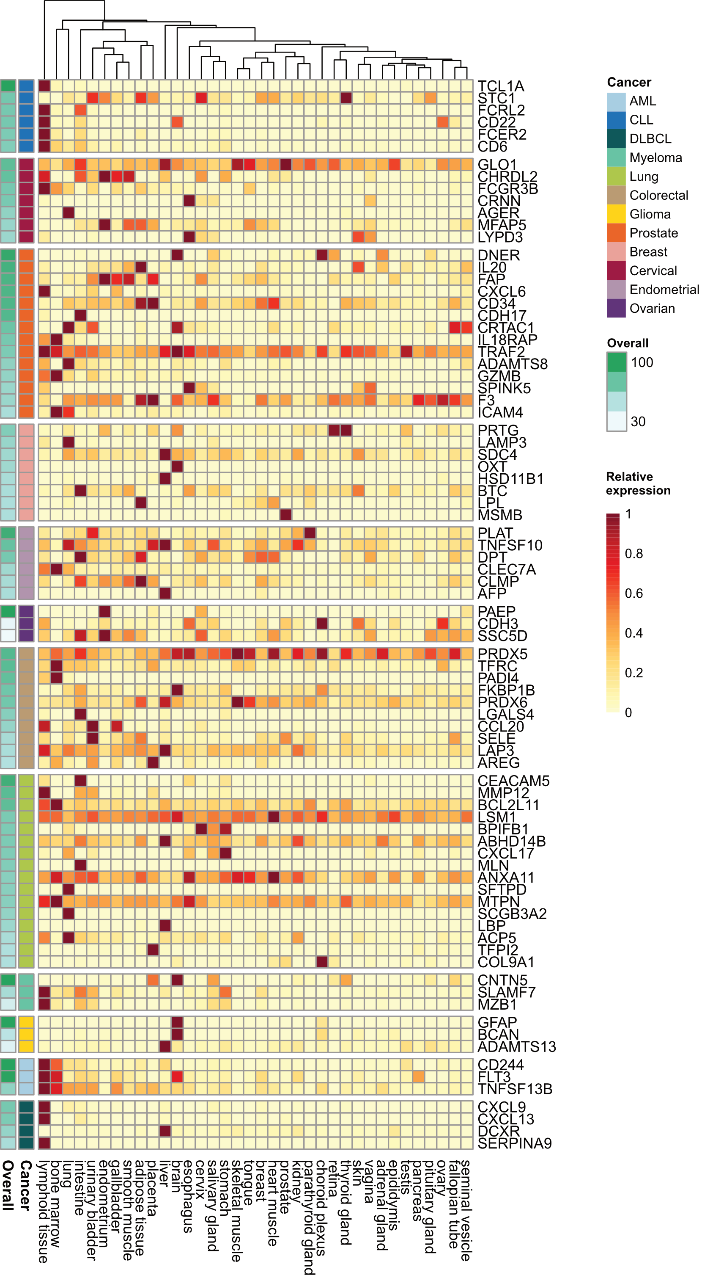
Fig. S6 | Summarized expression of the selected markers in tissues based on transcriptomics data. The heatmap shows the relative gene expression of the 83 selected markers across 36 tissues based on transcriptomics data from the Human Protein Atlas. For each marker, the cancer where it is identified to have the highest importance is indicated, together with the importance score obtained from the prediction models.
Figure S7
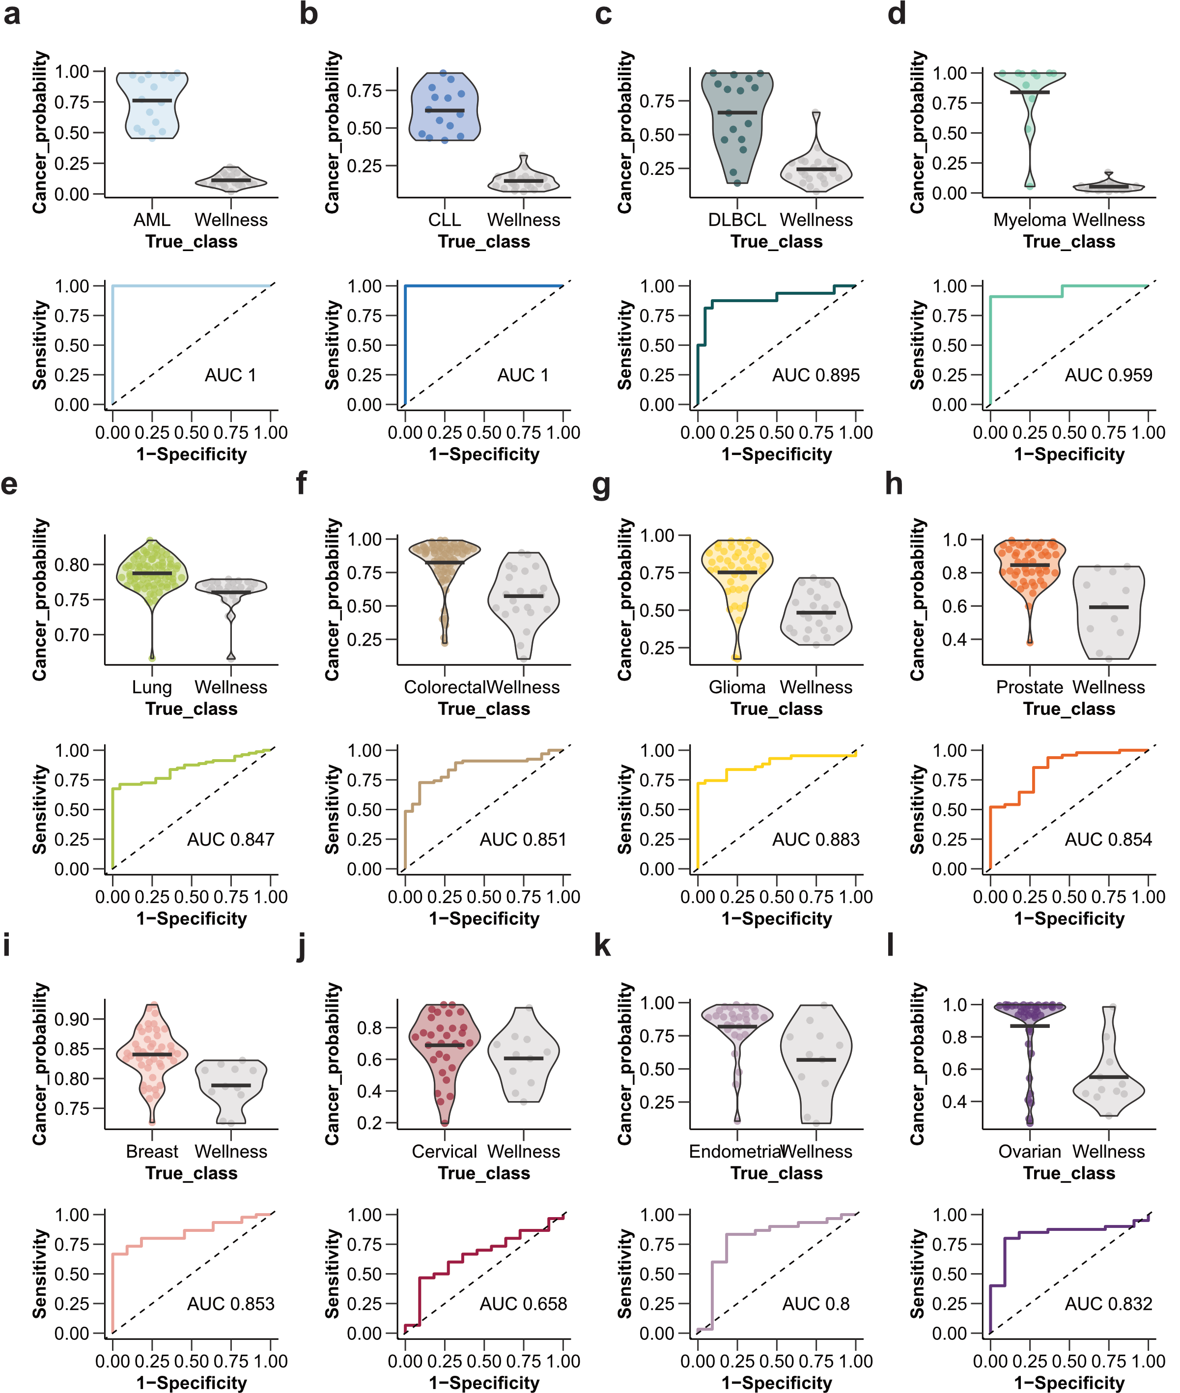
Fig. S7 | Evaluation of the prediction models built for the classification of cancer samples applied to the healthy cohort. The cancer probability for samples in the test set (top) and the corresponding ROC curves (bottom) are shown for the different cancers. The prediction models were based on a selection of 3- 18 proteins from the panel of 83 proteins for each cancer, respectively.
Captions for data S1-S4

Data S1 | Summary of the clinical metadata available for the pan-cancer cohort, including cancer diagnosis, age at diagnosis, sex, and cancer stage or grade.
Data S2 | Results from multivariate prediction models for the 12 cancer types using glmnet (overall importance glmnet) and random forest (overall importance rf) algorithms.
Data S3 | List of the 83 targets included in the pan-cancer protein panel including results from the disease prediction models (Protein importance) and differential expression (NPX difference between the specific cancer and other cancers and adjusted p-value).
Data S4 | List of Olink protein targets and mean expression per cancer type.

