Climatic Change

SUPPLMENTARY MATERIAL

Assessing 3-D climatic stability of world’s marine protected areas

Table S1. Percentage of variance of the principal component analysis for the 2D hypervolume analysis, considering only sea surface temperatures, and the 3D hypervolume analysis, considering both surface and bottom temperature data.
 | % of variance per axe |  |  | Cumulative %
 | PC1 | PC2 | PC3 | Cumulative %
2D approach | 86 | 13 | - | 99
3D approach | 79 | 12 | 5 | 96

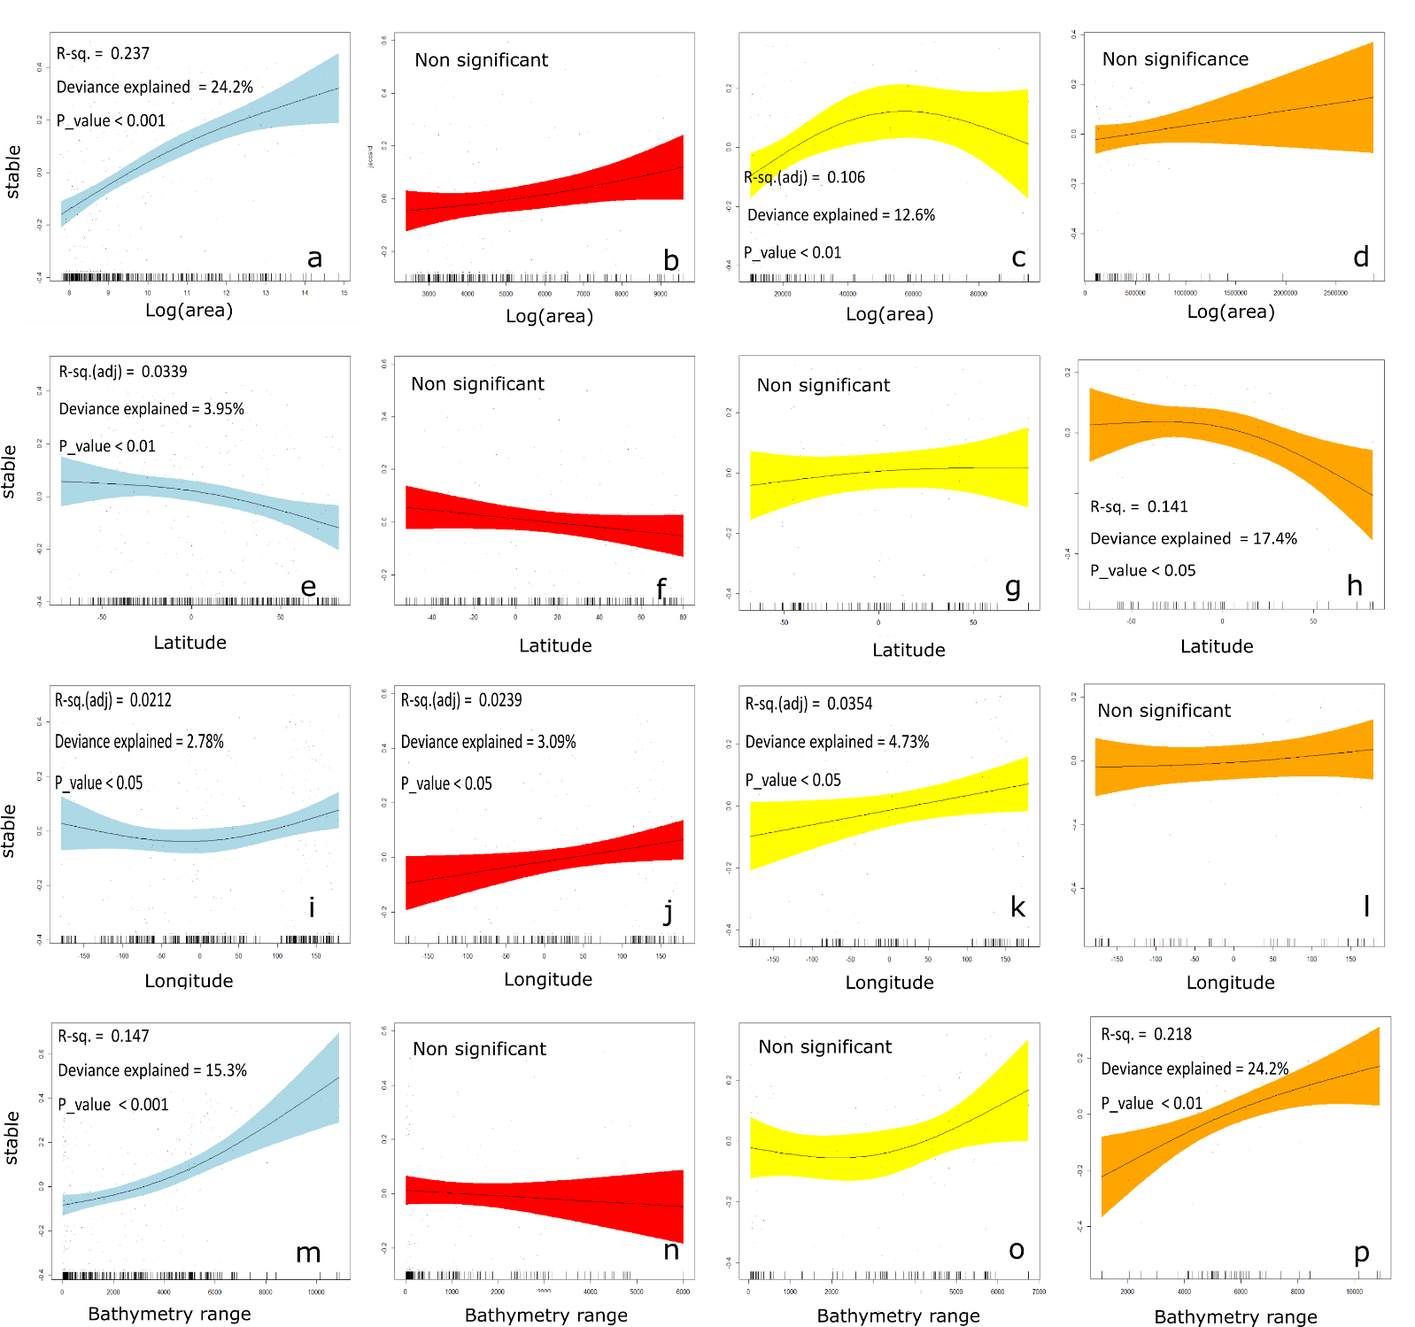
All extracted trends from generalized addictive models (GAMs) considering both 2D and 3D approaches are included in Figure S1 & S2. Our analysis examined if there is any relationship between the stable climate space and protected sites attributes (i.e., size, latitude, longitude and bathymetry range). As stable climatic space the Jaccard metric between the present and future climatic space of each protected surface was used.

Figure S1. Stable climatic space over area (a-d), latitude (e-h), longitude (i-l), and bathymetry range (m-p) of all (light blue), medium (red), large (yellow) and very large marine protected sites (orange) considering the 2D approach of surface climatic conditions within the 269 marine sites under protection.
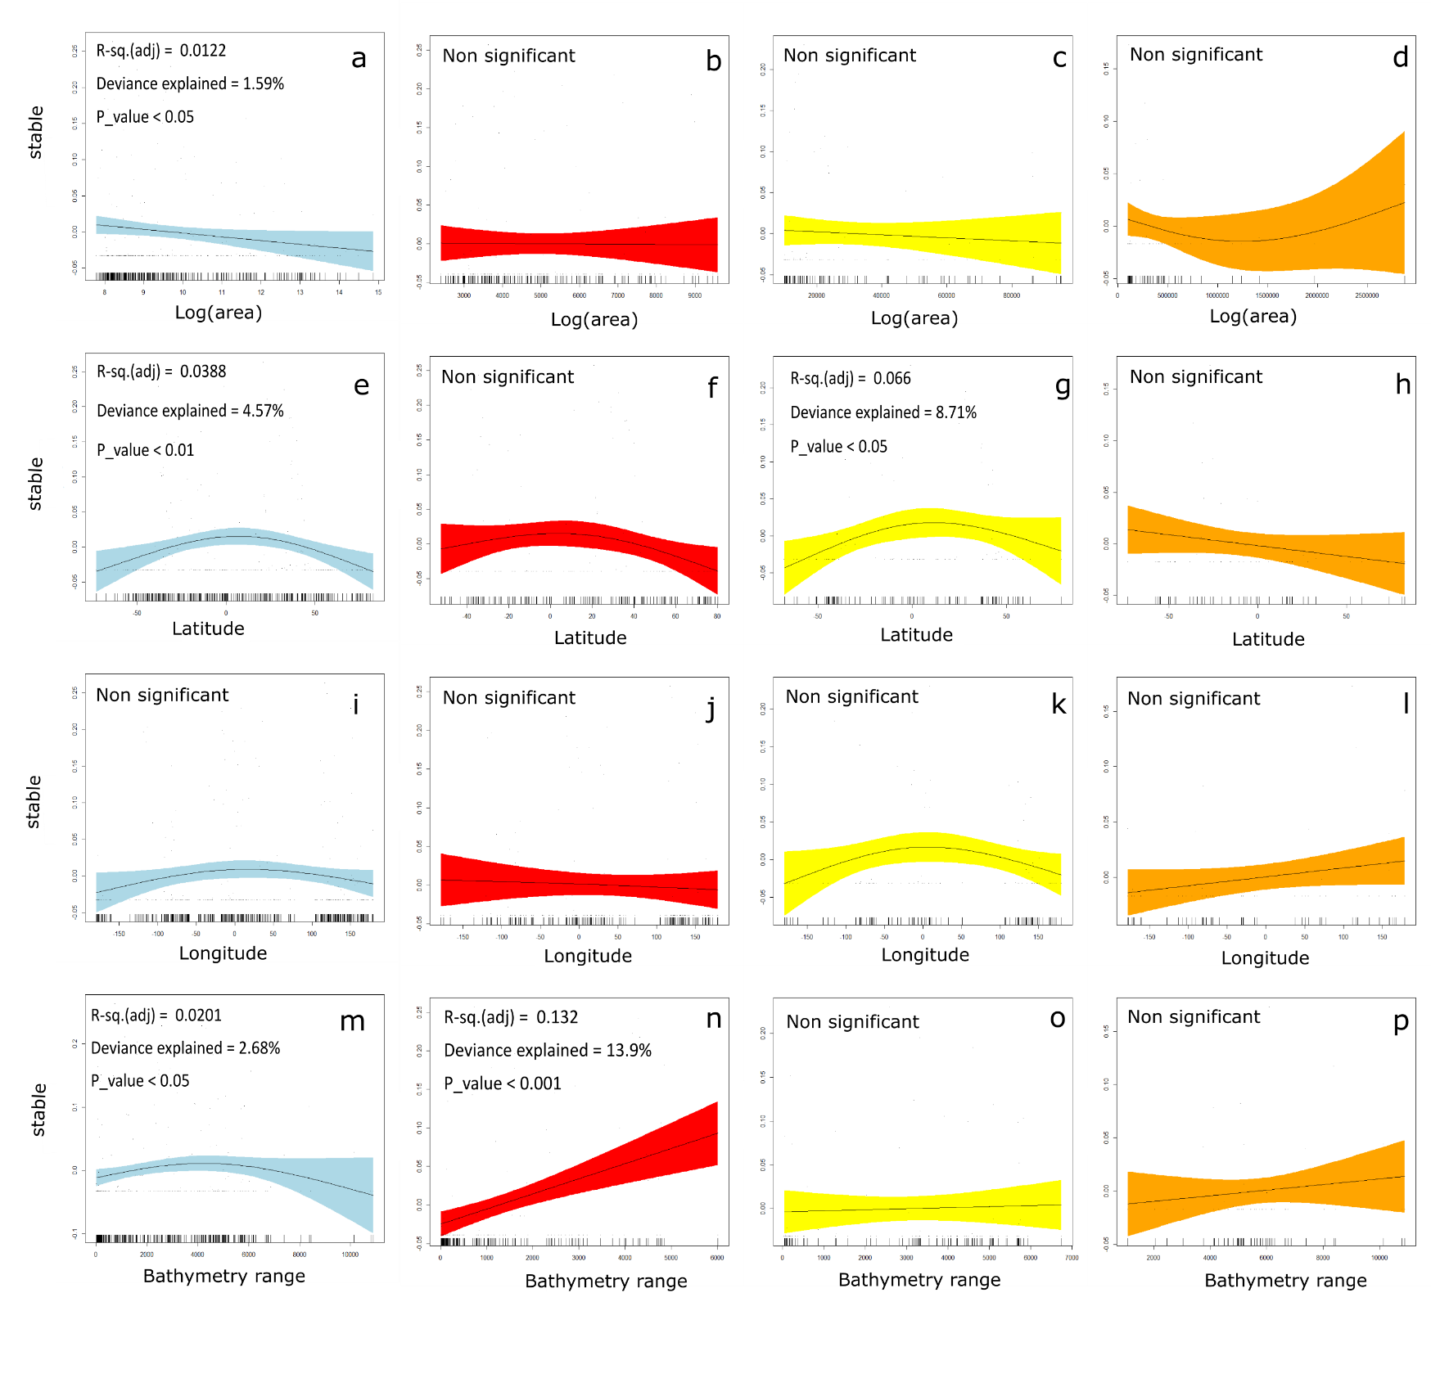
Figure S2. Stable climatic space over area (a-d), latitude (e-h), longitude (i-l), and bathymetry range (m-p) of all (light blue), medium (red), large (yellow) and very large marine protected sites (orange) considering the 3D approach of surface and bottom climatic conditions within the 269 marine sitesunderprotection.

