Supporting information
The effect of prolonged drought and recovery on soil VOC fluxes in an experimental rainforest
Giovanni Pugliese^{1,2}, Johannes Ingrisch³, Laura K. Meredith^{4,5}, Eva Y. Pfannerstill²*, Thomas Klüpfel², Kathiravan Meeran³, Joseph Byron², Gemma Purser^{6, 7}, Juliana Gil-Loaiza⁴, Joost van Haren^{4,5,8}, Jürgen Kreuzwieser¹, S. Nemiah Ladd^{1,9}, Christiane Werner¹, and Jonathan Williams²
¹Ecosystem Physiology, Faculty of Environment and Natural Resources, University of Freiburg, Freiburg, Germany
²Atmospheric Chemistry Department, Max Planck Institute for Chemistry, Mainz, Germany
³Institute of Ecology, University of Innsbruck, Innsbruck, Austria
⁴School of Natural Resources and the Environment, University of Arizona, Tucson, Arizona, USA
⁵Biosphere 2, University of Arizona, Oracle, AZ, USA
⁶UK Centre for Ecology & Hydrology, Penicuik, Edinburgh, UK
⁷School of Chemistry, The University of Edinburgh, Edinburgh, UK
⁸Honors College, University of Arizona, Tucson, Arizona, USA
⁹Department of Environmental Sciences, University of Basel, Basel, Switzerland
*now at: Department of Environmental Science, Policy, and Management, University of California at Berkeley, Berkeley, CA, USA
*Corresponding author: g.pugliese@mpic.de (ORCID: https://orcid.org/0000-0002-2869-3588)

Speciation of monoterpenes soil flux
For the speciation of monoterpenes soil fluxes, periodically isolated samples were collected from 3 manual PVC chambers placed at 3 fixed locations of the B2-TRF. Manual PVC chambers consisted of a PVC collar inserted ~ 1cm into the soil surface and a PVC lid containing two Teflon sample valves, an inlet and outlet. The lid was closed for ~ 1 minute prior to sampling. Samples were collected onto sorbent cartridges from the soil chamber by drawing air (200 ml min⁻¹ for ~ 10 minutes) from the outlet through a sorbent cartridge using a handheld pump (SKC ltd., Dorset, U.K). In addition, an ambient air sample was also taken from outside but close to the manual chamber. Samples were collected at The inert coated stainless steel cartridges (SilcoNert 2000 (SilcoTek™, Germany)) contained 150 mg of Tenax® TA (Buchem BV, Apeldoorn, The Netherlands) followed by 150 mg of Carbograph™ 5 TD (560 m²/g) (L.A.R.A s.r.l, Rome, Italy) sorbent. The size of the Carbograph™ particles was in the range of 20-40 mesh. Sample desorption was performed using a two-stage automated thermal desorber (TD100-xr, MARKES International, U.K.), with helium 6.0 as the carrier gas. The sample was desorbed at a temperature of 250 °C and a flow of 50 ml min⁻¹ of helium for 10 min, and was pre-concentrated onto a cold trap (materials emissions, MARKES International, U.K.) at -30 °C. The cold trap was purged with carrier gas for 1 min with a flow of 50 ml min⁻¹ then rapidly heated to 300 °C. The sample was removed from the cold trap with a flow of 3 ml min⁻¹ and injected into the column. The separation of the sampled compounds was achieved using a 30 m β-DEX™ 120 column with 0.25 mm internal diameter and a film thickness of 0.25 μm. The temperature program used was as follows, 40 °C for 5 minutes then 40 °C to 150 °C at 4 °C min⁻¹ and 150 °C to 200 °C at 30 °C min⁻¹. The column flow was set to 1 ml min⁻¹. Detection was achieved using a time of flight mass spectrometer (Bench TOF-Select, MARKES International, U.K.). A standard gas mixture (Apel-Riemer 2019) BVOC gas calibration standard containing all measured monoterpenes was used to identify and calibrate the sample.
Table S 1 VOC gas standard for daily calibration included in the two calibration standard cylinders with their respective detection limit (LOD) and total uncertainty. LOD was determined as the 3σ uncertainty of the zero calibration.
Compound | Protonated ion | (m/z) _{exact} | Concentration  Cylinder 1 [ppbV] | Concentration  Cylinder 2 [ppbV] | LOD range  [pptV] | Total  uncertainty [%]
Methanol | CH₅O⁺ | 33.0335 | 494 | 433 | 145 - 524 | 9
Acetonitrile | C₂H₄N⁺ | 42.0338 | 487 | 461 | 56 - 209 | 9
Ethanol | C₂H₇O⁺ | 47.0491 | 504 | 0 | 319 - 815 | 11
Propanal | C₃H₇O⁺ | 59.0491 | 0 | 463 | 123 - 364 | 6
Acetone | C₃H₇O⁺ | 59.0491 | 497 | 0 | 106 - 331 | 6
DMS | C₂H₇S⁺ | 63.0263 | 537 | 0 | 53 - 289 | 7
Isoprene | C₅H₉⁺ | 69.0699 | 509 | 0 | 56 - 233 | 6
Methacrolein, methyl vinyl ketone | C₄H₇O⁺ | 71.0491 | 252, 243 | 0 | 56 - 199 | 6
Benzene | C₆H₇⁺ | 79.0542 | 510 | 497 | 28 - 98 | 6
Toluene | C₇H₉⁺ | 93.0699 | 489 | 0 | 31 - 195 | 6
Furfural | C₅H₅O₂⁺ | 97.0284 | 479 | 0 | 78 - 791 | 9
Hexanal | C₆H₁₃O⁺ | 101.0961 | 0 | 494 | 58 - 160 | 9
Styrene | C₈H₉⁺ | 105.0699 | 0 | 498 | 44 - 110 | 6
m-Xylene | C₈H₁₁⁺ | 107.0855 | 0 | 499 | 37 - 87 | 6
Acetophenone | C₈H₉O⁺ | 121.0648 | 0 | 496 | 117 - 576 | 11
p-Isopropyltoluene | C₁₀H₁₅⁺ | 47.0491 | 0 | 474 | 140 - 280 | 8
α-Pinene, β-Pinene,  3-Carene, Limonene | C₁₀H₁₇⁺ | 137.1325 | 0 | 126, 125,  143, 148 | 58 - 122 | 6
Linalool | C₁₀H₁₉O⁺ | 155.1430 | 466 | 0 | 253 - 925 | 16
α-Cedrene | C₁₅H₂₅⁺ | 205.1951 | 105 | 0 | 21 -94 | 12
Hexamethylcyclotrisiloxane (D3) | C₆H₁₉O₃Si₄⁺ | 251.0406 | 502 | 509 | 15 - 54 | 6
Octamethylcyclotetrasiloxane (D4) | C₈H₂₅O₄Si₄⁺ | 297.0824 | 502 | 499 | 14 - 74 | 12
Decamethylcyclopentasiloxane (D5) | C₁₀H₃₁O₅Si₅⁺ | 371.1012 | 518 | 498 | 18 - 336 | 23
Dodecamethylcyclohexasiloxane (D6) | C₁₂H₃₇O₆Si₆⁺ | 445.1200 | 190 | 189 | 56 - 1530 | 13

Table S 2 List of tentatively identified VOCs that showed measurable soil fluxes.
(m/z) _{measured} | (m/z) _{exact} | Mass accuracy [ppm] | Protonated ion | Potential compound
33.0331 | 33.0335 | -12.11 | CH₅O⁺ | Methanol
45.0332 | 45.0335 | -6.66 | C₂H₄O⁺ | Acetaldehyde
47.0488 | 47.0491 | -6.38 | C₂H₇O⁺ | Ethanol
59.0498 | 59.0491 | 11.85 | C₃H₇O⁺ | Acetone/propanal
62.029* | 62.0236 | 87.06 | CH₄ONO⁺ | Methyl nitrite
63.0255 | 63.0263 | -12.69 | C₂H₇S⁺ | Dimethyl sulfide
69.07 | 69.0699 | 1.45 | C₅H₉⁺ | Isoprene
71.0493 | 71.0491 | 2.81 | C₄H₇O⁺ | Methacrolein/methyl vinyl ketone
73.0649 | 73.0648 | 1.37 | C₄H₉O⁺ | Butanone/butanal
85.0657 | 85.0648 | 10.58 | C₅H₉O⁺ | Ethyl vinyl ketone/cyclopentanone/pentenal
87.0809 | 87.0804 | 5.74 | C₅H₁₁O⁺ | Pentanone/pentanal
137.1320 | 137.1325 | -3.65 | C₁₀H₁₇⁺ | Monoterpenes
*subtraction of the contribution from the ¹³C isotopologues.

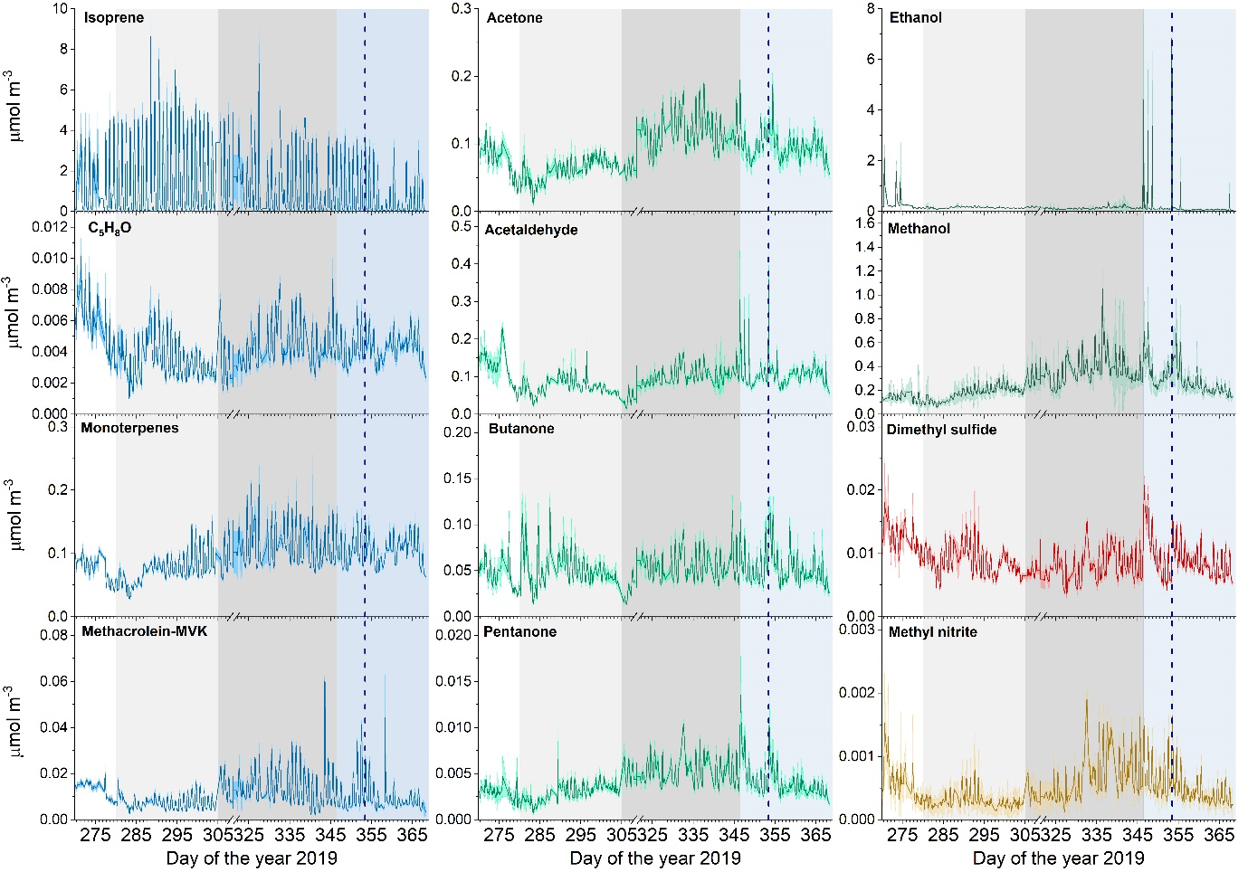
Figure S 1 Time series of ambient VOCs concentrations measured from the chambers with open lids during the last minute of the pre-purge. Lines represent averaged concentrations measured over all 12 chambers. The shaded areas indicate the standard deviation. Background colors indicate the different phases of the campaign: pre-drought (white), early drought (light gray), severe drought (dark gray), and recovery (light blue). The first drought-ending rain event occurred at the start of the recovery period, and the vertical blue line indicates the time of the second rain event.

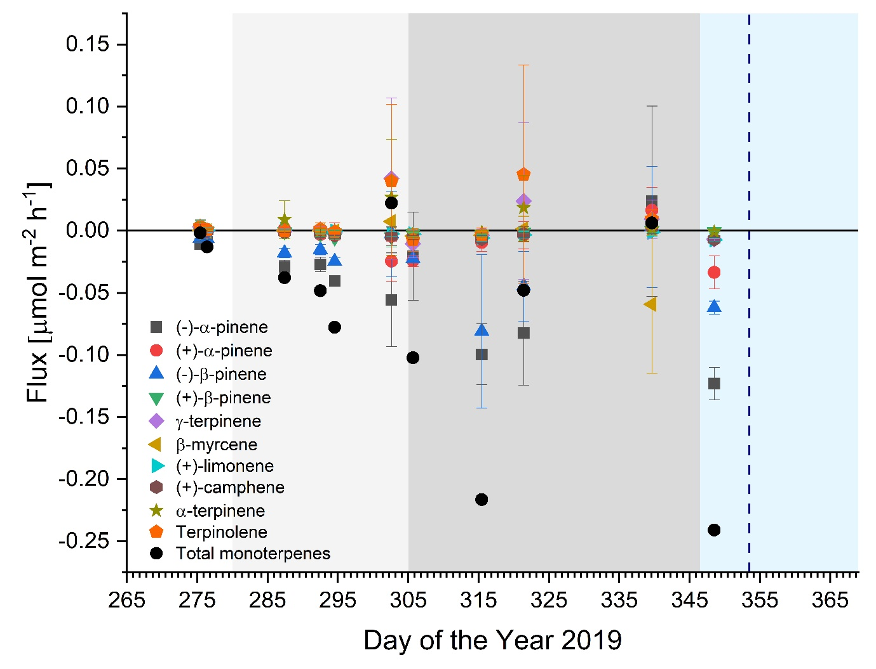
Figure S 2 Soil fluxes of speciated monoterpenes measured by GC-MS. Symbols represent averaged fluxes over the 3 manual chambers and error bars indicate the standard deviation. Black circle represents the sum of all monoterpenes flux. Background colors indicate the different phases of the campaign: pre-drought (white), early drought (light gray), severe drought (dark gray), and recovery (light blue). The first drought-ending rain event occurred at the start of the recovery period, and the vertical blue line indicates the time of the second rain event.
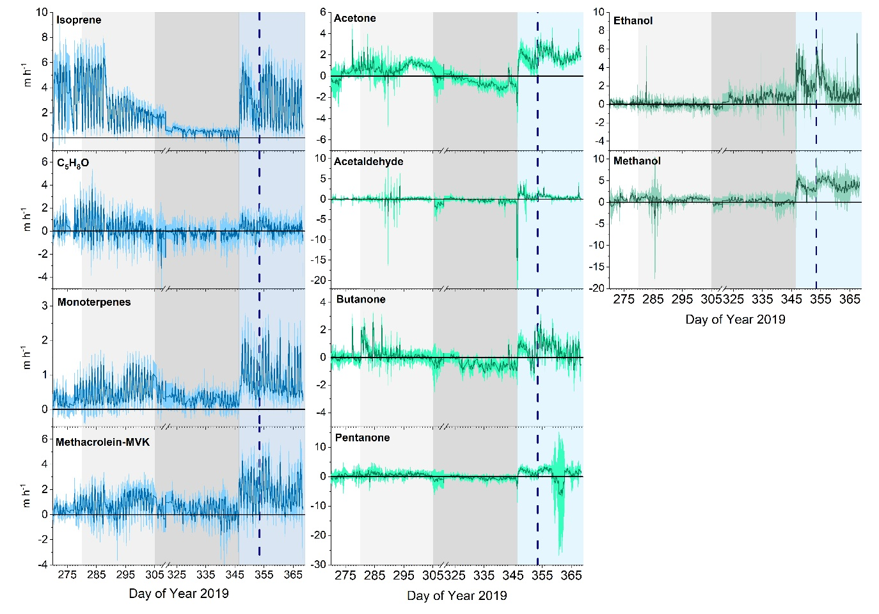
Figure S 3 Time series of deposition velocities for VOCs that were taken-up by the soil. Lines represent averaged deposition velocities over all 12 chambers. The shaded areas indicate the standard deviation. Background colors indicate the different phases of the campaign: pre-drought (white), early drought (light gray), severe drought (dark gray), and recovery (light blue). The first drought-ending rain event occurred at the start of the recovery period, and the vertical blue line indicates the time of the second rain event. Positive deposition velocities represent the concentration-independent VOC uptake capacity of soil, whereas negative deposition velocities are derived from emission fluxes and are not physically meaningful.

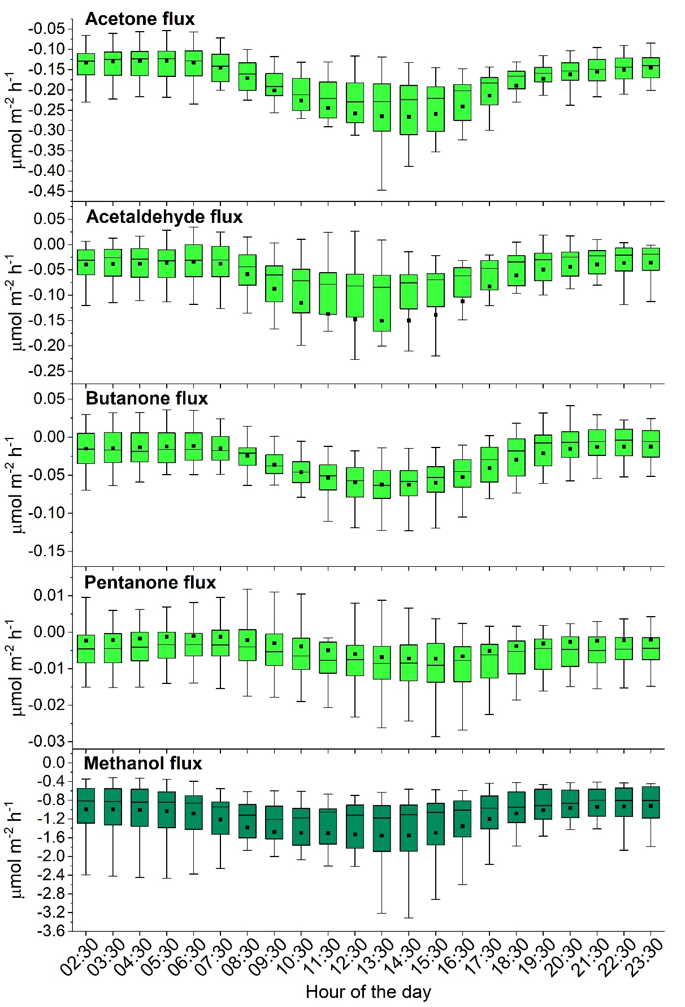
Figure S 4 Diel cycle observed during recovery period (from doy 347 of 2019 to doy 2 of 2020) for acetone, acetaldehyde, butanone, pentanone, and methanol soil fluxes. The boxes represent 25% to 75% of the dataset. The square dots and central lines indicate the mean and median values, respectively. The whiskers indicate the minimum and maximum data points.

