Supplementary Figures and Legends
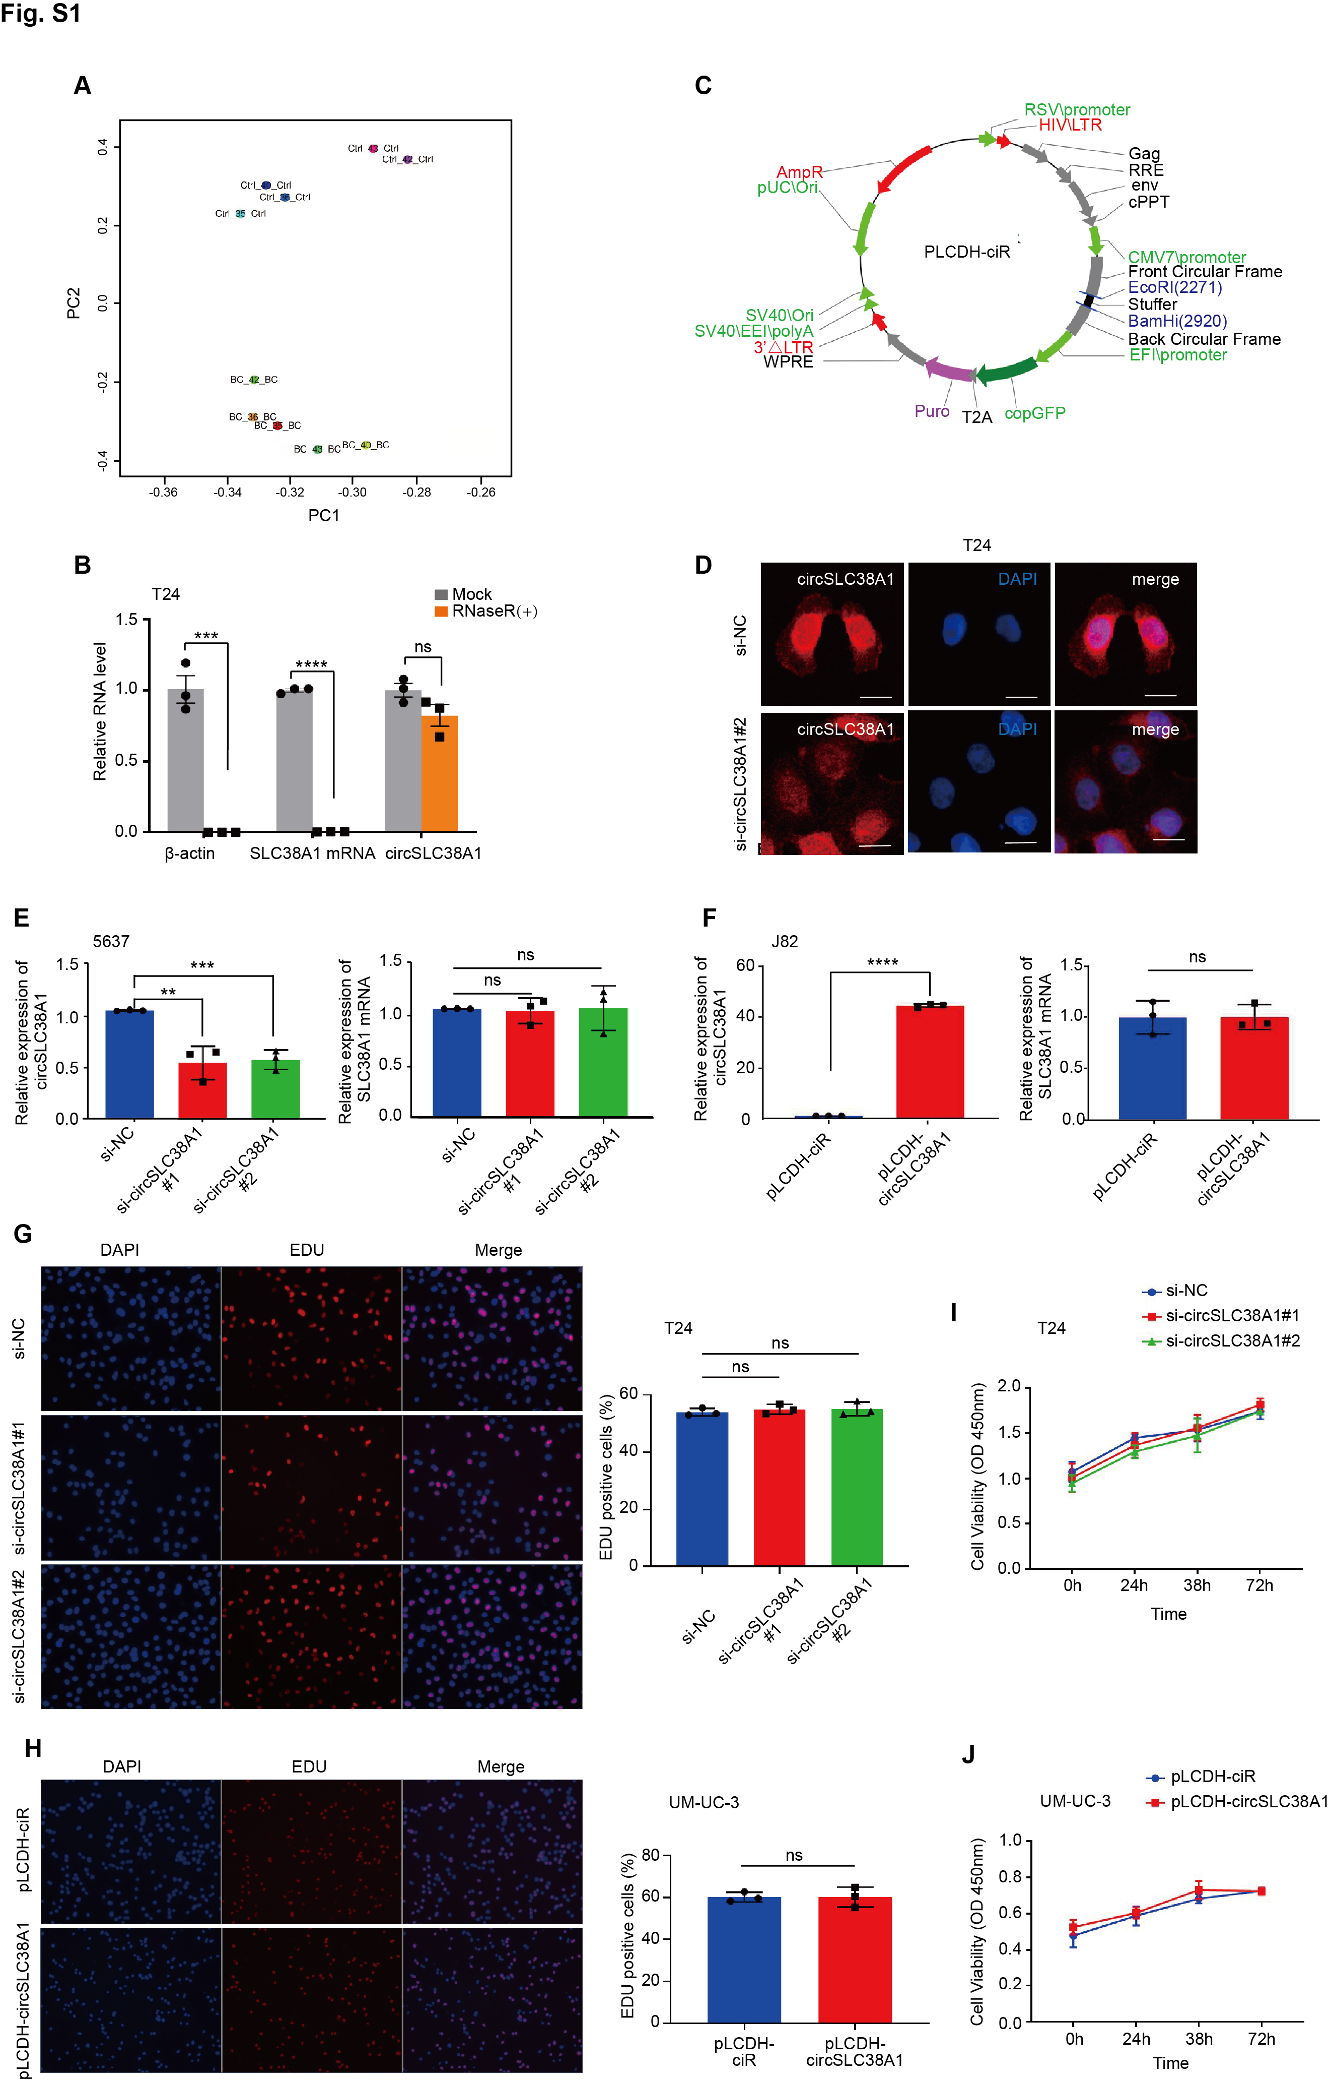

Figure S1. circSLC38A1 contributes less effect on BC cells proliferation.
a The principal component analysis (PCA) disclosed that BC tissues and corresponding adjacent nontumorous tissues could be differentiated by the RNA expression profile. b Relative RNA level of circSLC38A1 and linear SLC38A1 treated with RNase R. c Schematic view of the pLCDH-ciR vector used to construct the circSLC38A1 overexpression plasmid. d FISH with junction-specific probe was used to detect the knockdown effect of circSLC38A1 siRNA; scale bar: 25 μm. e Relative expression levels of circSLC38A1 and SLC38A1 mRNA in 5637 cells treated with circSLC38A1 si-circSLC38A1 or si-NC. f Relative expression levels of circSLC38A1 and SLC38A1 mRNA in J82 cells after transduction with circSLC38A1 overexpression plasmid or vector plasmid. g, h Left, EdU assays to detect proliferation of circSLC38A1-knockdown T24 cells and circSLC38A1 overexpressed UM-UC-3 cells. Right, quantitative analysis of EdU assays. i, j The cell viability of BC cell lines was detected by CCK8 in respective cell lines. Data are presented as means ± standard deviation from three independent experiments. *P < 0.05, **P < 0.01, ***P < 0.001, ****P < 0.0001.

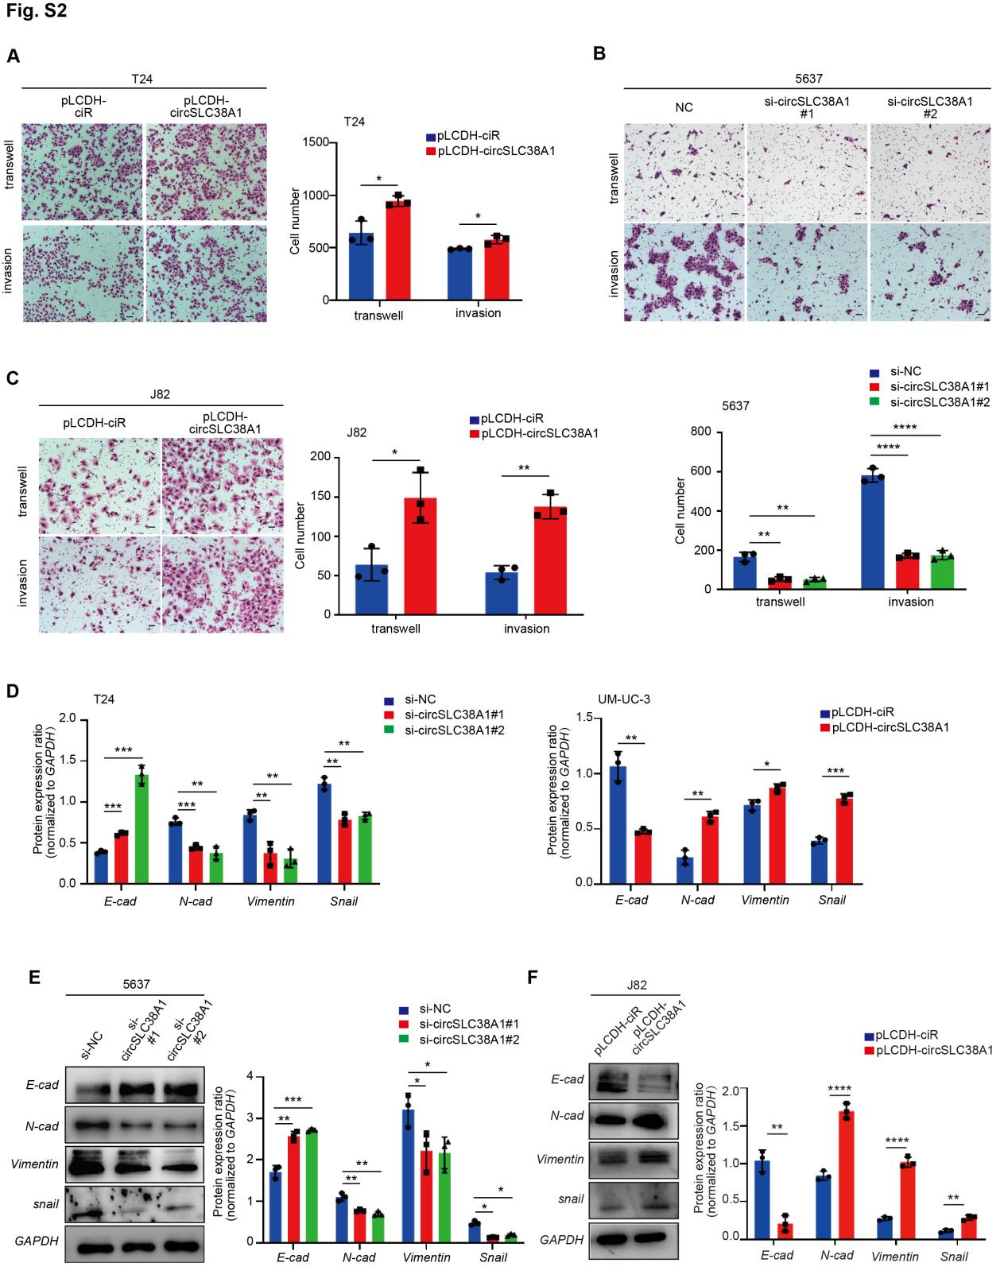

Figure S2. circSLC38A1 promotes migration and invasion capacities of BC cells in vitro.
a Transwell migration and matrigel invasion assays showed that increased cell invasion in circSLC38A1 overexpression T24 cells. Scale bar, 25µm. b Transwell migration and matrigel invasion assay showed that decreased cell invasion in circSLC38A1 knockdown 5637 cells. Scale bar, 25µm. c Transwell migration and matrigel invasion assay showed that increased cell invasion in circSLC38A1 overexpression J82 cells. Scale bar, 25µm. d Quantitative diagram of the expression levels of E-cadherin, N-cadherin, Vimentin and snail in circSLC38A1 deficient T24 cells with or in circSLC38A1 overexpressed UM-UC-3 cells measured by western blot. e, f The expression levels of E-cadherin, N-cadherin, Vimentin and snail in circSLC38A1 deficient 5637 cells with or in circSLC38A1 overexpressed J82 cells were detected by western blot. All experiments were repeated independently three times. Data are presented as means ± SD. *P < 0.05, **P < 0.01, ***P < 0.001, ****P < 0.0001.

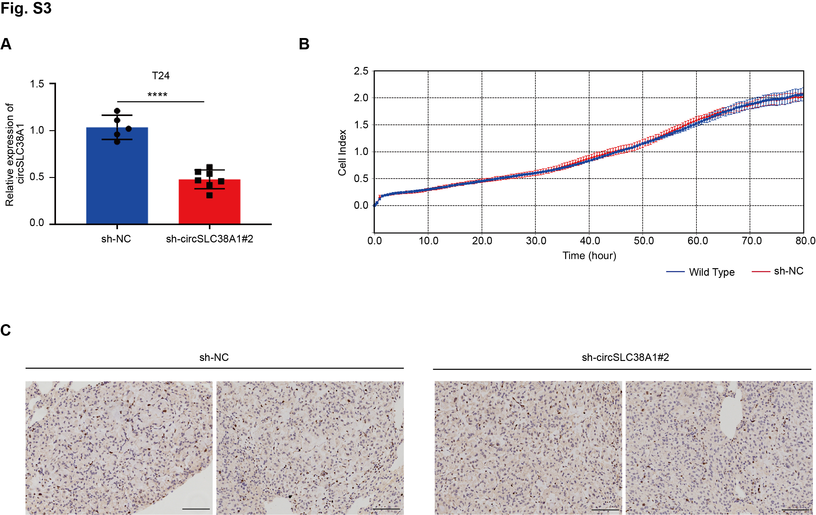

Figure S3. circSLCA1 contributes less effect on the proliferation of BC in vivo.
a Expression of circSLC38A1 was detected via qRT-PCR in xenograft generated from BC cells infected with sh-NC and sh-circSLC38A1 vectors. b The cell viability of T24 cell lines transfected with sh-NC and wild type T24 cells were recorded by RTCA system. c Representative ki67 staining of lung metastatic lesion through vein tail injection of circSLC38A1-NC BC cells or circSLC38A1-konckdown BC cells. Data are presented as means ± SD. **P < 0.01.

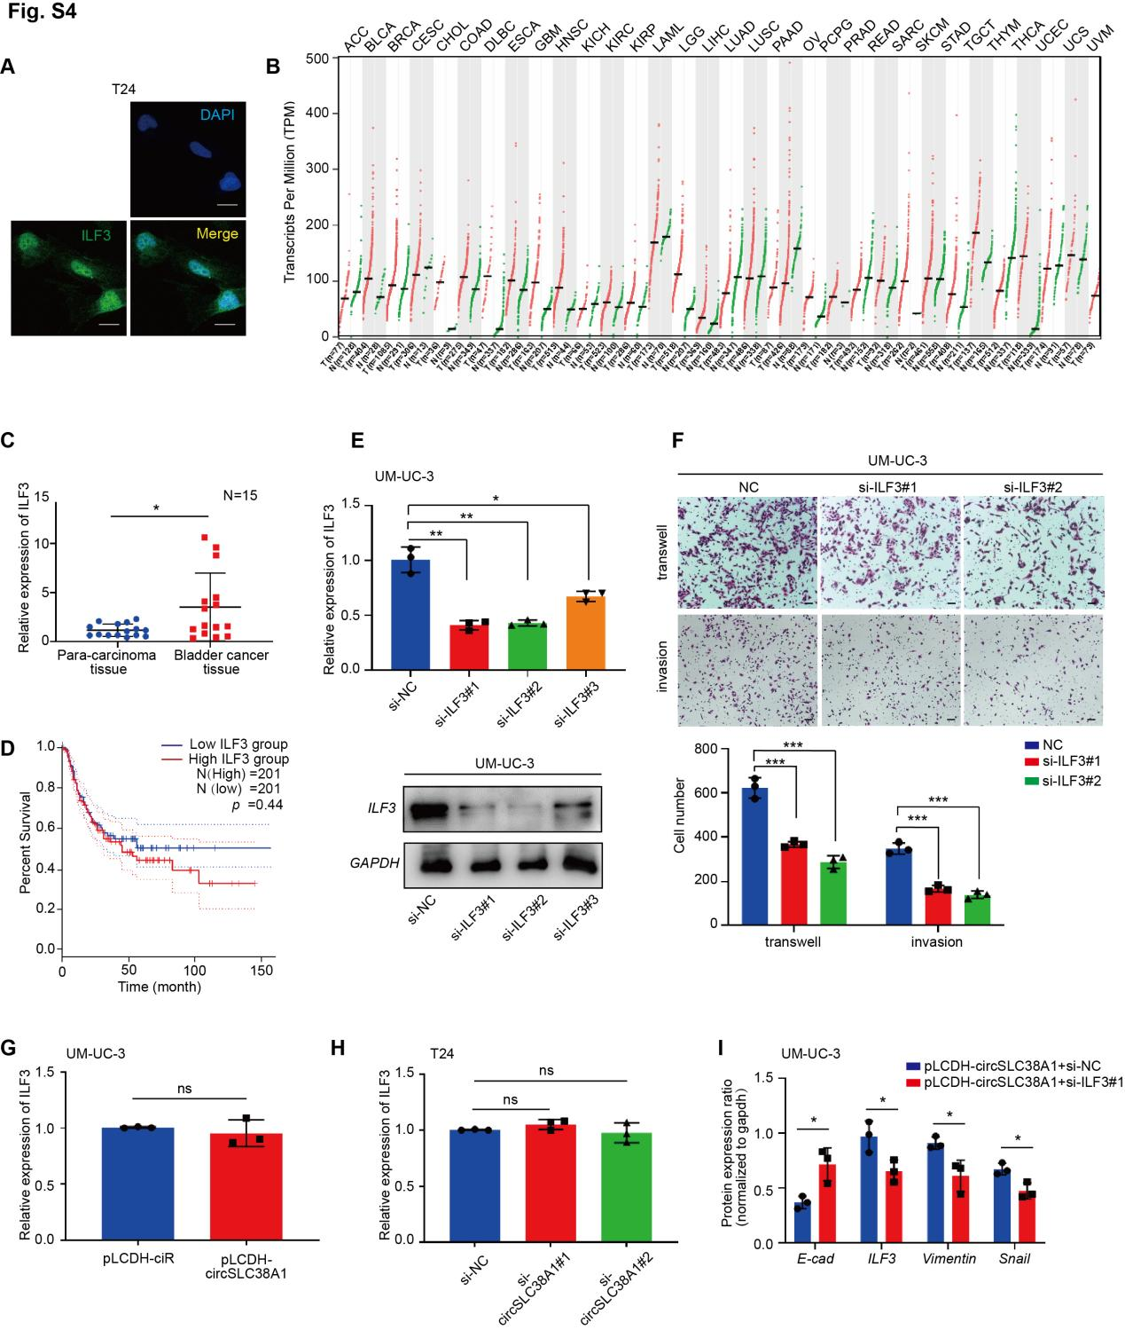

Figure S4. CircSLC38A1 interacted with ILF3 protein.
a Immunofluorescence staining for ILF3 protein showed that ILF3 mostly located at nucleus; scale bar: 25 μm. b The gene expression profile showed ILF3 was overexpressed in mostly tumor samples. c Expression levels of ILF3 in 15 paired BC and adjacent normal tissues were detected by qRT-PCR (P =0.0154). d Highly expression of ILF3 correlated with shorter disease-free survival time in BC. e The efficacy of three siRNAs targeting ILF3 was detected by qRT-PCR and western blot in UM-UC-3 cells. f Transwell migration and matrigel invasion assay showed that decreased cell invasion in ILF3 knockdown UM-UC-3 cells. g, h The expression levels of ILF3 mRNA with circSLC38A1 overexpression or circSLC38A1 deficient BC cells were detected by qRT-PCR. i Quantitative diagram protein of E-cadherin, Vimentin, snail and ILF3 in UM-UC-3 cells transfected with the indicated constructs. Data represent mean ± S.D. from three independent experiments; *P < 0.05, **P < 0.01, ***P < 0.001, ****P < 0.0001.
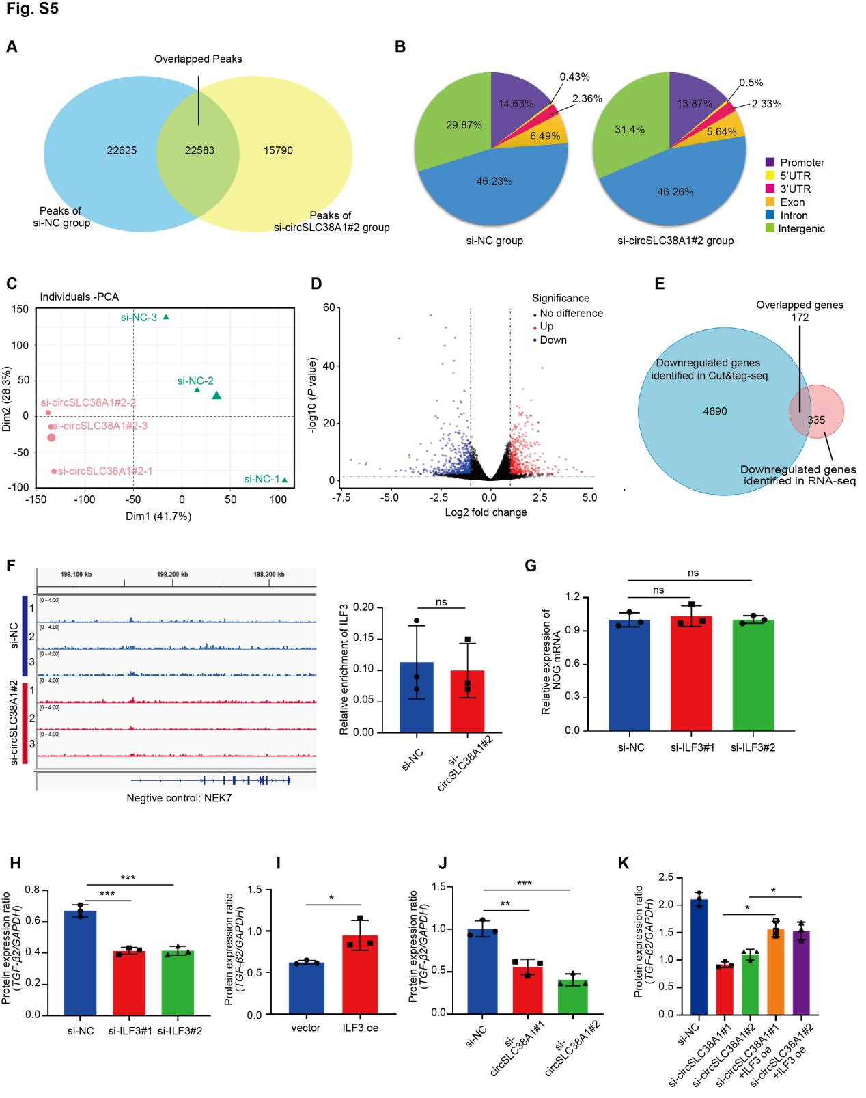

Figure S5. Determined the downstream targets of circSLC38A1-ILF3 complex by integrating analysis of CUT&Tag-seq and RNA-seq data.
a Venn diagram demonstrating the overlapped peaks enriched by ILF3 protein in the si-circSLC38A1#2 group and the control group. b Pie chart showing the distribution of identified peaks in si-circSLC38A1#2 and si-NC group. The sequences around CUT&Tag-seq peaks were highly conserved, and the peaks were frequent in promoters, introns, and intergenic regions. c The principal component analysis (PCA) disclosed that si-circSLC38A1#2 group and controls could be differentiated by the RNA expression profile. d Volcano plot of RNA expression, a total of 912 dysregulated RNAs were identified between circSLC38A1 deficient group and control group, of which 405 were upregulated and 507 RNAs were downregulated. e Venn diagram demonstrating the overlap of downregulated genes between CUT&Tag-seq and RNA-seq. f Right: the IGV showing the CUT&Tag signals of ILF3 at the NEK7 gene loci, NEK7 server as negative control. Left: quantitative diagram of the degree of enrichment of ILF3 signal on the NEK7 promoter. g Relative expression levels of NOG in T24 cells treated with ILF3 siRNA or corresponding negative control were measured by qRT-PCR. h, i Quantitative diagram of the protein levels of TGF-β2 in T24 cells with ILF3 deficient (h) or ILF3 overexpression (i). j Quantitative diagram of the protein levels of TGF-β2 in T24 cells with circSLC38A1 deficient. k Quantitative diagram protein of TGF-β2 in T24 cells transfected with the indicated constructs. Data represent mean ± S.D. from three independent experiments; *P < 0.05, **P < 0.01, ***P < 0.001, ****P < 0.0001.
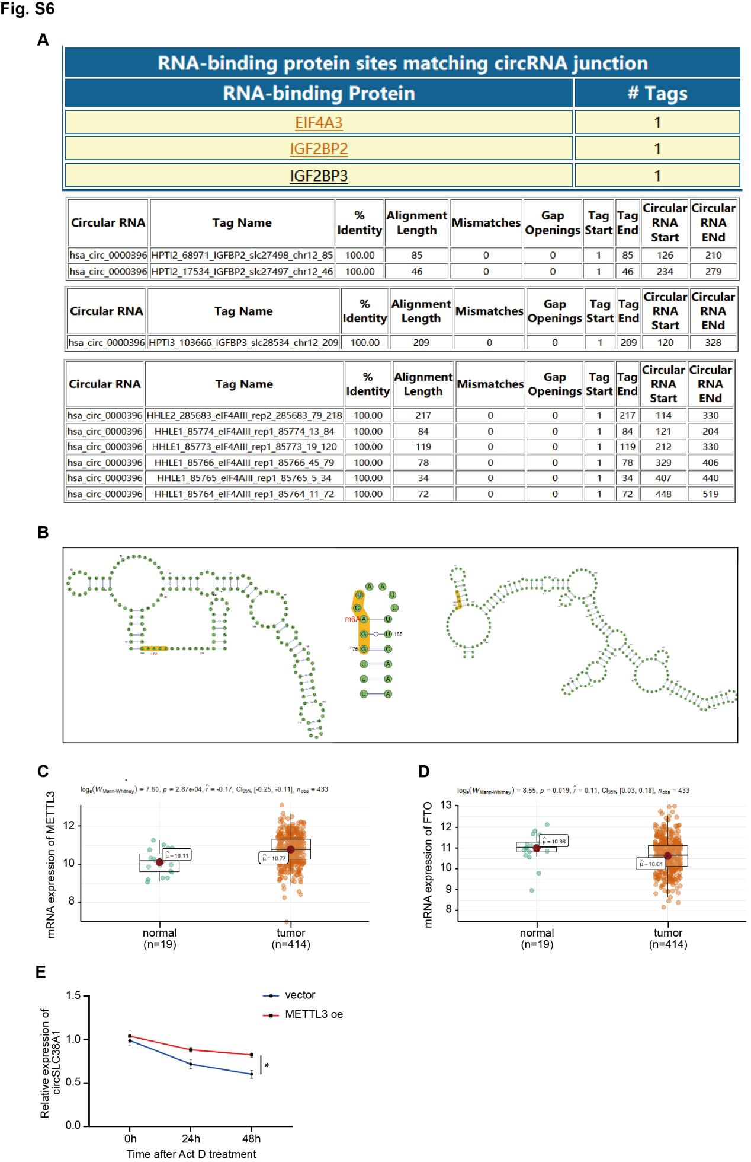

Figure S6. m6A modification is involved in the upregulation of circSLC38A1 in BC cells.
a Three m6A “reader’’ were found to bind circSLC38A1 at the junction site by using CircInteractome. b m6A modification sites on the circSLC38A1 sequence with high or very high confidence were predicted by using SRAMP. c m6A “writer” METTL3 was highly expressed in BC based on data available from TCGA database. d m6A “eraser” FTO was downregulated in BC based on data available from TCGA database. e Expression of circSLC38A1 was detected in T24 cells overexpressed METTL3 after treatment with Act D. Data represent mean ± S.D. from three independent experiments; *P < 0.05.

Supplementary Tables

Table S1. Characteristics of the study population in cohort I.

Variable | Patients  n=41
Age (years)
median | 65
Sex
Male | 32 (78.05%)
Female | 9 (21.95%)
TNM stage
I (NMIBC) | 14 (34.14%)
II-IV (MIBC) | 27 (65.86%)
Tumor grade
Low grade | 6 (14.63%)
High grade | 35 (85.37%)
Lymph node metastasis
Negative | 35 (85.37%)
Positive | 6 (14.63%)
Abbreviations: BC: bladder cancer; MIBC: muscle invasive bladder cancer;
NMIBC: non-muscle invasive bladder cancer.

Table S2. Characteristics of the study population in cohort III.

Variable | BC patients  n=65 | Healthy people  n=64 | P-Value
Age (years) |  |  | 0.79
≤65 | 35 (53.85%) | 33 (51.56%)
>65 | 30 (46.15%) | 31 (48.44%)
Sex |  |  | 0.96
Male | 52 (80.00%) | 51 (79.69%)
Female | 13 (20.00%) | 13 (20.31%)
TNM stage
I (NMIBC) | 41 (63.08%)
II-IV (MIBC) | 24 (36.92%)
Tumor grade
Low grade | 23 (35.38%)
High grade | 42 (64.62%)
Lymph node metastasis
Negative | 63 (96.92%)
Positive | 2 (3.08%)
Abbreviations: BC: bladder cancer; MIBC: muscle invasive bladder cancer; NMIBC: non-muscle invasive bladder cancer.

Table S3. Detailed information of 5 patients used for RNA sequencing.

Patient # | Age | Sex | Disease stage
Patient #1 | 69 | Male | MIBC (stage II)
Patient #2 | 39 | Male | NMIBC (stage I)
Patient #3 | 47 | Female | MIBC (stage II)
Patient #4 | 64 | Male | MIBC (stage II)
Patient #5 | 43 | Male | NMIBC (stage I)
Abbreviations: BC: bladder cancer; MIBC: muscle invasive bladder cancer;
NMIBC: non-muscle invasive bladder cancer.

Table S4. List of primers for qRT-PCR.
Gene | Sequence (5’-3’)
circSLC38A1 | F: TTTTGGGACTCGCCTTTGCC
circSLC38A1 | R: AATGGAAGCTTGACACCCCTG
SLC38A1 | F: TCCCTGCATTGTTCCAGAGC
SLC38A1 | R: TGACGGGTGGCAAACAAATG
GAPDH | F: GCACCGTCAAGGCTGAGAAC
GAPDH | R: TGGTGAAGACGCCAGTGGA
ILF3 | F: CGAACTCCTACAACTCTCCCG
ILF3 | R: CCTTGGTATGAGGAGCCGC
TGF-β2 | F: GCGCTACATCGACAGCAAAG
TGF-β2 | R: TGCAGCAGGGACAGTGTAAG
Abbreviations: qRT-PCR: quantitative Reverse Transcript PCR

Table S5. List of sequences for siRNAs and shRNAs
siRNA | Sequence (5’-3’)
Si-circSLC38A1#1 | sense: AUCCUACUUUUUCUAUAUUTT
 | antisense: AAUAUAGAAAAAGUAGGAUTT
Si-circSLC38A1#2 | sense: AAUCCUACUUUUUCUAUAUTT
 | antisense: AUAUAGAAAAAGUAGGAUUTT
Si-ILF3#1 | sense: CCUGUGUGAGAAAUCCAUUTT
 | antisense: AAUGGAUUUCUCACACAGGTT
Si-ILF3#2 | sense: GGAUGGACAGAAGUUCCAATT
 | antisense: UUGGAACUUCUGUCCAUCCTT
Si-ILF3#3 | sense: CCAACCAUGGAGGCUACAUTT
 | antisense: AUGUAGCCUCCAUGGUUGGTT
Si-METTL3#1 | sense: GCAAGAAUUCUGUGACUAUTT
 | antisense: AUAGUCACAGAAUUCUUGCTT
Si-METTL3#2 | sense:GGUGACUGCUCUUUCCUUATT
 | antisense: UAAGGAAAGAGCAGUCACCTT
Si-METTL3#3 | sense: GGUUGGUGUCAAAGGAAAUTT
 | antisense: AUUUCCUUUGACACCAACCTT
Si-FTO#1 | sense: GCAGCUGAAAUAUCCUAAATT
 | antisense: UUUAGGAUAUUUCAGCUGCTT
Si-FTO#2 | sense: GCCAGUGAAAGGGUCUAAUTT
 | antisense: AUUAGACCCUUUCACUGGCTT
Si-FTO#3 | sense: GUGGCAGUGUACAGUUAUATT
 | antisense: UAUAACUGUACACUGCCACTT
Si-NC | sense: UUCUCCGAACGUGUCACGUTT
 | antisense: ACGUGACACGUUCGGAGAATT
Sh-circSLC38A1#2 | AATCCTACTTTTTCTATAT
Sh-NC | TTCTCCGAACGTGTCACGT

Table S6. CircRNAs with high expression levels and potential functional roles

circRNA Name | Chromosome | Start site | End site | Homogenous mRNA
circSLC38A1 | 12 | 46229153 | 46243314 | SLC38A1
circBRCA1-1 | 17 | 43095846 | 43124115 | BRCA1
circBRCA1-2 | 17 | 43067608 | 43074521 | BRCA1
circAP1M2 | 19 | 10583606 | 10584070 | AP1M2
circFANCD2-1 | 3 | 10064729 | 10088950 | FANCD2
circFANCD2-2 | 3 | 10046580 | 10049505 | FANCD2
circTIAM-1 | 21 | 31182421 | 31203012 | TIAM1
circTIAM-2 | 21 | 31182421 | 31195305 | TIAM1
circSKP2 | 5 | 36166519 | 36177292 | SKP2

Table S7. List of top 10 proteins enriched by circSLC38A1 sense probe

Accession | Description | Mass | Score | emPAI
P02768 | Serum albumin  OS=Homo sapiens OX=9606 GN=ALB PE=1 SV=2 | 71317 | 165 | 0.25
Q12906 | Interleukin enhancer-binding factor 3  OS=Homo sapiens OX=9606 GN=ILF3 PE=1 SV=3 | 95678 | 160 | 0.66
P04264 | Keratin, type II cytoskeletal 1  OS=Homo sapiens OX=9606 GN=KRT1 PE=1 SV=6 | 66170 | 156 | 0.34
P08670 | Vimentin  OS=Homo sapiens OX=9606 GN=VIM PE=1 SV=4 | 53676 | 108 | 0.13
P13645 | Keratin, type I cytoskeletal 10  OS=Homo sapiens OX=9606 GN=KRT10 PE=1 SV=6 | 59020 | 100 | 0.24
Q00839 | Heterogeneous nuclear ribonucleoprotein U  OS=Homo sapiens OX=9606 GN=HNRNPU PE=1 SV=6 | 91269 | 89 | 0.04
P60709 | Actin, cytoplasmic 1  OS=Homo sapiens OX=9606 GN=ACTB PE=1 SV=1 | 42052 | 89 | 0.16
P06733 | Alpha-enolase  OS=Homo sapiens OX=9606 GN=ENO1 PE=1 SV=2 | 47481 | 88 | 0.14
P35527 | Keratin, type I cytoskeletal 9  OS=Homo sapiens OX=9606 GN=KRT9 PE=1 SV=3 | 62255 | 86 | 0.17
Q08211 | ATP-dependent RNA helicase A  OS=Homo sapiens OX=9606 GN=DHX9 PE=1 SV=4 | 142181 | 81 | 0.10

Table S8. Functional enrichment analysis of the downregulated genes

ID | Description | P value | Gene ID
GO:0050679 | positive regulation of epithelial cell proliferation | 9.66E-06 | NOG/CCND1/WNT7A/ITGB3/  VEGFA/CCL5/NME2/EGR3/  NR4A3
GO:0044321 | response to leptin | 1.24E-05 | CCND1/INHBB/EDN1/NR4A3
GO:0050673 | epithelial cell proliferation | 3.25E-05 | NOG/CCND1/WNT7A/ITGB3/  VEGFA/EHF/CCL5/NME2/  LGR5/EGR3/NR4A3/TGFB2
GO:0062044 | regulation of epithelial to mesenchymal transition | 4.38E-05 | NOG/TGFB2
GO:1905006 | regulation of epithelial to mesenchymal transition involved in endocardial cushion formation | 4.38E-05 | NOG/TGFB2
GO:0061082 | myeloid leukocyte cytokine production | 4.44E-05 | DDX58/CD74/NR4A3/TGFB2

