Supplementary Information
Rail induced lateral migration of particles across intact co-flowing liquids

Iwona Ziemecka,ª Amaury de Hemptinne,ª Vyacheslav R. Misko,ª Matthieu Briet,ª Pierre Gelin,ª Ilyesse Bihi,ª Dominique Maes,^{b} and Wim De Malsche,^{a*}
ª µFlow group, Department of Chemical Engineering Vrije Universiteit Brussel, Pleinlaan 2, 1050 Brussels, Belgium
^{b} Structural Biology Brussels, Vrije Universiteit Brussel, Pleinlaan 2, 1050 Brussel, Belgium

Below, supplementary figures mentioned in the main text are presented: Figures 1S, 2S and 3S.

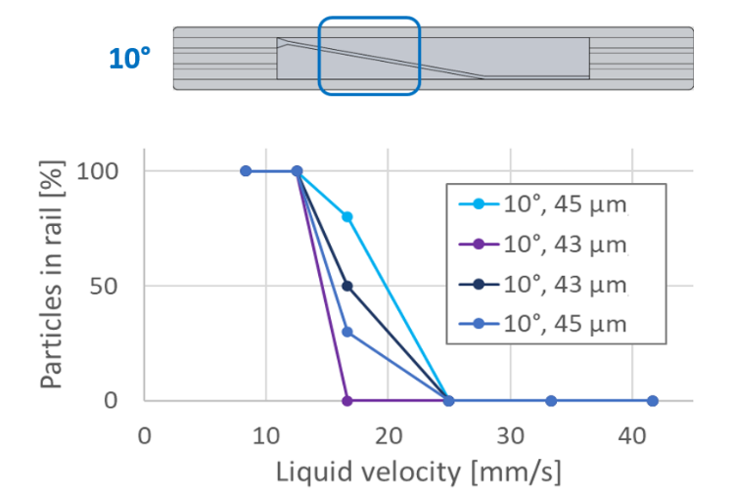
Figure 1S. Percentage of the particles of ø 89 µm following the rail. Reproducibility of the experiment in similar chips with rail of 44 ± 7 µm at an angle of 10°.
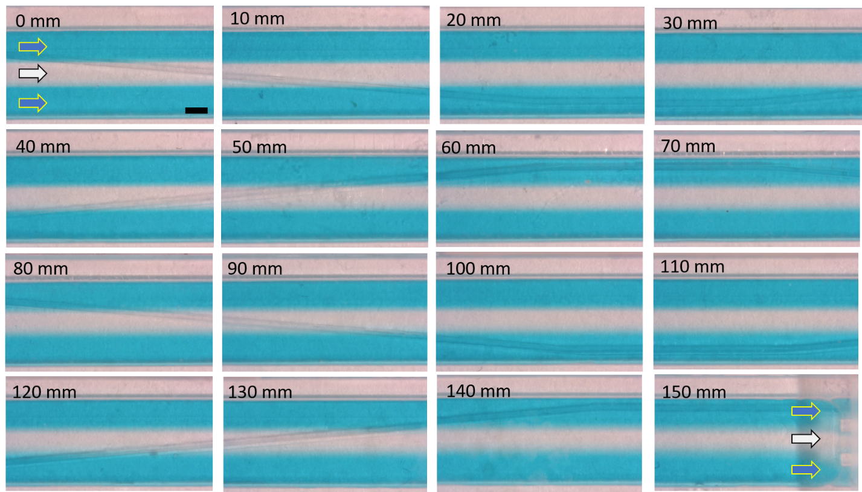
Figure 2S. Optical microscopy pictures of the channel at the different position of the chip. Side liquids: EtOH with blue dye, middle liquid: EtOH. All three liquids are introduced at liquid velocity of 25 mm s⁻¹. Scale bar is 1 mm. The radial diffusion of the blue dye over the length of the chip (15 cm) is negligible.
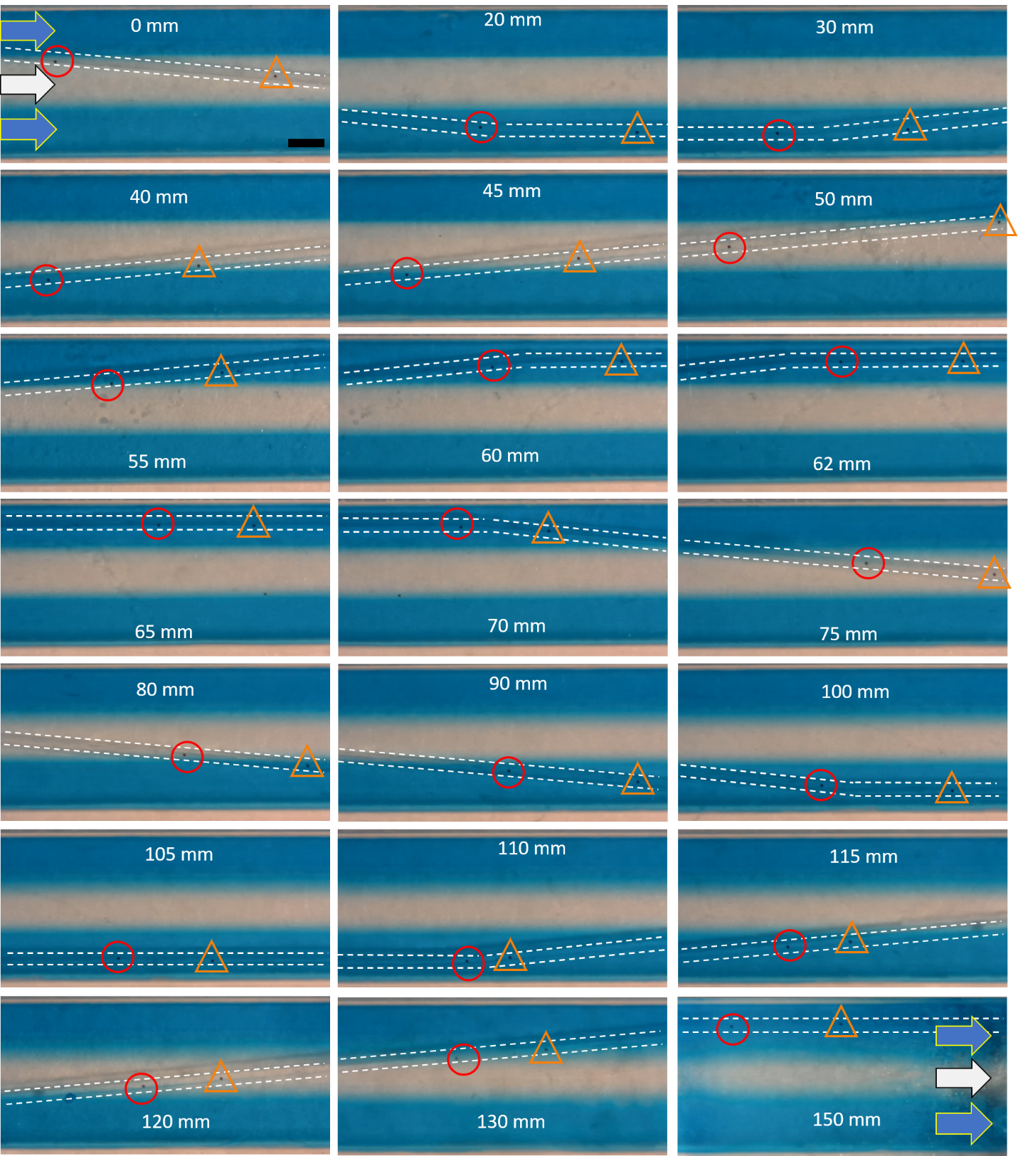
Figure 3S. Optical microscopy pictures of two particles traveling along the rail at different position of the chip. Full trajectory. Side liquids: EtOH with blue dye, middle liquid: EtOH. Liquid velocity is 25 mm s⁻¹. Scale bar is 1 mm.

