Fabrication of Chitosan Monolith by Thermally Induced Phase Separation of Chemically Modified Chitin to Remove Cu(II) Ions from the Water Solutions
Emil Hajili¹, Akihide Sugawara¹, Taka-Aki Asoh¹, Hiroshi Uyama^{1*}
¹Graduate School of Engineering, Osaka University, 2-1 Yamadaoka, Suita, Japan
*Corresponding author(s). E-mail(s): uyama@ chem.eng.osaka-u.ac.jp

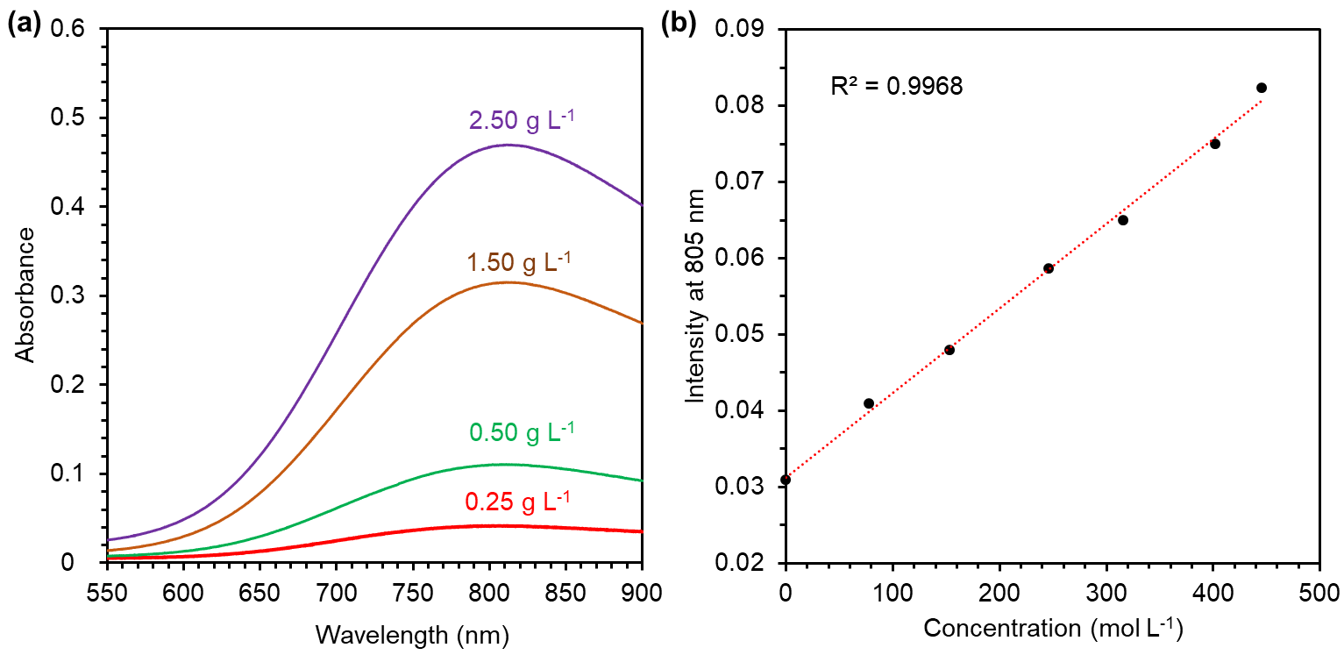
Fig. S1 (a) UV-vis absorption spectra of Cu(II) with different concentrations. (b) Standard curve of the concentration of Cu(II) in pH 5.5

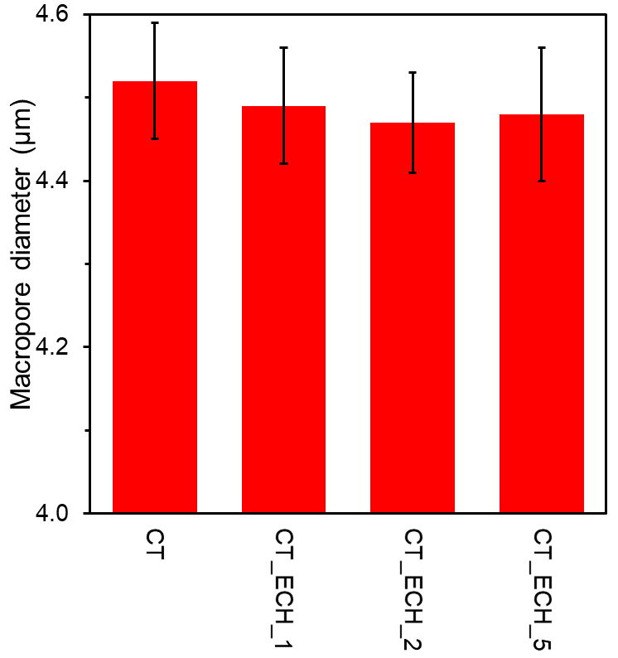
Fig. S2 The average macropore diameters of CT, CT_ECH_1, CT_ECH_2, and CT_ECH_5 monoliths

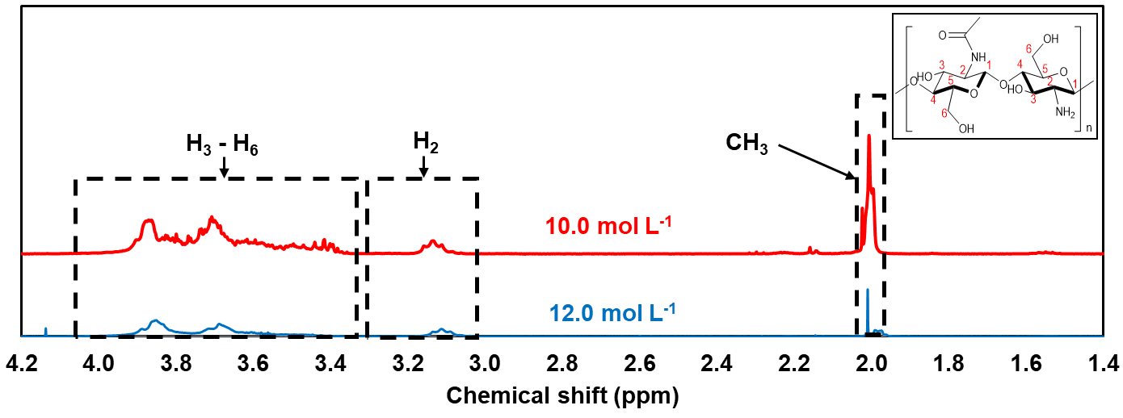
Fig. S3 ¹H NMR spectra of CS monoliths treated with 10.0 mol L⁻¹ and 12.0 mol L⁻¹ NaOH solutions

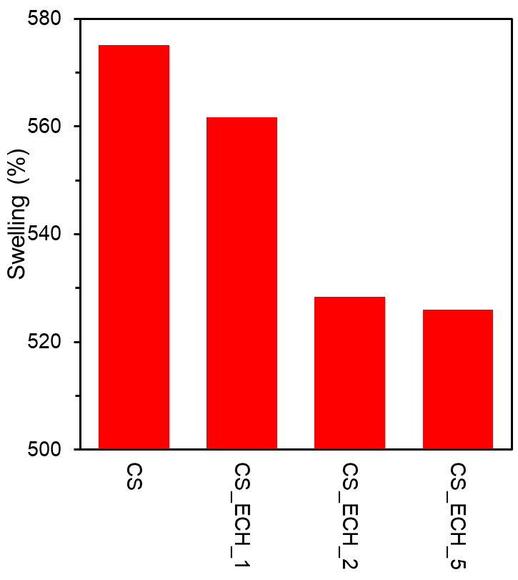
Fig. S4 The swelling percentage of CS, CS_ECH_1, CS_ECH_2, and CS_ECH_5 monoliths, in 0.1 mol L⁻¹ HCl solution

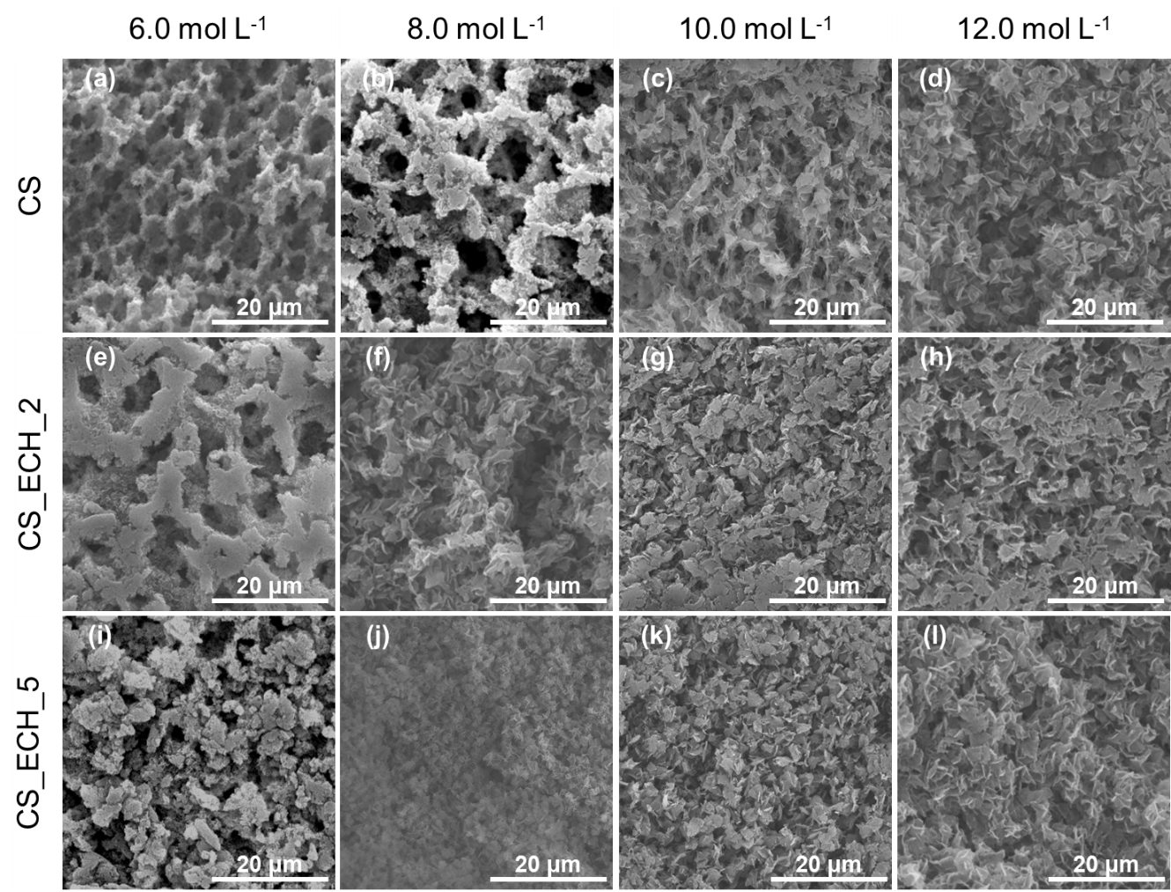
Fig. S5 SEM images of CS (a-d), CS_ECH_1 (e-h), and CS_ECH_5 (i-l) monoliths treated with 6.0, 8.0, 10.0 and 12.0 mol L⁻¹ NaOH solutions

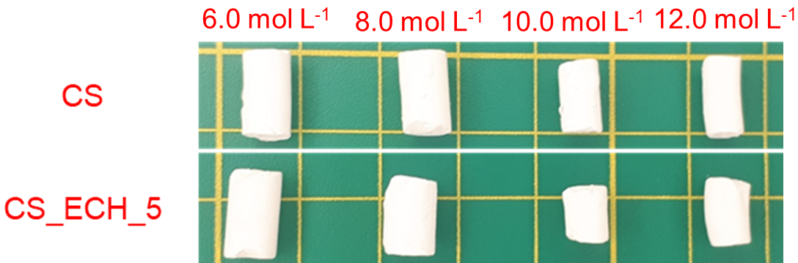
Fig. S6 Macroscopic images of CS and CS_ECH_5 monoliths treated with 6.0, 8.0, 10.0 and 12.0 mol L⁻¹ NaOH solution

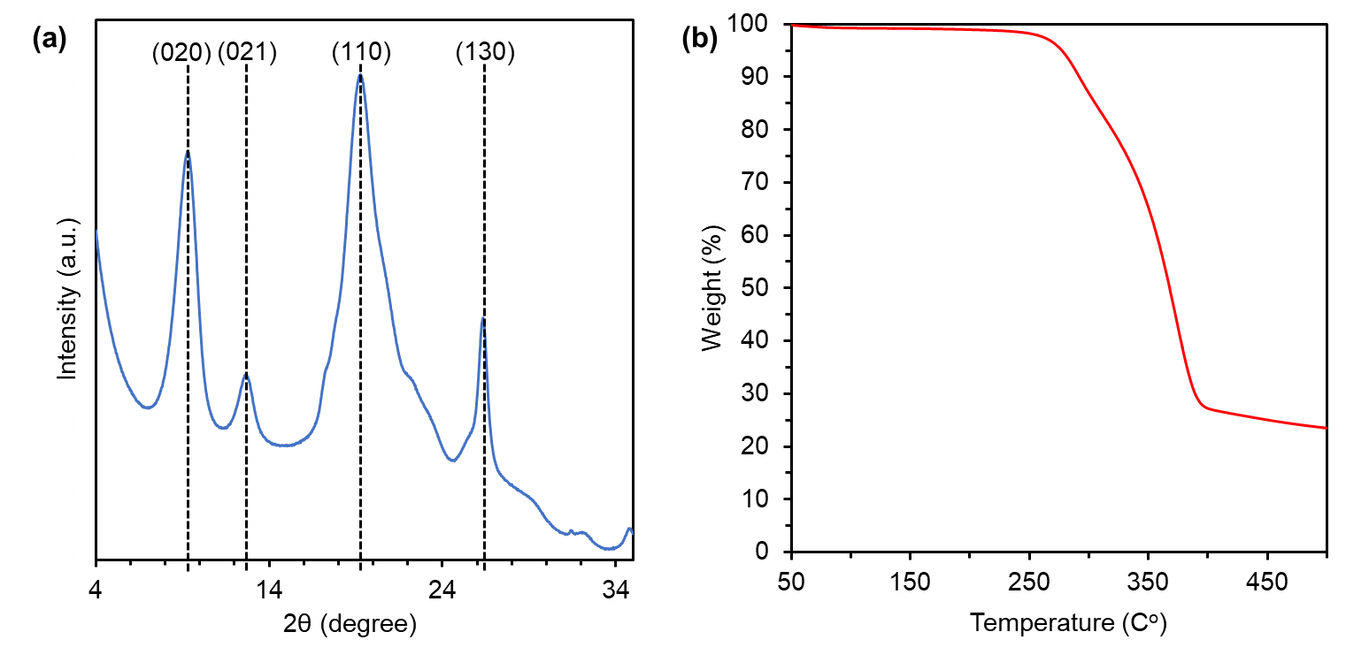
Fig. S7 (a) XRD pattern and (b) TGA profile of non-crosslinked CS monolith

