Supplementary data

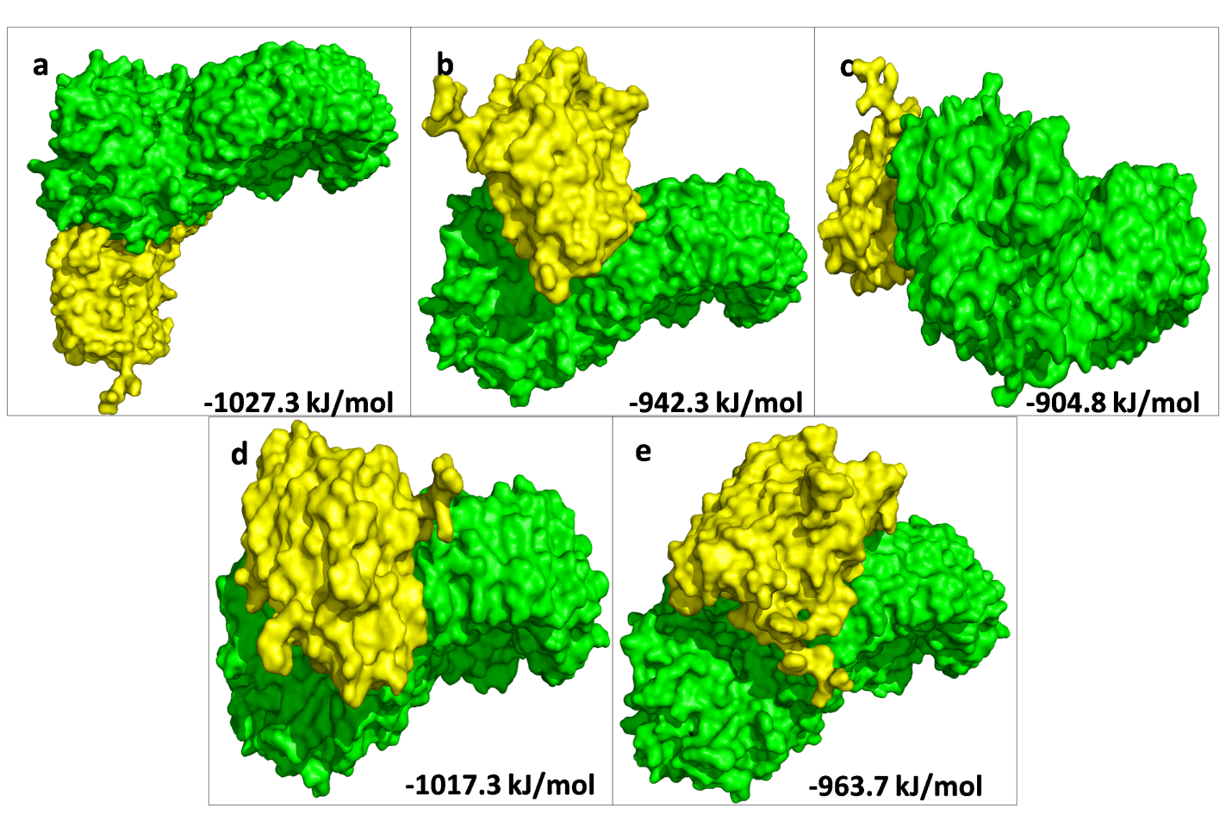
Figure S1. The top 5 docked models displaying interaction of NLRP3- catechin complex with Caspase-1.
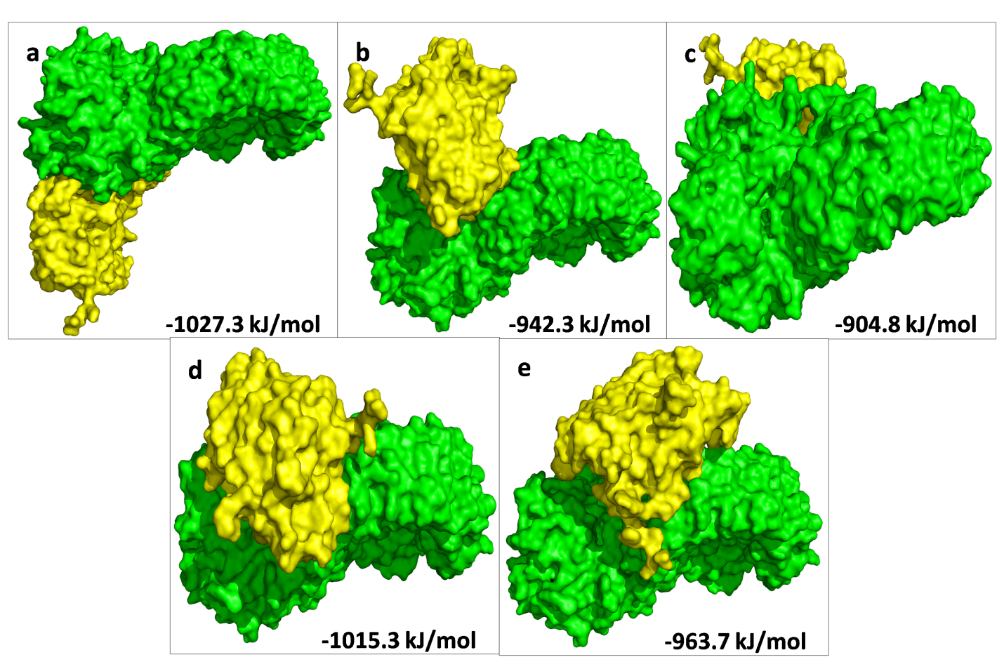
Figure S2. The top 5 docked models displaying interaction of NLRP3- curcumin complex with Caspase-1.
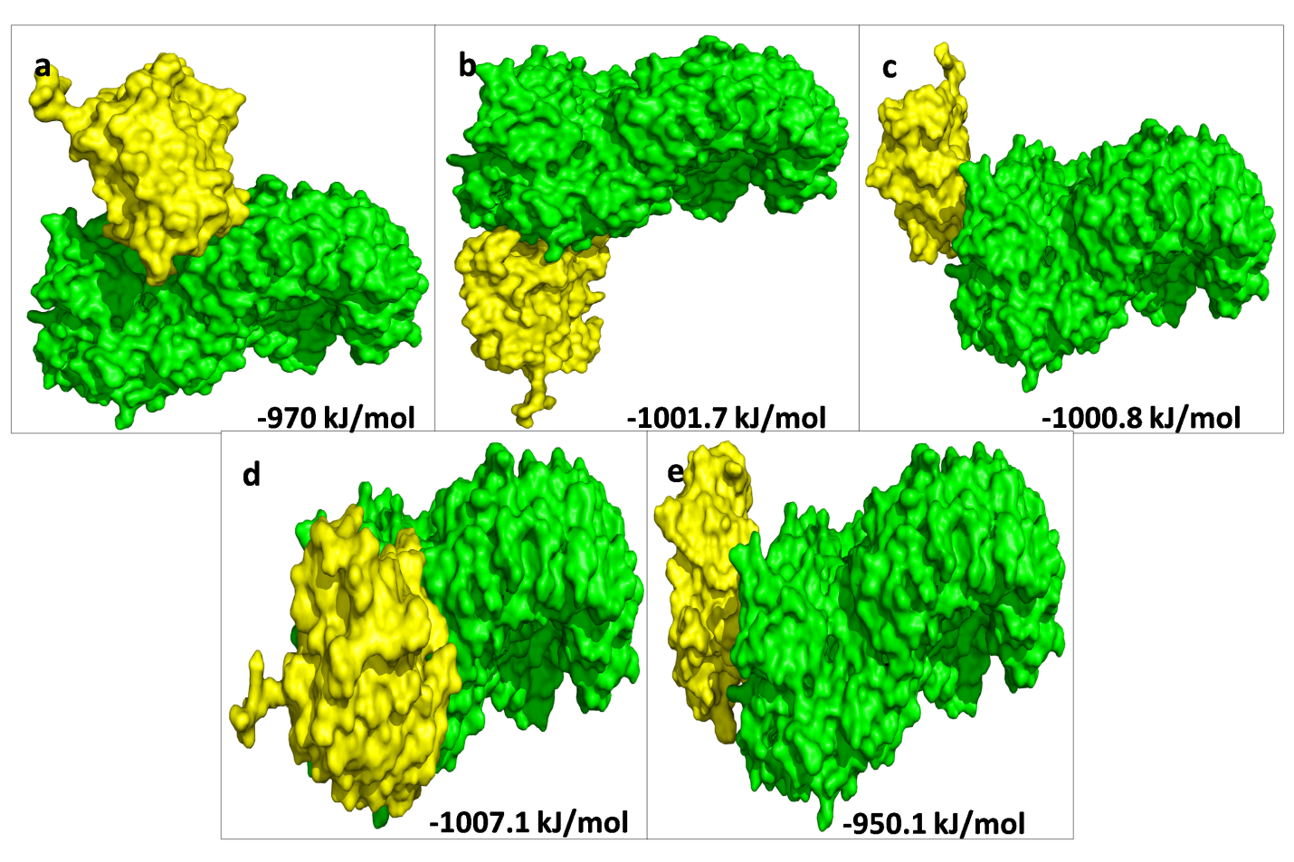

Figure S3. The top 5 docked models displaying interaction of NLRP3 with Caspase-1-catechin complex.

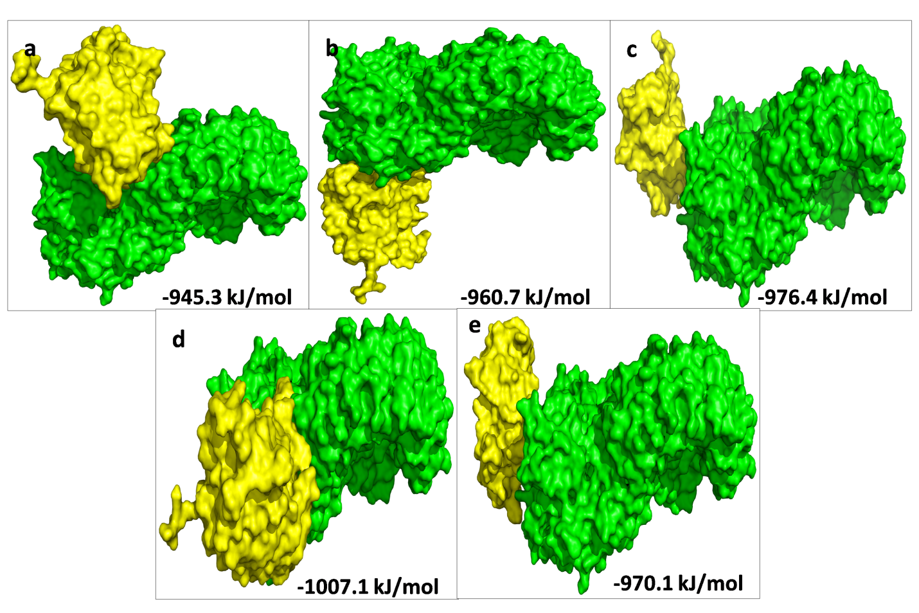
Figure S4. The top 5 docked models displaying interaction of NLRP3 with Caspase-1-curcumin complex.
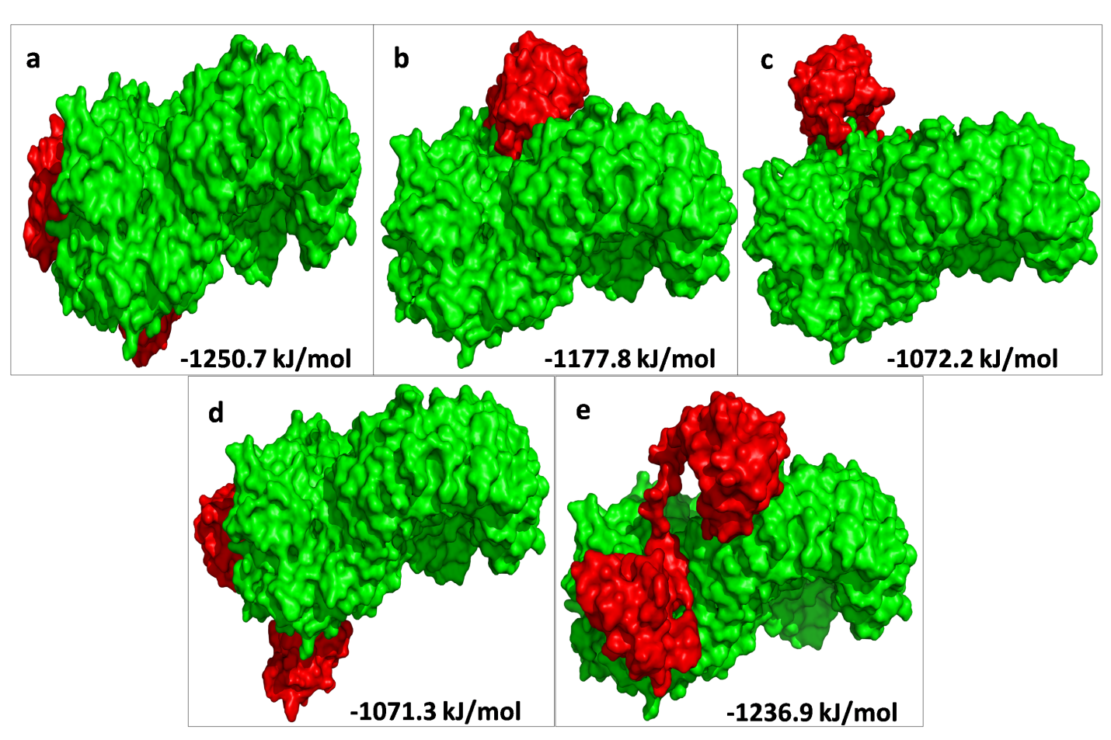
Figure S5. The top 5 docked models displaying interaction of NLRP3- catechin complex with ASC.
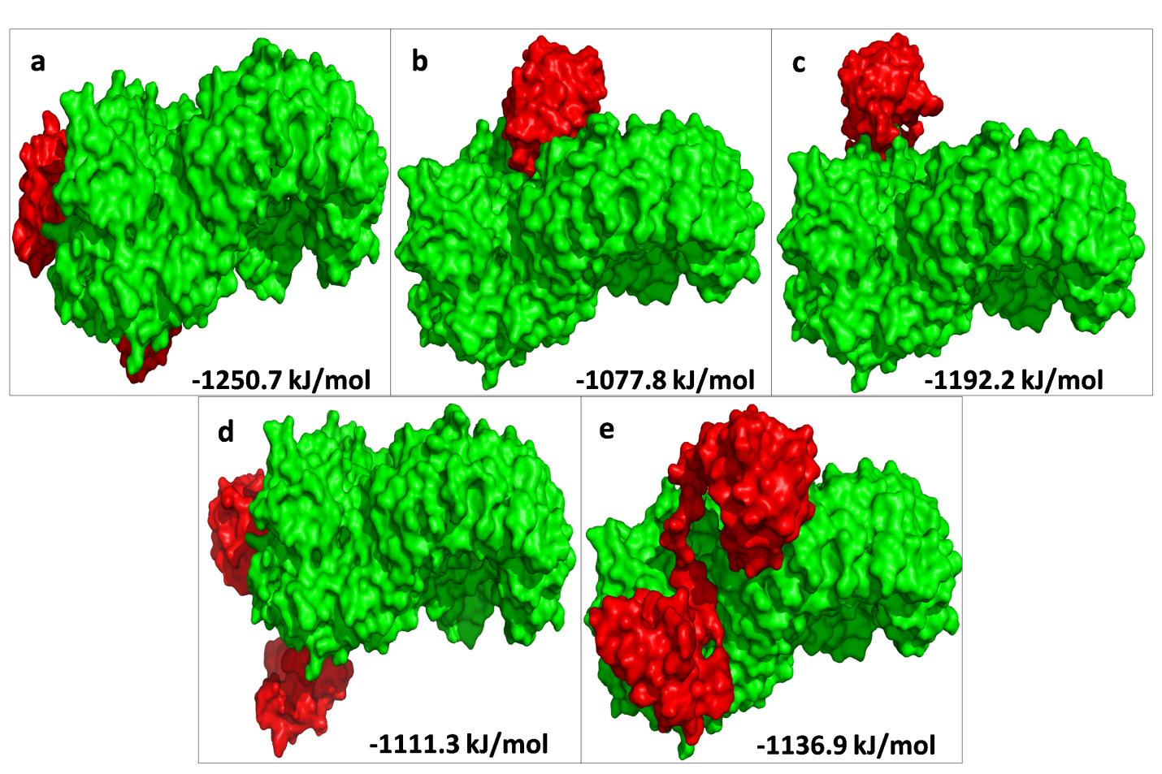

Figure S6. The top 5 docked models displaying interaction of NLRP3- curcumin complex with ASC.
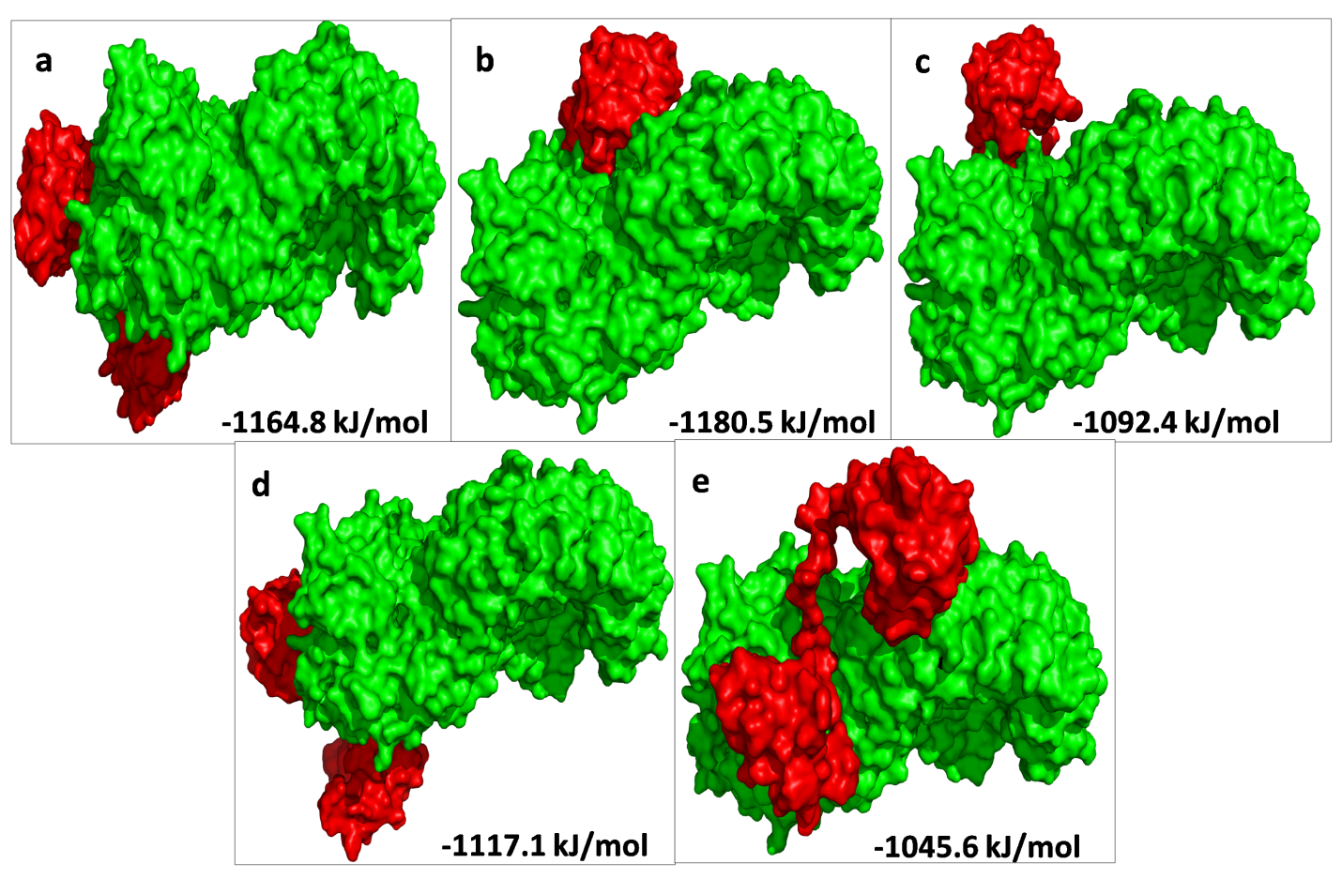
Figure S7. The top 5 docked models displaying interaction of NLRP3 with ASC-catechin complex.

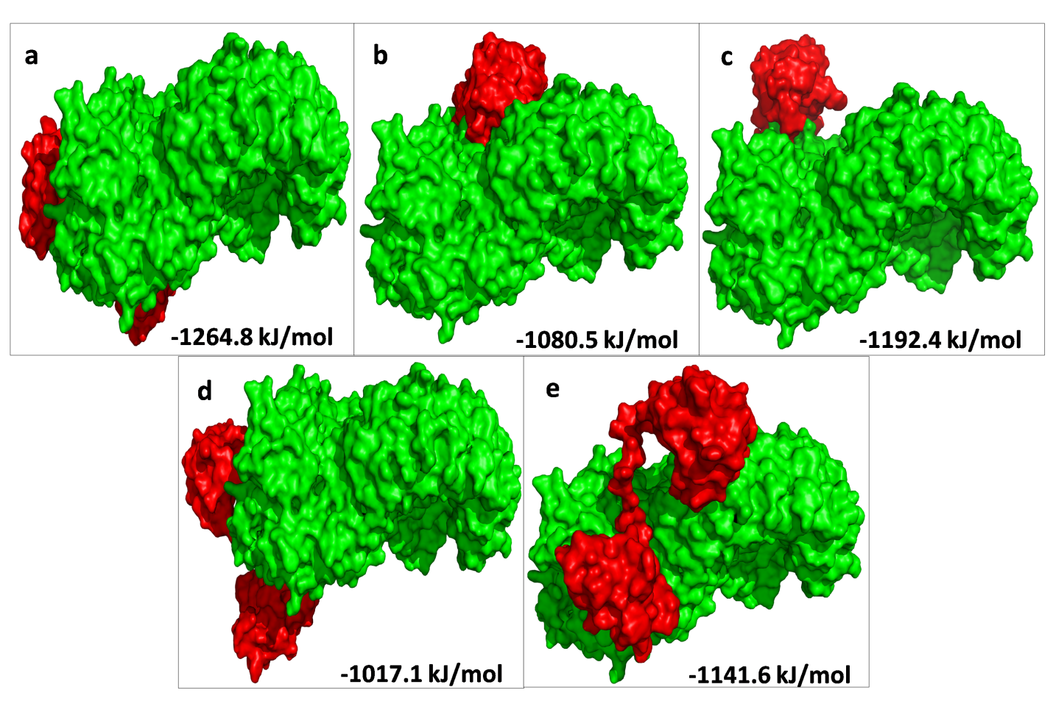
Figure S8. The top 5 docked models displaying interaction of NLRP3 with ASC-curcumin complex.

