Supplementary information:
Extending the Low Temperature Operating Range of Sodium Metal Batteries with Acyclic/Cyclic Ether-Based Electrolytes

Chuanlong Wang¹, Akila C. Thenuwara², Jianmin Luo¹, Pralav P. Shetty², Matthew T. McDowell^{2,3} , Weiyang Li^{1,*}

*Corresponding author
Email: weiyang.li@dartmouth.edu
¹Thayer School of Engineering, Dartmouth College, 14 Engineering Drive, Hanover, NH, 03755, USA
²G.W. Woodruff School of Mechanical Engineering, Georgia Institute of Technology, 801 Ferst Drive, Atlanta, GA, 30332, USA
³School of Materials Science and Engineering, Georgia Institute of Technology, 771 Ferst Drive, Atlanta, GA, 30332, USA

Table of contents
SEM in unary-solvent electrolytes 5
XPS in unary-solvent electrolytes 6
Supplementary Fig. 1 | Radar chart comparing performance of Na and Li metal anodes cycling at low temperatures (≤−40ºC) 8
Supplementary Fig. 2 | Investigation of the traditional electrolyte consisting of 1M NaPF₆-DEGDME across a range of temperatures 9
Supplementary Fig. 3 | Galvanostatic cycling of Na/Na symmetric cells operating at +20˚C in eight different electrolytes 10
Supplementary Fig. 4 | Enlarged voltage profiles at the 50th cycle of Na/Na symmetric cells cycling at +20˚C in six electrolytes 11
Supplementary Fig. 5 | SEM images of Na surfaces after cycling at +20˚C in 1M NaOTf-DEGDME, NaFSI-DME, NaClO₄-DEGDME, NaTFSI-DOL electrolytes 12
Supplementary Fig. 6 | SEM images of Na surfaces after cycling at +20˚C in 1M NaFSI-DEGDME, NaClO₄-DME, NaTFSI-DME, NaTFSI-DEGDME electrolytes 13
Supplementary Fig. 7 | SEM images of Na surfaces after cycling at −20˚C (symmetric Na/Na cells) in 1M NaOTf-DEGDME, NaClO₄-DME, NaTFSI-DME, NaFSI-DME electrolytes 14
Supplementary Fig. 8 | SEM images of Na surfaces after cycling at −20˚C in 1M NaClO₄-DEGDME, NaTFSI-DEGDME, NaFSI-DEGDME, NaTFSI-DOL electrolytes 15
Supplementary Fig. 9 | XPS depth profile analysis on Na after 50 cycles in 1M NaOTf-DEGDME electrolyte at +20˚C 16
Supplementary Fig. 10 | XPS depth profile analysis on Na after 50 cycles in 1M NaOTf-DEGDME electrolyte at −20˚C 17
Supplementary Fig. 11 | XPS depth profile analysis on Na after 50 cycles in 1M NaOTf-DEGDME electrolyte at −40˚C 18
Supplementary Fig. 12 | XPS of the Na surface after 50 cycles in 1M NaClO₄-DME electrolyte at +20˚C and −20˚C 19
Supplementary Fig. 13 | XPS depth profile analysis on Na after 50 cycles in 1M NaClO₄-DME electrolyte at +20˚C 20
Supplementary Fig. 14 | XPS depth profile analysis on Na after 50 cycles in 1M NaClO₄-DME electrolyte at −20˚C 21
Supplementary Fig. 15 | XPS of the Na surface after 50 cycles in 1M NaFSI-DME electrolyte at +20˚C and −20˚C 22
Supplementary Fig. 16 | XPS depth profile analysis on Na after 50 cycles in 1M NaFSI-DME electrolyte at +20˚C 23
Supplementary Fig. 17 | XPS depth profile analysis on Na after 50 cycles in 1M NaFSI-DME electrolyte at −20˚C 24
Supplementary Fig. 18 | XPS of the Na surface after cycling in 1M NaTFSI-DEGDME electrolyte at +20˚C and −20˚C 25
Supplementary Fig. 19 | XPS depth profile on Na after cycling in 1M NaTFSI-DEGDME electrolyte at +20˚C 26
Supplementary Fig. 20 | XPS depth profile on Na after 50 cycles in 1M NaTFSI-DEGDME electrolyte at −20˚C 27
Supplementary Fig. 21 | XPS of the Na surface after 50 cycles in 1M NaTFSI-DOL electrolyte at +20˚C and −20˚C 28
Supplementary Fig. 22 | XPS depth profile analysis on Na after 50 cycles in 1M NaTFSI-DOL electrolyte at +20˚C 29
Supplementary Fig. 23 | XPS depth profile analysis on Na surface after 50 cycles in 1M NaTFSI-DOL electrolyte at −20˚C 30
Supplementary Fig. 24 | Temperature-dependent galvanostatic cycling of Na/Na symmetric cells in 1M NaOTf-DEGDME/DOL (8:2 and 5:5) 31
Supplementary Fig. 25 | Temperature-dependent galvanostatic cycling of Na/Na symmetric cells in 0.5M NaOTf-DEGDME/DOL (8:2) and 0.5M NaOTf-DME/DOL (8:2, 5:5 and 2:8) 32
Supplementary Fig. 26 | Temperature-dependent galvanostatic cycling of Na/Na symmetric cells in 0.5M NaClO₄-DME/DOL (8:2 and 5:5) 33
Supplementary Fig. 27 | Temperature-dependent dynamic viscosity of DEGDME and DEGDME/DOL (8:2, 5:5 and 2:8) 34
Supplementary Fig. 28 | Photos of (1) 1M NaOTf-DEGDME, (2) 0.5M NaOTf-DEGDME/DOL (5:5) and (3) 0.5M NaOTf-DEGDME/DOL (2:8) after storing at +20˚C and −80˚C for 24 hours 35
Supplementary Fig. 29 | Galvanostatic cycling of Na/Na symmetric cells at 0.2 mA cm⁻² and 0.1 mAh cm⁻² at −80˚C 36
Supplementary Fig. 30 | SEM of a Na surface after cycling in 0.5M NaOTf DEGDME/DOL (5:5) at −80°C 37
Supplementary Fig. 31 | XPS of O_{1s} and F_{1s} profiles of Na surface after 50 cycles in 0.5M NaOTf-DEGDME/DOL (2:8) electrolytes at −80˚C 38
Supplementary Fig. 32 | XPS on Na surface after 50 cycles in 0.5M NaOTf-DEGDME/DOL (5:5) at −80˚C 39
Supplementary Fig. 33 | XPS depth profile analysis on Na after 50 cycles in 0.5M NaOTf-DEGDME/DOL (5:5) electrolyte at −80˚C 40
Supplementary Fig. 34 | XPS depth profile analysis on Na after 50 cycles in 0.5M NaOTf-DEGDME/DOL (2:8) at −80˚C 41
Supplementary Fig. 35 | TEM image that is the same as Fig. 4d but without colored overlays 42
Supplementary Fig. 36 | Selected-area electron diffraction pattern of the SEI formed at −40°C. 43
Supplementary Fig. 37 | CE as a function of cycle number in Na/stainless steel cells in 0.5M NaOTf-DEGDME/DOL (2:8) at −40°C and +20°C 44
Supplementary Table 1 | Summary comparing performance of Na and Li metal anodes cycling at low temperatures (≤−40ºC) 45
Supplementary Table 2 | Melting point, dielectric constant, and dynamic viscosity of DEGDME, DME and DOL 46
Supplementary Table 3 | Summary of the dissolution of five Na salts in three different solvents (in 1M concentration), 47
Supplementary Table 4 | Summary of overpotential plateaus and voltage spikes on the plateaus in eight 1M electrolyte candidates at the 50th cycle 48
Supplementary Table 5 | Summary of identified XPS peaks 49
Supplementary Table 6 | Summary of SEI composition (surface and bulk) 50
Supplementary Table 7 | Summary of salt dissolution in binary solvents at 1M/0.5M concentrations at −35°C 51
References 52

SEM in unary-solvent electrolytes
Supplementary Figs. 4 to 7 display the morphological structure of Na deposited from the 1M NaClO₄-DME, NaFSI-DME, NaTFSI-DEGDME and NaTFSI-DOL systems. Using 1M NaClO₄-DME, contrasting SEI conditions are present at different temperatures. A relatively smooth surface with spindle-shaped clusters is seen at −20°C, while a broken and detached one is at +20°C. As to 1M NaFSI-DME, corroded Na surfaces with deep cracks could be observed at −20°C while a number of pores are shown at +20°C. These pores are possibly attributed to the strong SO₂ gas evolution through the breakage of F(SO₂)₂N (decomposition product of FSI⁻) under strong attraction of oxygen (O) atoms to the metal surface at higher temperature¹⁻⁵.
Similar fractured and porous surfaces appear in NaTFSI based electrolytes, where the degree of fragmentation decreases significantly with the drop of temperature. Specifically, at +20°C, 1M NaTFSI-DEGDME readily exhibits badly damaged SEI early at the 16th cycle. In contrast, a mildly ruptured surface is observed after 50 cycles at −20°C. The above phenomena correspond well with previous reports that NaTFSI and NaFSI salts tend to cause side reactions even though LiTFSI is a frequently used salt for Li metal¹⁻⁵.
Another interesting observation is that DOL is more liable to evolve gases (larger pores are seen at +20°C in NaTFSI-DOL) than DME/DEGDME at ambient temperature, attributed to the distinct HOMO-LUMO energies of the complex of Na⁺ ion and solvent¹. However, such gas-evolving reaction can be effectively suppressed at reduced temperatures (no pores are observed at −20°C in NaTFSI-DOL).

XPS in unary-solvent electrolytes
Supplementary Figs. 11 to 22 present the chemical composition of 1M NaClO₄-DME, NaFSI-DME, NaTFSI-DEGDME and NaTFSI-DOL. In 1M NaClO₄-DME, the chemistry of the SEI is very sensitive to temperature^{6,12-14}. Specifically, the NaCl (198.4 eV) component is ubiquitous at +20°C. In contrast, NaClO₄ (208.5 eV) and NaClO₃ (206.3 eV) are exhibited on the surface and NaClO₂ (203.8 eV) is present at the inner zone at −20°C. Such differences suggest that a lower temperature can alleviate severe corrosion caused by the reduction from NaClO₄ to NaCl.
As for 1M NaFSI-DME, −20°C samples show more complicated SEI in comparison to those at +20°C⁶⁻¹¹. At +20°C, -SO₂F enriched species (170.2 eV) and Na₂S₂O₃ (168.7 eV) exist on the surface in addition to NaF (684.1 eV), C-O-Na (531.2 eV) and organic debris while Na₂S (161.1 eV) appears in the bulk. At −20°C, Na₂SO₃ (167.2 eV), NaN₃ (403.6 and 398.5 eV) and Na₂O (528.2 eV) are detected besides the above ingredients. Interestingly, the low temperature does not seem to reduce the extent of the reactions, but preferentially triggers more complete FSI⁻ decomposition.
Given the different anion structure of TFSI⁻, the SEI species in 1M NaTFSI-DEGDME are moderately dissimilar compared to those using FSI⁻⁶⁻¹¹. In particular, -CF₂ containing compounds (292.3 eV) and NaCN (397.4 eV) are revealed instead of -SO₂F enriched ones. When DEGDME is replaced with DOL (in 1M NaTFSI-DOL), the decomposition of TFSI⁻ is suppressed to some extent as supported by the existence of -SO₂CF_{x} (x=2 or 3) enriched species (168.9 eV) ⁶⁻¹¹. Such inhibition is more effective at lower temperatures as less-complicated SEI chemistry is unveiled at −20°C.

Supplementary Fig. 1 | Radar chart comparing performance of Na and Li metal anodes cycling at low temperatures (≤−40ºC)¹⁵⁻¹⁸, based on Supplementary Table 1.

Supplementary Fig. 2 | Investigation of the traditional electrolyte consisting of 1M NaPF₆-DEGDME across a range of temperatures. a, Electrochemical impedance spectroscopy of Na/Na symmetric cells (reversible electrodes) using 1M NaPF₆-DEGDME at temperatures of +20˚C and −20˚C. Note that the Nyquist plot at −20˚C shows 18 times higher impedance than that at +20˚C. b, Electrolyte resistance evaluation of 1M NaPF₆-DEGDME using blocking electrodes (symmetric stainless steel/stainless steel electrodes) at a range of temperatures. Note that the increase of impedance from +20˚C to −45˚C is due to the increase of electrolyte resistance with decreasing temperature, especially below −20˚C, likely due to the precipitation of NaPF₆. Inset: salt precipitation (marked in red square) observed at the bottom of the vial for 1M NaPF₆-DEGDME stored at −35˚C overnight.

Supplementary Fig. 3 | Galvanostatic cycling of Na/Na symmetric cells operating at +20˚C in eight different electrolytes at a current density of 0.5 mA cm⁻² and a capacity of 0.5 mAh cm⁻². Note that the metallic Na performance (overpotential and cycle life) in the eight electrolytes exhibits the following decreasing trend: NaOTf-DEGDME > NaFSI-DME > NaFSI-DEGDME > NaClO₄-DME > NaClO₄-DEGDME > NaTFSI-DOL > NaTFSI-DEGDME > NaTFSI-DME.

Supplementary Fig. 4 | Enlarged voltage profiles at the 50th cycle of Na/Na symmetric cells cycling at +20˚C in six electrolytes (1M concentration), at a current density of 0.5 mA cm⁻² with a capacity of 0.5 mAh cm⁻². Note that 1M NaTFSI-DME and NaTFSI-DEGDME result in early failure before the 50th cycle.

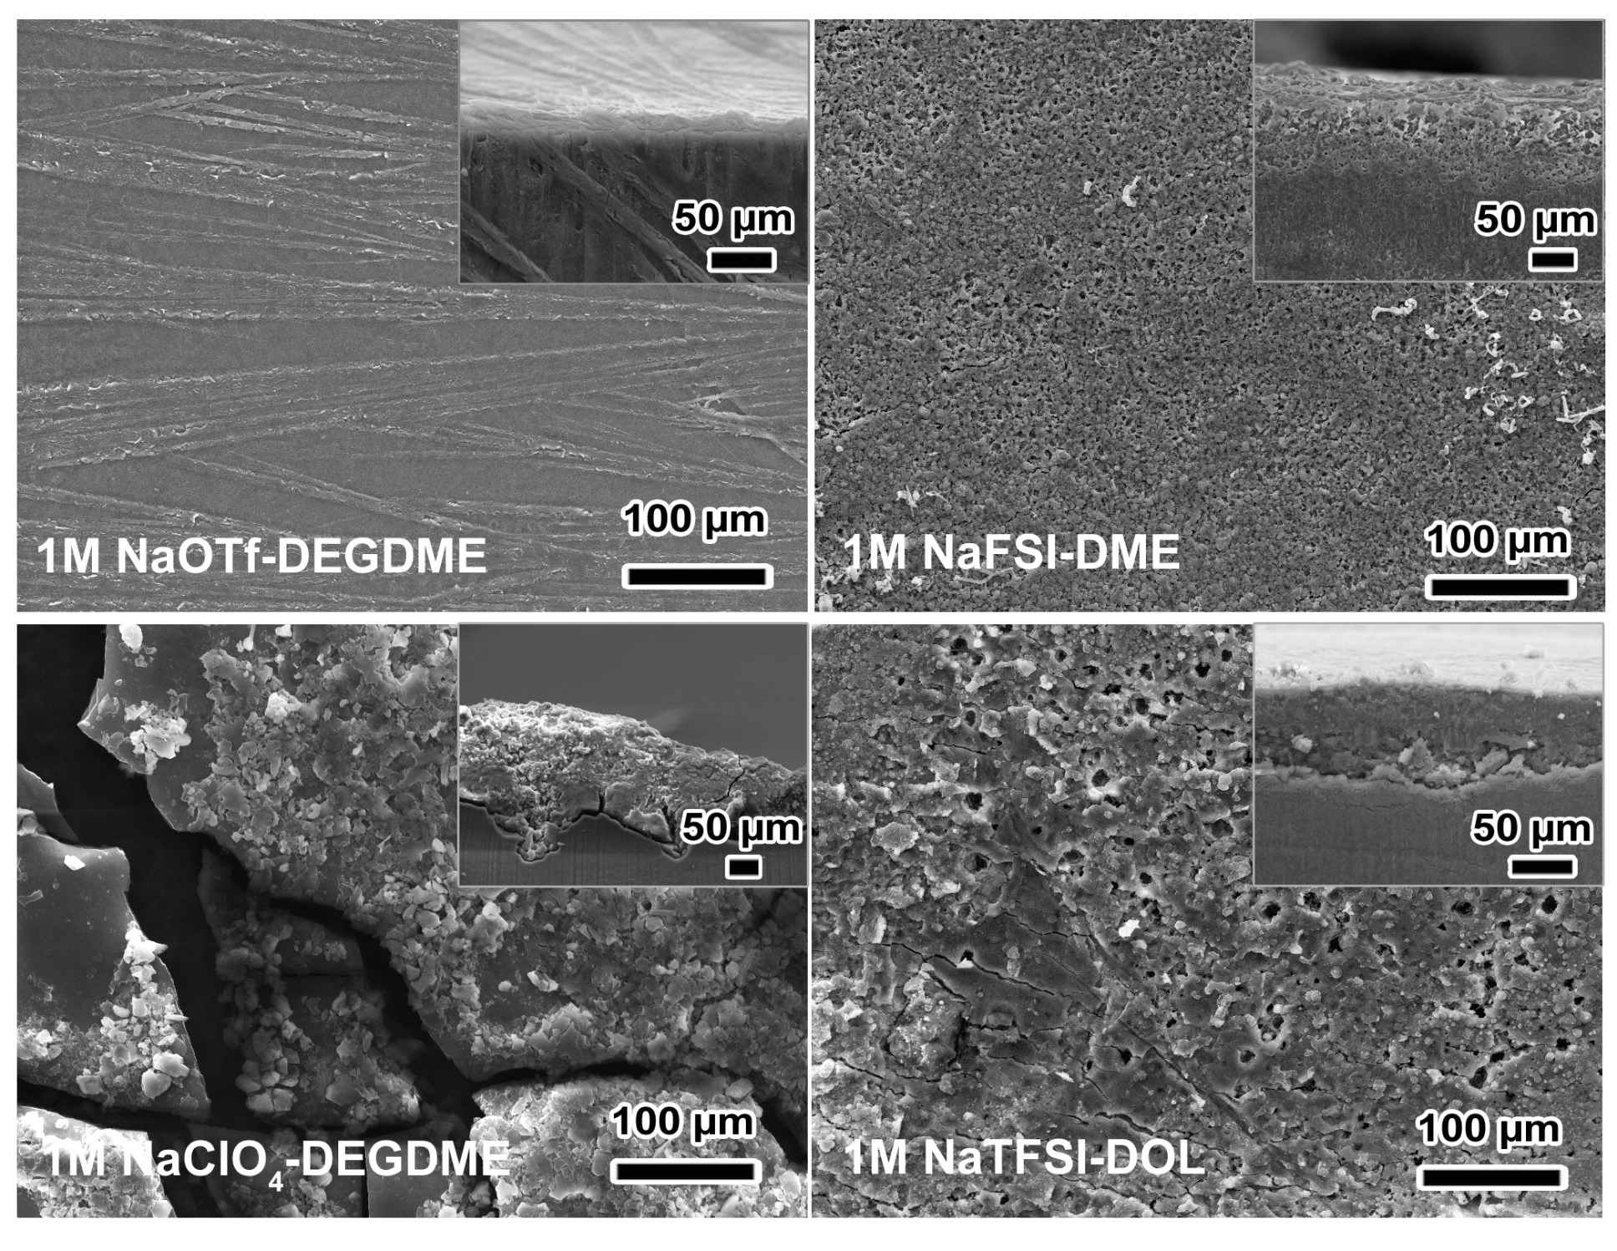
Supplementary Fig. 5 | SEM images of Na surfaces after cycling at +20˚C (symmetric Na/Na cells) in 1M NaOTf-DEGDME, NaFSI-DME, NaClO₄-DEGDME, NaTFSI-DOL electrolytes at a current density of 0.5 mA cm⁻² with a capacity of 0.5 mAh cm⁻² (Insets: corresponding cross-sectional SEM images).
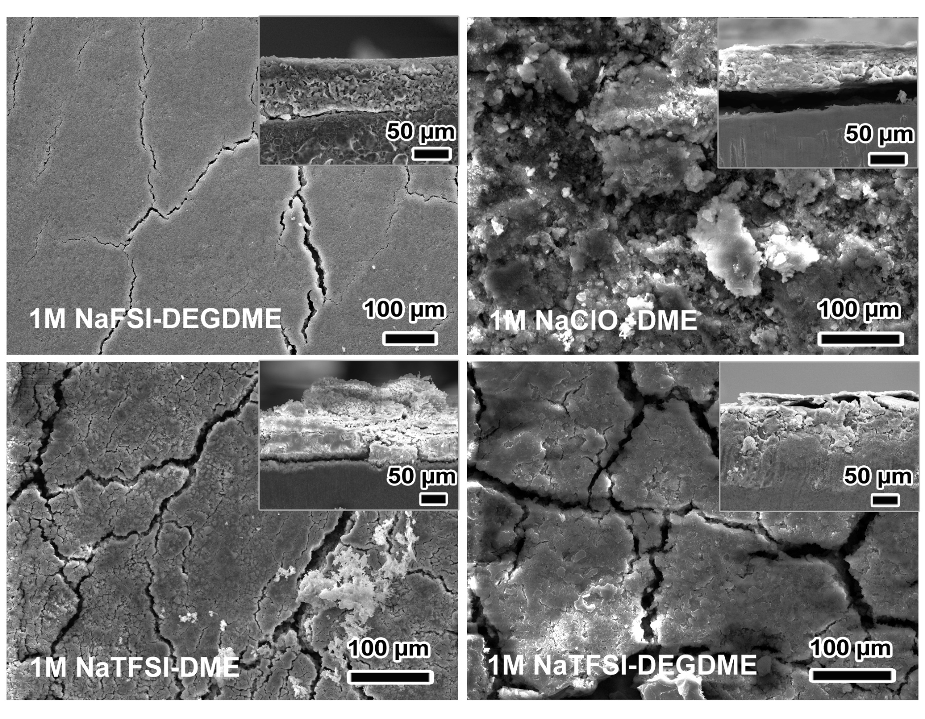
Supplementary Fig. 6 | SEM images of Na surfaces after cycling at +20˚C (symmetric Na/Na cells) in 1M NaFSI-DEGDME, NaClO₄-DME, NaTFSI-DME, NaTFSI-DEGDME electrolytes at a current density of 0.5 mA cm⁻² with a capacity of 0.5 mAh cm⁻². Note that 1M NaTFSI-DME failed at the 22nd cycle and 1M NaTFSI-DEGDME failed at the 16th cycle (Insets: corresponding cross-sectional SEM images).

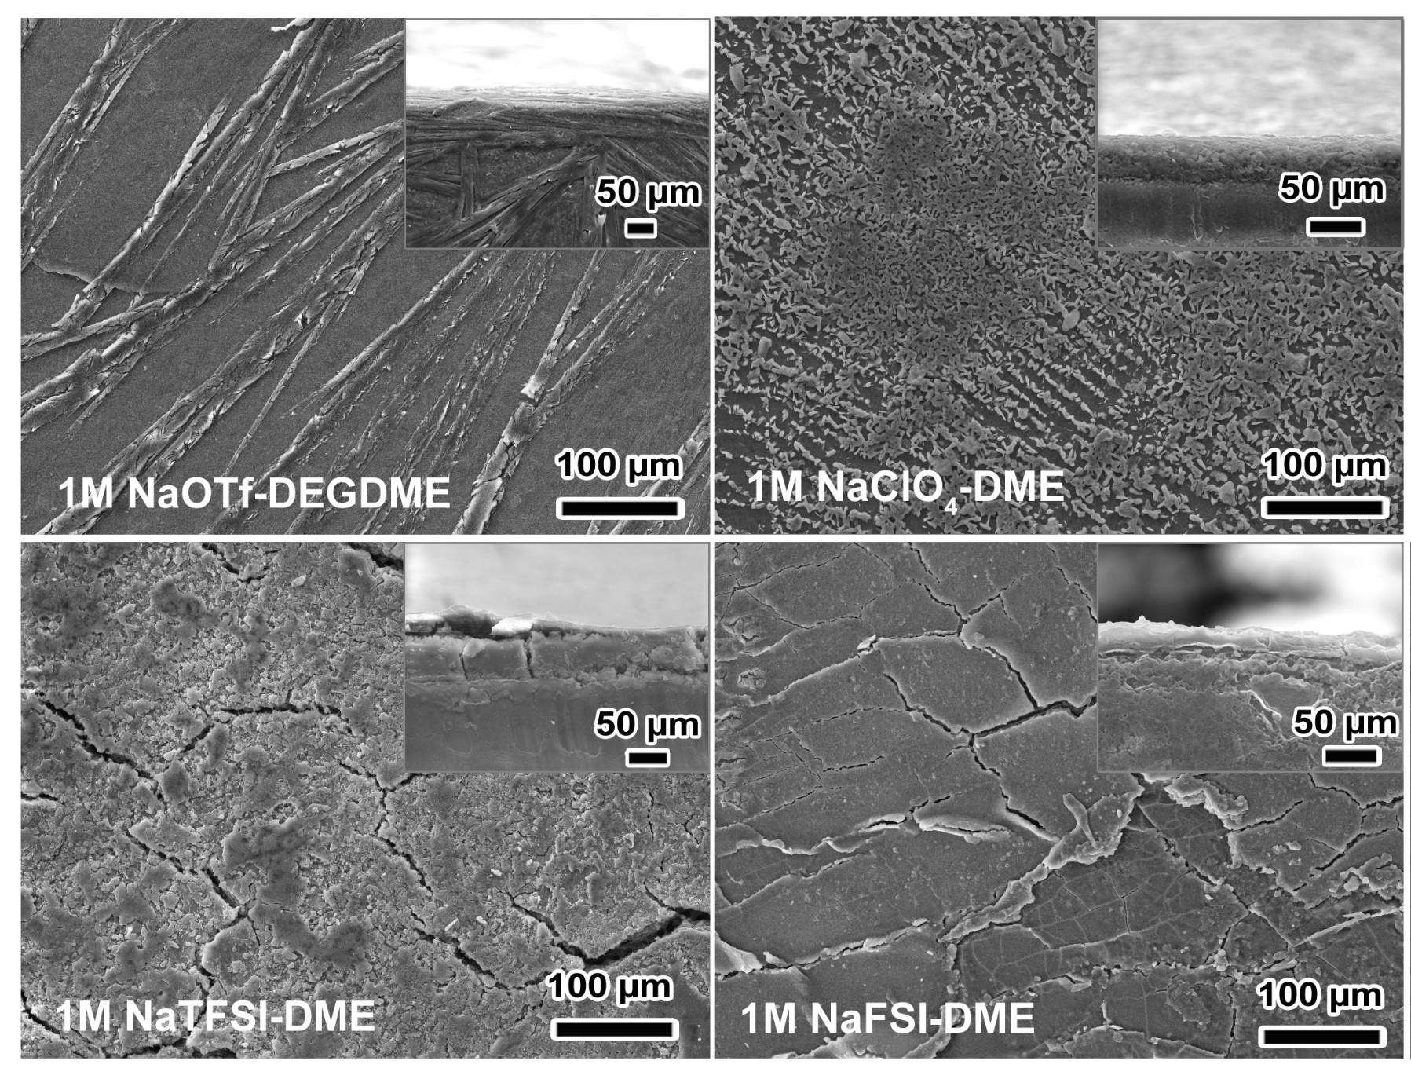
Supplementary Fig. 7 | SEM images of Na surfaces after cycling at −20˚C (symmetric Na/Na cells) in 1M NaOTf-DEGDME, NaClO₄-DME, NaTFSI-DME, NaFSI-DME electrolytes at a current density of 0.5 mA cm⁻² with a capacity of 0.5 mAh cm⁻² (Insets: corresponding cross-sectional SEM images).

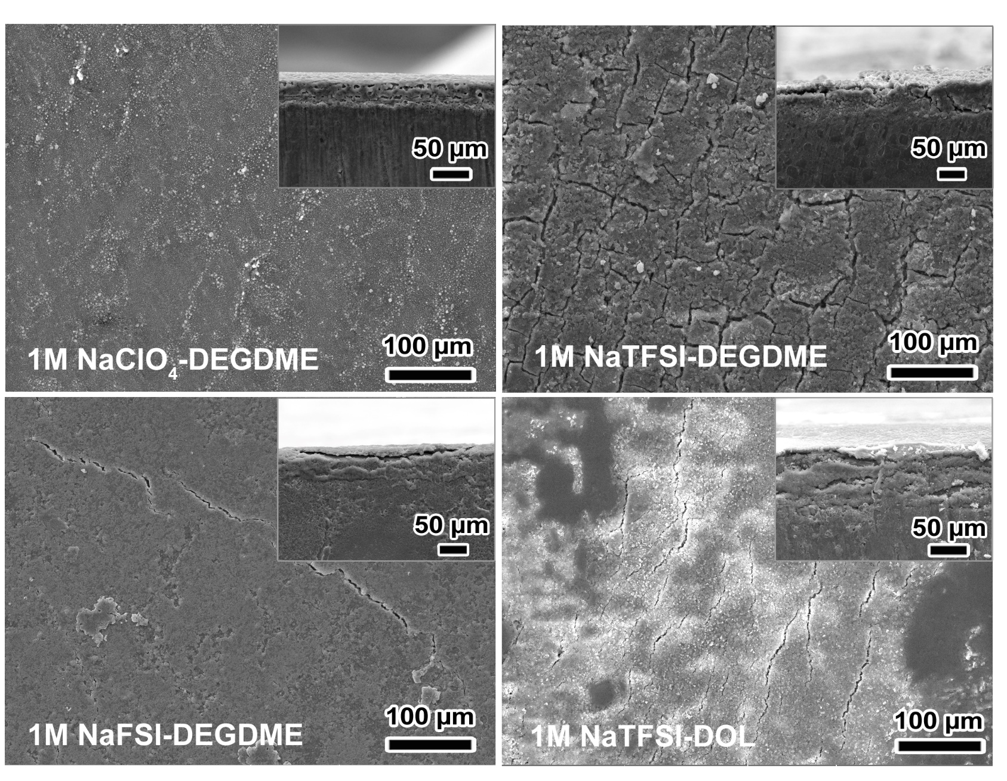
Supplementary Fig. 8 | SEM images of Na surfaces after cycling at −20˚C (symmetric Na/Na cells) in 1M NaClO₄-DEGDME, NaTFSI-DEGDME, NaFSI-DEGDME, NaTFSI-DOL electrolytes at a current density of 0.5 mA cm⁻² with a capacity of 0.5 mAh cm⁻² (Insets: corresponding cross-sectional SEM images).

Supplementary Fig. 9 | XPS depth profile analysis on Na after 50 cycles (symmetric Na/Na cells) in 1M NaOTf-DEGDME electrolyte at +20˚C at a current density of 0.5 mA cm⁻² with a capacity of 0.5 mAh cm⁻².

Supplementary Fig. 10 | XPS depth profile analysis on Na after 50 cycles (symmetric Na/Na cells) in 1M NaOTf-DEGDME electrolyte at −20˚C at a current density of 0.5 mA cm⁻² with a capacity of 0.5 mAh cm⁻².
Supplementary Fig. 11 | XPS depth profile analysis on Na after 50 cycles (symmetric Na/Na cells) in 1M NaOTf-DEGDME electrolyte at −40˚C at a current density of 0.5 mA cm⁻² with a capacity of 0.5 mAh cm⁻².

Supplementary Fig. 12 | XPS of the Na surface after 50 cycles (symmetric Na/Na cells) in 1M NaClO₄-DME electrolyte at +20˚C and −20˚C at a current density of 0.5 mA cm⁻² with a capacity of 0.5 mAh cm⁻². The binding energies of all elements were calibrated with respect to C_{1s} at 284.8 eV. In the C_{1s} profile, besides O-C=O (288.7 eV) and C-O-C (286.6 eV), the peaks at 287.6 eV and 289.7 eV are ascribed to C-Cl and polycarbonate while 279.6 eV and 277.9 eV correspond to ClO₄⁻ (1s) and ClO₃⁻ (1s). In the O_{1s} spectrum, the peaks at 533.3 eV and 531.2 eV correspond to polyether-like compounds and C-O-Na (e.g. RCH₂ONa) while the one at 536.3 eV is attributed to Na KLL. For Cl_{2p} XPS peak-fitting, Cl_{3/2} to Cl_{1/2} area ratio is fixed at 2:1 where the doublet separation is 1.60 eV. In the Cl_{2p} profile, the peak at 198.4 eV (based on 2p_{3/2}) is assigned to Cl⁻ while those at 208.5 eV and 206.3 eV are respectively ascribed to ClO₄⁻ (based on 2p_{3/2}) and ClO₃⁻ (based on 2p_{3/2}) ^{6,12-14}.

Supplementary Fig. 13 | XPS depth profile analysis on Na after 50 cycles (symmetric Na/Na cells) in 1M NaClO₄-DME electrolyte at +20˚C at a current density of 0.5 mA cm⁻² with a capacity of 0.5 mAh cm⁻². XPS peaks are identified in supplementary Fig. 11.

Supplementary Fig. 14 | XPS depth profile analysis on Na after 50 cycles (symmetric Na/Na cells) in 1M NaClO₄-DME electrolyte at −20˚C at a current density of 0.5 mA cm⁻² with a capacity of 0.5 mAh cm⁻². In addition to the XPS peaks identified in supplementary Fig. 11, the one at 203.8 eV is attributed to ClO₂^{- 6,12-14}.

Supplementary Fig. 15 | XPS of the Na surface after 50 cycles (symmetric Na/Na cells) in 1M NaFSI-DME electrolyte at +20˚C and −20˚C at a current density of 0.5 mA cm⁻² with a capacity of 0.5 mAh cm⁻². The binding energies of all elements were calibrated with respect to C_{1s} at 284.8 eV. In the C_{1s} XPS profile, the binding energy at 289.3 eV corresponds to HCF in addition to C-O-C (286.6 eV). In the O_{1s} spectrum, the peaks at 533.3 eV and 531.2 eV correspond to polyether-like compounds and C-O-Na (e.g. RCH₂ONa), respectively, while the one at 536.3 eV is attributed to Na KLL. For S_{2p} peak-fitting, the 2p_{3/2} to 2p_{1/2} area ratio is fixed at 2:1 according to the ratio of degeneracy, where the doublet separation is 1.18 eV. In S_{2p} XPS, the doublet at 170.2 eV (based on 2p_{3/2}) is assigned to F-SO₂ while the ones at 168.7 eV and 167.2 eV (based on 2p_{3/2}) are ascribed to S₂O₃²⁻ and SO₃²⁻. As for F_{1s}, the peaks at 687.8 eV and 684.1 eV are assigned to S-F and NaF, respectively. For N_{1s}, the peak at 399.3 eV reveals N-S⁶⁻¹¹.

Supplementary Fig. 16 | XPS depth profile analysis on Na after 50 cycles (symmetric Na/Na cells) in 1M NaFSI-DME electrolyte at +20˚C at a current density of 0.5 mA cm⁻² with a capacity of 0.5 mAh cm⁻². Besides the XPS peaks identified in Supplementary Fig. 14, an additional S_{2p} XPS peak at 161.1 eV (based on the 2p_{3/2}) is assigned to S²⁻ ⁶⁻¹¹.
Supplementary Fig. 17 | XPS depth profile analysis on Na after 50 cycles (symmetric Na/Na cells) in 1M NaFSI-DME electrolyte at −20˚C at a current density of 0.5 mA cm⁻² with a capacity of 0.5 mAh cm⁻². Besides the XPS peaks identified in Supplementary Fig. 14, the N_{1s} XPS peaks at 403.6 eV and 398.5 eV correspond to Na-NN*N* (1N) and Na-N*NN (2N), respectively. Furthermore, the energy at 528.2 eV is attributed to Na₂O in the O_{1s} profile while the one at 161.1 eV (based on the 2p_{3/2}) is ascribed to S²⁻ in the S_{2p} profile⁶⁻¹¹.
Supplementary Fig. 18 | XPS of the Na surface after cycling (symmetric Na/Na cells) in 1M NaTFSI-DEGDME electrolyte at +20˚C and −20˚C at a current density of 0.5 mA cm⁻² with a capacity of 0.5 mAh cm⁻². Note that 1M NaTFSI-DEGDME at +20˚C failed early while 1M NaTFSI-DEGDME at −20˚C was purposely stopped. The binding energies of all elements were calibrated with respect to C_{1s} at 284.8 eV. In the C_{1s} XPS profile, besides O-C=O (288.7 eV), the peaks at 287.2 eV and 292.3 eV are attributed to C-SO₂.and -CF₂. In the O_{1s} spectrum, the peaks at 533.3 eV and 531.2 eV correspond to polyether-like compounds and C-O-Na (e.g. RCH₂ONa), respectively, while the one at 536.3 eV is attributed to Na KLL. For S_{2p} peak-fitting, the 2p_{3/2} to 2p_{1/2} area ratio is fixed at 2:1 according to the ratio of degeneracy, where the doublet separation is 1.18 eV. In S_{2p} XPS, the doublets at 167.2 eV and 161.1 eV (based on 2p_{3/2}) are ascribed to SO₃²⁻ and S²⁻. As to F_{1s}, the peaks at 689.3 eV and 684.1 eV are assigned to C-F and NaF. For N_{1s}, the peak at 397.4 eV is assigned to NaCN⁶⁻¹¹.

Supplementary Fig. 19 | XPS depth profile on Na after cycling (symmetric Na/Na cells) in 1M NaTFSI-DEGDME electrolyte at +20˚C at a current density of 0.5 mA cm⁻² with a capacity of 0.5 mAh cm⁻². Note that 1M NaTFSI-DEGDME at +20˚C failed early. XPS peaks are identified in Supplementary Fig. 17⁶⁻¹¹.
Supplementary Fig. 20 | XPS depth profile on Na after 50 cycles (symmetric Na/Na cells) in 1M NaTFSI-DEGDME electrolyte at −20˚C at a current density of 0.5 mA cm⁻² with a capacity of 0.5 mAh cm⁻². XPS peaks are identified in Supplementary Fig. 17⁶⁻¹¹.
Supplementary Fig. 21 | XPS of the Na surface after 50 cycles (symmetric Na/Na cells) in 1M NaTFSI-DOL electrolyte at +20˚C and −20˚C at a current density of 0.5 mA cm⁻² with a capacity of 0.5 mAh cm⁻². The binding energies of all elements were calibrated with respect to C_{1s} at 284.8 eV. In the C_{1s} XPS profile, besides C-O-C (286.6 eV), O-C=O (288.7 eV) and C-SO₂ (287.2 eV), the binding energies at 292.3 eV and 293.4 eV correspond to -CF₂ and -CF₃. In the O_{1s} spectrum, the peaks at 533.3 eV and 531.2 eV correspond to polyether-like compounds and C-O-Na (e.g. RCH₂ONa), respectively, while the one at 536.3 eV is attributed to Na KLL. For S_{2p} peak-fitting, the 2p_{3/2} to 2p_{1/2} area ratio is fixed at 2:1 according to the ratio of degeneracy, where the doublet separation is 1.18 eV. In S_{2p} XPS, there are two doublets at 168.9 eV and 167.2 eV (based on the 2p_{3/2}), respectively, which can be assigned to CF_{x}-SO₂ and SO₃²⁻. As to F_{1s}, the peaks at 689.3 eV and 684.1 eV are assigned to C-F and NaF, respectively. For N_{1s}, the peaks at 403.6 eV and 398.5 eV correspond to Na-NN*N* (1N) and Na-N*NN (2N), respectively, while the one at 399.3 eV indicates N-S⁶⁻¹¹.

Supplementary Fig. 22 | XPS depth profile analysis on Na after 50 cycles (symmetric Na/Na cells) in 1M NaTFSI-DOL electrolyte at +20˚C at a current density of 0.5 mA cm⁻² with a capacity of 0.5 mAh cm⁻². Besides the XPS peaks identified in Supplementary Fig. 20, an additional S_{2p} XPS peak at 161.1 eV (based on the 2p_{3/2}) is assigned to S²⁻ ⁶⁻¹¹.
Supplementary Fig. 23 | XPS depth profile analysis on Na surface after 50 cycles (symmetric Na/Na cells) in 1M NaTFSI-DOL electrolyte at −20˚C at a current density of 0.5 mA cm⁻² with a capacity of 0.5 mAh cm⁻². Besides the XPS peaks identified in Supplementary Fig. 20, an additional S_{2p} XPS peak at 161.1 eV (based on the 2p_{3/2}) is assigned to S²⁻ ⁶⁻¹¹.
Supplementary Fig. 24 | Temperature-dependent galvanostatic cycling of Na/Na symmetric cells in 1M NaOTf-DEGDME/DOL (8:2 and 5:5) at a current density of 0.2 mA cm⁻² with a capacity of 0.1 mAh cm⁻².

Supplementary Fig. 25 | Temperature-dependent galvanostatic cycling of Na/Na symmetric cells in 0.5M NaOTf-DEGDME/DOL (8:2) and 0.5M NaOTf-DME/DOL (8:2, 5:5 and 2:8) at a current density of 0.2 mA cm⁻² with a capacity of 0.1 mAh cm⁻².

Supplementary Fig. 26 | Temperature-dependent galvanostatic cycling of Na/Na symmetric cells in 0.5M NaClO₄-DME/DOL (8:2 and 5:5) at a current density of 0.2 mA cm⁻² with a capacity of 0.1 mAh cm⁻².
Supplementary Fig. 27 | Temperature-dependent dynamic viscosity of DEGDME and DEGDME/DOL (8:2, 5:5 and 2:8).

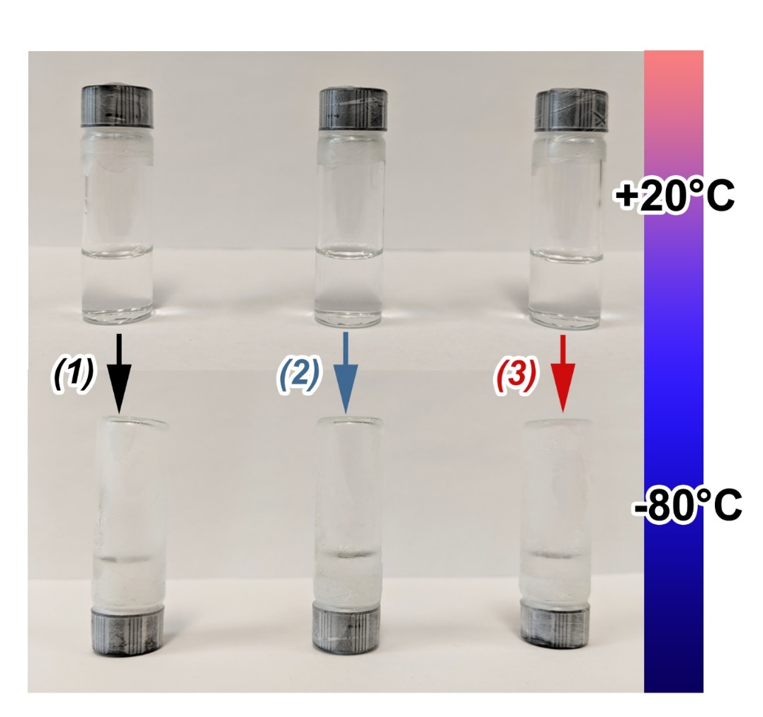
Supplementary Fig. 28 | Photos of (1) 1M NaOTf-DEGDME, (2) 0.5M NaOTf-DEGDME/DOL (5:5) and (3) 0.5M NaOTf-DEGDME/DOL (2:8) after storing at +20˚C and −80˚C for 24 hours. All three electrolytes are stable at −80˚C, showing no precipitation of salts.

Supplementary Fig. 29 | Galvanostatic cycling of Na/Na symmetric cells at 0.2 mA cm⁻² and 0.1 mAh cm⁻² at −80˚C. Note that initial stepwise temperature drop was carried out to stabilize the cells.

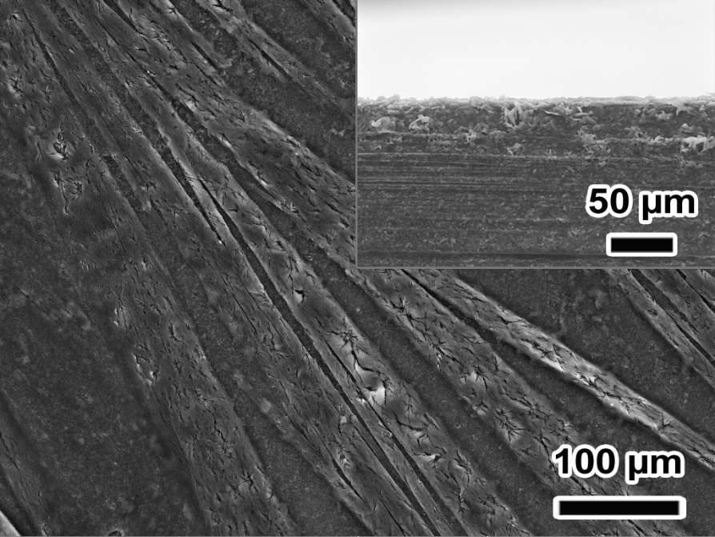
Supplementary Fig. 30 | SEM of a Na surface after cycling in 0.5M NaOTf DEGDME/DOL (5:5) at −80°C (Inset: corresponding cross-sectional SEM image).

Supplementary Fig. 31 | XPS of O_{1s} and F_{1s} profiles of Na surface after 50 cycles (symmetric Na/Na cells) in 0.5M NaOTf-DEGDME/DOL (2:8) electrolytes at −80˚C.

Supplementary Fig. 32 | XPS on Na surface after 50 cycles (symmetric Na/Na cells) in 0.5M NaOTf-DEGDME/DOL (5:5) at −80˚C.

Supplementary Fig. 33 | XPS depth profile analysis on Na after 50 cycles (symmetric Na/Na cells) in 0.5M NaOTf-DEGDME/DOL (5:5) electrolyte at −80˚C.

Supplementary Fig. 34 | XPS depth profile analysis on Na after 50 cycles (symmetric Na/Na cells) in 0.5M NaOTf-DEGDME/DOL (2:8) at −80˚C.

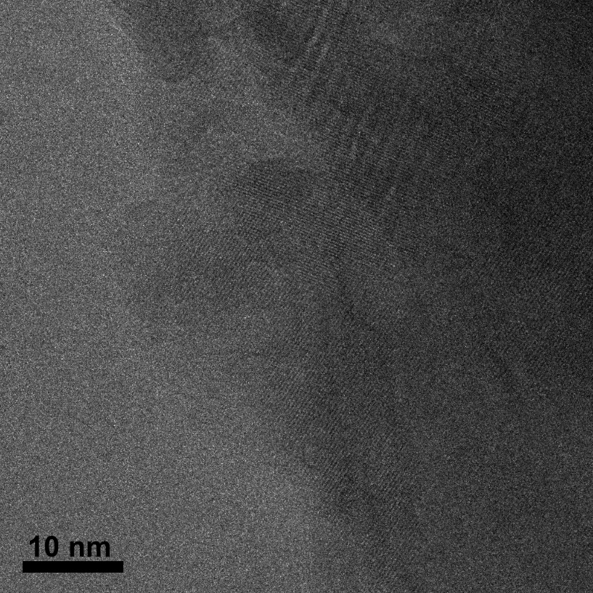
Supplementary Fig. 35 | TEM image that is the same as Fig. 4d but without colored overlays.

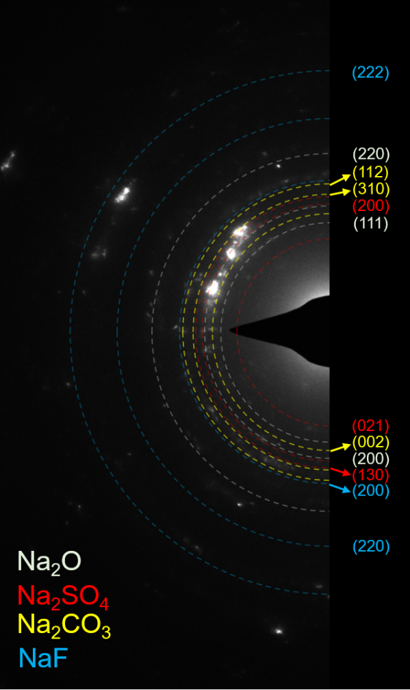
Supplementary Fig. 36 | Selected-area electron diffraction pattern of the SEI formed at −40°C. The positions of the rings expected to be most intense from Na₂O, Na₂SO₄, Na₂CO₃, and NaF are labeled; the large variety of crystalline phases likely present makes it difficult to fully index structures. These crystalline phases also give rise to extra rings which are not marked, which likely account for the reflections that fall between marked lines. Note that the presence of Na₂O may be attributed to the transfer process for these samples.

Supplementary Fig. 37 | CE as a function of cycle number in Na/stainless steel cells in 0.5M NaOTf-DEGDME/DOL (2:8) at −40°C and +20°C at a current density of 0.5 mA cm⁻² with a capacity of 0.5 mAh cm⁻². Note that cells failed after a few cycles at +20°C.

Supplementary Table 1 | Summary comparing performance of Na and Li metal anodes cycling at low temperatures (≤−40ºC)¹⁵⁻¹⁸ (* indicates short-term temperature-dependent investigation; N/A indicates no long-term cycling).
System | Temperature  (ºC) | Current  (mA cm⁻²) | Capacity  (mAh cm⁻²) | Overpotential  (mV) | Cycle  number | Ref
Na/Na | −40 | 1.0 | 1.0 | ~110 | >165 | This work
Na/Na | −80 | 0.5 | 0.25 | ~150 | >715 | This work
Na/Na | −80 | 0.2 | 0.1 | ~50 | >3,900 | This work
Li/Cu | −40 | 0.5 | 0.5 | ~150 | N/A | 15
Li/Cu | −60 | 0.2 | 0.5 | ~250 | N/A | 15
Li/Li | −40 | 0.5 | 0.25 | ~500 | 10* | 16
Li/Li | −60 | 0.5 | 0.25 | ~1,000 | 10* | 16
Li/Li | −80 | 0.2 | 0.1 | ~300 | 10* | 17
Na/Na | −40 | 0.5 | 1.0 | ~40 | 5* | 18

Supplementary Table 2 | Melting point, dielectric constant, and dynamic viscosity of DEGDME, DME and DOL.
Solvent | Melting point (°C) | Dielectric constant (ɛ) at +25°C | Dynamic viscosity (η) (mPa·S) at −35°C
DEGDME | −64 | 7.30 | 2.34
DME | −58 | 7.20 | 1.89
DOL | −95 | 7.00 | 1.82

Supplementary Table 3 | Summary of the dissolution of five Na salts in three different solvents (in 1M concentration), respectively, at −35°C (“Yes” indicates fully dissolved, “No” indicates not fully dissolved).
 | NaPF₆ | NaOTf | NaClO₄ | NaFSI | NaTFSI
Diglyme | No | Yes | Yes | Yes | Yes
DME | No | No | Yes | Yes | Yes
DOL | No | No | No | No | Yes

Supplementary Table 4 | Summary of overpotential plateaus and voltage spikes on the plateaus in eight 1M electrolyte candidates at the 50th cycle (100 hours).
 | +20°C |  | −20°C
Electrolyte | Plateau (mV) | Spike (mV) | Plateau (mV) | Spike (mV)
1M NaOTf-DEGDME | 8 | N/A | 13 | N/A
1M NaClO₄-DME | 43 | 23 | 10 | N/A
1M NaClO₄-DEGDME | 70 | >130 | 13 | N/A
1M NaTFSI-DEGDME | 30 (at failure) | >5000 (at failure) | 20 | N/A
1M NaTFSI-DME | 400 (at failure) | >5000 (at failure) | 30 | >40
1M NaFSI-DME | 21 | >20 | 40 | >100
1M NaFSI-DEGDME | 17 | >40 | 57 | >150
1M NaTFSI-DOL | >400 | >100 | 60 | >250

Note: “N/A” indicates no obvious voltage spikes.

Supplementary Table 5 | Summary of identified XPS peaks⁶⁻¹⁴.
C_{1s} (eV) | O_{1s} (eV) | F_{1s} (eV) | S_{2p} (eV) | Cl_{2p} (eV) | N_{1s} (eV)
-CF₃ (293.4)  -CF₂ (292.3)  Polycarbonate (289.7)  HCF (289.3)  O-C=O / CO₃²⁻ (288.7)  C-Cl (287.6)  C-SO₂ (287.2)  C-O-C (286.6)  C-C (284.8)  ClO₄⁻, 1s (279.6)  ClO₃⁻, 1s (277.9) | Na Kll (536.3)  Polyethers (533.3)  C-O-Na (531.2)  Na₂O (528.2) | C-F (689.3)  S-F (687.8)  Na-F (684.1) | F-SO₂ (170.2)  SO₄²⁻ (169.6)  CF_{x}-SO₂ (168.9)  S₂O₃²⁻ (168.7)  SO₃²⁻ (167.2)  S²⁻ (161.1) | ClO₄⁻ (208.5)  ClO₃⁻ (206.3)  ClO₂⁻ (203.8)  Cl⁻ (198.4) | Na-NN*N*, 1N (403.6)  S-N (399.3)  Na-N*NN*, 2N (398.5)  Na-C≡N (397.4)

NOTE: XPS positions in S_{2p} and Cl_{2p} spectra are based on 2p_{3/2}. For XPS peak-fitting of S_{2p}, 2p_{3/2} to 2p_{1/2} area ratio is fixed at 2:1 according to the ratio of degeneracy, where 1.18 eV is employed as the doublet separation of 2p_{3/2} and 2p_{1/2}. For XPS peak-fitting for Cl_{2p}, Cl_{3/2} to Cl_{1/2} area ratio is fixed at 2:1, while the doublet separation of Cl_{3/2} and Cl_{1/2} is 1.60 eV.

Supplementary Table 6 | Summary of SEI composition (surface and bulk)⁶⁻¹⁴ .
 | +20°C |  | −20°C
Electrolytes | Surface (<1 nm) | Bulk (2-15 nm) | Surface (<1 nm) | Bulk (2-15 nm)
1M NaOTf-DEGDME | -CF₃ containing components, Na₂SO₄, Na₂SO₃, NaF, Na₂CO₃, C-O-Na, organic debris | Na₂S (appear) | -CF₃ containing components, Na₂SO₄, NaF, Na₂CO₃, C-O-Na, organic debris | Na₂SO₃ (appear)
1M NaClO₄-DME | NaCl, Na₂CO₃, C-O-Na, organic debris | N/A | NaClO₄, NaClO₃,C-O-Na, organic debris | NaClO₂ (appear)
1M NaFSI-DME | -SO₂F containing components, Na₂S₂O₃, NaF, C-O-Na, organic debris | Na₂S (appear) | -SO₂F containing components, Na₂S₂O₃, Na₂SO₃, NaF, C-O-Na, organic debris | Na₂S, Na₂O, NaN₃ (appear);  Na₂SO₃ (disappear)
1M NaTFSI-DEGDME | -CF₂ containing components, Na₂SO₃, Na₂CO₃, Na₂S, NaF, NaCN, C-O-Na, organic debris | -CF₂ containing components (disappear) | -CF₂ containing components, Na₂SO₃, Na₂CO₃, Na₂S, NaF, NaCN, C-O-Na, organic debris | -CF₂ containing components (disappear)
1M NaTFSI-DOL | -SO₂CF₃/ SO₂CF₂ containing components, Na₂SO₃, Na₂CO₃, NaF, NaN₃, C-O-Na, organic debris | Na₂S (appear);  -SO₂CF₂ containing components, Na₂CO₃ (disappear) | -SO₂CF₃ containing components, Na₂SO₃, NaF, C-O-Na, organic debris | Na₂S (appear);

Note: “appear” indicates that a component is not detected on the surface but observed in the bulk; “disappear” indicates that a component is shown on the surface but not in the bulk; “N/A” indicates that same components are observed on the surface and in the bulk.
Supplementary Table 7 | Summary of salt dissolution in binary solvents at 1M/0.5M concentrations at −35°C (“Yes” indicates fully dissolved, “No” indicates not fully dissolved, “N/A” indicates no results or failure in previous screening).
 | NaOTf (1M) | NaOTf (0.5M) | NaClO₄ (0.5M)
DEGDME-DOL (8:2) | Yes | Yes | N/A
DEGDME-DOL (5:5) | Yes | Yes | N/A
DEGDME-DOL (2:8) | No | Yes | N/A
DME-DOL (8:2) | N/A | Yes | Yes
DME-DOL (5:5) | N/A | Yes | Yes
DME-DOL (2:8) | N/A | Yes | No

NOTE: The salt concentration below 0.4M shows a marked decrease in conductivity, which makes such electrolytes not practical. Concentrations above 1M cause significant salt precipitation at low temperature (e.g. −20°C)¹⁹. The salt concentrations between 0.4M and 1M are therefore chosen in the study.

References

[1] Chen, X. et al. Ion–solvent complexes promote gas evolution from electrolytes on a sodium metal anode. Angew. Chem. Int. Ed. 57,734-737 (2018).
[2] Miao, R. et al. Novel dual-salts electrolyte solution for dendrite-free lithium-metal based rechargeable batteries with high cycle reversibility. J. Power Sources 271, 291-297 (2015).
[3] Qu, C. et al. LiNO₃-free electrolyte for Li-S battery: a solvent of choice with low K_{sp} of polysulfide and low dendrite of lithium. Nano Energy 39, 262-272 (2017).
[4] Chen, X., Zhang, X.-Q., Li, H.-R. & Zhang, Q. Cation−solvent, cation−anion, and solvent−solvent interactions with electrolyte solvation in lithium batteries. Batteries & Supercaps 2, 128 –131 (2019).
[5] Liu, Q. et al. Insight on lithium metal anode interphasial chemistry: reduction mechanism of cyclic ether solvent and SEI film formation. Energy Storage Mater. 17, 366-373 (2019).
[6] Moulder, J. F. Handbook of X-ray Photoelectron Spectroscopy: A Reference Book of Standard Spectra for Identification and Interpretation of XPS Data (Physical Electronics Division, Perkin-Elmer Corporation Press, 1992).
[7] Aurbach, D. et al. On the surface chemical aspects of very high energy density, rechargeable Li-Sulfur batteries. J. Electrochem. Soc. 156, A694-A702 (2009).
[8] Fiedler, C., Luerssen, B., Rohnke, M., Sann, J. & Janek, J. XPS and SIMS analysis of solid electrolyte interphases on lithium formed by ether-based electrolytes. J. Electrochem. Soc. 164, A3742-A3749 (2017).
[9] Gu, Y. et al. Designable ultra-smooth ultra-thin solid-electrolyte interphases of three alkali metal anodes. Nat. Commun. 9, 1339 (2018).
[10] Cao, X. et al. Monolithic solid–electrolyte interphases formed in fluorinated orthoformate-based electrolytes minimize Li depletion and pulverization. Nat. Energy 4, 796-805 (2019).
[11] Lutz, L. et al. Role of electrolyte anions in the Na–O₂ battery: implications for NaO₂ solvation and the stability of the sodium solid electrolyte interphase in glyme ethers. Chem. Mater. 29, 6066–6075 (2017).
[12] Maibach, J. et al. A high pressure x-ray photoelectron spectroscopy experimental method for characterization of solid-liquid interfaces demonstrated with a Li-ion battery system. Rev. Sci. Instrum. 86, 044101 (2015).
[13] Bodenes, L., Darwiche, A., Monconduit, L & Martinez, H. The solid electrolyte interphase a key parameter of the high performance of Sb in sodium-ion batteries: comparative x-ray photoelectron spectroscopy study of Sb/Na-ion and Sb/Li-ion batteries. J. Power Sources 273, 14-24 (2015).
[14] Lin, Y.-C. et al. Sputter-induced chemical transformation in oxoanions by combination of C₆₀⁺ and Ar⁺ ion beams analyzed with x-ray photoelectron spectrometry. Analyst 134, 945–951 (2009).
[15] Gao, Y. et al. Low-temperature and high-rate-charging lithium metal batteries enabled by an electrochemically active monolayer-regulated interface. Nat. Energy, 5, 534–542 (2020)
[16] Thenuwara, A. et al. Efficient low-temperature cycling of lithium metal anodes by tailoring the solid-electrolyte interphase. ACS Energy Lett. 5, 2411-2420 (2020).
[17] Thenuwara, A., Shetty, P. & McDowell, M. Distinct nanoscale interphases and morphology of lithium metal electrodes operating at low temperatures. Nano Lett. 19, 8664–8672 (2019).
[18] Hu, X et al. Deeply cycled sodium metal anodes at low temperature and in lean electrolyte conditions. Angew. Chem. 133, 2–8 (2021).
[19] Nazri, G.-A. &, Pistoia, G. Lithium Batteries: Science and Technology. Ch.17 (Springer, Press, 2003)

