List of Additional file 1
Table S1 BMI classification of WHO and WGOC and IOM recommendations for gestational weight gain
Figure S1 Meta-analysis summary results: forest plot for above and below the GWG of IOM recommendations (A and B)
Figure S2 Sensitivity analysis (A-K)
Figure S3 Comparison of optimal gestational weight gain between IOM and Chinese studies

Table S1 BMI classification of WHO and WGOC and IOM recommendations for gestational weight gain
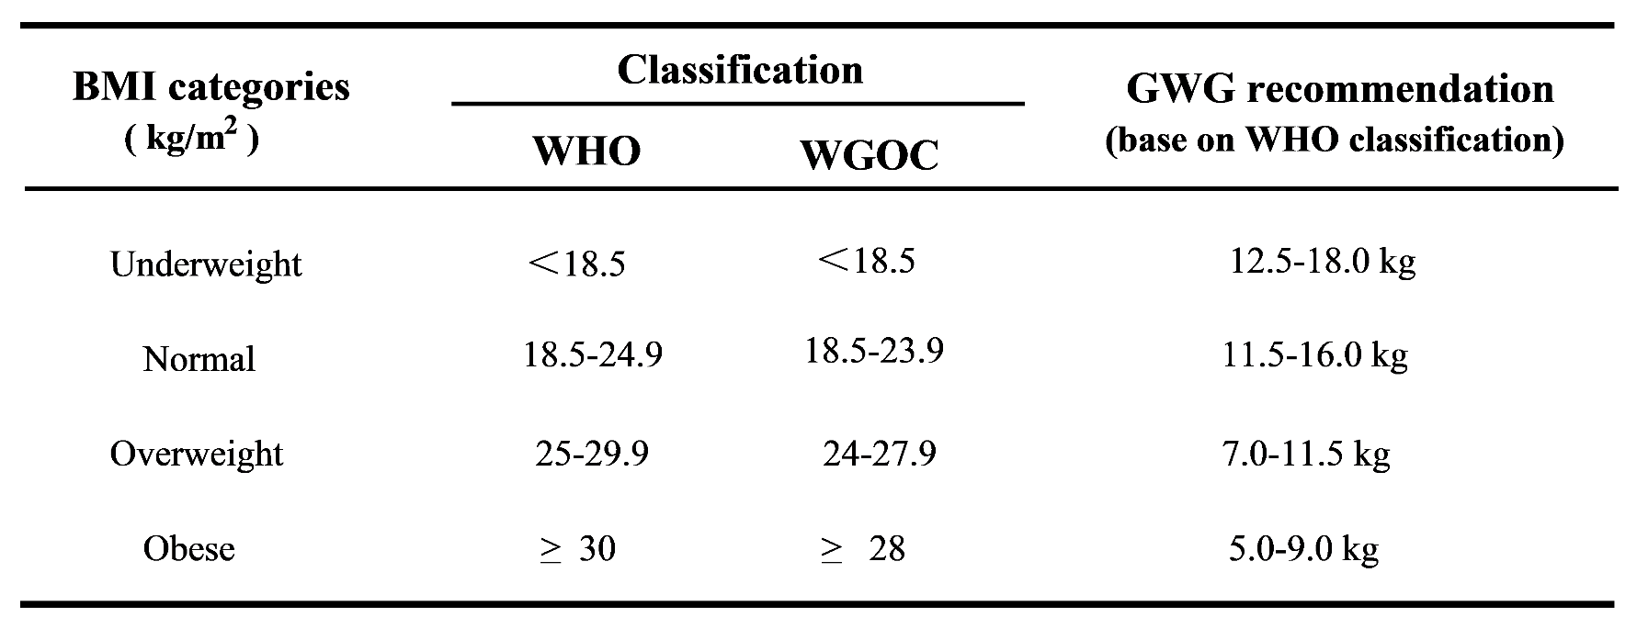
WHO, World health organization; WGOC, Working Group on Obesity in China; IOM, Institute of Medicine; BMI, body mass index; GWG, gestational weight gain

Figure S1 Meta-analysis summary results: forest plot for above and below the GWG of IOM recommendations (A and B)

A: Above the IOM recommendations B: Below the IOM recommendations

Figure S2 sensitivity analysis (A-K)
A: The impact of underweight on macrosomia B: The impact of overweight on macrosomia

C: The impact of obesity on macrosomia D: The impact of overweight on large for gestational age

E: The impact of excess GWG on large for gestational age F: The impact of insufficient GWG on large for gestational age
G: The impact of overweight on preterm birth H: The impact of excess GWG on preterm birth

I: The impact of excess GWG on cesarean section J: The impact of insufficient GWG on cesarean section
K: The impact of overweight on gestational hypertension

Figure S3 Comparison of optimal gestational weight gain between IOM and Chinese studies
