Supplementary material

Figure S1

Figure S1. Comparisons of regional differences in a) sea surface temperatures (SST; ^{O}C), and b) global horizontal irradiance (GHI), the total daily solar radiation incident on a horizontal surface at ground level (W m⁻² day⁻¹) acquired from Copernicus Atmosphere Monitoring Service (CAMS; http://www.soda-pro.com/web-services/radiation/cams-radiation-service; accessed September 22nd, 2021). Shown are solar radiation levels (Feb 2019 – Feb 2020), for the northern GoA (Eilat; in Orange), where H. stipulacea is native, eastern Mediterranean Sea (Limassol; black circles) and the eastern Caribbean (St. Eustatius; blue circles), representing historic and more recent invasion habitats, respectively.
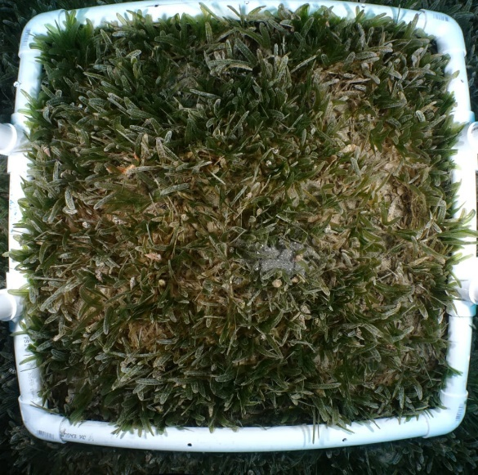
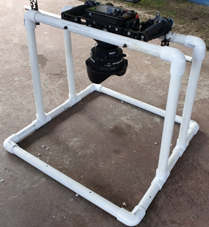
Figure S2

Figure S2. (a) Custom-made dedicated tripod used to keep angle and distance constant 50x50 cm photoquadrats. (b) An example of the photo quadrat captured underwater at 18m. Photographs by G. Winters (a) and D. Golomb (b).

Figure S3
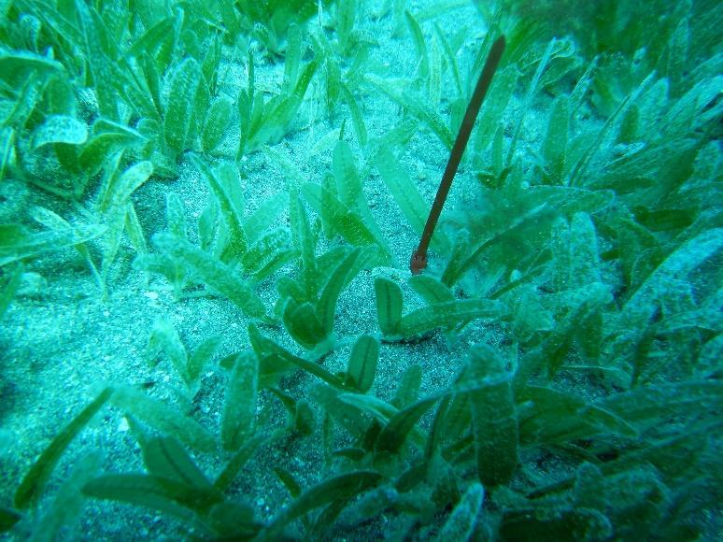
Figure S3. Measuring in situ growth rates: a cable-tie is placed just behind the apical shoot (containing two mature and two young leaves; Photo: G. Winters).

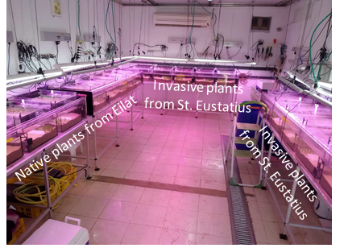
Figure S4
Figure S4. Comparing the performance of native and invasive populations using a mesocosm experiment. The seagrass dedicated mesocosm facility, containing 20 aquaria fully controlled for water temperature, light, and salinity. Aquaria were layered with natural sediment and filled with artificial seawater. 10 aquaria contained invasive plants collected from 10 m from the island of Sint Eustatius (the Dutch eastern Caribbean) and 10 aquaria contain native H. stipulacea plants collected from 10 m from the north beach, Eilat (northern GoA).

