The relation of VEGFA, VEGFR2, VEGI, and HIF1A genetic variants and their serum protein levels with breast cancer in Egyptian patients
Amani A. Abdelgalil^{a,}*, Rehan Monir^{b,c}, Mohamed Elmetwally^{d}, Maivel H. Ghattas^{e}, Fagr B. Bazeed^{b}, Noha M. Mesbahª, Dina M. Abo-Elmattyª and Eman T. Mehannaª
ª Department of Biochemistry, Faculty of Pharmacy, Suez Canal University, , Ismailia, Egypt
^{b} Department of Medical Biochemistry, Faculty of Medicine, Mansoura University, Mansoura, Egypt
^{c} Department of Medical Biochemistry, Faculty of Medicine, King Khalid University, Abha, Saudi Arabia
^{d} Department of Surgical Oncology, Oncology Center, Mansoura University, Mansoura, Egypt
^{e} Department of Medical Biochemistry, Faculty of Medicine, Port Said University, Port Said, Egypt

Corresponding author:
Amani A. Abdelgalil
Suez Canal University, Faculty of Pharmacy,
Department of Biochemistry, Ismailia,
Egypt
E-mail: Amani.anwar1983@gmail.com
Mob: 002 01014121629
Tel.: 002 050 2321097

Table S1 Primer sequence and reaction conditions used for genotyping
Gene/SNP | Primers | PCR product size | Annealing temp.(˚C) | Restriction enzyme | DNA fragment  size (bp)
VEGFA  rs25648 | F: 5ʹ-GGTGTGCGCAGACAGTGCT–3ʹ  C allele R: 5ʹ-AGCAGAAAGTTCATGGTTTCG–3ʹ  T allele R: 5ʹ-AGCAGAAAGTTCATGGTTTCA–3ʹ | 185 | 55 | ---- | 185
VEGFR2  rs2071559 | F:5′-CAAACTTTCACTAGGGCTCTTCGT-3′  R:5′-AGCCACAAGGGAGAAGCGGATA-3′ | 290 | 60 | BsmI | 290  174  116
HIF1a  rs 11549465 | F:5’-AAGGTGTGGCCATTGTAAAAACTC-3’  R:5’-GCACTAGTAGTTTCTTTATGTATG-3’ | 346 | 58 | HphI | 346  228  118
VEGI  rs6478106 | F:5'-ACTTCATCCACTTCTCCTC-3'  R:5'-AGACGTTCTGACTACTATTCC-3 | 256 | 55 | Eco53KI | 256  151  105

Table S2 Hardy-Weinberg equilibrium (HWE) for the control group
SNP | X² | P- value
VEGFA rs25648 | 1.79 | 0.18
VEGFR2 rs2071559 | 2.67 | 0.10
VEGI rs6478106 | 1.56 | 0.21
HIF1A rs11549465 | 3.29 | 0.07

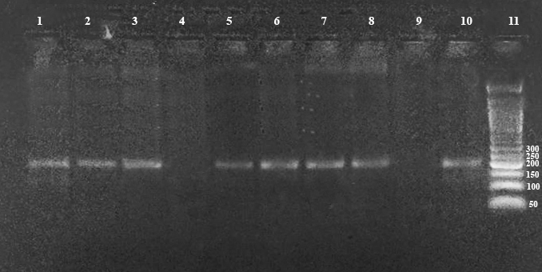
Fig. S1 3% Agarose gel electrophoresis of VEGFA rs25648 polymorphism

Fig. S2 3% Agarose gel electrophoresis of VEGFR2 (rs2071559) polymorphism digested by BsmI restriction enzyme. Lanes 1, 2, 4,5,6,7 are heterozygous mutant genotype (C/T); Lanes 3, 9, 10 are homozygous wild genotype (T/T); lane 8 is homozygous mutant genotype (C/C); lane 11 is DNA marker.

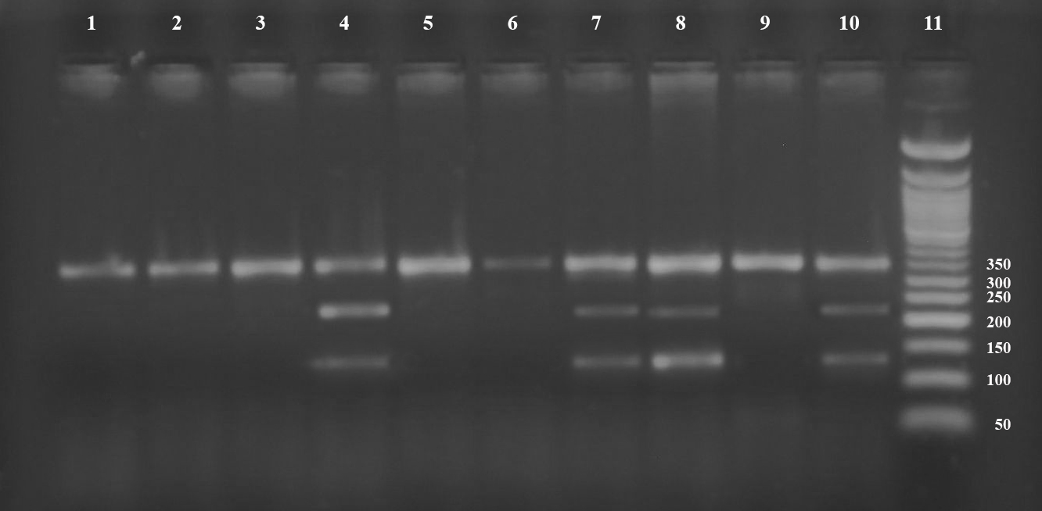
Fig. S3 3% Agarose gel electrophoresis of HIF1Agene (rs11549465) polymorphism digested by HphI restriction enzyme. Lanes 1, 2, 3, 5, 6, 9 arehomozygous mutant genotype (T/T); Lanes 4, 7, 8, and 10 areheterozygous mutant genotype (C/T); lane 11 is DNA marker.

Fig. S4 3% Agarose gel electrophoresis of TNFSF15 (VEGI) gene rs6478106 polymorphism digested by Eco53KI restriction enzyme. Lane 1, 4, 9 are Homozygous wild genotype (C/C); lanes 2, 3, 5, 6, 7, 8 are Heterozygous mutant genotype (C/T); lane 10 is Homozygous mutant genotype (T /T); lane 11 is DNA marker.

