SUPPLEMENTARY MATERIALS
MIL-101-based SPE-GC/MS method for simultaneous determination of alachlor, acetochlor and pretilachlor in waters
Yujuan Cai ^{a,*}, Liying Li ^{a, *}, Jun Zhang ª, Zhenjie Li ^{b}, Fengmei Zhang ^{b}, Yanqun Xu ^{b}, Zhigang Tai ^{a,}

ª Faculty of Life Science and Technology, Kunming University of Science and Technology, Kunming, 650500, P.R. China
^{b} Yunnan Key Laboratory of Tobacco Chemistry, R&D Center of China Tobacco Yunnan Industry Co., Ltd., Kunming, 650231, P.R. China

1. Target herbicides and GC–MS parameters
Table 1
Physico-chemical properties and GC–MS parameters of the target herbicides
Compound | MW^{b}  (g mol-1) | pKa | Retention time (RT /min) | Selected ions (m/z)
Alachlor | 269.77 | 1.20±0.50 | 12.50 | 160.2, 188.1, 237.1
Acetochlor | 269.77 | 1.29±0.50 | 12.10 | 238.2, 162.2, 176.2
Preochlor | 311.85 | 1.41±0.50 | 16.61 | 146.1, 162.1, 223.1
2. Method validation
2.1 Standard curve for alachlor，acetochlor and pretilachlor
Fig.1.Standard curve for alachlor in organic solvent

Fig.2.Standard curve for alachlor in matrix
Fig.3.Standard curve for acetochlor in organic solvent
Fig.4.Standard curve for acetochlor in matrix
Fig.5.Standard curve for pretilachlor in organic solvent

Fig.6.Standard curve for pretilachlor in matrix
2.2 Structure and mass spectrogram
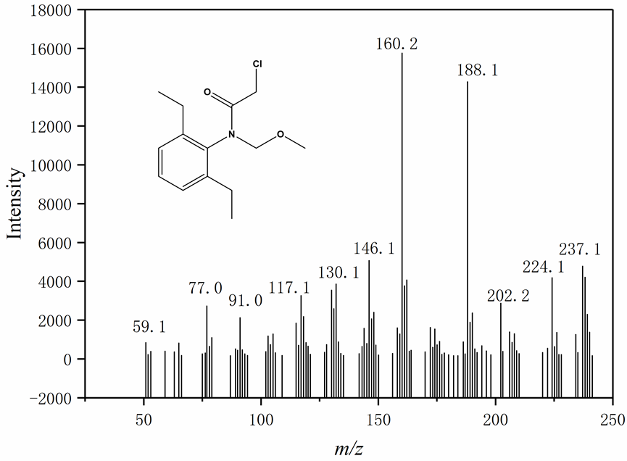
Fig.7. Structure and mass spectrogram of alachlor
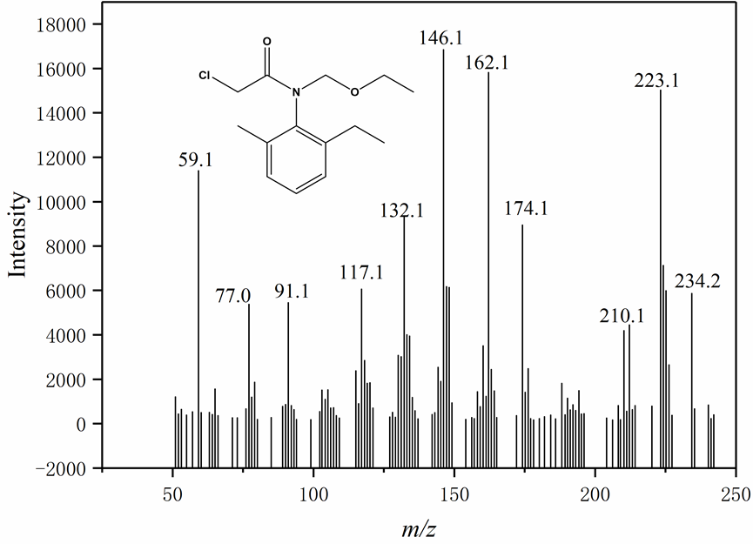
Fig.8. Structure and mass spectrogram of acetochlor
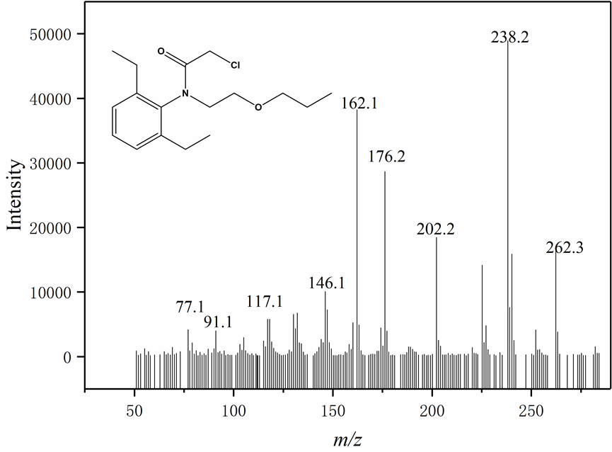
Fig.9. Structure and mass spectrogram of pretilachlor
2.3 Intra-day and inter-day precisions
Table 2
Intra-day precisions for alachlor, acetochlor and preochlor. (n=3)
Compound | c (μg mL⁻¹) |  |  | Average | SD | RSD
Alachlor | 0.9012 | 0.9402 | 0.9321 | 0.9245 | 2.06 | 2.23
Acetochlor | 0.8912 | 0.9024 | 0.9371 | 0.9102 | 2.39 | 2.63
Preochlor | 0.8865 | 0.9026 | 0.9627 | 0.9173 | 4.02 | 4.38

Table 3
Inter-day precisions for alachlor, acetochlor and preochlor. (n=6)
Compound | c (μg mL⁻¹) |  |  |  |  |  | Average | SD | RSD
Alachlor | 0.9012 | 0.9402 | 0.9604 | 0.9267 | 0.9301 | 0.9281 | 0.9311 | 1.93 | 2.07
Acetochlor | 0.8912 | 0.9024 | 0.9601 | 0.8824 | 0.8965 | 0.9126 | 0.9075 | 2.77 | 3.05
Preochlor | 0.8865 | 0.9026 | 0.9324 | 0.9069 | 0.8765 | 0.8798 | 0.8975 | 2.10 | 2.34

2.4 Comparison with C18, PSA and Florisil.
Table 4
Comparison of the adsorption performance of the MIL-101 with C18, PSA and Florisil cartridges.
Compound | MIL-101 |  | Florisil |  | C18 |  | PSA
Compound | Average | RSD | Recovery(%) | RSD | Average | RSD | Average | RSD
Alachlor | 107.4 | 1.94 | 88.3 | 0.89 | 77.6 | 2.13 | 36.4 | 1.68
Acetochlor | 96.0 | 0.65 | 86.1 | 2.75 | 74.3 | 0.85 | 38.6 | 1.24
Preochlor | 90.7 | 0.10 | 85.6 | 1.85 | 74.7 | 1.96 | 43.5 | 0.98

3.Real sample detection
Table 6
Content (μg kg⁻¹) of the amide herbicides in soil samples
samples |  | alachlor | acetochlor | Pretilachlor
Wheat field | 0-10cm | ND | 8.04±0.036 | ND
 | 10-20cm | ND | 6.98±0.042 | ND
 | 20-30cm | ND | 5.23±0.014 | ND
 | 30-40cm | ND | 0.97±0.028 | ND
Corn field | 0-10cm | 2.03±0.012 | 4.92±0.028 | ND
 | 10-20cm | 0.86±0.006 | 2.35±0.021 | ND
 | 20-30cm | 0.64±0.003 | 0.94±0.007 | ND
 | 30-40cm | ND | 0.62±0.004 | ND
Soybean field | 0-10cm | 1.17±0.008 | 2.08±0.012 | ND
 | 10-20cm | 0.72±0.004 | 0.67±0.005 | ND
 | 20-30cm | ND | ND | ND
 | 30-40cm | ND | ND | ND
ND: not detected

These authors contributed equally to this work. Corresponding author: Zhigang Tai, Email: taizg@kust.edu.cn * These authors contributed to the work equllly and should be regarded as co-first authors.

