Retinopathy of prematurity risk predictors in peripheral avascular retina after intravitreal ranibizumab treatment: Vasculogenesis analysis
Jin-Guo Chen ¹, Li-Chun Xiong¹, Guan-Yu Ruan^{2, 3}*, Jian-Zhang Hu⁴*
*Correspondence to:
Jian-Zhang Hu
Department of Ophthalmology, Fujian Medical University Union Hospital, 29 Xinquan Road, Fuzhou, Fujian 350005, P. R. China
Email: ophhjz@163.com
Guan-Yu Ruan
Laboratory of Gynecologic Oncology & Fujian Key Laboratory of Women and Children’s Critical Diseases Research, Fujian Maternity and Child Health Hospital, College of Clinical Medical College for Obstetrics & Gynecology and Pediatrics, Fujian Medical University, 18 Daoshan Road, Fuzhou, Fujian 350001, P. R. China
Email: gyruan@fjmu.edu.cn
Supplementary material

Vasculogenesis speed assessment
We believe that retinal vasculogenesis speed (RVS) may be a more meaningful indicator in the postoperative monitoring of IVR. Considering that vessels grow slowly and do not easily produce changes over 1 week, the time unit of observation was set to months. Previous studies reported a mean time to reactivation of 8 weeks after the initial IVR, which may be related to the fact that this is the time when VEGF factors are once again elevated in the retina (1).
Binocular fundus images were acquired using the RetCam III Imaging System (Clarity Medical Systems Inc.) for patients 2 months post-IVR. The latest images in which the temporal retinal vasculature reached the farthest limit were selected and then compared with the preoperative images. Two images were rotated and moved to align and coincide with the optic papilla and central retinal vessel using an image-processing software (Photoshop; Adobe Inc., San Jose, CA, USA). The locations of preoperative and postoperative lesions could be seen simultaneously by adjusting the transparency of the preoperative image, and the corresponding overlapping image was saved as a new montage image. The mean optic DD was 1.05 mm and showed little differences or variance in each infant (2). Digimizer software (MedCalc Software, Ostend, Belgium) was used for measurements. The DD of one healthy infant was set to one DD. In montage images, the distance between vascular endings at two time points was calculated using the number of DDs (3, 4). Given that the distance was different at each clock hour, RVS (DD/month) was assessed as the average of the longest and shortest distance and then divided by two (months) (Figure 1).
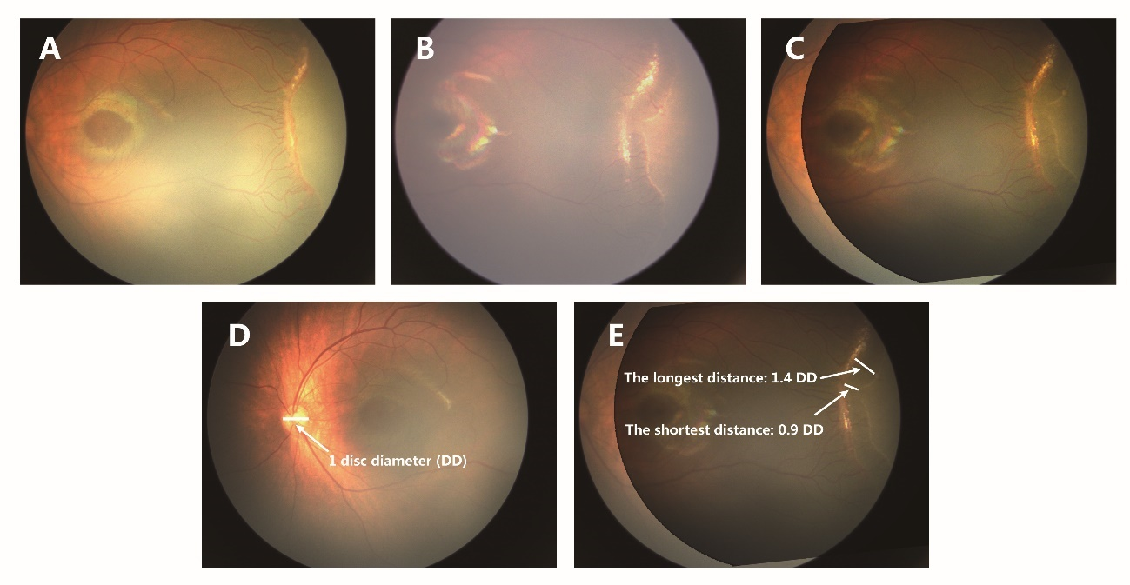
Fig. 1 Vascular outgrowth speed assessment. A: Preoperative fundus images. B: Postoperative fundus images at 2 months. C: Pre- and postoperative montage images. D–E: Screenshot of Digimizer software to show measuring method of vascular outgrowth distance. D: One healthy infant’s disc diameter (DD) was set as 1 DD. E: The longest and the shortest distance between the vascular endings at two timepoints in the montage images were calculated by the numbers of DDs.

References
1. Huang Q, Zhang Q, Fei P, Xu Y, Lyu J, Ji X, et al. Ranibizumab Injection as Primary Treatment in Patients with Retinopathy of Prematurity: Anatomic Outcomes and Influencing Factors. Ophthalmology 124, 1156-1164 (2017).
2. Xia F, Lyu J, Peng J, Zhao P. Repeated intravitreal ranibizumab for reactivated retinopathy of prematurity after intravitreal ranibizumab monotherapy: vascular development analysis. Graefes Arch Clin Exp Ophthalmol 260, 2837-2846 (2022).
3. Kandasamy Y, Smith R, Wright IM, Hartley L. Optic disc measurements in full term infants. Br J Ophthalmol 96, 662-664 (2012).
4. Padhi TR, Bhusal U, Padhy SK, Patel A, Kelgaonker A, Khalsa A, et al. The retinal vascular growth rate in babies with retinopathy of prematurity could indicate treatment need. Indian J Ophthalmol 70, 1270-1277 (2022).

