A facile one-pot, three-component protocol for, chiral synthesis of Cyanolactone as key intermediate of the Nafithromycin
Furqan Diwan, Amit Pund, Prathmesh Deshpande, Rajesh Pursani, Mohammad Rafeeq, Ram Prasad Yadav, Arvind Merwade*
Wockhardt Research Centre, D-4, MIDC, Chikalthana, Aurangabad, 431 006, India
*amerwade@wockhardt.com

Characterization data:
¹H NMR, 400 MHz, CDCl₃
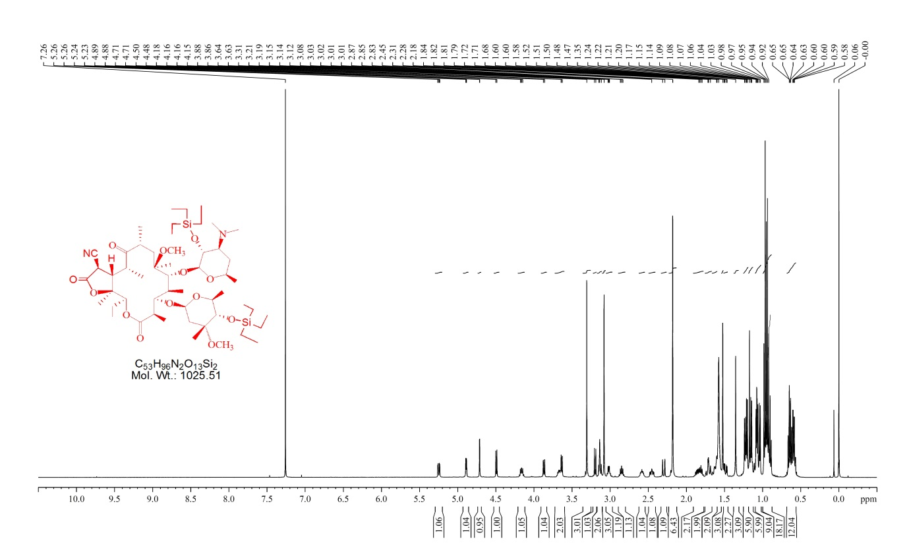

¹H NMR, 400 MHz, CDCl₃
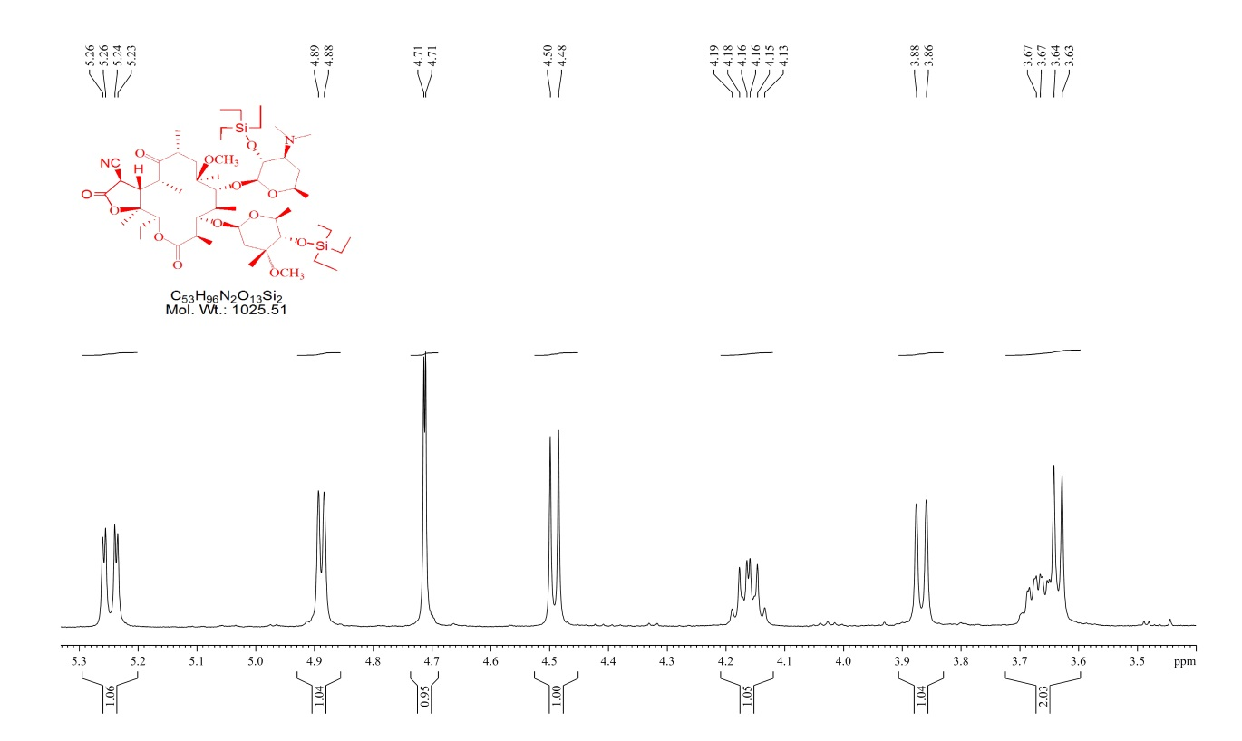

¹H NMR, 400 MHz, CDCl₃
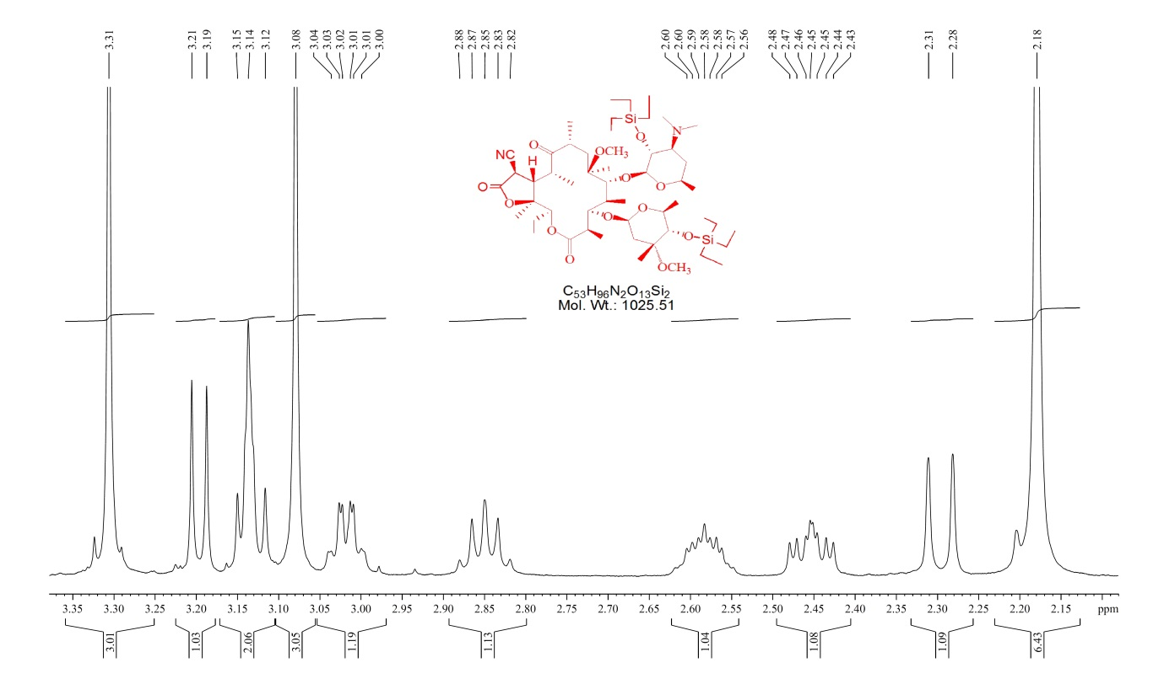

¹H NMR, 400 MHz, CDCl₃
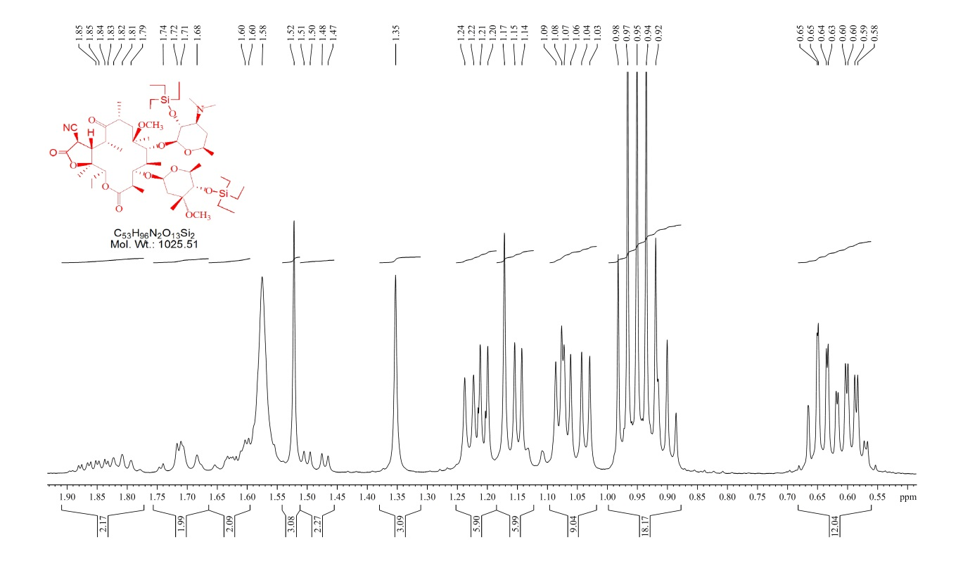

¹³C NMR, 125 MHz, CDCl₃
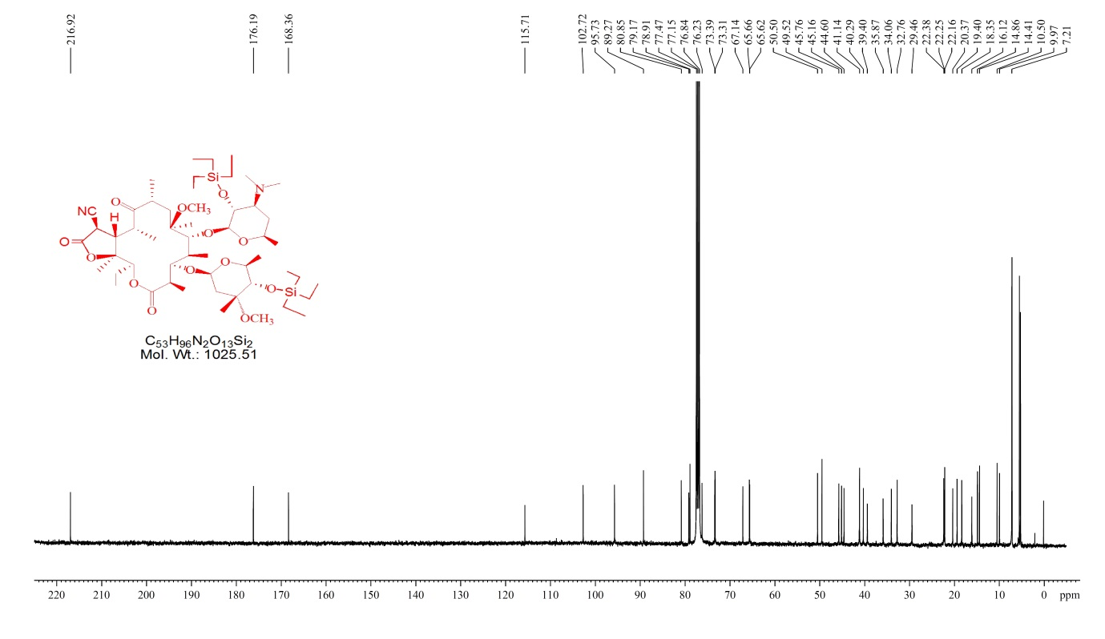

¹³C NMR, 125 MHz, CDCl₃
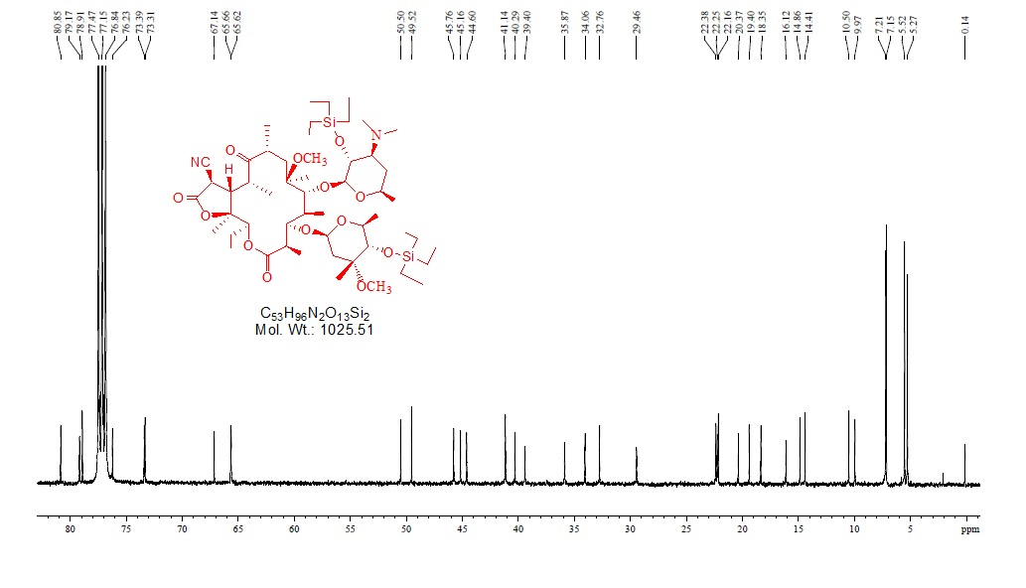

¹³C NMR (DEPT), 125 MHz, CDCl₃
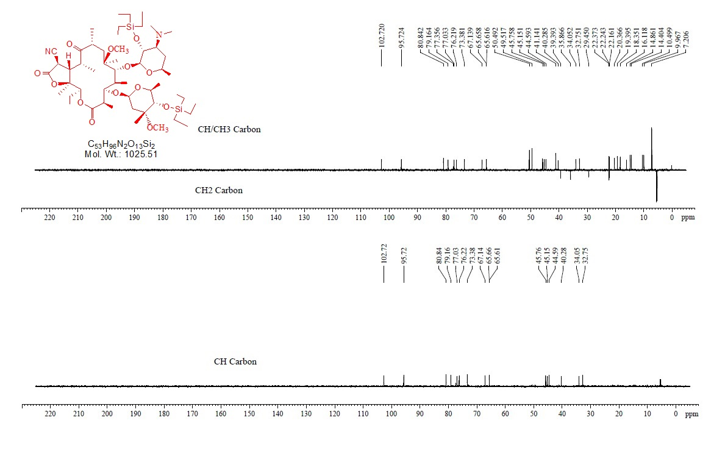

FT-IR
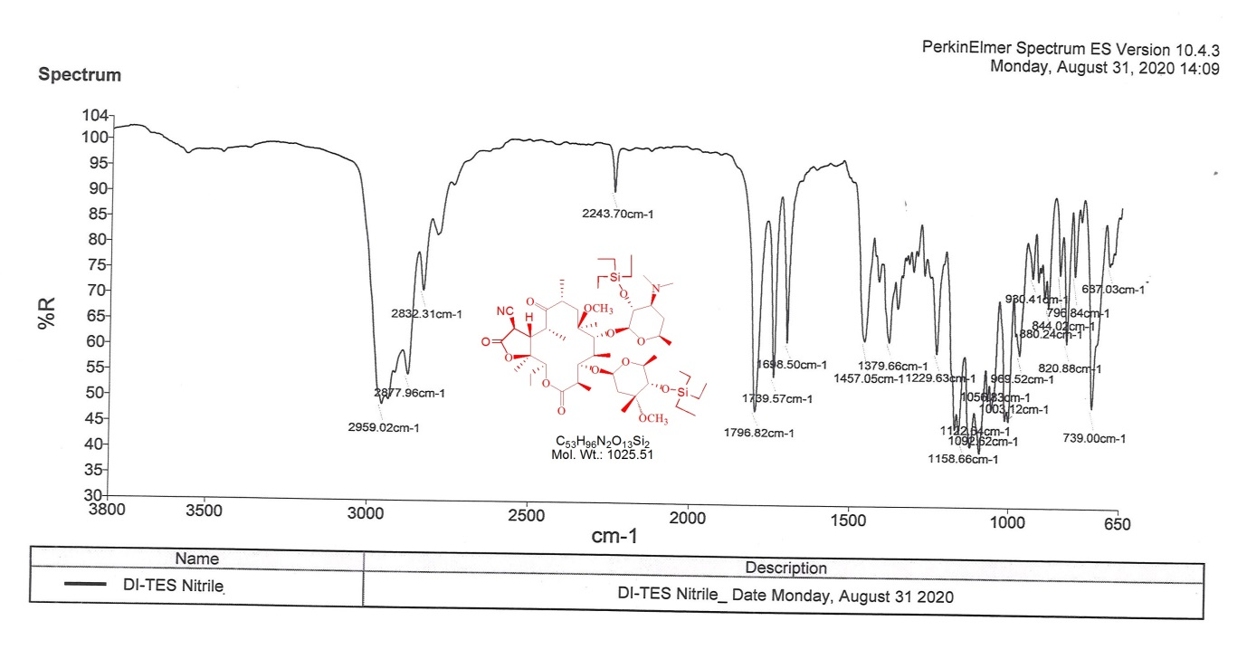

ES-MS
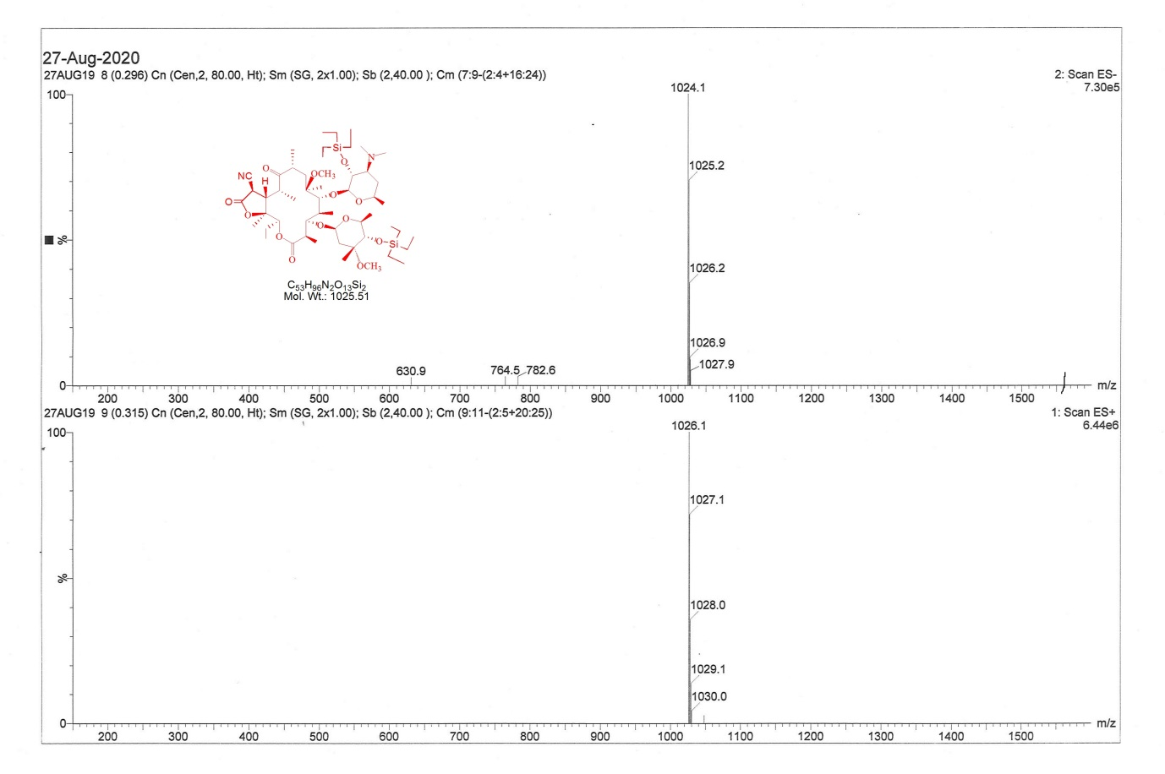

CHNS analysis
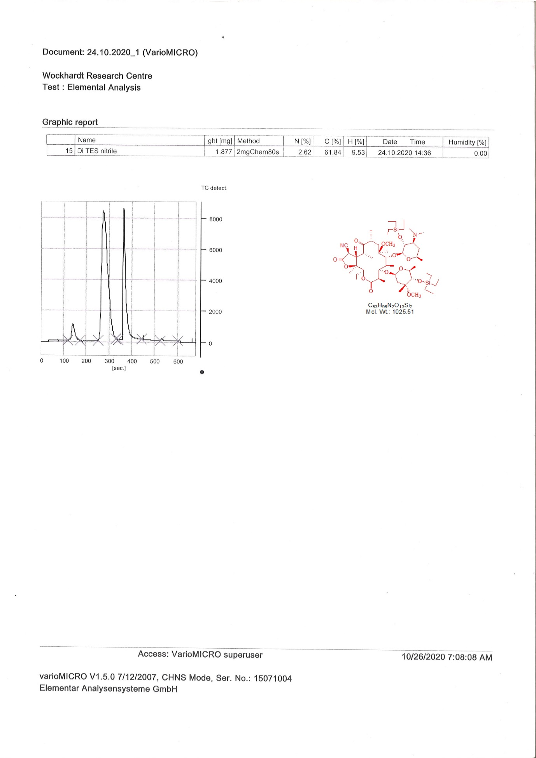

SOR analysis
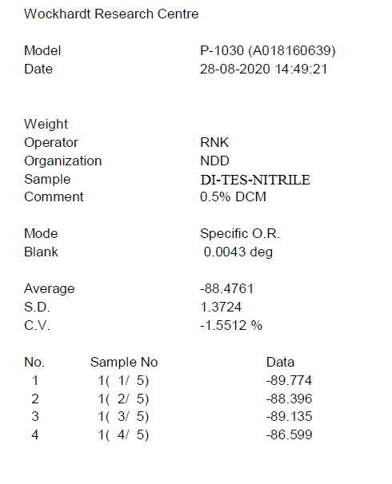

HPLC Purity
