Environmentally driven phenotypic convergence and niche conservatism accompany speciation in hoary bats

J. Angel Soto-Centeno^{1,2}*, and Nancy B. Simmons²
¹ Department of Earth and Environmental Sciences, Rutgers University, Newark, NJ 70102
² Department of Mammalogy, Division of Vertebrate Zoology, American Museum of Natural History, New York, NY 10024, USA

*Corresponding author: angelo.soto@rutgers.edu

Supplementary Figure S1: Results from principal component analysis on the phenotypic variability of Hoary bats. The explained variance of PC1 = 50.4% and PC2 = 7.9%. Solid lines represent 68% data ellipses to help visualize the phenotypic overlap among species. Notably, Lasiurus cinereus can be discriminated from L. villosissimus and L. semotus along PC1. Contrary to the known phylogenetic hypothesis (see Fig. 1), L. villosissimus and L. semotus show high overlap in morphological space, indicating that these species are phenotypically more similar to each other.

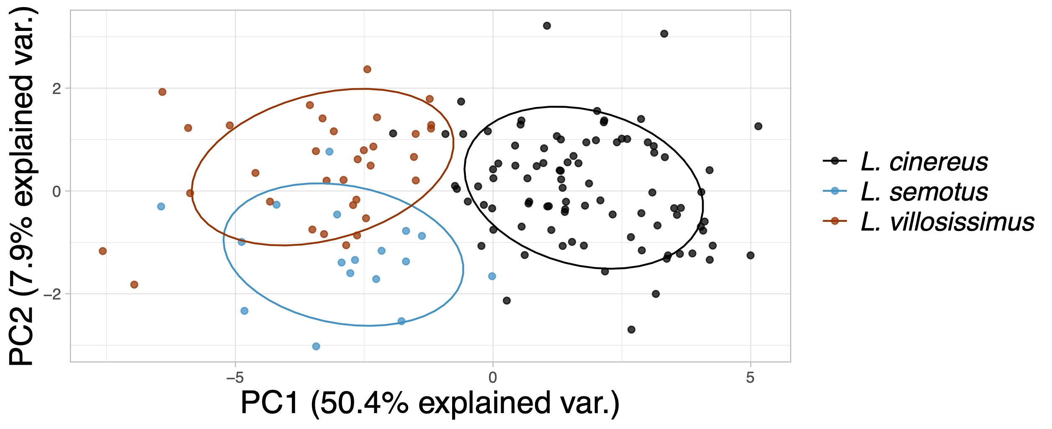

Supplementary Figure S2: Stepwise Multiple Linear Regression result plots for Hoary bats examining the relationship between phenotypic variability and four environmental features (A = Max. Temperature of Warmest Month, B = Min. Temperature of Coldest Month, C = Precipitation of Wettest Quarter, and D = Precipitation of Driest Quarter) and latitude (E). For the overall model, multiple R² = 0.623, adjusted R² = 0.6059 (F = 36.62 on 6 and 133 DF, P < 2.2e-16). Full model results listed in Table 3 of main article. In each plot, black circles = L. cinereus, blue circles = L. semotus, and brown circles = L. villosissimus.
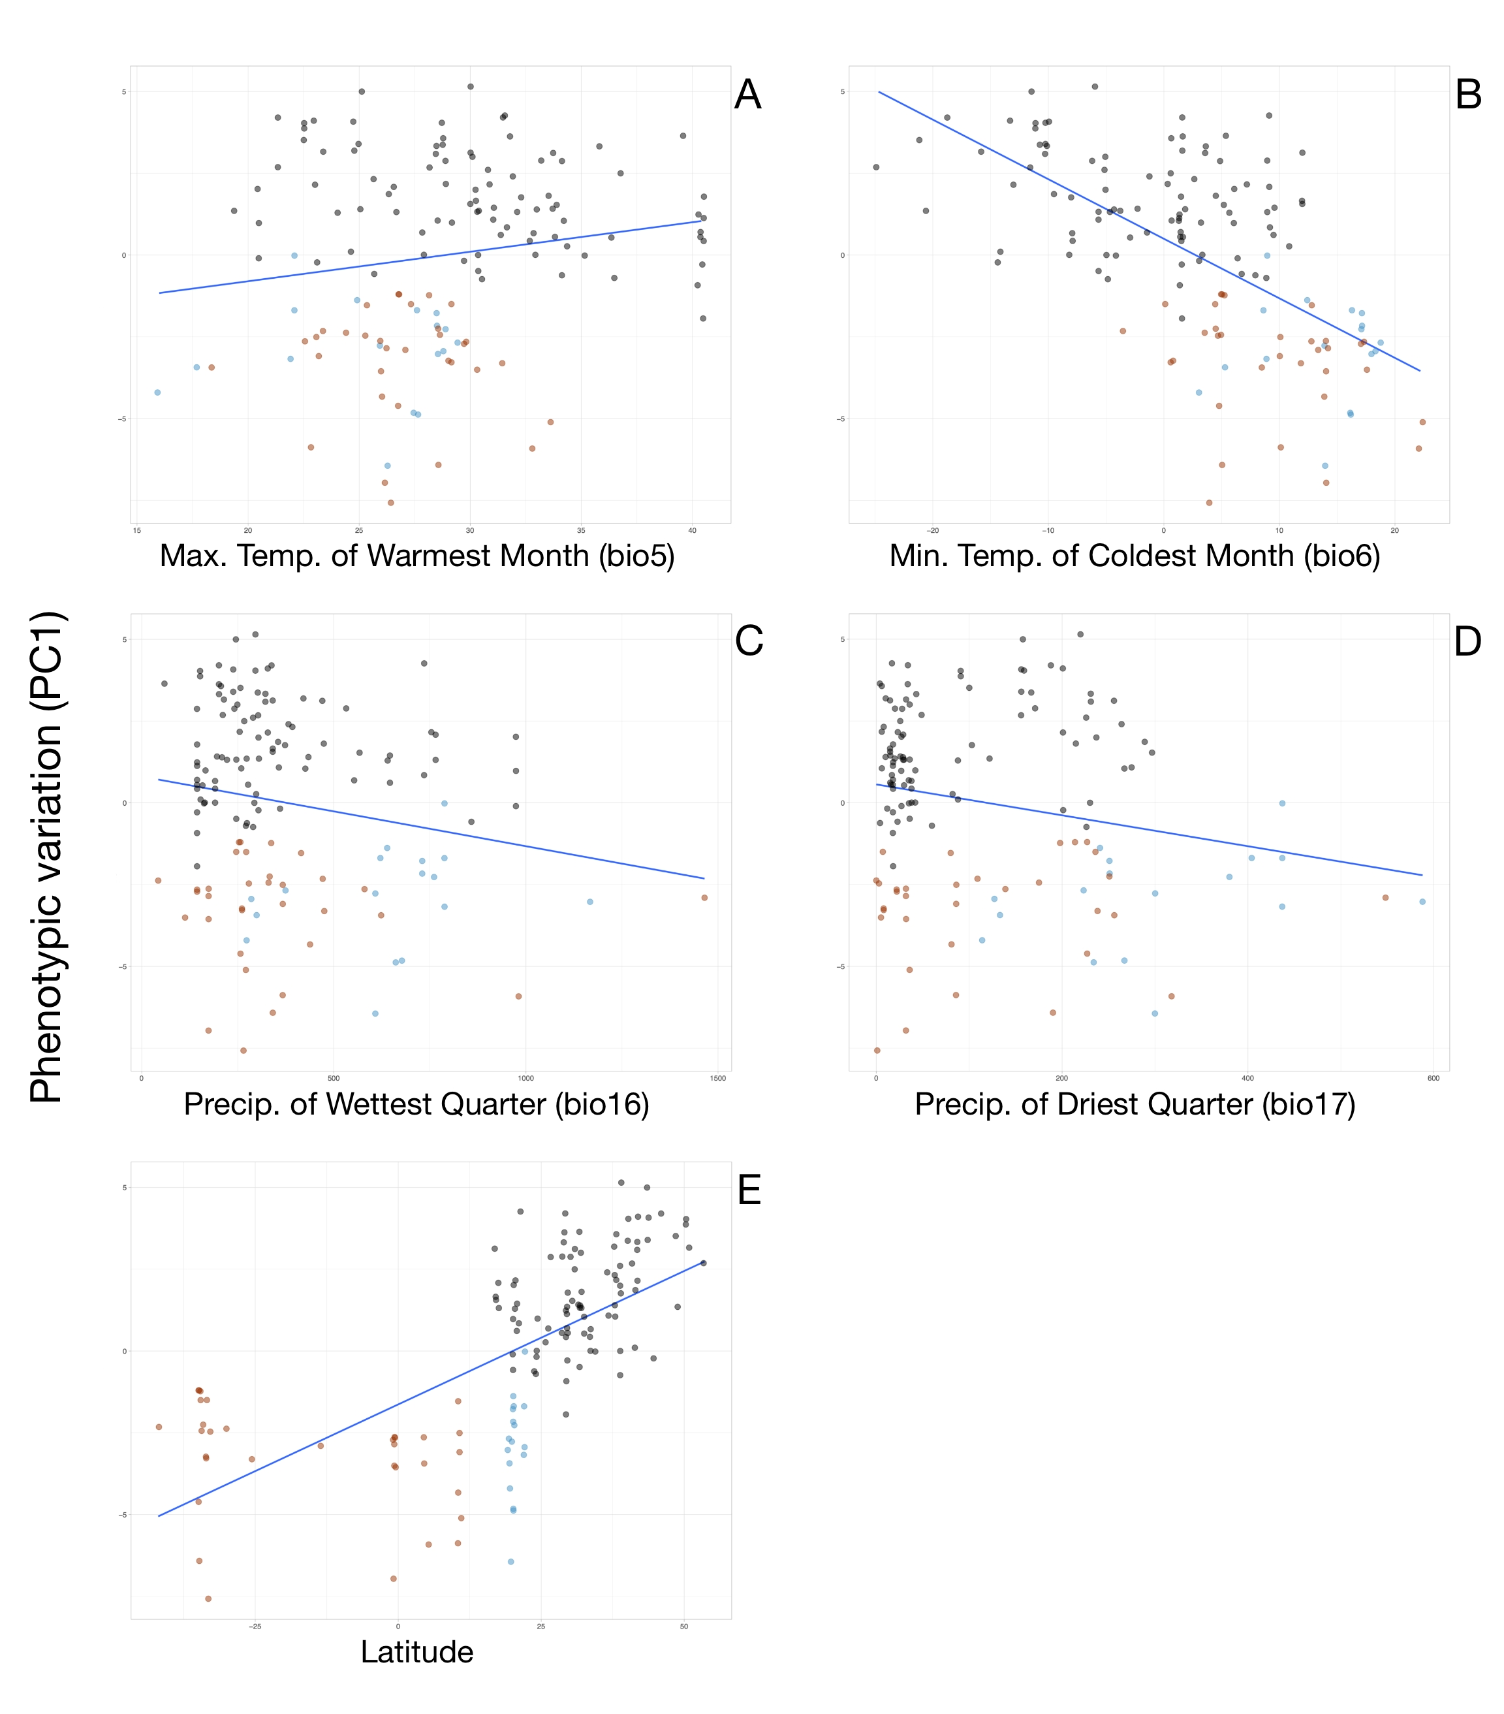
Table S1. Genbank accession numbers for hoary bat specimens (Lasiurus cinereus, L. semotus, and L. villosissimus) used in genetic analysis.

Species | Museum No. | Genbank No. | Genes
L. cinereus | AK11006 | MF990053.1, MF990138.1 | COI, RAG2
L. cinereus | AK11013 | MF990054.1, MF990140.1 | COI, RAG2
L. cinereus | AK11097 | MF990055.1, MF990142.1 | COI, RAG2
L. cinereus | AK11210 | MF990056.1, MF990144.1 | COI, RAG2
L. cinereus | AK11212 | MF990057.1, MF990146.1 | COI, RAG2
L. cinereus | ASK1079 | MF990058.1, MF990148.1 | COI, RAG2
L. cinereus | ASK3520 | MF990059.1, MF000149.1 | COI, RAG2
L. cinereus | ASK4288 | KR350014.1, KR350135.1 | COI, RAG2
L. cinereus | BPBM185003 | MF990062.1, MF990151.1 | COI, RAG2
L. cinereus | BPBM185519 | MF990066.1, MF990155.1 | COI, RAG2
L. cinereus | BPBM185539 | MF990068.1, MF990157.1 | COI, RAG2
L. cinereus | CM82018 | KR350019.1, KR350137.1 | COI, RAG2
L. cinereus | FJB27 | KR350046.1, KR350091.1 | COI, RAG2
L. cinereus | FJB61 | KR350075.1, KR350127.1 | COI, RAG2
L. cinereus | FJB62 | KR350076.1, KR350129.1 | COI, RAG2
L. cinereus | LSUM368 | KR350081.1, KR350139.1 | COI, RAG2
L. cinereus | MVZ199246 | KR350082.1, KR350141.1 | COI, RAG2
L. cinereus | NK3562 | MF990071.1, MF990159.1 | COI, RAG2
L. cinereus | NK3580 | MF990073.1, MF990162.1 | COI, RAG2
L. cinereus | NK3599 | MF990074.1, MF990163.1 | COI, RAG2
L. cinereus | NK3627 | MF990075.1, MF990164.1 | COI, RAG2
L. cinereus | NK3642 | MF990076.1, MF990166.1 | COI, RAG2
L. cinereus | NK36563 | MF990072.1, MF990160.1 | COI, RAG2
L. cinereus | NK6534 | MF990077.1, MF990168.1 | COI, RAG2
L. cinereus | NK8096 | MF990078.1, MF990170.1 | COI, RAG2
L. cinereus | NK9191 | MF990079.1, MF990172.1 | COI, RAG2
L. cinereus | NK9250 | MF990080.1, MF990174.1 | COI, RAG2
L. cinereus | NK9273 | MF990081.1, MF990175.1 | COI, RAG2
L. semotus | BPBM178452 | MF990060.1, MF990150.1 | COI, RAG2
L. semotus | BPBM185245 | MF990063.1, MF990152.1 | COI, RAG2
L. semotus | BPBM185478 | MF990064.1, MF990153.1 | COI, RAG2
L. semotus | BPBM185479 | MF990065.1, MF990154.1 | COI, RAG2
L. semotus | BPBM185538 | MF990067.1, MF990156.1 | COI, RAG2
L. semotus | BPBM185540 | MF990069.1, MF990158.1 | COI, RAG2
L. semotus | FJB35 | KR350054.1, KR350093.1 | COI, RAG2
L. semotus | FJB37 | KR350056.1, KR350095.1 | COI, RAG2
L. semotus | FJB41 | KR350060.1, KR350097.1 | COI, RAG2
L. semotus | FJB42 | KR350061.1, KR350099.1 | COI, RAG2
L. semotus | FJB44 | KR350062.1, KR350103.1 | COI, RAG2
L. semotus | FJB45 | KR350063.1, KR350105.1 | COI, RAG2
L. semotus | FJB46 | KR350064.1, KR350107.1 | COI, RAG2
L. semotus | FJB47 | KR350065.1, KR350109.1 | COI, RAG2
L. semotus | FJB49 | KR350066.1, KR350111.1 | COI, RAG2
L. semotus | FJB52 | KR350067.1, KR350113.1 | COI, RAG2
L. semotus | FJB53 | KR350068.1, KR350115.1 | COI, RAG2
L. semotus | FJB55 | KR350069.1, KR350117.1 | COI, RAG2
L. semotus | FJB57 | KR350071.1, KR350119.1 | COI, RAG2
L. semotus | FJB58 | KR350072.1, KR350121.1 | COI, RAG2
L. semotus | FJB59 | KR350073.1, KR350123.1 | COI, RAG2
L. semotus | FJB60 | KR350074.1, KR350125.1 | COI, RAG2
L. semotus | FJB63 | KR350077.1, KR350131.1 | COI, RAG2
L. semotus | FJB64 | KR350078.1, KR350133.1 | COI, RAG2
L. villosissimus | M260258 | KR350012.1 | COI
L. villosissimus | M268079 | KR350013.1 | COI
L. villosissimus | NK11502 | MF990082.1, MF990176.1 | COI, RAG2

Table S2. Description of morphological characters measured in hoary bats. Additional details about each character can be obtained from the original sources.

Character Description | Character Abbreviation | Source
Cranial
Greatest Skull Length | GSL | Freeman (1981)
Rostral Length | ROST LEN | Freeman (1981)
Lacrimal Width | LACR W | Freeman (1981)
Postorbital Width | POSTORB W | Freeman (1981)
Breadth at Mastoids | MASTOID | Freeman (1981)
Width at Upper Canines | C1 C1 | Freeman (1981)
Width at Upper Molars | M3 M3 | Freeman (1981)
Length of Glenoid Fossa | GLENO L | Freeman (1981)
Length of maxillary tooth row | MAX TOOTH | Jacobs (1996)
Dentary
Dentary Length | DEN L | Freeman (1981)
Lower Toothrow | LOW TR | Freeman (1981)
Moment Arm of Temporal | MOM1 COR | Freeman (1981)
Moment Arm of Masseter | MOM2 ANG | Freeman (1981)
Dentary Thickness | DEN TH | Freeman (1981)
Length of Condyle | CON L | Freeman (1981)
Length of masseter muscle scar | MASS MUSC | Jacobs (1996)

Jacobs, D. S. (1996). Morphological divergence in an insular bat, Lasiurus cinereus semotus. Funct. Ecol. 10, 622–630.
Freeman, P. W. (1981). A multivariate study of the family Molossidae (Mammalia, Chiroptera): morphology, ecology, evolution. Fieldiana 7, 1–168.

Table S3. List of specimens studied for phenotypic analyses. AMNH = American Museum of Natural History; BM = Burke Museum of Natural History and Culture; EBD = Estación Biológica de Doñana, Sevilla; FMNH = Field Museum of Natural History; KU = University of Kansas Natural History Museum; LACM = Natural History Museum of Los Angeles County, MNCN = Museo Nacional de Ciencias Naturales, Madrid; MVZ = Museum of Vertebrate Zoology; ROM = Royal Ontario Museum; UF = Florida Museum of Natural History; USNM = United States National Museum.

Genus | Species | Museum | Number
Lasiurus | cinereus | AMNH | 1270
Lasiurus | cinereus | AMNH | 17515
Lasiurus | cinereus | AMNH | 27327
Lasiurus | cinereus | AMNH | 137322
Lasiurus | cinereus | AMNH | 166058
Lasiurus | cinereus | AMNH | 176197
Lasiurus | cinereus | AMNH | 205168
Lasiurus | cinereus | AMNH | 207428
Lasiurus | cinereus | AMNH | 208907
Lasiurus | cinereus | AMNH | 258284
Lasiurus | cinereus | AMNH | 258285
Lasiurus | cinereus | EBD | 13022
Lasiurus | cinereus | EBD | 13132
Lasiurus | cinereus | FMNH | 10864
Lasiurus | cinereus | FMNH | 140700
Lasiurus | cinereus | FMNH | 172513
Lasiurus | cinereus | FMNH | 172514
Lasiurus | cinereus | FMNH | 195676
Lasiurus | cinereus | KU | 40831
Lasiurus | cinereus | KU | 44746
Lasiurus | cinereus | KU | 73579
Lasiurus | cinereus | KU | 73580
Lasiurus | cinereus | KU | 73581
Lasiurus | cinereus | KU | 73582
Lasiurus | cinereus | KU | 73583
Lasiurus | cinereus | KU | 73584
Lasiurus | cinereus | KU | 73585
Lasiurus | cinereus | KU | 73586
Lasiurus | cinereus | KU | 73588
Lasiurus | cinereus | KU | 80297
Lasiurus | cinereus | KU | 82921
Lasiurus | cinereus | KU | 92950
Lasiurus | cinereus | KU | 98486
Lasiurus | cinereus | KU | 98487
Lasiurus | cinereus | KU | 98735
Lasiurus | cinereus | KU | 98736
Lasiurus | cinereus | KU | 98737
Lasiurus | cinereus | KU | 100398
Lasiurus | cinereus | LACM | 13835
Lasiurus | cinereus | MNCN | 617
Lasiurus | cinereus | MNCN | 618
Lasiurus | cinereus | MNCN | 619
Lasiurus | cinereus | MVZ | 55030
Lasiurus | cinereus | MVZ | 80311
Lasiurus | cinereus | MVZ | 80312
Lasiurus | cinereus | MVZ | 93897
Lasiurus | cinereus | MVZ | 114537
Lasiurus | cinereus | MVZ | 121716
Lasiurus | cinereus | MVZ | 124780
Lasiurus | cinereus | MVZ | 139199
Lasiurus | cinereus | MVZ | 139200
Lasiurus | cinereus | MVZ | 199246
Lasiurus | cinereus | MVZ | 225665
Lasiurus | cinereus | ROM | 18458
Lasiurus | cinereus | ROM | 22967
Lasiurus | cinereus | ROM | 25996
Lasiurus | cinereus | ROM | 29536
Lasiurus | cinereus | ROM | 29537
Lasiurus | cinereus | ROM | 32149
Lasiurus | cinereus | ROM | 32291
Lasiurus | cinereus | ROM | 36122
Lasiurus | cinereus | ROM | 58731
Lasiurus | cinereus | ROM | 58732
Lasiurus | cinereus | ROM | 78358
Lasiurus | cinereus | ROM | 78359
Lasiurus | cinereus | ROM | 78360
Lasiurus | cinereus | ROM | 78613
Lasiurus | cinereus | ROM | 78614
Lasiurus | cinereus | ROM | 78615
Lasiurus | cinereus | ROM | 78616
Lasiurus | cinereus | ROM | 78617
Lasiurus | cinereus | ROM | 2441481
Lasiurus | cinereus | ROM | 33620975
Lasiurus | cinereus | UF | 11185
Lasiurus | cinereus | UF | 13128
Lasiurus | cinereus | UF | 31008
Lasiurus | cinereus | USNM | 15345
Lasiurus | cinereus | USNM | 38610
Lasiurus | cinereus | USNM | 123816
Lasiurus | cinereus | USNM | 178141
Lasiurus | cinereus | USNM | 200373
Lasiurus | cinereus | USNM | 218756
Lasiurus | cinereus | USNM | 276572
Lasiurus | cinereus | USNM | 329591
Lasiurus | cinereus | USNM | 329597
Lasiurus | cinereus | USNM | 347569
Lasiurus | cinereus | USNM | 398462
Lasiurus | cinereus | USNM | 448255
Lasiurus | cinereus | USNM | 508889
Lasiurus | cinereus | USNM | 508890
Lasiurus | semotus | AMNH | 208651
Lasiurus | semotus | AMNH | 276739
Lasiurus | semotus | MVZ | 112947
Lasiurus | semotus | MVZ | 113294
Lasiurus | semotus | MVZ | 113386
Lasiurus | semotus | MVZ | 113387
Lasiurus | semotus | MVZ | 114344
Lasiurus | semotus | MVZ | 114345
Lasiurus | semotus | MVZ | 184549
Lasiurus | semotus | ROM | 91239
Lasiurus | semotus | USNM | 8545
Lasiurus | semotus | USNM | 15630
Lasiurus | semotus | USNM | 16138
Lasiurus | semotus | USNM | 16139
Lasiurus | semotus | USNM | 38983
Lasiurus | semotus | USNM | 505291
Lasiurus | semotus | USNM | 505292
Lasiurus | villosissimus | AMNH | 15128
Lasiurus | villosissimus | AMNH | 71356
Lasiurus | villosissimus | AMNH | 268078
Lasiurus | villosissimus | AMNH | 268079
Lasiurus | villosissimus | AMNH | 268080
Lasiurus | villosissimus | BM | 4171
Lasiurus | villosissimus | BM | 5812
Lasiurus | villosissimus | BM | 138161
Lasiurus | villosissimus | BM | 138162
Lasiurus | villosissimus | FMNH | 23629
Lasiurus | villosissimus | FMNH | 42428
Lasiurus | villosissimus | FMNH | 49153
Lasiurus | villosissimus | FMNH | 51223
Lasiurus | villosissimus | FMNH | 73664
Lasiurus | villosissimus | FMNH | 73665
Lasiurus | villosissimus | FMNH | 78685
Lasiurus | villosissimus | LACM | 59566
Lasiurus | villosissimus | MNCN | 620
Lasiurus | villosissimus | MVZ | 118559
Lasiurus | villosissimus | MVZ | 118560
Lasiurus | villosissimus | MVZ | 145371
Lasiurus | villosissimus | ROM | 35843
Lasiurus | villosissimus | ROM | 50220
Lasiurus | villosissimus | ROM | 76339
Lasiurus | villosissimus | ROM | 76340
Lasiurus | villosissimus | USNM | 15745
Lasiurus | villosissimus | USNM | 200367
Lasiurus | villosissimus | USNM | 240941
Lasiurus | villosissimus | USNM | 307973
Lasiurus | villosissimus | USNM | 370971
Lasiurus | villosissimus | USNM | 370972
Lasiurus | villosissimus | USNM | 387740
Lasiurus | villosissimus | USNM | 441840

