Supplement Table 1. Prevalence of hypertension, diabetes, and dyslipidaemia
 | Without migraine | With migraine
Men | HA | TE | NTNE | p-value
Hypertension, N (%) | 4,747 (53.1) | 764 (65.2) | 8,025 (59.1) | <0.001
Diabetes, N (%) | 1,325 (14.8) | 167 (14.3) | 2,053 (15.1) | 0.654
Dyslipidaemia, N (%) | 2,720 (30.4) | 451 (38.5) | 4,560 (33.6) | <0.001
Women
Hypertension, N (%) | 5,365 (49.9) | 2,274 (60.0) | 13,867 (57.7) | <0.001
Diabetes, N (%) | 1,410 (13.1) | 441 (11.6) | 3,082 (12.8) | 0.064
Dyslipidaemia, N (%) | 4,452 (41.4) | 1,896 (50.1) | 10,830 (45.0) | <0.001
Hypertension and diabetes mellitus were defined based on a self-reported questionnaire completed at the baseline check-up or as any prescription for anti-hypertensive and anti-diabetic medication, respectively.
Dyslipidaemia was defined as any prescription for a lipid-lowering agent.

Supplement Table 2. Multivariable Cox proportional hazards analysis for the development of cardiovascular disease and ischemic cerebrovascular disease between the NTNE and TE groups after full adjustment
Sex | HRs (95% CIs) | With migraine
 |  | NTNE | TE
Men | CVD | 1 | 0.84 (0.69–1.02)
 | Ischemic CbVD | 1 | 0.88 (0.70–1.10)
Women | CVD | 1 | *0.79 (0.70–0.90)
 | Ischemic CbVD | 1 | *0.85 (0.73–0.98)
Abbreviations: CVD, cardiovascular disease; CbVD, cerebrovascular disease, TE, triptan or ergotamine users; NTNE, neither triptan nor ergotamine users
Adjusted for age, smoking status, alcohol consumption, physical activity, economic status, body mass index, systolic blood pressure, total serum cholesterol, fasting glucose, hypertension, diabetes mellitus, and dyslipidaemia

*P-value < 0.05

Supplementary Figure 1. The estimated cumulative incidence of cardiovascular disease
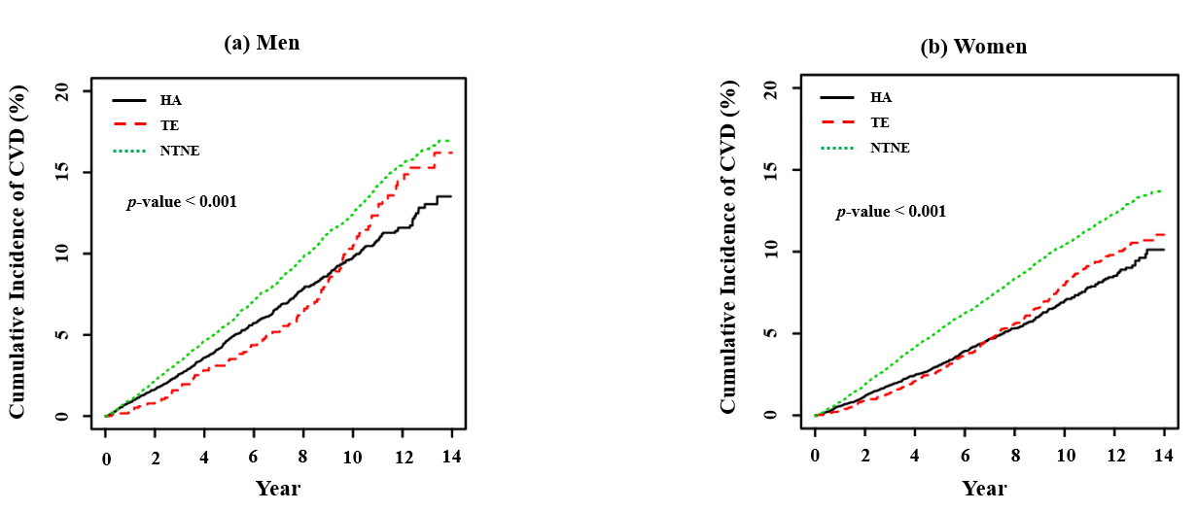

Cumulative incidence is 1-survival rate. The p-value is from the log-rank test.

Supplementary Figure 2. The estimated cumulative incidence of ischemic cerebrovascular disease
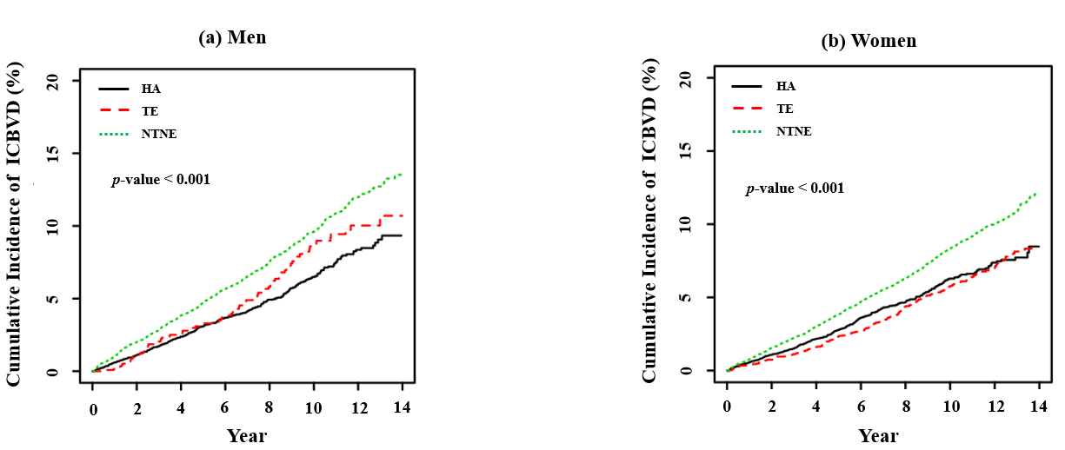

Cumulative incidence is 1-survival rate. The p-value is from the log-rank test.

Supplement Figure 3. The estimated cumulative incidence of ischemic cardio-cerebrovascular disease between the NTNE and TE groups
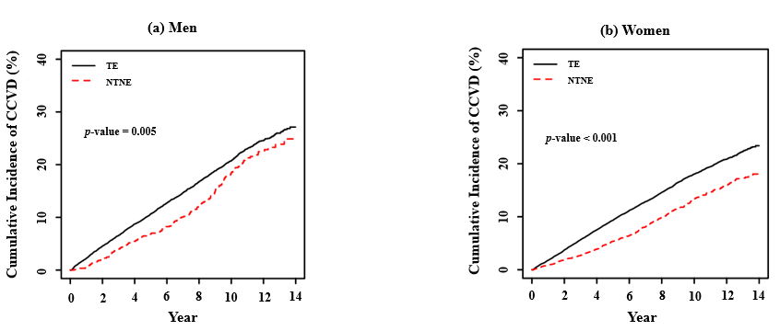

Cumulative incidence is 1-survival rate. The p-value is from the log-rank test.

Supplement Figure 4. The estimated cumulative incidence of cardiovascular disease between the NTNE and TE groups
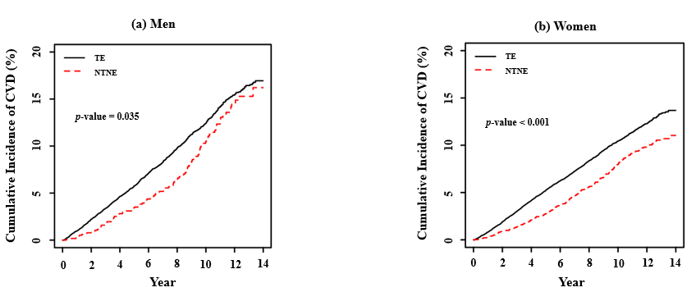

Cumulative incidence is 1-survival rate. The p-value is from the log-rank test.

Supplement Figure 5. The estimated cumulative incidence of ischemic cerebrovascular disease between the NTNE and TE groups
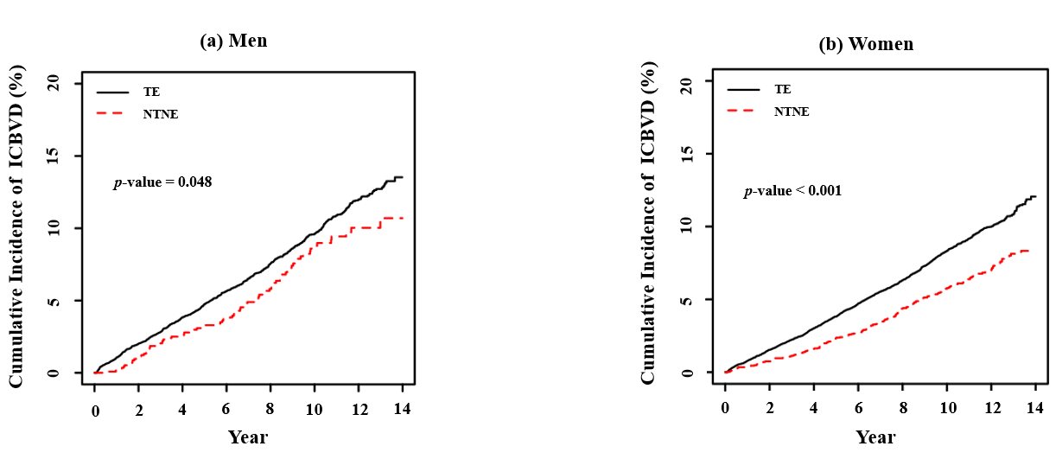

Cumulative incidence is 1-survival rate. The p-value is from the log-rank test

