Supplementary Materials
Table S1. Treatment response in patients with R-CHOP regimen between HBsAg-negative and positive DLBCL groups

 | HBV+ | HBV- | P Value
Complete response | 42 | 114 | 0.105
Partial response | 15 | 28 | 0.105
Stable disease | 0 | 1 | 0.105
Progressive disease | 3 | 0 | 0.105

Table S2. Treatment response in patients with CHOP regimen between HBsAg-negative and positive DLBCL groups

 | HBV+ | HBV- | P Value
Complete response | 36 | 82 | 0.962
Partial response | 25 | 55 | 0.962
Stable disease | 1 | 3 | 0.962
Progressive disease | 4 | 10 | 0.962

Table S3. Multivariate Cox proportional hazards model for analysis of survival in HBsAg-negative DLBCL patients

Characteristics | P value | HR | 95% CI
Characteristics | P value | HR | Lower | Upper
Clinical staging | 0.014
I/II | 0.014 | 1 | - | -
III/IV | 0.014 | 2.999 | 1.250 | 7.191
Treated with rituximab | 0.006
Yes | 0.006 | 0.318 | 0.140 | 0.724
No | 0.006 | 1 | - | -

Figure S1. Survival analysis of HBsAg-negative and positive diffuse large B-cell lymphoma patients under 60 years of age
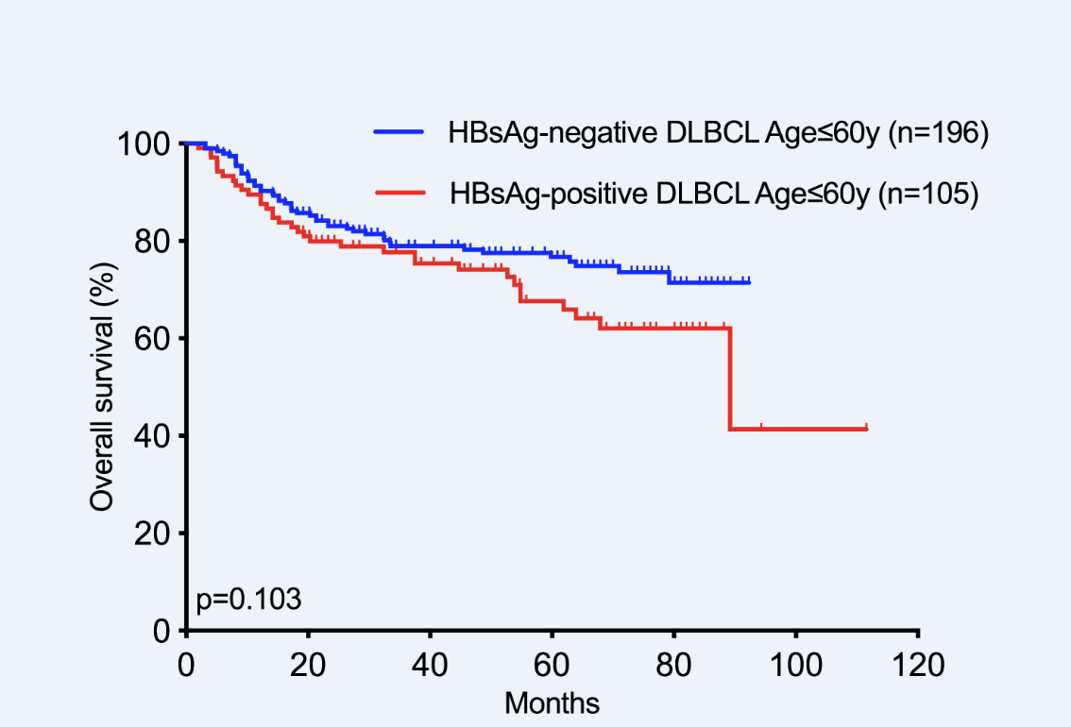

Figure S2. Survival analysis of HBsAg-negative diffuse large B-cell lymphoma patients. A. OS of HBsAg- negative DLBCL patients of more than 60 years old and less than 60 years old. B. OS of clinical staging in HBsAg- negative DLBCL patients. C. OS of HBsAg- negative DLBCL patients with and without elevated LDH. D. OS of HBsAg- negative DLBCL patients with and without spleen involvement. E. OS of HBsAg- negative DLBCL patients with and without B symptoms. F. OS of HBsAg- negative DLBCL patients treated with R-CHOP or CHOP regimens. G. OS of HBsAg- negative DLBCL patients with and without coexpression of BCL2 and MYC. H. OS of HBsAg- negative DLBCL patients between GCB subgroup and non-GCB subgroup.

