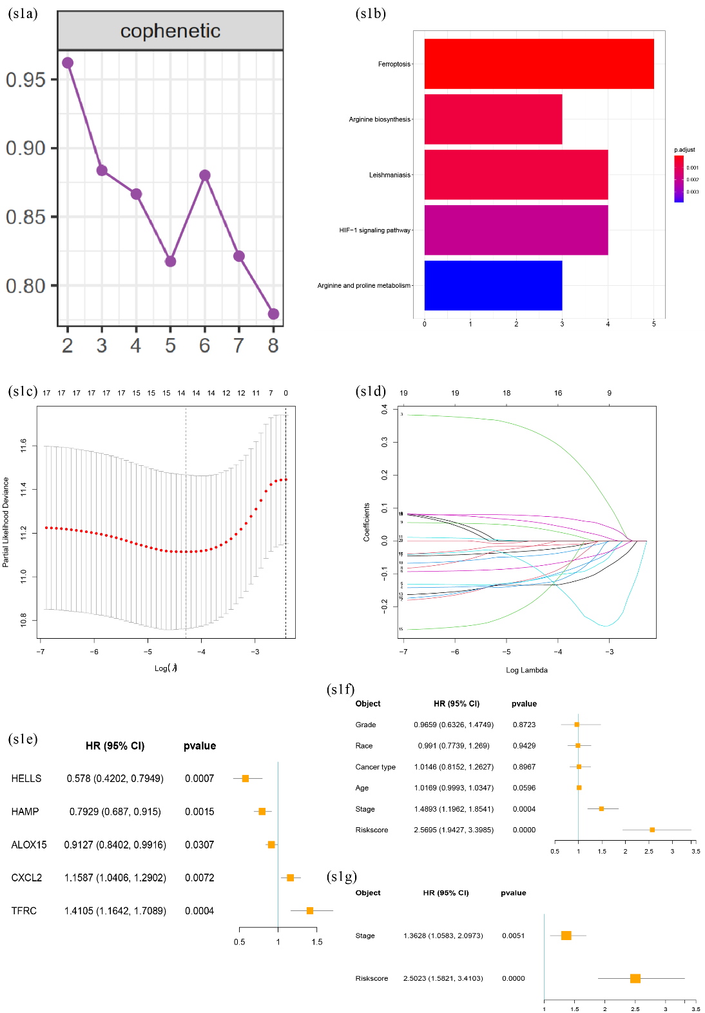
Figure s1. Construction of risk signature for predicting CC patients’ prognosis. (s1a) Cophenetic coefficient of NMF analysis for CESC patients with 21 ferroptosis-related DEGs. The comprehensive coefficient is optimal when K = 2. (s1b) KEGG enrichment analysis of the above 21 genes. (s1c, s1d) LASSO regression analysis was performed to further cut down the above 21 genes. (s1e) Multivariate Cox regression analysis finally identified five FRGs to construct the risk model, including HELLS, HAMP, ALOX15, CXCL2 and TFRC. (s1f, s1g) Univariate and multivariate COX regression analyses for the risk score and other clinicopathologic factors suggested that the risk score was an independent and favorable prognostic factor in patients with cervical cancer.

