Do we properly quantify P from Mehlich 1 or Mehlich 3 extracting solutions?

Denison Pogorzelski⁽¹⁾, Wedisson Oliveira Santos⁽²⁾, Gabriel Grossi Pimentel⁽¹⁾, Fabiane Ballotin^{(1)*}, Patrícia Matias⁽¹⁾ and Leonardus Vergütz^{(1,3)}

Supplementary material

Reagents
Ammonium fluoride (NH₄F, MW = 37.04 g mol⁻¹ and 98 % purity).
Ammonium molybdate ((NH4)6Mo₇O₂₄ 4H₂O, MW = 1235.86 g mol⁻¹ and 99 % purity)
Ammonium nitrate (NH₄NO₃, MW = 80.04 g mol⁻¹ and 95 % purity).
Ascorbic acid (C₆H₈O₆, MW = 176.13 g mol⁻¹ and 99 % purity).
Bismuth subcarbonate ((BiO)₂CO₃, MW = 510.01 g mol⁻¹ and 91 % purity).
Ethylenediaminetetraacetic acid-EDTA (C₁₀H₁₆N₂O₈, MW = 292.24 g mol⁻¹ and 98 % purity).
Glacial acetic acid (CH₃COOH, ρ = 1.05 kg L⁻¹, MW = 60.05 g mol⁻¹ and 99.7 % purity).
Hydrochloric acid (HCl, ρ = 1.19 kg L⁻¹, MW = 36.46 g mol⁻¹ and 37 % purity).
Nitric acid (HNO₃, ρ= 1.41 kg L⁻¹, MW = 63.01 g mol⁻¹ and 65 % purity).
Potassium antimonyl tartrate (C₈H₄K₂O₁₂Sb₂ 3H₂O, MW = 667.87 g mol⁻¹ and 98 % purity).
Sulfuric acid (H₂SO₄, ρ = 1.84 kg L⁻¹, MW = 98.08 g mol⁻¹ and 96 % purity).

Soil test extracting solutions
Mehlich 1 with double concentration, we added 8.3 mL of HCl and 1.4 mL of H₂SO₄ in 200 mL of deionized water and final volume brought to 1 L. The Mehlich 3 with double concentration, we added 22.94 mL of CH₃COOH, 1.79 ml of HNO₃ and 42.13 g of NH₄NO₃ in 200 mL of water and the final volume was completed to 0.5 L (Solution A). Posteriorly, we added 1.13 g of NH₄F and 0.60 g of EDTA in 200 mL of water and completed the final volume to 0.5 L (Solution B). The M3 2X was prepared, always near its use, from the mixture of solution A with B in the ratio 1:1.

Formation and stability of PMB species
The table S1 presents the procedure performed in obtaining the reading solutions that represent the different backgrounds. This procedure is similar to obtaining a calibration curve (Table S2), except that it has a unique concentration of P (1 mg L⁻¹). The reading solution contains M1 or M3 present pH ~1.6 and ~2.6, respectively.

Table S1. Components of the reading solution (RD) using Murphy & Riley (M&R) or Braga & Defelipo (B&D) colorimetric reagents
ªBackground | ^{b}PSS | ^{c}M1 or M3 2X | H₂O | B&D or M&R reagent | RD
 | mL
B&D M1 1:4 | 1 | 4 | 3 | 2 | 10
M&R M1 1:4 | 1 | 4 | 3 | 2 | 10
B&D M3 1:4 | 1 | 4 | 3 | 2 | 10
M&R M3 1:4 | 1 | 4 | 3 | 2 | 10
B&D M3 1:1 | 1 | 2.5 | 4.5 | 2 | 10
M&R M3 1:1 | 1 | 2.5 | 4.5 | 2 | 10
ªBackground of the reading solutions. ^{b}Phosphorus standard solution (10 mg L⁻¹). ^{c}Mehlich 1 or Mehlich 3 with double concentration.

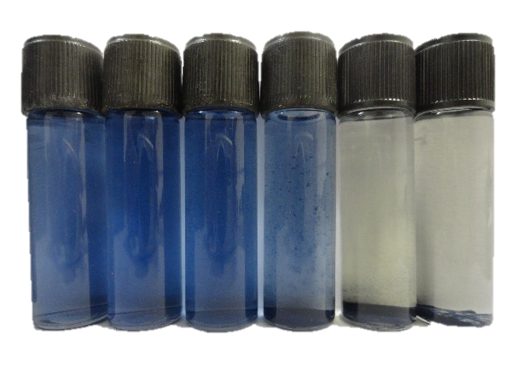
Figure S1. Final solution from Murphy & Riley method in Mehlich 3 extract at volume ratio 1:1 (colorimetric reagent:extract) and in different rest times (5, 15, 30, 60, 120 and 180 min, from left to right) after mixed of the colorimetric reagent (1 mg L⁻¹ P).

Linear range of the methods
Table S2. Calibration curve and components of the reading solution (RD) at volume ratio 1:4 and using Murphy & Riley (M&R) or Braga & Defelipo (B&D) colorimetric reagents.
[P] | ªPSS | ^{b}M1 or M3 2X | H₂O | B&D or M&R reagent | RD
-mg L⁻¹- | -----------------------------------------mL--------------------------------------------
0 | 0 | 4 | 4 | 2 | 10
0.25 | 0.1 | 4 | 3.9 | 2 | 10
0.5 | 0.2 | 4 | 3.8 | 2 | 10
1 | 0.4 | 4 | 3.6 | 2 | 10
1.5 | 0.6 | 4 | 3.4 | 2 | 10
2 | 0.8 | 4 | 3.2 | 2 | 10
5 | 2 | 4 | 2 | 2 | 10
10 | 4 | 4 | 0 | 2 | 10
ªPhosphorus standard solution (25 mg L⁻¹). ^{b}Mehlich 1 or Mehlich 3 with double concentration.

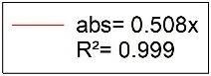
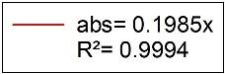
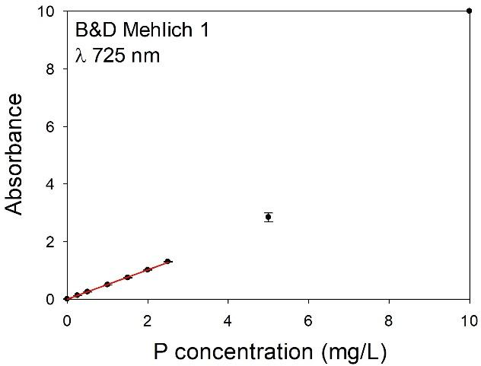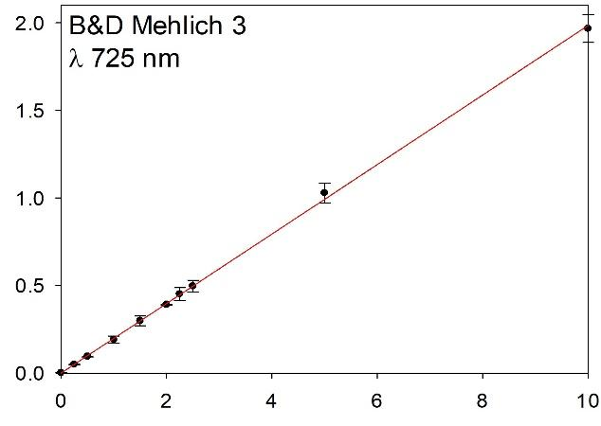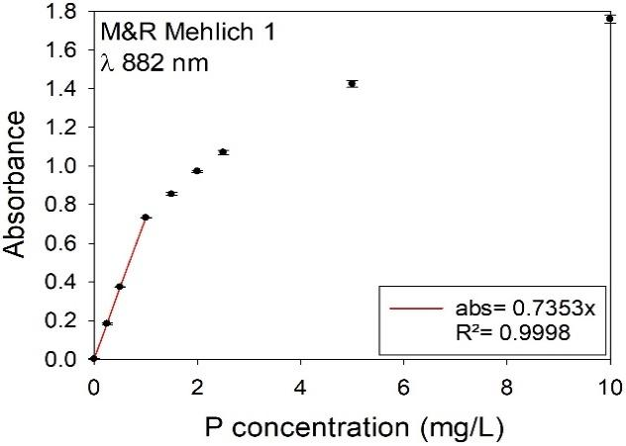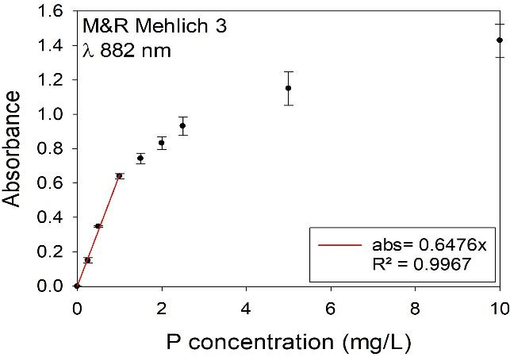
Figure S2. Calibration curve at the concentrations 0, 0.25, 0.5, 1, 1.5, 2, 2.5, 5 and 10 mg L⁻¹ P (n=3). Regression analyses at concentration range of 0-1 mg L⁻¹ P to Braga & Defelipo (B&D) and Murphy & Riley (M&R) methods in Mehlich 1 or Mehlich 3 extracting solutions. Absorbance reading taken 30 min after of reagent addition. Volume ratio 1:4 (colorimetric reagent: extract).

