Gene | Forward primer | Reverse primer
Actin | CAGTTAAATCACGACCAGCAAGAT | TGTCCCTATTTACGAGGGTTATGC
SlSOD | CTTCTTCGCAGTTTGAACG | AACACAGCCTTGACACGA
SlCAT | CCTTACCTGTGCTGATTTCC | TGGGACTTAGGATTTGGCT
SlAPX | TTCTCCAGCTGGTACTTTGAT | GAAGTGCATAACTTCCCATCT
SlMDHAR | CTAACTGCACACACGCACAC | CCTCCCCAACATTGTCACCA
SlTrxh | ACGAGATATGCAGGTTCGAGG | CGGGATGAGCCCTTCAGTTC
SlPrx | AAGTCCGGTGGTCTAGGTGA | CCTGAACGTATTGCAACGCC
SlGrx | GTCGCTCGGAATTTCGCTTC | TAACCGTCCATCCCGTTTGC
SlNRT2.4 | TCCTTTCACTGCTTGGCGTA | CTGCAAACCAAACCACCTTTGA
SlNR | CCGGATCATGGTTTTCCGGT | TTGTACCACCAAGCTTCCGC
SlNiR | TTGGCGAGTGTGATAAGGAAA | GGCAGCACTACTCCACGAAT
SlGS | GGCGTGACACTGAGAAGGAA | GAGCTTCAGCCTCAAGGGTT
SlGOGAT | GGTCTCGGGAGAACTAGGGT | CCCGAAGCTTGGCTCCATAA
Table S1. Specific primers of RT-qPCR amplification of antioxidant enzyme and nitrogen metabolites.

Table S2. Differential gene ontology (GO) categorization table.
Pair | biological process | molecular function | cellular component
Ck-vs-Ck-N | 747 | 720 | 410
Ck-N-vs-T1 | 977 | 943 | 591
Ck-N-vs-T2 | 761 | 753 | 408
T1-vs-T2 | 480 | 489 | 258

Table S3 The expression of enzymes of antioxidant and nitrogen metabolism in transcriptome of tomato roots under N starve and re-supply.
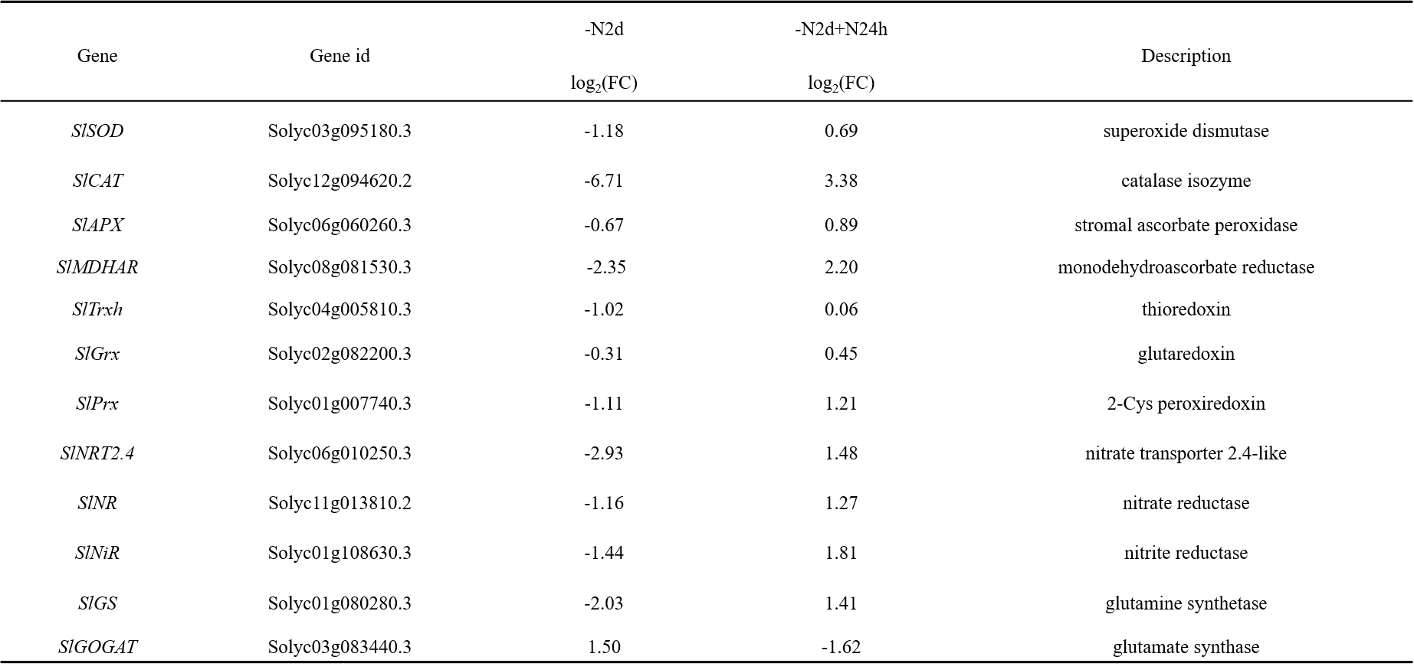

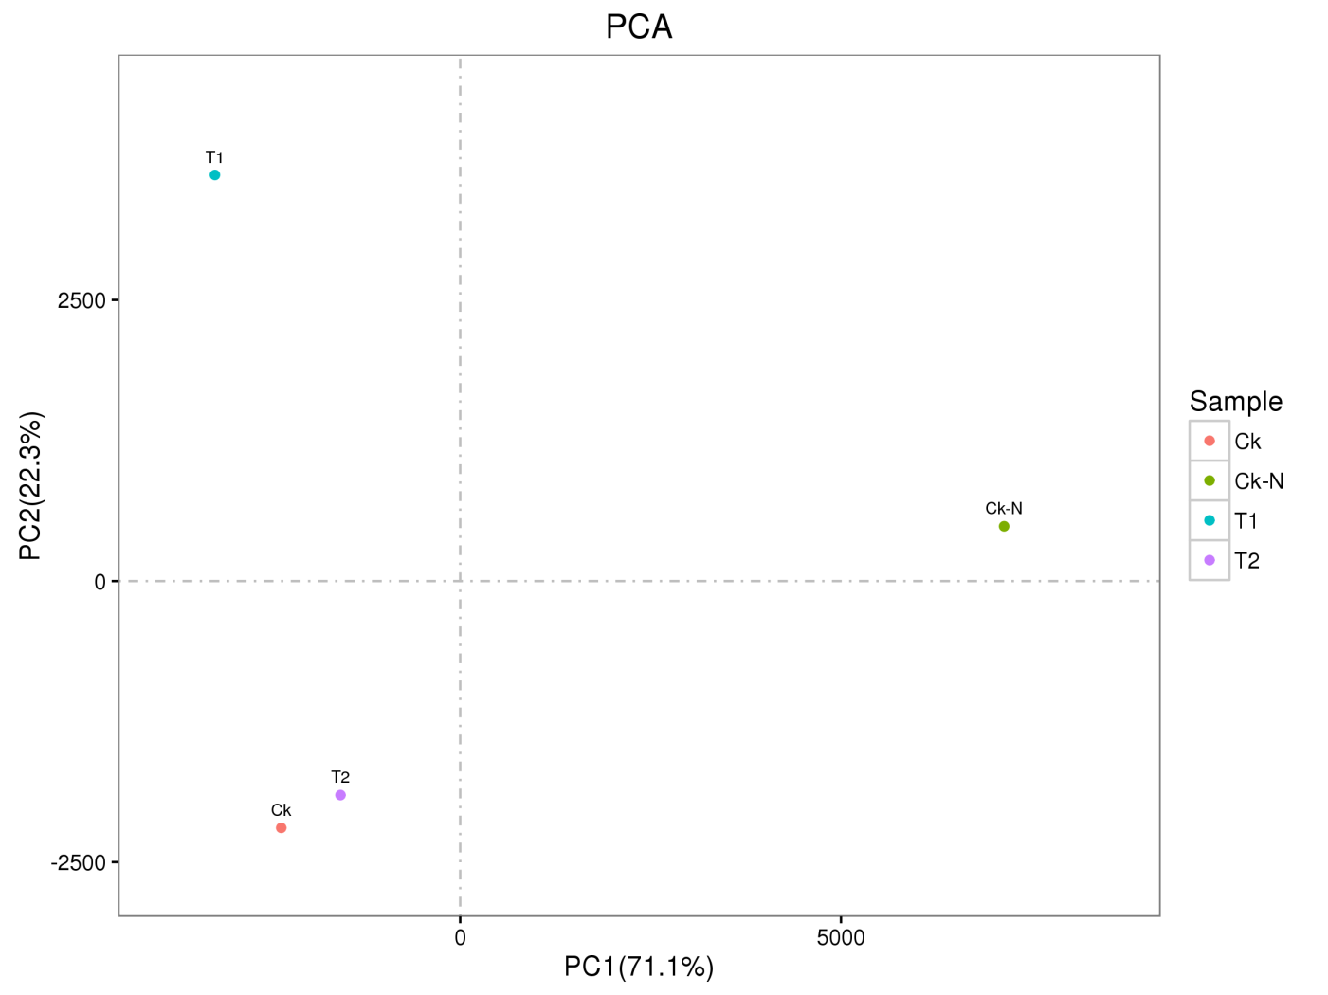
Fig. S1 .CK, CK-N, T1, T2 principal component analysis chart.

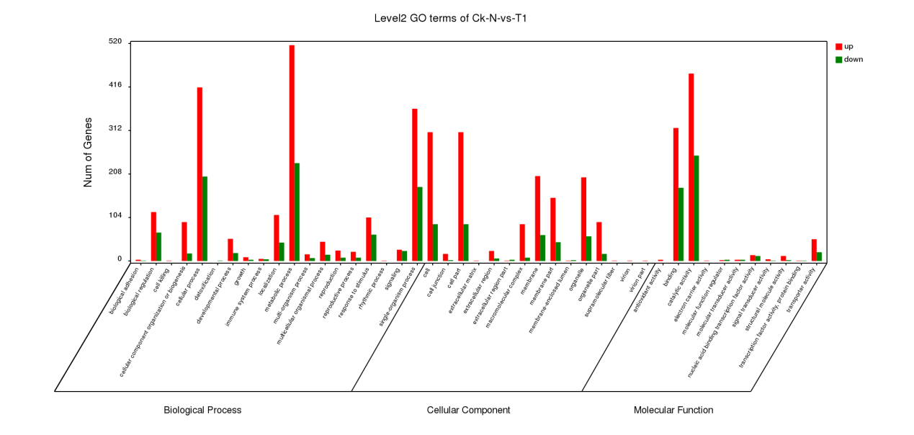
Fig. S2. The GO classification charts of CK-N and T1.

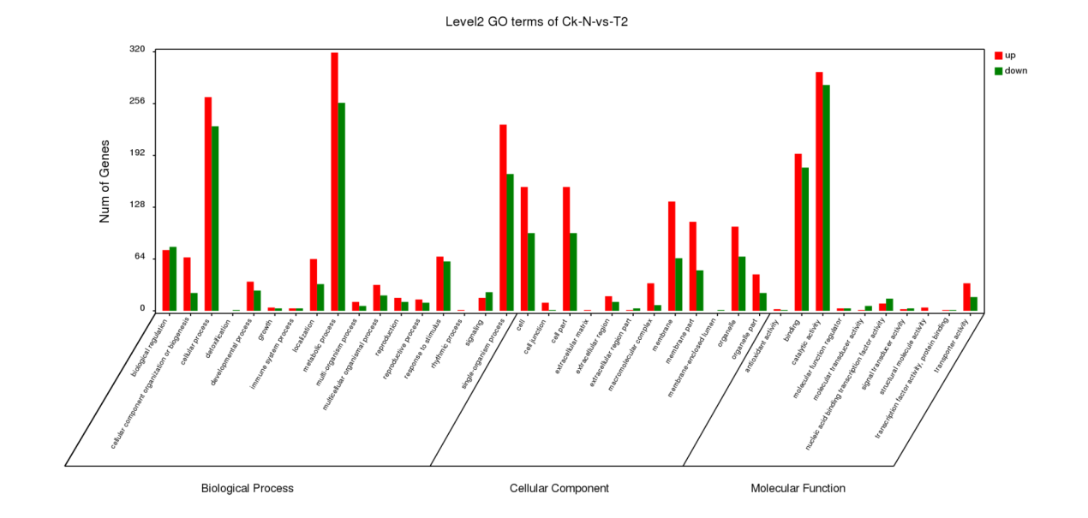
Fig. S3. The GO classification charts of CK-N and T2.

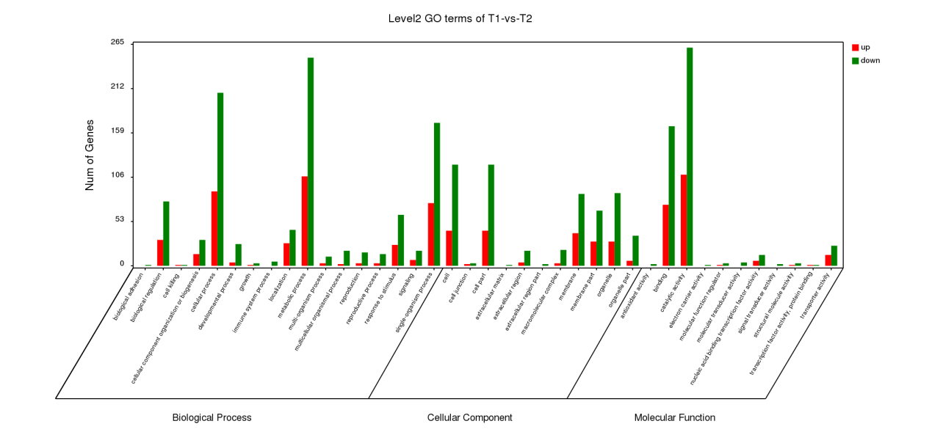
Fig. S4. The GO classification charts of T1 and T2

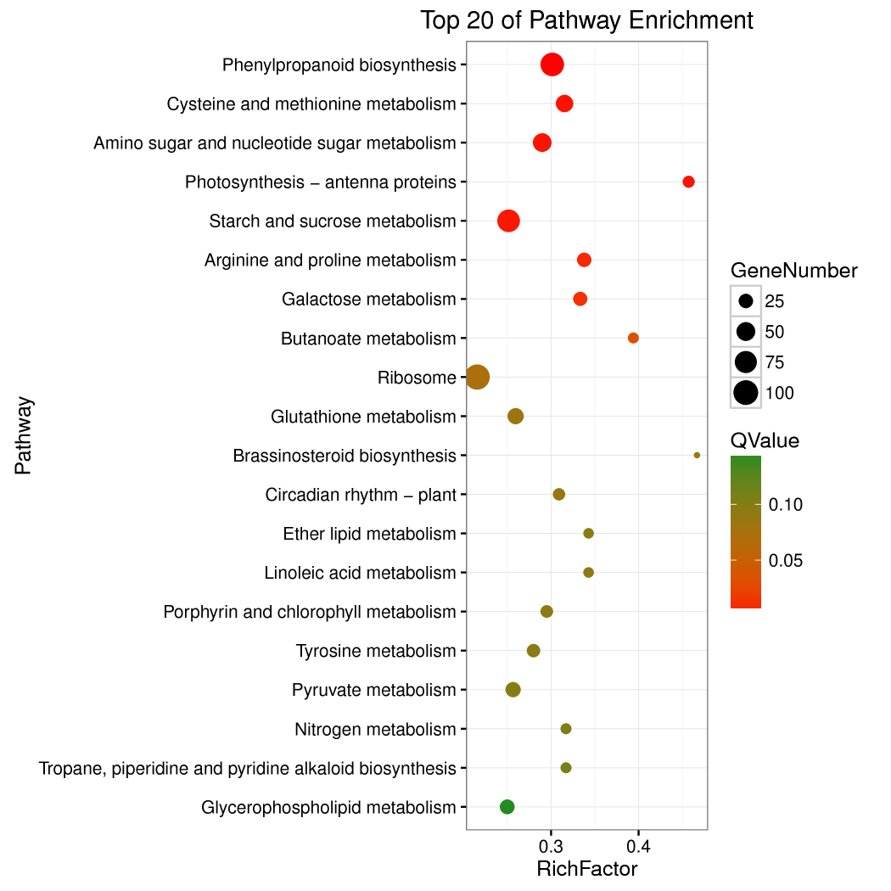
CK-N VS T1
Fig. S5. CK-N and T1 The KEGG metabolism pathway categories of DEGs. The pathway names are provided in the vertical axis, rich factor in the horizontal axis, size of the point represents the number of DEGs, and the color of the dot represents the q value.

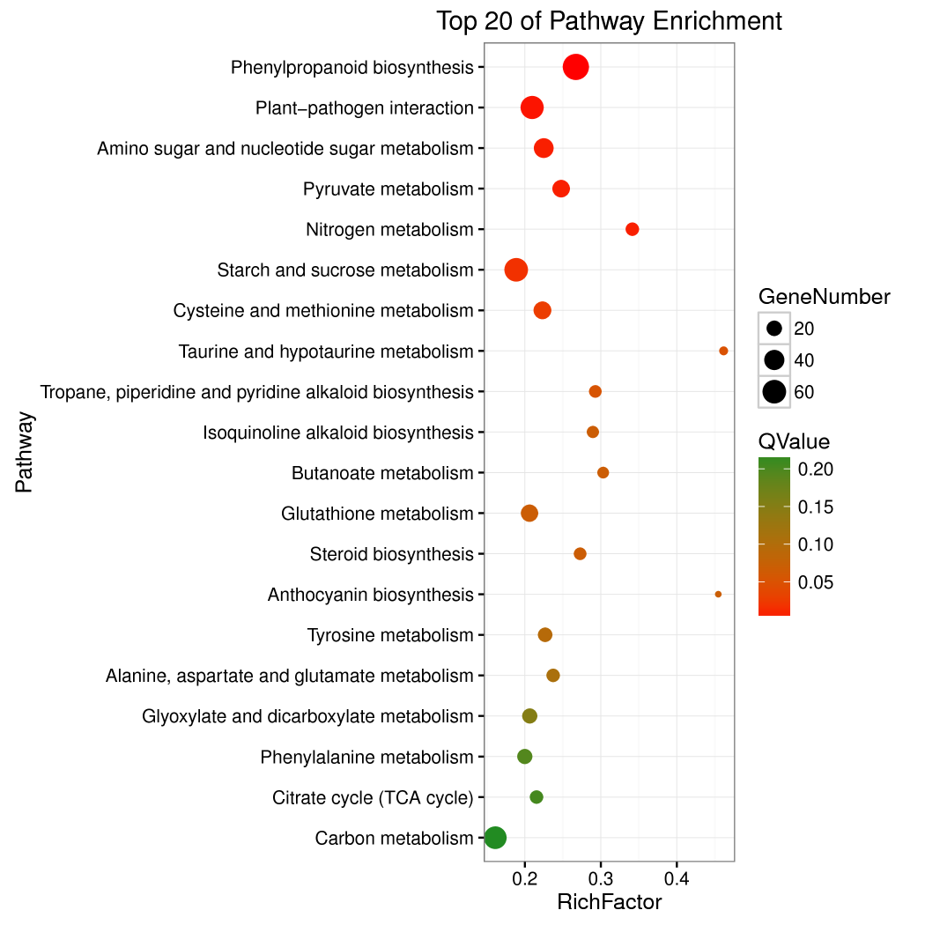
CK-N VS T2
Fig. S6. CK and T2、The KEGG metabolism pathway categories of DEGs. The pathway names are provided in the vertical axis, rich factor in the horizontal axis, size of the point represents the number of DEGs, and the color of the dot represents the q value

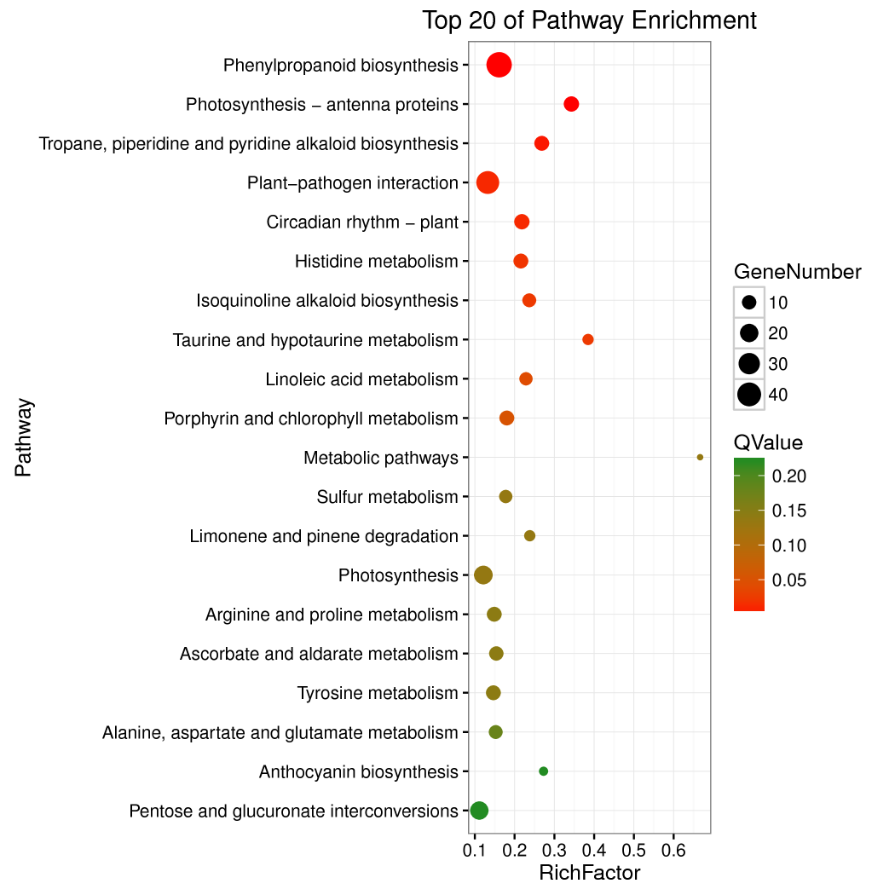
T1 VS T2
Fig. S7. T1 and T2 The KEGG metabolism pathway categories of DEGs. The pathway names are provided in the vertical axis, rich factor in the horizontal axis, size of the point represents the number of DEGs, and the color of the dot represents the q value

