Table 1 Typical morphological features of natural and synthetic microfibers
Microfiber type | Micrograph | Morphological Feature
Wool | 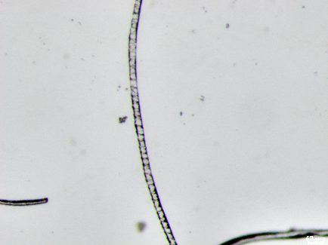  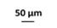 | Scale patterns
Cotton |  | Flat, ribbon-like, with irregular twisting around the fiber axis (convolutions).
Flax | 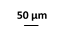  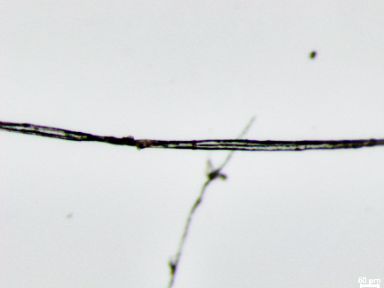 | Cross markings and dislocation, very narrow lumen.
Polyester | 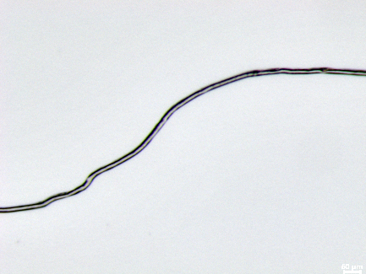 | Fine, regular longitudinal structure, circular cross-section.
Polyamide | 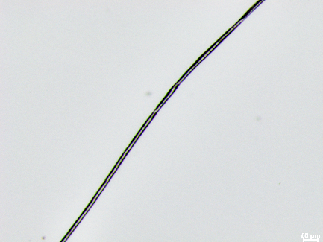 | Fine, regular longitudinal structure and featureless, circular cross-section

